Geometry Formula:
Triangle | 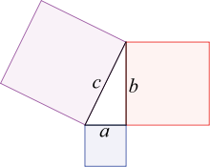  Formula
Pythagorean Theorem  - degree phenomenon  30-60-90 degree phenomenon  Combinations: (3-4-5), (5-12-13), (8-15-17), (6-8-10), ( 9-12-15), (12-16-20), (10-24-26) | $a^{2}$+$b^{2}$=$c^{2}$  x: x: x$\sqrt{2}$ (h=x$\sqrt{2}$)  x:$x\sqrt{3}$: 2x (b=x$\sqrt{3}$)  If the sum of two angles = third angle, then it is a right angled triangle.
Perimeter of Triangle | S1 + S1+ S3
Area of any Triangle  Area of Isosceles Triangle  Area of Right Triangle  Area of Equilateral triangle | 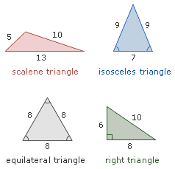  ½(BH)  $\frac{b}{4}$ $\sqrt{4a^{2}+b^{2}}$  $\frac{1}{2}$(L1 . L2)  $\frac{s^{2}}{4}\sqrt{3}$.
Square | Formula
Perimeter  Area#1  Area #2  Relationship between side and diagonal | 4S  S²  $\frac{1}{2}{Diagonal}^{2}$.  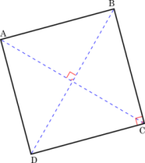  D=$s^{2}$ or D=$\sqrt{2}$s
Rectangle | Formula
Perimeter  Area  Relationship between side and diagonal | 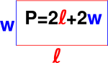  2(L+W)  L.W  ${length}^{2}+{width}^{2}={Diagonal}^{2}$.
Parallelogram | Formula
Perimeter  Area | 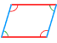  2(L+W)  B.W
Rhombus | Formula
Perimeter  Area #1  Area#2 | 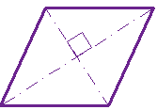  4S  B.H  $\frac{1}{2}\left(d1.d2\right)$.
Trapezoid | Formula
Perimeter  Area | 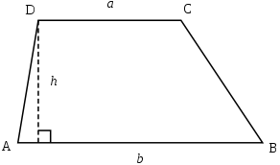  B1+B2+S1+S2  1/2(Base1+Base2).Height
Circle | Formula
Circumference(C)  Area  Diameter  Radius  Area of Sector  Arc length(Central Angle)  Arc length(Inscribed Angle)  Perimeter of Sector of Circle | 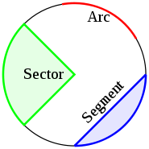  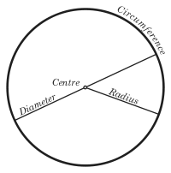  $2πr$. Or $πd$.  $πr^{2}$.  C/$π$  C/2$π$  $\frac{Degree of Cental Angle}{{360}^{0}}πr^{2}$.  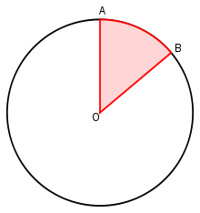  $\frac{Degress of Central Angle}{{360}^{o}}$.C  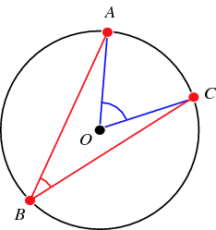  $\frac{2.Degress ofInscibed Angle}{{360}^{o}}$.C  Arc Measure + 2r
Rectangular Solids | Formula
Volume  Area of Front & Back Faces  Area of Top & Bottom Faces  Area of Front & Back Faces  Total Surface  Diagonal | 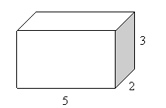  L.W.H  2(L.H)  2(L.W)  2(W.H)  2(LH+LW+WH)
Cube | Formula
Area of Cube  Volume  Diagonal | 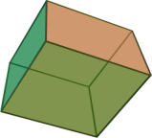  6$s^{2}$  $s^{3}$.
Cylinder | Formula
Lateral Surface Area  Total Surface Area  Volume | 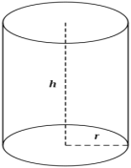  $2πrh$.  $2πr^{2}$+$2πrh$.  $πr^{2}h$.
Coordinate Geometry | Formula
Distance  Mid-Point  General form  Slope | Y = mx+b
Polygon | Formula
Sum of interior angles of a polygon with n sides = (n-2)*180

Arithmetic & Algebra formulas:
Properties of Numbers | Formula
- For any number a, exactly one of the following is true: a is Negative or Positive , a=0
- If a and b are integers, the following four terms are synonymous: a is a divisor of b, a is a factor of b, b is divisible by a, b is multiple of a.
- Even integer has a finite set of factors(or divisors) @ an infinite set of multiples
- The product of an even number of negative factor is positive
- The product of an odd number of negative factor is negative
- The reciprocal of any nonzero a is 1/a
- The product of any number and its reciprocal is 1: a x (1/a)=1
- The sum of any number and its opposite is 0: a+(-a)=0
- The number of integers from “A to B inclusive” is =B-A+1
- An integer is any number in the set (-2-1, 0,1,2)
- The average consecutive numbers. Ex: from 14 to 26=(14+26)/2=20
- The numbers -2, -1, 0, 1, 2, 3 are consecutive integers..can be represented n, n+1, n+3
- A prime num is a positive integer has the exactly two different positive divisors, 1 and itself. Ex: 1,2,3,5,7,11
- The numbers 0,2,4,6 are consecutive even integers can be written 2n, 2n+2, 2n+4….
- The numbers 1,3,5,7 are consecutive odd integers can be written 2n+1, 2n+3, 2n+5…..
- The properties of 0 is neither positive or negative
Fractions, Ratio, & Proportion | Formula
Fractions = $\frac{part}{Whole}$ , Ratio=$\frac{of…}{to…}$  The reciprocal of $\frac{n}{d}$ is $\frac{d}{n}$. (Where n & d are not zero) | GCD= Greatest Common Divisor. Ex: The gcd of 8 & 36 is 4.  LCD=Least Common Multiple. Ex: For $\frac{2}{3}$+$\frac{1}{6},$the lcm of 3 & 6 is 6To solve n for the proportion $\frac{2}{3}$ = $\frac{n}{4}$ ( just example)
Permutations & Combinations | Formula
Combinations: nCk = n!/((n-k)k!)!
Permutations: nPk = n!/(n-k)!
Circular: (n-1)!
k = number of objects selected from a pile of n objects
n = total number of objects from which k objects can be selected

Real numbers | Formula
To say that the number n is between 1 & 4 on the number line means that n>1 & n<4, that is 1, 1<n<4. If n is ‘between 1 & 4, inclusive’, then 1 $≤$ n $≤$ 4.

Interest | Formula
The most basic:  S.I (simple interest)  Interest paid Annually  Interest paid Quarterly  Interest paid Monthly | FV=PV(1+i)^{n}  Principal × Interest × Time  P (1 + R)^{n} (n=number of years)  P (1 + R /4)^{4 x t} (t= number of years)  P (1 + R /12)^{12 X t} (t= number of years)
Speed, Distance and Time | Formula
Distance= Rate x time …..Average speed = Total distance / Total Time
Case1: When equal distances are covered in different speed then Average Speed = 2ab / (a + b)
Case 2: For Different distances in same time then Average Speed is = (a + b) / 2

Fractions & Decimals | Formula
There are two method of comparing fractions: 1) cross multiply 2) Convert them to decimals(by dividing)
- If a/b is the number of a whole that satisfies some property, then 1-(a/b) is the fraction of that whole that does not satisfy it.
The period or decimal point determines the place value of the digits. For example the digit number 7654.321 have the following place values or decimal points:
7 is thousands, 6 is hundreds, 5 is tens, 4 is ones or units. 3 is tenths, 2 is hundredths, 1 is thousandths
Example of decimal follow: .0321=$\frac{0}{10}+\frac{3}{100}+\frac{2}{1000}+\frac{1}{10000}=\frac{321}{10,000}$

Percents | Formula
Part=Percent * whole. % increase or decrease =$\frac{Amount of increase or decrease}{Original whole}×100$

Sets | Formula
- n(AuB)  - n(AuB)/  - n(AuBuC)  - n(AuBuC)/  - n(AnB/)  - n(AnBnC/  - n(AnB/nC/) | n(A)+n(B)-n(AnB)  n(U) - n(A) - n(B) + n(AnB)  n(A)+n(B)+n(C) - n(AnB) - n(AnC) - n(BnC)+ n(AnBnC)  n(U)-n(A)-n(B)-n(C)+n(AnB)+n(AnC)+n(BnC) - n(AnBnC)n(A)-n(AnB)  n(AnB)- n(AnBnC)  n(A)- n(AnB) – n(AnC) + n( AnBnC)
Quadratic Equations | Formula
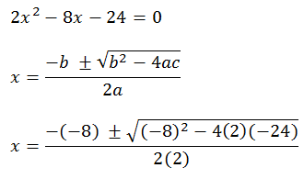

Powers and roots of Numbers | Formula
For any numbers b & c & positive integers m & n:
b^{m}b^{n}=b^{m+n} , $\frac{b^{m}}{b^{n}}=b^{m+n}$, (b^{m})^{n}=b^{mn}, b^{m}c^{m}=bc^{m}

To square a number that is greater than, or, raising it to a higher power, results in a larger number. Squaring a number between 0 and 1 results in a smaller number

Properties of Prime Number | Formula
1) 2 and 3 are the lowest even and odd prime numbers respectively.
2) 2 is the only even prime number
3) Prime numbers between 1 and 100 are
2, 3, 5, 7, 11, 13, 17, 19, 23, 29, 31, 37, 41, 43, 47, 53, 59, 61, 67, 71, 73, 79, 83, 89, 97.
There are 25 prime numbers between 1 and 100
4) There are no negative prime numbers
5) All prime numbers except 2 and 5, end in 1, 3, 7 or 9, since numbers ending in 0, 2, 4, 6 or 8 are multiples of 2 and numbers ending in 0 or 5 are multiples of 5
6) All prime numbers above 3 are of the form 6n + 1, because all other numbers are divisible by 2 or 3 where n>=1

Progression | Formula
Sum of squares of 1st n natural numbers = n (n+1)(2n+1) / 6
Sum of cubes of 1st n natural numbers =[n (n+1)/2]²
1+2+3………………………… ….n = n*n+1/2

Inequalities | Formula
- For any number a and b: a>b means that a-b is positive
- For any number a and b: a<b means that a-b is negative
- For any number a and b, exactly one of the following is true: a>b or a=b or a<b
- Adding a number to an inequality or subtracting a number from an inequality preserves it: If a<b, then a+c<b+c and a-c<b-c
- Adding inequalities in the same direction preserves them:
If a<b and c<d, then a+c<b+d
- Multiplying or dividing an inequality by a positive number preserves it:
If a<b and c is positive , then ac<bc and $\frac{a}{c}$<$\frac{b}{c}$
- Multiplying or dividing an inequality by a negative number preserves it:
If a<b and c is negative , then ac>bc
- Taking negative reserves an inequality:
If a <b , then –a>-b and if a>b, then –a<-b
- If two numbers are each positive or negative, then taking reciprocals reverses an equality.
- If a and b are both positive or both negative and a<b, then $\frac{1}{a}$ > $\frac{1}{b}$

Important Inequalities for numbers between o and 1:
If 0<x<1, and a is positive, then xa<a fro ex: .85 x 19<19
If 0<x<1, and m and n are integers with m>n, then x^{m}<x^{n}<x
If o<x<1, then $\sqrt{x}$>x
If o<x<1, then $\frac{1}{x}$>x. in fact, $\frac{1}{x}$ >1

Way to add hours and minutes together | Formula
lets add 1hr & 35 mins and 3 hrs & 55mins together
Take these two times as simple natural numbers like 135 and 355
We get 135 + 355 = 490
Now add a constant number 40 to it:
We get 490+ 40 = 530
so the time is 5 hrs and 30 mins simple....

