Geometry Formula:
Triangle | Formula
Area of Isosceles Triangle  Area of Right Triangle  Area of Equilateral triangle | 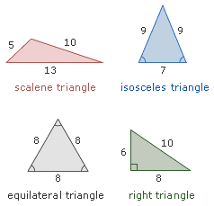  $\frac{b}{4}$ $\sqrt{4a^{2}+b^{2}}$  $\frac{1}{2}$(L1. L2)  $\frac{s^{2}}{4}\sqrt{3}$.
Square | Parallelogram
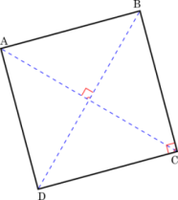  Area#1 S²  Area #2 $\frac{1}{2}{Diagonal}^{2}$. | 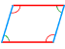  Perimeter: 2(L+W)  Area: B.W
Trapezoid | Rhombus
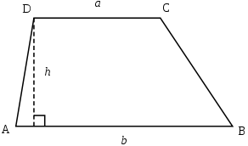  Perimeter: B1+B2+S1+S2  Area : 1/2(B1+B2).H | 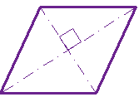  Perimeter: 4S  Area #1: B.H  Area#2 : $\frac{1}{2}\left(d1.d2\right)$.
Circle | Formula
Circumference(C)  Area  Diameter  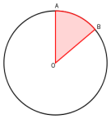  Radius  Area of Sector  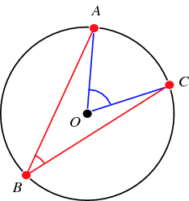  Arc length(Central Angle)  Arc length(Inscribed Angle) | 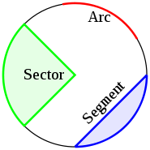  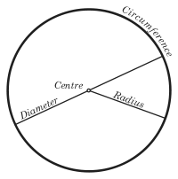  $2πr$.  $πr^{2}$.  C/$π$  C/2$π$  $\frac{Degree of Cental Angle}{{360}^{0}}πr^{2}$.  $\frac{Degress of Central Angle}{{360}^{o}}$.C  $\frac{2.Degress ofInscibed Angle}{{360}^{o}}$.C
Rectangular Solids | Cube
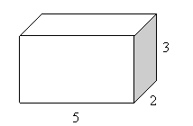  Volume : L.W.H  Total Surface: 2(LH+LW+WH) | 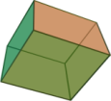  Area of Cube: 6$s^{2}$  Volume: $s^{3}$.
Cylinder | Formula
Lateral Surface Area  Total Surface Area  Volume | 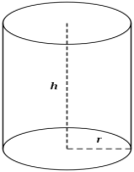  $2πrh$.  $2πr^{2}$+$2πrh$.  $πr^{2}h$.
Coordinate Geometry | Formula
Distance  Mid-Point  General form  Slope | Y = mx+b
Polygon | Formula
Sum of interior angles of a polygon with n sides = (n-2)*180

