GMAT Tricks
Exponents – splitting up an exponent
e.g. 4¹⁸ 2¹⁸2¹⁸ 2³⁶
n2739178: The reasoning behind converting to reciprocals is the oft used 'cross multiplication'
If I have and I need to find the value of m, I can simply treat this as and cross multiply to get . So the left side denominator goes to right with the right side numerator and right side denominator goes to left with the left side numerator. Here, since the numerators are 1, it doesn't matter.
Though, if you have all the 2s of the left side and the right side in the denominator, you can simply compare them there and do not need to cross multiply. Here I can simply say m =3. The important thing is that all powers of a certain prime should be consolidated in one place on the left side and same for the right side.
e.g.
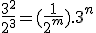
Here m = 3 and n = 2

$$\sqrt{80}+\sqrt{125}= ?$$
First, express the number under the radical as the product of PRIME FACTORS. Because pairs of factors under the radical form a perfect square, we can take that factor outside the radical.
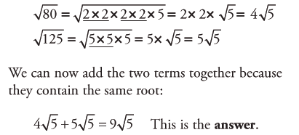
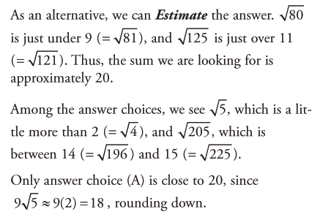
Because a ratio is essentially a fraction, you can SIMPLIFY THE RATIO by dividing both sides by common factors.

Notice a proportion can be used to compare say km’s to miles when asked to find e.g. how many miles in x km when you’re given the conversion ratio.
e.g.
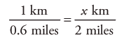

When you have a decimal in a fraction, eliminate the decimal accordingly…

When you see COMPOUND INTEREST, be sure to FOLLOW THE MONEY step by step…
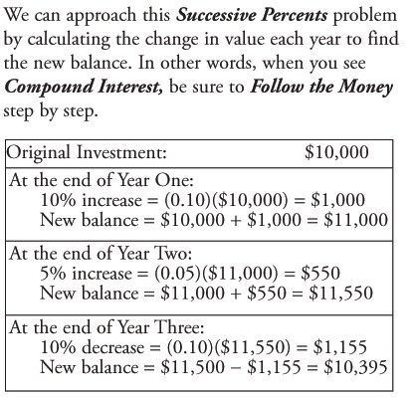

Avoid computing products before CANCELLING as many factors as possible…

