I just wanted to share what I’ve learned about using Twitter to help with the V section on the GMAT. Twitter can be somewhat customised to:
- Act as a merciless ‘relevant article generator’
- Target your weak topics in RC and improve your general knowledge
- Help you save precious time during your prep
- Get you so used to tackling difficult and complex articles that the GMAT shouldn’t phase you
Over the last month, instead of using twitter to tweet, I have tried to turn it into a GMAT tool. So far, it’s working great. Instead of following famous people etc, i’ve been following GMAT-specific profiles that can help me to improve my verbal score. I have made Twitter my main article generator for RC and it only took a few minutes to set up. Many of you probably do this already, or have an RSS feed set up, but for those of you who don’t…
During prep, many people recommend doing 2 or 3 RC passages a day and reading other quality articles for appx 30 minutes. However, finding these quality articles can take up a lot of your time, especially if find yourself aimlessly browsing the internet for divine article inspiration. This wastes time and Twitter can help you circumvent that. If you subscribe to the right kind of twitter profiles, you can have a great range of frequently updated articles at your disposal 24/7.
Setting up a twitter account is free and easy. I check mine periodically - perhaps 5 times a day. And every time I log on, I make myself read one new article (enthusiastically) before logging off. Below are groups that include different profiles you can subscribe to. These topics constantly appear on the GMAT in the RC and CR sections.
When you log onto your profile and visit your Homepage, you will have several ‘randomly generated’ articles waiting to be read. To mimic the GMAT’s randomness, it’s a good idea to resign yourself to reading from the top down without skipping to a tweeted article that you find interesting. You won’t have this option to pick and choose on the GMAT so you shouldn’t when using twitter! Mark other interesting articles as ‘favourites’ so you can return to view them another time or after you’ve read the ‘mandatory’ article. It’s important to get used to the fact that you have no control over what you can read in the GMAT. If you take this more disciplined route to using Twitter for GMAT prep, it can make coming across difficult/complex passages a common occurance for you. And hopefully by the time the GMAT comes, you will be desensitized to the point of not caring and simply getting on with acing the questions.
These are obviously rough groups, but if you add even just 2 from each group, you will have great access to random articles encompassing:
- Medicine
- History
- Business/Finance/Global news/General analysis
- Nature
- Science

I’m sure there are countless other relevant profiles that you can subscribe and follow, however, the below are pretty good ones from my experience. Just be careful when chosing because you can easily find yourself in a situation where you are adding Conan O’Brien and don’t even realise it!

Medicine
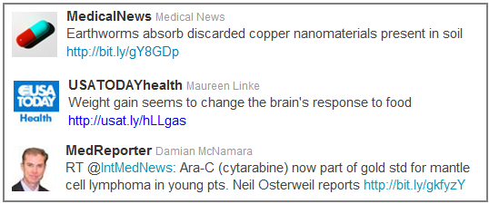
History
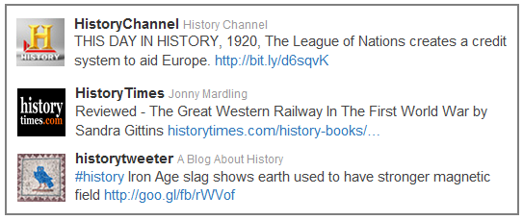

Business/Finance/Global
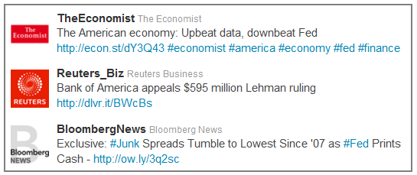

Nature
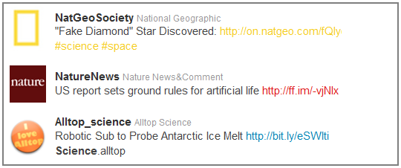
Science
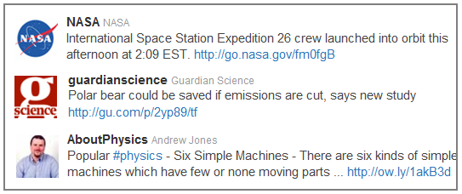
Targeting your weaknesses
Let’s say its 4 weeks before G-day and you have been using twitter as your article epicentre for 1-3 months. You should now have a good idea about the types of articles you:
- find very interesting, easy to read, and can comprehend/retain easily
and
- those you find difficult, overly complex, and annoying
Here’s where you can use Twitter to target your weak areas. If you absolutely love reading about the habitat’s of various sea dwelling creatures and hedge row inhabitants, it’s time to stop following the nature profiles. If you find that reading about the industrial revolution and its effect on international trade in the mid 1800s is the most benign and upsettingly hard-to-digest load of crud in the world, then subscribe to more history profiles and follow on with the twitter discipline of reading several articles a day! This just means that more of the articles you dislike will appear randomly. You don’t need to begin liking the content, but you need to be able to trick your brain into reading those passages in an active and enthusiastic way.

Here’s an example of what you may find on your homepage when you log in. Obviously, skip Duke at the start and go straight to the NatGeoSociety (one of my favourites) and read that Saturn article. Don’t skip the Saturn article!
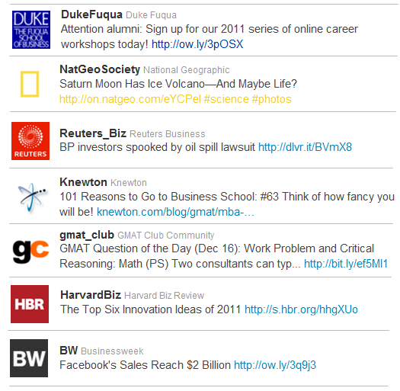
Other uses for Twitter when prepping for GMAT
Prep providers are very active and you can get great info on course packages and special offers:
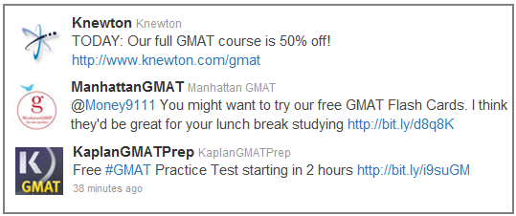

You can begin doing some recon work on potential schools. Some schools are really active on twitter and frequently update their profiles. You may find information through tweets that you won’t easily find elsewhere! Connect with students, find school-specific articles, and get a range of other useful info. Chances are that an admissions person updates these tweets, so it the tweet content for a school may prove to be a great conversation starter at an info session or some other event:

Our very own GMAT Club is really active on twitter! Receive links to articles, offers, updates, debriefs, and other great content that you may accidentally miss on the site. Twitter is a really good social extension to the forum. For instance, I bought my Knewton course after reading a tweet from GmatClub :
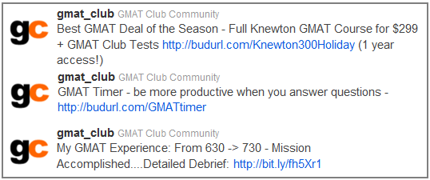

All in all, Twitter can be used in some way, shape, or form to improve your prep. It will probably help marginally for a few people who try it but for me it has helped to add significant structure to my verbal prep. Hope you give it a shot. If anyone finds great tweets with good articles or thinks of other important groups to include in the above, just post them here for everyone. Thoughts on how to improve the above are appreciated.

Rux10

