22.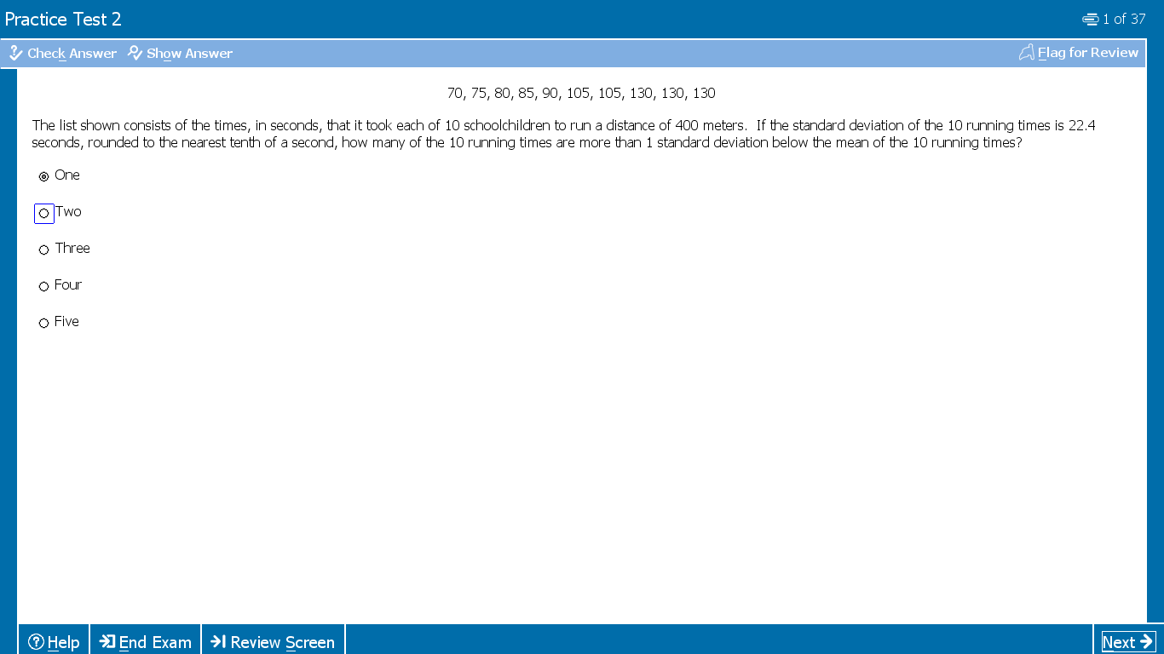
Answer will be 70 and 75 , it is asking more that 1 SD BELOW the mean , mean is 100 , 100-22.4=77.6, 70 and 75 are below 77.6

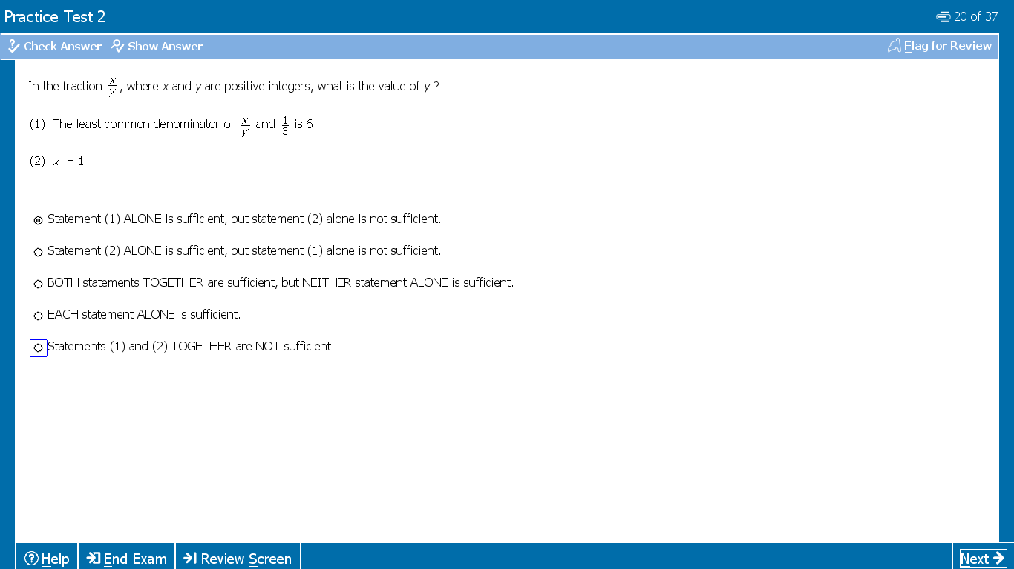

From 1 Y can be 2 or 6 , not sufficient
From 2 , X=1 , no info about Y. not sufficient

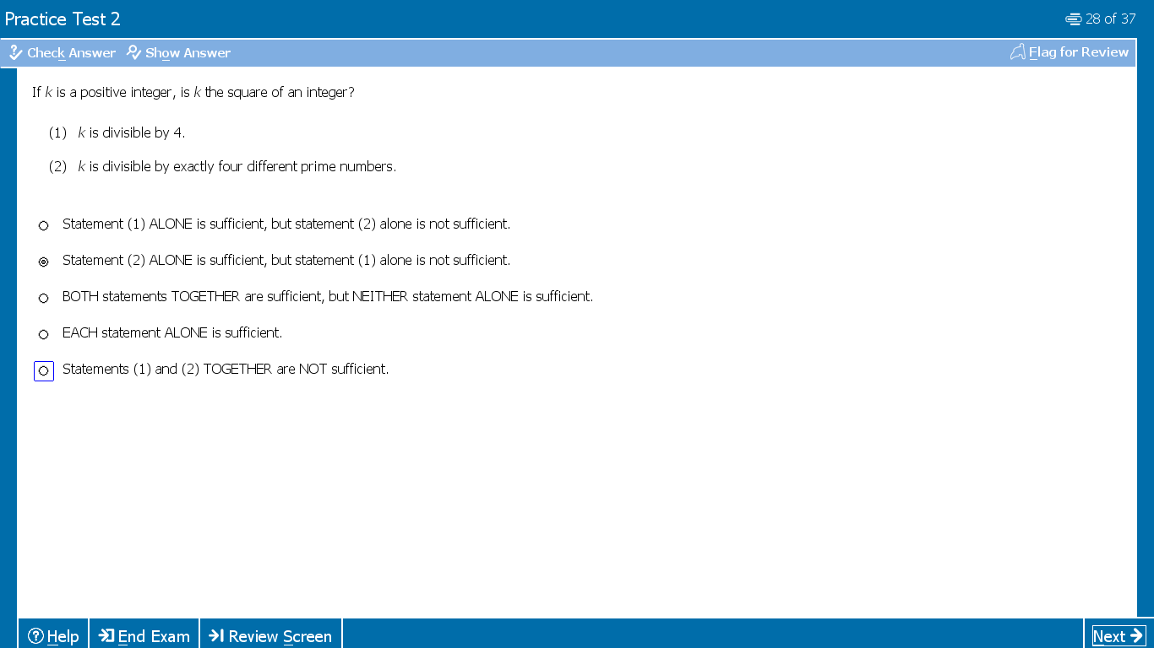
Take K=4 , k/4 is 1 and 1 is square of 1, True
Take k=8 , k/4 is 2 but 2 is not square of a positive int , False . Hence statement 1 Insuff.
Let k = 2x3x5x7 ( 4 different prime numbers) k is divisible by 2x3x5x7 , we get 1 and 1 is square of 1, True
Let K is 2x(2x3x5x7) , still divisible by exactly 2x3x5x7 but K is 2 but 2 is not square of a positive int , False . Hence statement 2 Insuff.

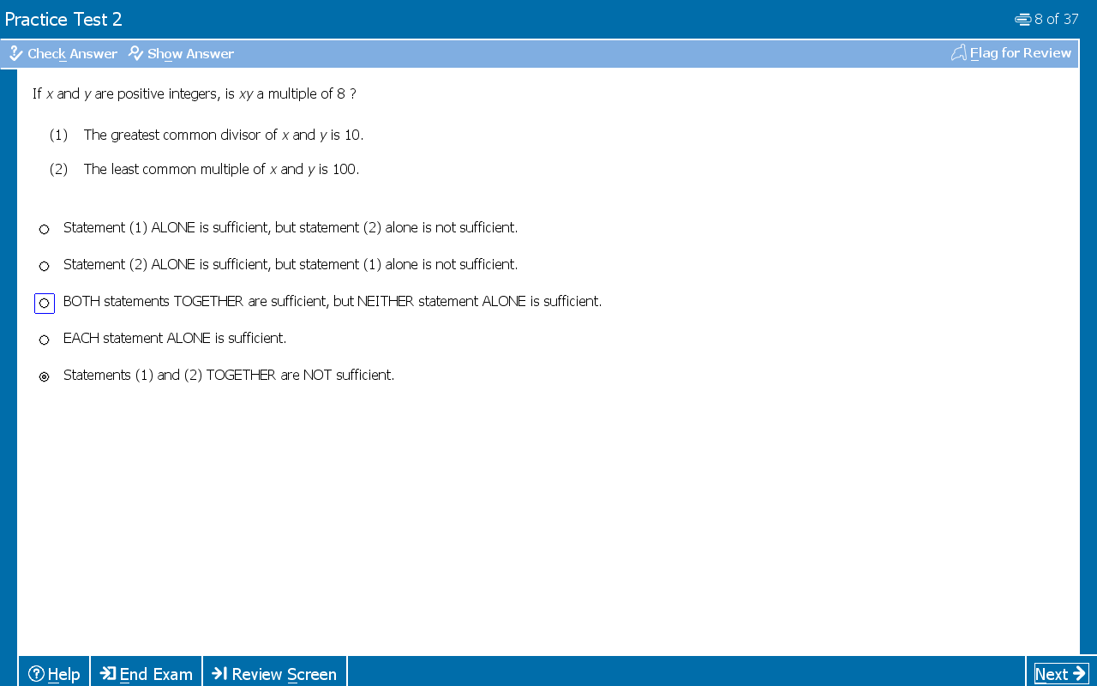
Remember this product of 2 number X, Y = GCD(X,Y) x LCM(X,Y)

