ALL ODD NUMBERED QUESTIONS ARE QUANTITATIVE

ALL EVEN NUMBERED QUESTIONS ARE VERBAL

- Q
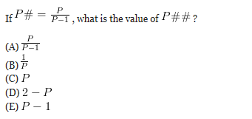

- Q
No one knows what purposes, if any, dreams serve, although there are a number of hypotheses. According to one hypothesis, dreams are produced when the brain is erasing “parasitic connections” (meaningless, accidental associations between ideas), which accumulate during the day and which would otherwise clog up our memories. Interestingly, the only mammal that does not have rapid eye movement sleep, in which we humans typically have our most vivid dreams, is the spiny anteater, which has been seen as anomalous in that it has a very large brain relative to the animal’s size. This fact provides some confirmation for the parasitic-connection hypothesis, since the hypothesis predicts that for an animal that did not dream to have an effective memory that animal would need extra memory space for the parasitic connections.

The parasitic-connection hypothesis, if true, most strongly supports which one of the following?

(A) The animals with the smallest brains spend the most time sleeping.
(B) Immediately after a person awakens from normal sleep, her or his memory contains virtually no accidental associations between ideas.
(C) When a mammal that would normally dream is prevented from dreaming, the functioning of its memory will be impaired.
(D) Insofar as a person’s description of a dream involves meaningful associations between ideas, it is an inaccurate description.
(E) All animals other than the spiny anteater dream.

- Q

If equation |X| + |Y| = 5 encloses a certain region on the graph, what is the area of that region?

(A) 5
(B) 10
(C) 25
(D) 50
(E) 100

- Q

Many scientists believe that abnormalities in brain chemistry cause clinical depression, but they have not established what these abnormalities are or how they lead to illness.

(A) cause clinical depression, but they have not established what these abnormalities are or
(B) cause clinical depression, but they have not established either what these abnormalities are nor
(C) are the cause of clinical depression, but they have neither not established what these abnormalities are or
(D) are the cause of clinical depression, but they have not established either what these abnormalities are nor
(E) causes clinical depression, but they have not established what these abnormalities are nor

- Q
A contractor estimated that his 10-men crew could complete the construction in 110 days if there was no rain. (Assume the crew does not work on any rainy day and rain is the only factor that can deter the crew from working). However, after 5 days of rain, on the 61-st day, he hired 6 more people to finish the project early. If the job was done in 100 days, on how many days after day 60 was it raining?

(A) 4
(B) 5
(C) 6
(D) 7
(E) 8

- Q
Monarch butterflies, whose average life span is nine months, migrate from the midwestern United States to selected forests outside Mexico City. It takes at least three generations of monarchs to make the journey, so the great-great-grandchildren who finally arrive in the Mexican forests have never been there before. Yet they return to the same trees their forebears left. Scientists theorize that monarchs, like homing pigeons, map their routes according to the earth’s electromagnetic fields. As a first step in testing this theory, lepidopterists plan to install a low-voltage transmitter inside one grove of “butterfly trees” in the Mexican forests. If the butterflies are either especially attracted to the grove with the transmitter or especially repelled by it, lepidopterists will have evidence that______

(A) monarch butterflies have brains, however minuscule
(B) monarch butterflies are sensitive to electricity
(C) low-voltage electricity can affect butterflies, whether positively or adversely
(D) monarchs map their routes according to the earth’s electromagnetic fields
(E) monarchs communicate in intergenerationally via electromagnetic fields

- Q
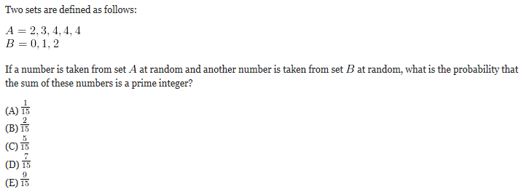

- Q

People can debate the aesthetic merits of these overwrought, disquieting, sometimes gruesome works of art, but no one can dispute their creators’ mastery of the paintbrush as a blunt instrument.

(A) but no one can dispute their creators’ mastery of the paintbrush as a blunt instrument.
(B) but none can dispute their creators’ mastery of the paintbrush as a blunt instrument.
(C) but not a one can dispute their creators’ mastery of the paintbrush as a blunt instrument.
(D) but no person can dispute their creators’ mastery of the paintbrush as a blunt instrument.
(E) but none can dispute to their creators’ mastery of the paintbrush as a blunt instrument.

- Q
It takes Jack 2 more hours than Tom to type 20 pages. Working together, Jack and Tom can type 25 pages in 3 hours. How long will it take Jack to type 40 pages?

(A) 5 hours
(B) 6 hours
(C) 8 hours
(D) 10 hours
(E) 12 hours

- Q

On the Great Plains, nineteenth-century settlers used mud and grass to build their homes, doing it without timber and nails.

(A) settlers used mud and grass to build their homes, doing it without
(B) settlers used mud and grass to build their homes, did it without
(C) settlers used mud and grass to build their homes, making them while not having
(D) settlers used mud and grass to build their homes, making do without
(E) settlers’ homes were built of mud and grass, making do without

- Q

Is the range of a non-empty set S bigger than its mean?

1. All members of S are negative
2. The median of set S is negative

- Q
When Bob’s Bistro opened in the town of Montrose last year, the proprietors of Andrew’s Eatery, the only other restaurant in town, feared that their business would suffer. Surprisingly though, in the past year the average number of meals per day served at Andrew’s Eatery has actually increased significantly.

Which of the following, if true, provides the best explanation for this occurrence?

(A) The meals at Andrew’s Eatery are substantially lower in price than those offered at Bob’s Bistro.
(B) Bob’s Bistro is closed on Sundays, and so for Sunday brunch residents of Montrose would either go to Andrew’s Eatery or venture to a neighboring town.
(C) The profit per meal is higher, on average, at Bob’s Bistro than it is at Andrew’s Eatery.
(D) Bob’s Bistro attracts a large number of patrons that had never dined in Montrose before, and on many days Bob’s Bistro attracts more customers than it can seat.
(E) Andrew’s Eatery serves considerably more meals on weekends than it does on weekdays, which is not the case at Bob’s Bistro.

- Q

Two sacks together contained 43.25 kg of sugar. If after 4.75 kg of sugar was taken from the first sack and poured into the second, the weight of the sugar in the first sack became 73% the weight of the sugar in the second one, what was the original difference in the weights of the sacks?

(A) 1.25 kg
(B) 2.00 kg
(C) 2.75 kg
(D) 3.25 kg
(E) 3.50 kg

- Q

When a company refuses to allow other companies to produce patented technology, the consumer invariably loses. The company that holds the patent can charge exorbitant prices because there is no direct competition. When the patent expires, other companies are free to manufacture the technology and prices fall. Companies should therefore allow other manufacturers to license patented technology.

The argument above presupposes which of the following?

(A) Companies cannot find legal ways to produce technology similar to patented technology.
(B) Companies have an obligation to act in the best interest of the consumer.
(C) Too many patents are granted to companies that are unwilling to share them.
(D) The consumer can tell the difference between patented technology and inferior imitations.
(E) Consumers care more about price than about quality.

- Q
With both valves open, the pool will be filled with water in 48 minutes. The first valve alone would fill the pool in 2 hours. What is the capacity of the pool if every minute the second valve admits 50 cubic meters of water more than the first?

(A) 9000 cubic meters
(B) 10500 cubic meters
(C) 11750 cubic meters
(D) 12000 cubic meters
(E) 12500 cubic meters

- Q
If the new airboat does what it is to be doing — travel at high speeds undeterred by sandbars, crocodile-infested mudflats, or marshy hippo haunts — it could revolutionize transport on the 2,900-mile-long Congo River.

(A) If the new airboat does what it is to be doing
(B) If the new airboat does what it is supposed to do
(C) If it does as the new airboat is supposed to do
(D) Doing what it is the new airboat is supposed to do
(E) Doing what the new airboat is to be doing

- Q
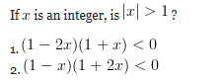

- Q
Decision makers tend to have distinctive styles. One such style is for the decision maker to seek the widest possible input from advisers and to explore alternatives while making up his or her mind. In fact, decision makers of this sort will often argue vigorously for a particular idea, emphasizing its strong points and downplaying its weaknesses, not because they actually believe in the idea but because they want to see if their real reservations about it are idiosyncratic or are held independently by their advisers.

Which one of the following is most strongly supported by the statement above?

(A) If certain decision makers’ statements are quoted accurately and at length, the content of the quote could nonetheless be greatly at variance with the decision eventually make.
(B) Certain decision makers do not know which ideas they do not really believe in until after they have presented a variety of ideas to their advisers
(C) If certain decision makers dismiss an idea out of hand, it must be because its weaknesses are more pronounced than any strong points it may have.
(D) Certain decision makers proceed in a way that makes it likely that they will frequently decide in favor of ideas in which they do not believe.
(E) If certain decision makers’ advisers know the actual beliefs of those they advise, those advisers will give better advice than they would if they did not know those beliefs.

- Q
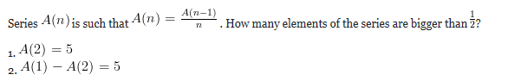

- Q
Medical education in the United States has focused almost exclusively on curative medicine, while preventive care has been given scant attention. This is misguided. Medical schools should invest as much time in teaching their students how to prevent illness as in teaching them how to cure it.

Which of the following, if true, most strengthens the argument above?

(A) Many contagious diseases can be prevented with vaccines.
(B) In 1988, for every three cents the United States spent on prevention, it spent 97 cents on curative treatment.
(C) The number of students enrolled in medical school is the highest it has ever been.
(D) More people die each year from disease than from accidental causes.
(E) As the population grows, the number of doctors in certain specialties has not been keeping pace.

- Q

It took the bus 4 hours to get from town A to town B. What was the average speed of the bus for the trip?

1. In the first 2 hours the bus covered 100 miles
2. The average speed of the bus for the first half of the distance was twice its speed for the second half

- Q
The Sunrise policy at Melvin Prexart & Co states that, henceforth, the strategy guidelines should be implemented quicker than they had been in the past.

(A) the strategy guidelines should be implemented quicker than they had been in the past
(B) the strategy guidelines should be implemented quicker than they have been in the past
(C) the strategy guidelines should be implemented quicker than they did in the past
(D) the strategy guidelines should be implemented more quickly than they have been in the past
(E) the strategy guidelines should be implemented more quickly than they had been in the past

- Q

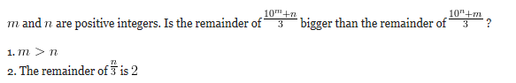

- Q

The woodland sub-species were in isolation from contact with humans longer than either their marsh cousins or the tree-dwelling sub-species.

(A) in isolation from contact with humans longer than
(B) isolated from contact with humans longer than
(C) in isolation from contact with humans longer than were
(D) isolated from contact with humans longer than were
(E) in isolation and without contacts with humans longer than

- Q

If in triangle ABC angle ABC is the largest and point D lies on segment AC, is the area of triangle ABD larger than that of triangle DBC?

1. AD < DC
2. AB < BC

- Q

The U.S. Forest Service, then five years old, decided to put out every fire in its domain, and within three decades the agency formulated what it called the 10 A.M. policy, directing that fires be extinguished quicker than they had been in the past.

(A) within three decades the agency formulated what it called the 10 A.M. policy, directing that fires be extinguished quicker than they had been in the past.
(B) within three decades the agency has formulated what it called the 10 A.M. policy, directing that fires be extinguished quicker than they had been in the past.
(C) within three decades the agency had formulated what it called the 10 A.M. policy, directing that fires be extinguished quicker than they had been in the past.
(D) within three decades the agency formulated what it called the 10 A.M. policy, directing that fires be extinguished more quickly than they had been in the past.
(E) within three decades the agency has formulated what it called the 10 A.M. policy, directing that fires be extinguished more quickly than they had been in the past.

- Q
The sum of first N consecutive odd integers is N² . What is the sum of all odd integers between 13 and 39 inclusive?

(A) 351
(B) 364
(C) 410
(D) 424
(E) 450

- Q
Current farm policy is institutionalized penalization of consumers. It increases food prices for middle- and low-income families and costs the taxpayer billions of dollars a year.

Which of the following statements, if true, would provide support for the author’s claims above?

I. Farm subsidies amount to roughly $20 billion a year in federal payouts and $12 billion more in higher food prices.
II. According to a study by the Department of Agriculture, each $1 of benefits provided to farmers for ethanol production costs consumers and taxpayers $4.
III. The average full-time farmers have an average net worth of over $300,000.

(A) I only
(B) II only
(C) III only
(D) I and II only
(E) I, II, and III

- Q

What positive number is 224% bigger than its reciprocal?

(A) 0.8
(B) 1.1
(C) 1.5
(D) 1.8
(E) 2.2

- Q

After adopting broadband internet access, wireless personal digital assistants, and super-fast home PCs, Weston Insurance has hired new employees, which doubles to 250 the junior staff in the claims department working from home.

(A) which doubles to 250 the junior staff in the claims department
(B) doubling to 250 the number of junior staff members in the claims department
(C) which doubles to 250 the junior staff of the claims department
(D) doubling to 250 the number of junior staff members of the claims department
(E) which doubles to 250 the junior staff in the claims department that

- Q

& represents the ten digit number in number A = 1543&2. What is &?

1. A is divisible by 9
2. A is divisible by 4

- Q

The exhibition of ancient Egyptian funerary art — imposing statues, intricately painted coffins, and numerous accouterments, drew hundreds of people each day, equivalent to the number of visitors to last year’s Impressionist show.

(A) equivalent to the number of visitors to
(B) the equivalent of those that visited
(C) equal to those who visited
(D) as many as the visitation to
(E) as many as visited

- Q
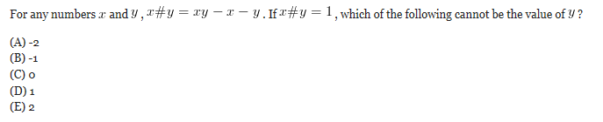

- Q

A conservation group in the United States is trying to change the long-standing image of bats as frightening creatures. The group contends that bats are feared and persecuted solely because they are shy animals that are active only at night.

Which of the following, if true, would cast the most serious doubt on the accuracy of the group’s contention?

(A) Bats are steadily losing natural roosting places such as caves and hollow trees and are thus turning to more developed areas for roosting.
(B) Bats are the chief consumers of nocturnal insects and thus can help make their hunting territory more pleasant for humans.
(C) Bats are regarded as frightening creatures not only in the United States but also in Europe, Africa, and South America.
(D) Raccoons and owls are shy and active only at night; yet they are not generally feared and persecuted.
(E) People know more about the behavior of other greatly feared animal species, such as lions, alligators, and snakes, than they do about the behavior of bats.

- Q

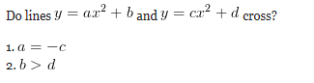

- Q
In the United States, of the people who moved from one state to another when they retired, the percentage who retired to Florida has decreased by three percentage points over the past ten years. Since many local businesses in Florida cater to retirees, this decline is likely to have a noticeably negative economic effect on these businesses.

Which of the following, if true, most seriously weakens the argument?

(A) Florida attracts more people who move from one state to another when they retire than does any other state.
(B) The number of people who move out of Florida to accept employment in other states has increased over the past ten years.
(C) There are far more local businesses in Florida that cater to tourists than there are local businesses that cater to retirees.
(D) The total number of people who retired and moved to another state for their retirement has increased significantly over the past ten years.
(E) The number of people who left Florida when they retired to live in another state was greater last year than it was ten years ago.

- Q
A luxury liner, Queen Marry II, is transporting several cats as well as the crew (sailors, a cook, and one-legged captain) to a nearby port. Altogether, these passengers have 15 heads and 41 legs. How many cats does the ship host?

(A) 3
(B) 5
(C) 6
(D) 7
(E) 8
- Q
Visby is the largest city on the Swedish island of Gotland; arguably the best-preserved medieval town in Scandinavia, and has become a World Heritage Site.

(A) arguably the best-preserved medieval town in Scandinavia, and has become a World Heritage Site.
(B) it is arguably the best-preserved medieval town in Scandinavia, and, as a result of this, has become a World Heritage Site.
(C) arguably the best-preserved medieval town in Scandinavia, it has become a World Heritage Site.
(D) it has become a World Heritage Site, and arguably the best-preserved medieval town in Scandinavia.
(E) is arguably the best-preserved medieval town in Scandinavia, a World Heritage Site.

- Q
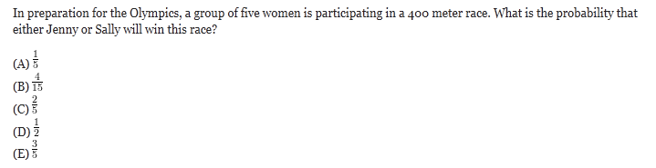

- Q
Columnist: Almost anyone can be an expert, for there are no official guidelines determining what an expert must know. Anybody who manages to convince some people of his or her qualifications in an area—whatever those may be—is an expert.

The columnist’s conclusion follows logically if which one of the following is assumed?

(A) Almost anyone can convince some people of his or her qualifications in some area.
(B) Some experts convince everyone of their qualification in almost every area.
(C) Convincing certain people that one is qualified in an area requires that one actually be qualified in that area.
(D) Every expert has convinced some people of his or her qualifications in some area.
(E) Some people manage to convince almost everyone of their qualifications in one or more areas.

- Q

If a portion of a half water/half alcohol mix is replaced with 25% alcohol solution, resulting in a 30% alcohol solution, what percentage of the original alcohol was replaced?

(A) 3%
(B) 20%
(C) 66%
(D) 75%
(E) 80%

- Q
Damaged nerves in the spinal cord do not regenerate themselves naturally, nor even under the spur of nerve-growth stimulants. The reason, recently discovered, is the presence of nerve-growth inhibitors in the spinal cord. Antibodies that deactivate those inhibitors have now been developed. Clearly, then, nerve repair will be a standard medical procedure in the foreseeable future.

Which of the following, if true, casts the most serious doubt on the accuracy of the prediction above?

(A) Prevention of the regeneration of damaged nerves is merely a by-product of the main function in the human body of the substances inhibiting nerve growth.
(B) Certain nerve-growth stimulants have similar chemical structures to those of the antibodies against nerve-growth inhibitors.
(C) Nerves in the brain are similar to nerves in the spinal cord in their inability to regenerate themselves naturally.
(D) Researchers have been able to stimulate the growth of nerves not located in the spinal cord by using only nerve-growth stimulants.
(E) Deactivating the substances inhibiting nerve growth for an extended period would require a steady supply of antibodies.
- Q
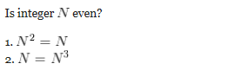

- Q
Researchers blamed the low rate of growth in the harbor’s toad population on lake toxicity as well as on the weather, hotter and more humid than average in the Ohio region, which slowed metabolism and reproductive activity.

(A) hotter and more humid than average in the Ohio region, which slowed
(B) which was hotter and more humid than average in the Ohio region, slowing
(C) since it was hotter and more humid than average in the Ohio region, which slowed
(D) being hotter and more humid than averages in the Ohio region, which slowing
(E) having been hotter and more humid than was average in the Ohio region, and slowed
- Q
Water flows into an empty tank of 54 liters via 12 small pipes. The rate of each pipe is 1 liter per hour. However, water flows out of the tank via several big pipes at the rate of 1.5 liter per hour. If after 12 hours, the tank is completely full, how many big pipes are there?

(A) 2.5
(B) 3
(C) 4
(D) 5
(E) 6
- Q
In the 1980’s the rate of increase of the minority population of the United States was nearly twice as fast as the 1970’s.

(A) twice as fast as
(B) twice as fast as it was in
(C) twice what it was in
(D) two times faster than that of
(E) two times greater than
- Q
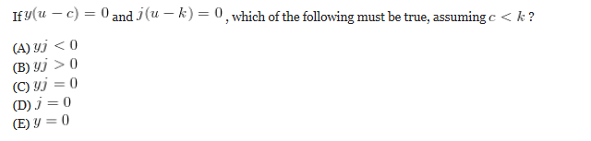
- Q
George Bernard Shaw wrote: “That any sane nation, having observed that you could provide for the supply of bread by giving bakers a pecuniary interest in baking for you, should go on to give a surgeon a pecuniary interest in cutting off your leg is enough to make one despair of political humanity.”

Shaw’s statement would best serve as an illustration in an argument criticizing which of the following?

(A) Dentists who perform unnecessary dental work in order to earn a profit
(B) Doctors who increase their profits by specializing only in diseases that affect a large percentage of the population
(C) Grocers who raise the price of food in order to increase their profit margins
(D) Oil companies that decrease the price of their oil in order to increase their market share
(E) Bakers and surgeons who earn a profit by supplying other peoples’ basic needs
- Q
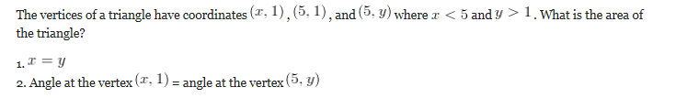
- Q
The aristocratic values expressed in the writings of Marguerite Yourcenar place her within the French classical tradition, as does her passionate interest in history, particularly Roman history.

(A) as does
(B) so do
(C) as do
(D) so is the case with
(E) similarly, does
- Q
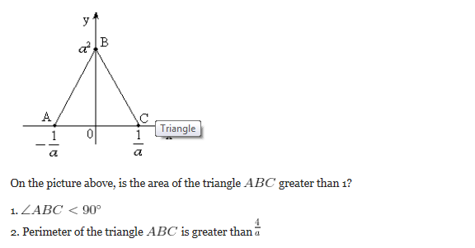
- Q
Not one of the potential investors is expected to make an offer to buy First Interstate Bank until a merger agreement is signed that includes a provision for penalties if the deal were not to be concluded.

(A) is expected to make an offer to buy First Interstate Bank until a merger agreement is signed that includes a provision for penalties if the deal were
(B) is expected to make an offer for buying First Interstate Bank until they sign a merger agreement including a provision for penalties if the deal was
(C) is expected to make an offer to buy First Interstate Bank until a merger agreement be signed by them with a provision for penalties if the deal were
(D) are expected to make an offer for buying First Interstate Bank until it signs a merger agreement with a provision for penalties included if the deal was
(E) are expected to be making an offer to buy First Interstate Bank until they sign a merger agreement including a provision for penalties if the deal were
- Q
How many odd three-digit integers greater than 800 are there such that all their digits are different?
(A) 40
(B) 56
(C) 72
(D) 81
(E) 104
- Q
A new test for AIDS has proved helpful in eliminating blood, contaminated with the virus, from the nation’s blood supply.

(A) in eliminating blood, contaminated with the virus, from the nation’s blood supply
(B) in eliminating blood from the nation’s blood supply that is contaminated with the virus
(C) in eliminating from the nation’s blood supply blood that is contaminated with the virus
(D) to eliminate blood that is contaminated with the virus from the nation’s blood supply
(E) to eliminate blood from the nation’s blood supply that is contaminated with the virus
- Q
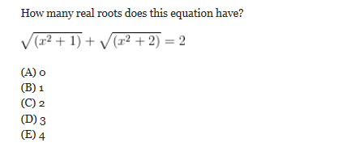
- Q
Which of the following most logically completes the argument?

The irradiation of food kills bacteria and thus retards spoilage. However, it also lowers the nutritional value of many foods. For example, irradiation destroys a significant percentage of whatever vitamin B1 a food may contain. Proponents of irradiation point out that irradiation is no worse in this respect than cooking. However, this fact is either beside the point, since much irradiated food is eaten raw, or else misleading, since _______.

(A) many of the proponents of irradiation are food distributors who gain from food’s having a longer shelf life
(B) it is clear that killing bacteria that may be present on food is not the only effect that irradiation has
(C) cooking is usually the final step in preparing food for consumption, whereas irradiation serves to ensure a longer shelf life for perishable foods
(D) certain kinds of cooking are, in fact, even more destructive of vitamin B1 than carefully controlled irradiation is
(E) for food that is both irradiated and cooked, the reduction of vitamin B1 associated with either process individually is compounded
- Q
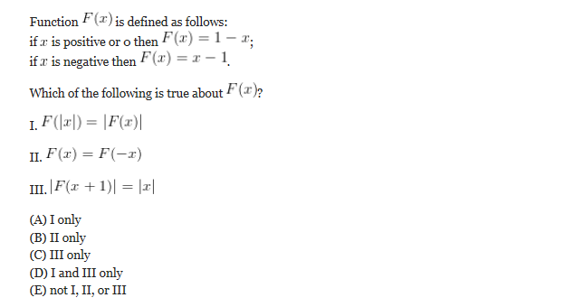
- Q
While Governor Verdant has been in office, the state’s budget has increased by an average of 6 percent each year. While the previous governor was in office, the state’s budget increased by an average of 11.5 percent each year. Obviously, the austere budgets during Governor Verdant’s term have caused the slowdown in the growth in state spending.

Which of the following, if true, would most seriously weaken the conclusion drawn above?

(A) The rate of inflation in the state averaged 10 percent each year during the previous governor’s term in office and 3 percent each year during Verdant’s term.
(B) Both federal and state income tax rates have been lowered considerably during Verdant’s term in office.
(C) In each year of Verdant’s term in office, the state’s budget has shown some increase in spending over the previous year.
(D) During Verdant’s term in office, the state has either discontinued or begun to charge private citizens for numerous services that the state offered free to citizens during the previous governor’s term.
(E) During the previous governor’s term in office, the state introduced several so-called “austerity” budgets intended to reduce the growth in state spending.
- Q
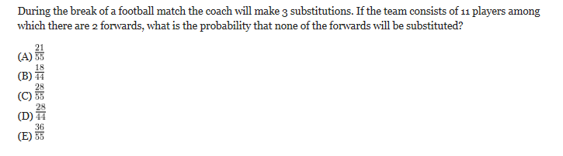
- Q
Advertisement: The world’s best coffee beans come from Colombia. The more Colombian beans in a blend of coffee, the better the blend, and no company purchases more Colombian beans than Kreemo Coffee. Inc. So it only stands to reason that if you buy a can of Kreemo’s coffee, you’re buying the best blended coffee available today.

The reasoning of the argument in the advertisement is flawed because it overlooks the possibility that

(A) the equipment used by Kreemo to blend and package its coffee is no different from that used by most other coffee producers
(B) not all of Kreemo’s competitors use Colombian coffee beans in the blends of coffee they sell
(C) Kreemo sells more coffee than does any other company
(D) Kreemo’s coffee is the most expensive blended coffee available today
(E) the best unblended coffee is better than the best blended coffee
- Q
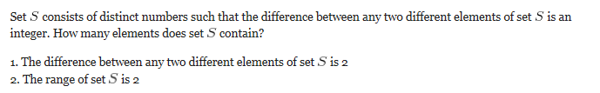
- Q
Heirloom tomatoes, grown from seeds saved from the previous year, only look less appetizing than their round and red supermarket cousins, often green and striped, or have plenty of bumps and bruises, but are more flavorful.

(A) cousins, often green and striped, or have plenty of bumps and bruises, but are
(B) cousins, often green and striped, or with plenty of bumps and bruises, although
(C) cousins, often green and striped, or they have plenty of bumps and bruises, although they are
(D) cousins; they are often green and striped, or with plenty of bumps and bruises, although
(E) cousins; they are often green and striped, or have plenty of bumps and bruises, but they are
- Q
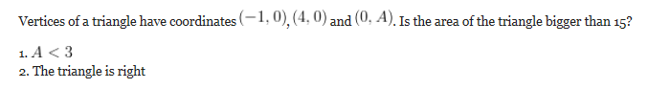
- Q
Four generations of Americans have developed the habit of reading daily newspapers due to the comic strips being appealing.

(A) due to the comic strips being appealing
(B) because of the appeal of the comic strips
(C) for the fact of the comic strip’s appeal
(D) as a result of the comic strips having appeal
(E) since the comic strips were appealing
- Q
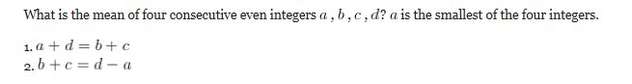
- Q
In the United States, vacationers account for more than half of all visitors to what are technically called “pure aquariums” but for fewer than one quarter of all visitors to zoos, which usually include a “zoo aquarium” of relatively modest scope.

Which of the following, if true, most helps to account for the difference described above between visitors to zoos and visitors to pure aquariums?

(A) In cities that have both a zoo and a pure aquarium, local residents are twice as likely to visit the aquarium as they are to visit the zoo.
(B) Virtually all large metropolitan areas have zoos, whereas only a few large metropolitan areas have pure aquariums.
(C) Over the last ten years, newly constructed pure aquariums have outnumbered newly established zoos by a factor of two to one.
(D) People who visit a zoo in a given year are two times more likely to visit a pure aquarium that year than are people who do not visit a zoo.
(E) The zoo aquariums of zoos that are in the same city as a pure aquarium tend to be smaller than the aquariums of zoos that have no pure aquarium nearby.
- Q
Is the perimeter of a rectangle greater than 8 inches?

1. The diagonal of the rectangle is twice as long as its shorter side
2. The diagonal of the rectangle is 4 inches longer than its shorter side
- Q
Some parents have a very difficult time coming to grips with the fact that their offspring have become adults; consequently, they see their children as they were during their adolescence.

(A) they see their children as they were during
(B) they see their children as they had been during
(C) they see their children as if during
(D) their children appear to them as they did in
(E) their children appear to them as though in
- Q
A rectangle is inscribed in a circle of radius 5. Is the area of the rectangle bigger than 48 ?

1. The ratio of the lengths of sides of the rectangle is 3:4
2. The difference between the lengths of sides of the rectangle is smaller than 3
- Q
In Patton City, days are categorized as having heavy rainfall (more than two inches), moderate rainfall (more than one inch, but no more than two inches), light rainfall (at least a trace, but no more than one inch), or no rainfall. In 1990, there were fewer days with light rainfall than in 1910 and fewer with moderate rainfall, yet total rainfall for the year was 20 percent higher in 1990 than in 1910.

If the statements above are true, then it is also possible that in Patton City

(A) the number of days with heavy rainfall was lower in 1990 than in 1910
(B) the number of days with some rainfall, but no more than two inches, was the same in 1990 as in 1910
(C) the number of days with some rainfall, but no more than two inches, was higher in 1990 than in 1910
(D) the total number of inches of rain that fell on days with moderate rainfall in 1990 was more than twice what it had been in 1910
(E) the average amount of rainfall per month was lower in 1990 than in 1910
- Q
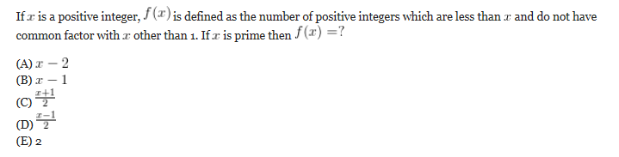
- Q
According to psychoanalytic theory, people have unconscious beliefs that are kept from becoming conscious by a psychological mechanism termed “repression.” Researchers investigating the nature of this mechanism observed occasions on which a patient undergoing therapy became aware of and expressed a previously unconscious belief. They found that such occasions were marked by an unusual decrease in the patient’s level of anxiety.

If the information above is true, and if the researchers’ investigation was properly conducted, then which of the following must also be true?

(A) Changes in the patient’s anxiety level during therapy can generally be used as an accurate measure of the extent to which the patient is becoming conscious of previously repressed beliefs.
(B) Even when one of a patient’s unconscious beliefs remains unconscious, researchers are sometimes able to discover this belief.
(C) If psychoanalytic theory is correct, then most conscious beliefs originate as unconscious beliefs.
(D) Researchers were able to distinguish expressed beliefs that had previously been unconscious from those that had long been conscious but that the patient had not previously expressed.
(E) Although the beliefs on which the mechanism of repression works are all unconscious, the operation of the mechanism itself is something of which patients are consciously aware.
- Q
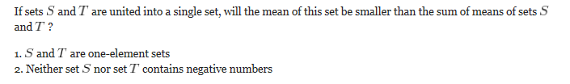
- Q
The average age of chief executive officers in a large sample of companies is 57.The average age of CEO’s in those same companies 20 years ago was approximately eight years younger. On the basis of those data,it can be concluded that CEO’s in general tend to be older now.

Which of the following casts the most doubt on the conclusion drawn above?

(A) The dates when the CEO’s assumed their current positions have not been specified.
(B) No information is given concerning the avg no of years that CEO’s remain in office.
(C) The information is based only on companies that have been operating for at least 20 years.
(D) Only approximate information is given concerning the avg age of the CEO’s 20 years ago.
(E) Information concerning the exact number of companies in the sample has not been given.
- Q
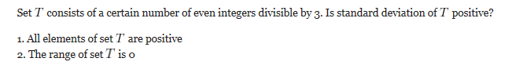
- Q
A study attempting to link fertility with increased sexual availability concluded that women unconsciously dress more attractively during ovulation. The study was conducted using pairs of photographs of 200 women and volunteer viewers who chose the photograph in which they thought the woman appeared more attractive. Researchers found that 67% of the time viewers chose the photo taken when the woman was ovulating.

The methodology of the study above is flawed for which of the following reasons?

(A) The study fails to specify what is meant by the word attractive, leaving it up to the opinion of the individual viewer.
(B) Because all the viewers were male, the results of the study were skewed by individual responses to attractive women.
(C) The study fails to account for the psychological complexity of sexual desire in women
(D) The study assumes that women will dress more attractively when they have greater sexual desire.
(E) Most women do not know when they are ovulating, and so would not dress more attractively on that day.
- Q
A 4 cm cube is cut into 1 cm cubes. What is the percentage increase in the surface area after such cutting?

(A) 4%
(B) 166%
(C) 266%
(D) 300%
(E) 400%
- Q
Corporate finance committees do not plan the detailed activities of the various divisions in a large firm, but by their allocation of investment funds they make strategic judgments as to where the firm should expand.

(A) by their allocation of investment funds they make strategic judgments as to where the firm should expand
(B) when they allocate investment funds, they make strategic judgments about where the firm might be expanding
(C) they make strategic judgments on where the firm should expand when they allocate investment funds
(D) by allocating investment funds, they will make strategic judgments about where the firm might be expanding
(E) allocations of investments fund as to where the firm should expand are their exercise in strategic judgment
- Q
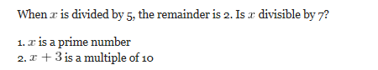
- Q
Although no proof yet exists of electromagnetic fields generated by household appliances posing any health threat, mounting scientific evidence has convinced many experts that there is cause for concern.

(A) of electromagnetic fields generated by household appliances posing any health threat
(B) of electromagnetic fields generated by household appliances that pose any threat to health
(C) that electromagnetic fields generated by household appliances pose any threat to health
(D) that poses any threat to health from electromagnetic fields generated by household appliances
(E) for any health threat posed by electromagnetic fields generated by household appliances
- Q

- Q

- Q

- Q

- Q

problems which are not that hard. Though each question below has a trap or trick so be careful when solving

http://gmatclub.com/forum/12-easy-pieces-or-not-126366.html

- C
- C
- D
- A
- B
- B
- D
- B
- E
- D
- D
- D
- C
- B
- D
- B
- C
- A
- D
- A
- E
- E
- B
- D
- A
- D
- B
- D
- D
- B
- A
- E
- D
- D
- E
- D
- C
- D
- C
- A
- E
- A
- E
- B
- B
- C
- C
- A
- C
- A
- A
- A
- C
- C
- A
- E
- C
- A
- C
- C
- A
- E
- B
- B
- B
- B
- B
- A
- A
- A
- B
- D
- E
- C
- B
- A
- D
- A
- E
- C

