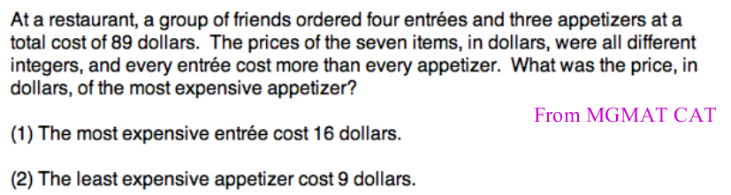



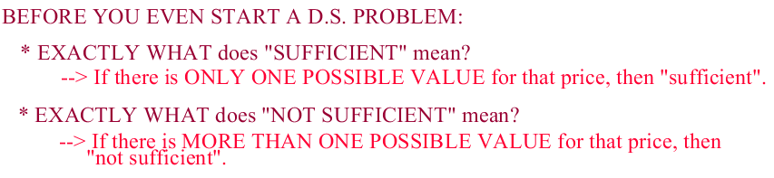

First Step: Organize a word problem (though not super fancy)
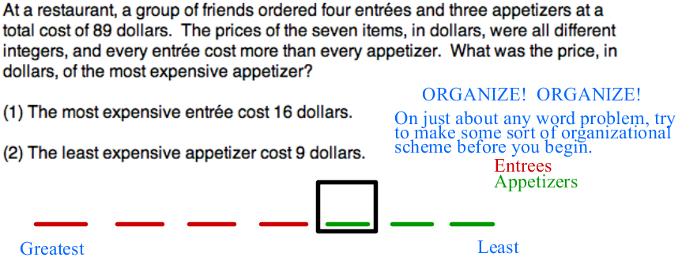

Lets analyze Statement1:

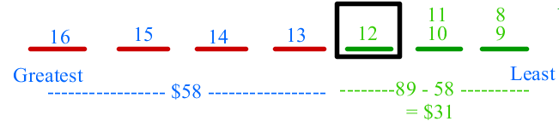

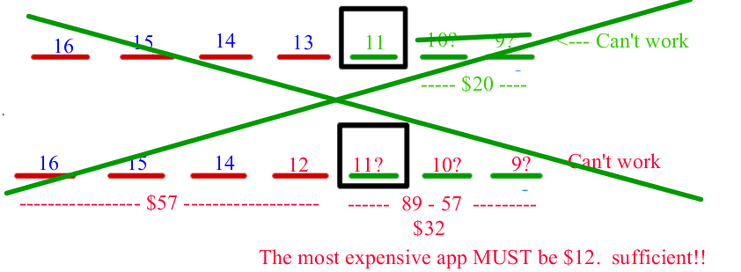

Questions arises:
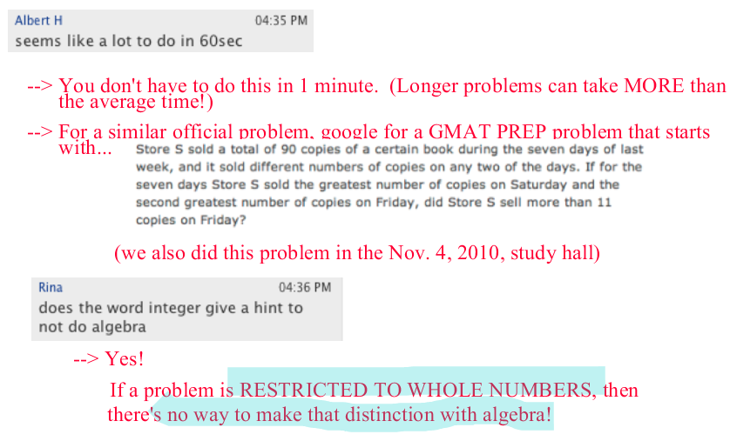

Let's analyze Statement 2:
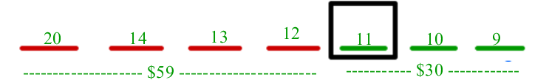

Lets see if we could fit any other number at the required box:
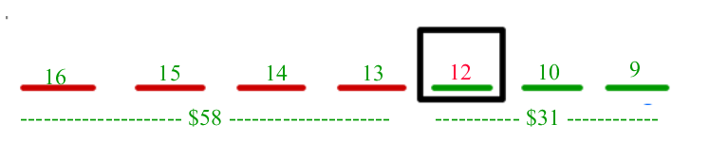

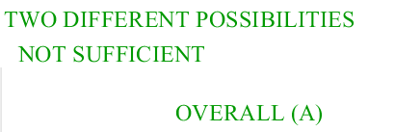

More questions:


Let's move to next question:

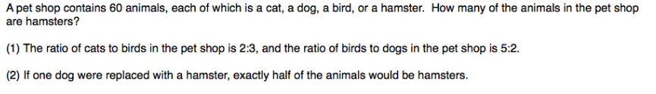

Let's organize:
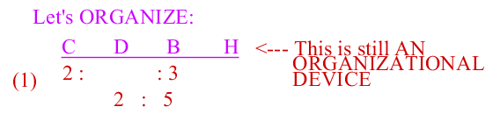

One way we could proceed is combining the ratios:
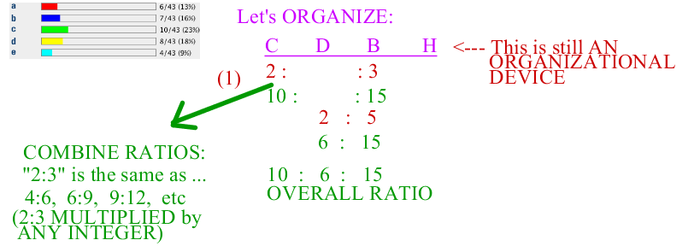

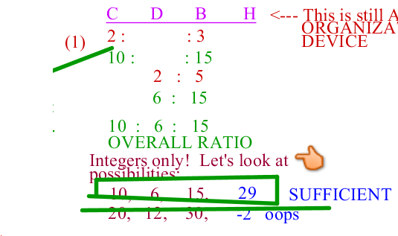
Other way, we could have approached the statement 1:
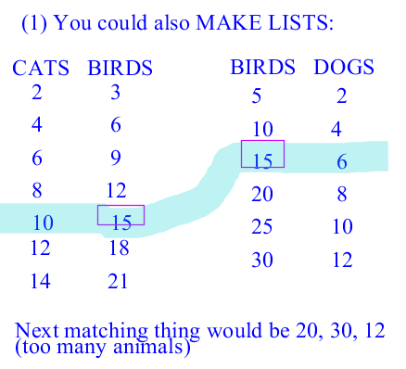
Caution!


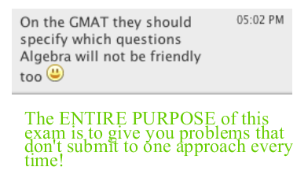
Now, let's look at statement 2:
Hint :


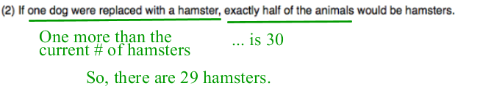
So, its Sufficient too.

Next Question:
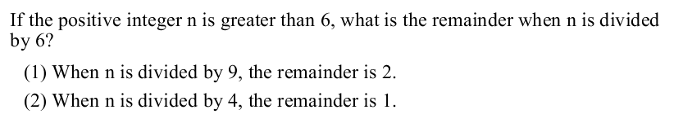

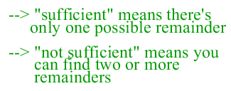

Statement1:
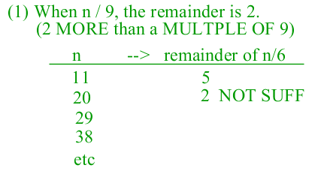

Statement2:
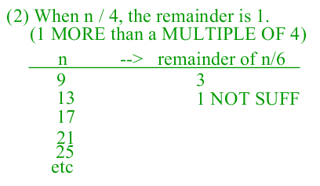
Both not sufficient, lets combine both statement and analyze:
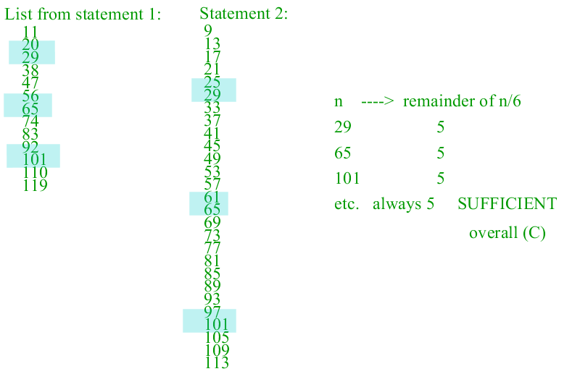

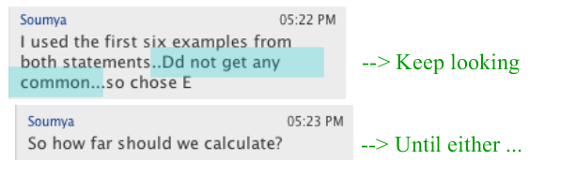

Next Problem:


