Nov13, 2009: Sentence Correction

Here start the session, take 1:30 minutes and try to solve below question:

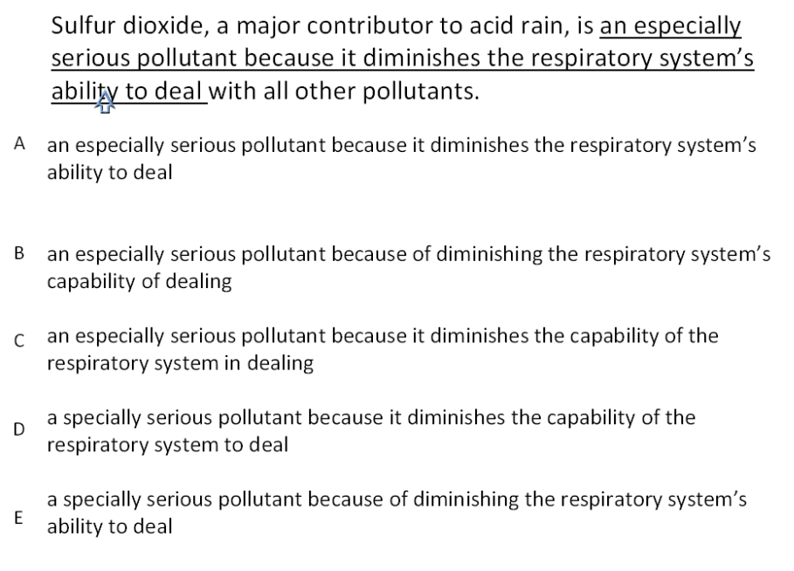

Now, let’s analyze it. Check for the variation in answer choices (below)
Now, as we compare answer sentences, we see these sentences are different from one another on basis of idioms and the word especially/specially.

Also, in first look, many of us would neglect answer choices because of pronoun ‘it’. Technically, it has been used here as ambiguous pronoun but is it so, let’s find it out?

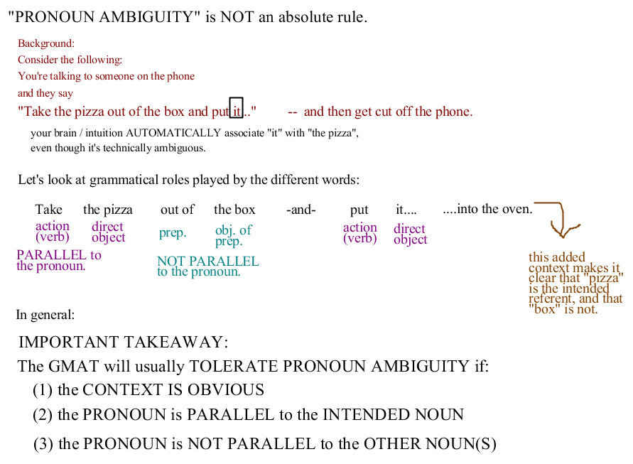

Now, it used in the sentence is tolerable as it passes all three criterion (mention above). So based on this theory, lets solve our actual question: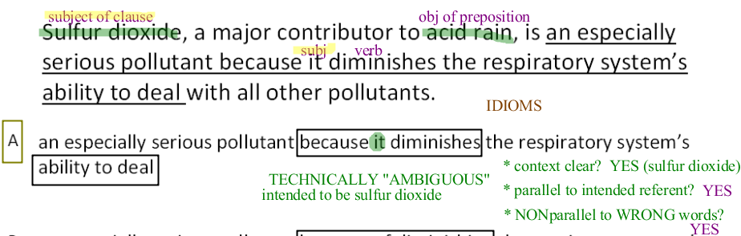

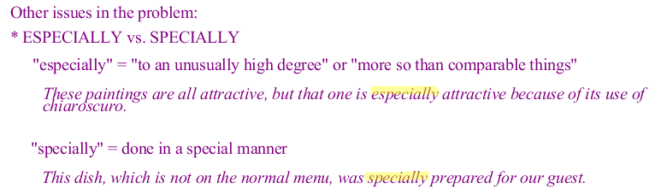
Options remain ABC

Now, Which idiom is correct - ‘Because of diminishing’ or ‘because it diminishes’?
Because of VERBing = incorrect idiom (note: Because of NOUN\Because CLAUSE is correct) so based on these B can be ruled out.
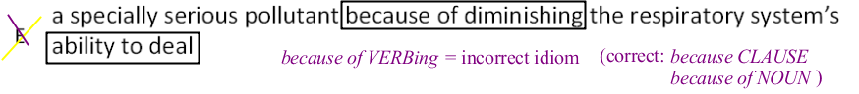
Also,

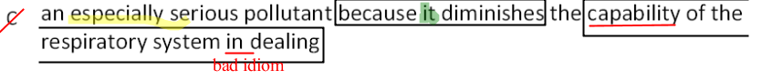

More reference problems(on this concept):


