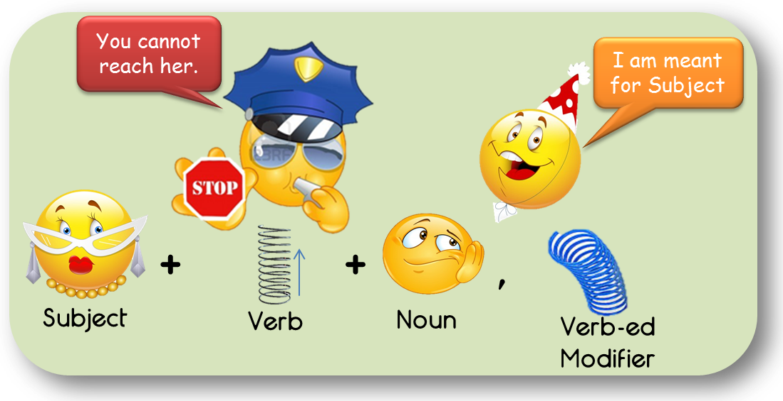
Verb-ed Modifiers cannot jump over verbs

Hi all,
Recently, I came across a thread where the posters were discussing whether a comma + verb-ed modifier placed after a clause can jump over the Verb and modify the Subject.
I have written a few articles on the usage of Verb-ed Modifiers.
(Following are the links for the same:
http://gmatclub.com/forum/verb-ed-modifiers-vs-verb-ing-modifiers-125611.html
http://gmatclub.com/forum/ed-forms-verbs-or-modifiers-134691.html )
As I have earlier mentioned in my articles on verb-ed modifiers, they are noun modifiers, and on GMAT they ALWAYS refer to the immediate preceding noun entity. Now this preceding entity can be a single noun word or a noun phrase.
If the immediate preceding noun entity is a noun phrase, then the verb-ed modifier may modify the head of this noun phrase if the context of the sentence so demands. This modification has been dealt with in great details in the article Noun modifiers can modify slightly far away noun. Here is the link for the same:
http://gmatclub.com/forum/noun-modifiers-can-modify-slightly-far-away-noun-135868.html

Verb-ed modifiers outside the GMAT world
Outside the GMAT verbal, in general English language, we may come across instances where a comma + verb-ed modifier modifies the Subject of the preceding clause or for that matter, even the entire preceding clause. You may see these usages in articles from popular publications such as The New York Times, Wall Street Journal, The Economists, etc.

We care for GMAT usage
Now let’s get back to the interesting question of the thread I mentioned in the beginning of this article (the inspiration for this article) – can a comma + verb-ed modifier placed after a clause modify the Subject of the preceding clause? My research of official questions let me say it confidently – NO. There is not a single official question in which I have seen this usage. If placed after a clause, comma or no comma, verb-ed modifier always modifies the immediate preceding clause.

Verb-ed modifier does refer to the Subject
However when a verb-ed modifier begins a sentence, it ALWAYS modifies the Subject of the clause. We have plethora of official questions where we can see this usage. This is the most appropriate way to use the verb-ed modifier to modify the Subject of the clause. And yes, this usage is widely tested too. Here comes one of those many questions that test you on this usage. This is OG12#25:
Based on accounts of various ancient writers, scholars have painted a sketchy picture of the activities of an all-female cult that, perhaps as early as the sixth century B.C., worshipped a goddess known in Latin as Bona Dea, “the good goddess.”
(A) Based on accounts of various ancient writers
(B) Basing it on various ancient writers’ accounts
(C) With accounts of various ancient writers used for a basis
(D) By the accounts of various ancient writers they used
(E) Using accounts of various ancient writers (Correct answer)
Choice A is incorrect here because “Based”, the opening verb-ed modifier must refer to the Subject of the following main clause. The Subject of the main clause is “scholars”. It is evident that “based” does not logically modifies the Subject. We need a proper modifier in the beginning of the sentence to refer to “scholars”. This is the reason why Choice E is correct answer.
Let’s take another example where the usage of verb-ed modifier is NOT TESTED. This is the correct version of OG13#98:
Ranked as one of the most important of Europe’s young playwrights, Franz Xaver Kroetz has written forty plays; his works—translated into over thirty languages—are produced more often than those of any other contemporary German dramatist.
In this sentence, without any confusion, “ranked”, the verb-ed modifier modifies the Subject of the following clause “Franz Kroetz”. Because “ranked” is meant to modify “Franz Kroetz”, it has been placed in the beginning of the clause and not after the clause.
To reiterate the point I made earlier, because the verb-ed modifier is meant to modify the Subject of the main clause, “Ranked…” has been placed in the beginning of the clause and not after the clause.

Comma before verb-ed modifier does not affect modification
Another thing to note is that the comma before the verb-ed modifier has no bearing on the entity it will modify. On GMAT, verb-ed modifier ALWAYS refers to the immediate preceding noun. It is not so that if there is comma before the verb-ed modifier placed after the clause, the verb-ed modifier gets the liberty to jump over the verb to modify the Subject of the preceding clause. Let’s review OG13#81:
Fossils of the arm of a sloth found in Puerto Rico in 1991, and dated at 34 million years old, made it the earliest known mammal of the Greater Antilles islands.
A. sloth found in Puerto Rico in 1991, and dated at 34 million years old, made it the earliest known mammal of
B. sloth, that they found in Puerto Rico in 1991, has been dated at 34 million years old, thus making it the earliest mammal known on
C. sloth that was found in Puerto Rico in 1991, was dated at 34 million years old, making this the earliest known mammal of
D. sloth, found in Puerto Rico in 1991, have been dated at 34 million years old, making the sloth the earliest known mammal on (Correct answer)
E. sloth which, found in Puerto Rico in 1991, was dated at 34 million years old, made the sloth the earliest known mammal of
In the original sentence, the verb-ed modifier “found” is not preceded by a comma but in choice D, it has been. Is that one of the reasons why choice D is better than choice A? One may say that because in choice A, “found” is not preceded by a comma, this verb-ed modifier refers to the immediate preceding noun “a sloth” and not “Fossils”, the entity that it should modify. But in choice D, the comma makes all the difference. Now “found” correctly refers to “Fossils”.
Well, if you think this could be a reason, think again. Preceded by a comma or not, “found” in both cases refer to the “Fossils” because that the entity that it is supposed to modify. Placement of a comma before it does not bring about any change in the entity that is meant to modify.
Choice A is incorrect for other reasons.

Verb-ed modifier does not jump a verb
There is no correct official question where verb-ed modifier jumps the verb to modify the Subject, but here is certainly an incorrect official questions where comma + verb-ed has been placed after the clause to refer to the Subject of the preceding clause. Let me bring that official example – OG13#57:
Many of the earliest known images of Hindu deities in India date from the time of the Kushan Empire, fashioned either from the spotted sandstone of Mathura or Gandharan grey schist.
A. Empire, fashioned either from the spotted sandstone of Mathura or
B. Empire, fashioned from either the spotted sandstone of Mathura or from
C. Empire, either fashioned from the spotted sandstone of Mathura or
D. Empire and either fashioned from the spotted sandstone of Mathura or from
E. Empire and were fashioned either from the spotted sandstone of Mathura or from
If we study this sentence carefully, we will notice that the verb-ed modifier “fashioned” is meant to modify the Subject of the preceding clause “Many of the earliest known images of Hindu deities”. This usage has been declared incorrect because per the OG explanation “fashioned” “suggests that the Empire (the closest noun), not the images of the deities, was fashioned out of those materials”.
From this explanation, we can understand that on GMAT, “verb-ed modifier” is used to modify “the closest noun”. If the verb-ed modifier placed after a clause is meant to refer to the Subject of the preceding clause, then it cannot be called the closest noun, especially if there is a noun immediately before the verb-ed modifier.
So we at e-gmat go by the rule that verb-ed modifier modifies the immediate preceding noun. If we come across an official sentence where we see otherwise, we will modify our rule to comply with the GMAT usages.
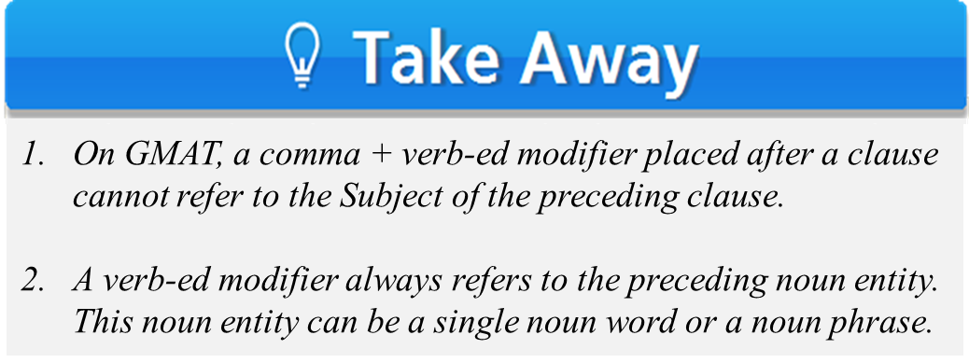
Hope this helps.
Thanks.
Shraddha

