Geometry Formula:
Triangle | Formula
Pythagorean Theorem  - Isosceles Triangles  30-60-90 Equilateral Triangles  Combinations: (3-4-5), (5-12-13), (8-15-17), (6-8-10), ( 9-12-15), (12-16-20), (10-24-26) | 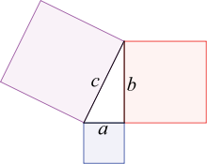+=  x: x: x (h=x)  x:: 2x (b=x)
Area of any Triangle/Right Triangle  Area of Equilateral triangle  Exterior angles of a triangle: | ½(BH)  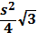.  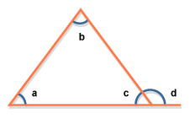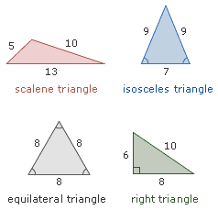  - a + b + c = 180;  - c + d = 180  - d = a + b
Square | Formula
Perimeter  Area#1  Area #2  Relationship between side and diagonal  Percent increase of new area= | 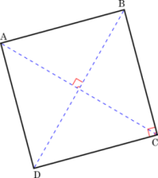4S  S²  .  D= or D=s  X%+y%+(x%y%)/100
Rectangle | Formula
Perimeter  Area  Relationship between side and diagonal | 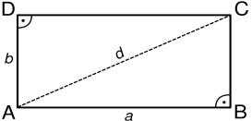2(L+W)  L.W  .  (L+w)^2-2LW
Parallelogram | Formula
Perimeter  Area | 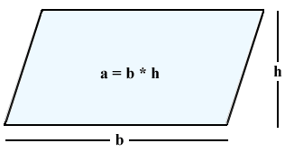2(L+W)  B.H
Trapezoid | Formula
Perimeter  Area  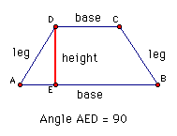  Trapezoid can be cut into 2 right triangles and 1 rectangle | 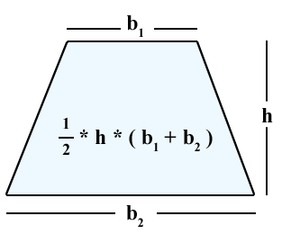B1+B2+S1+S2  1/2(B1+B2).Height  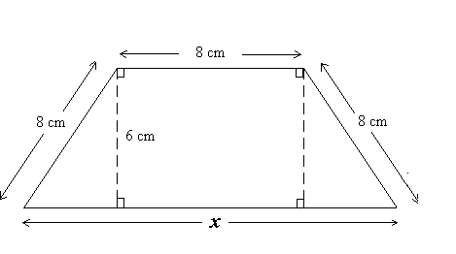
Circle | Formula
Circumference(C)  Area  Diameter  Radius  Area of Sector  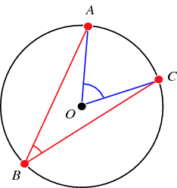  Arc length(Central Angle)  Arc length(Inscribed Angle)  Perimeter of Sector of a Circle  - According to central angle theory, the measure of inscribed angle is always half the measure of the central angle.  - If a triangle is inscribed in a semicircle, it must be a right triangle | 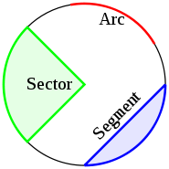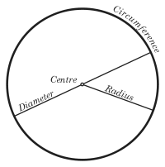.  .  C/  C/2  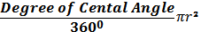.  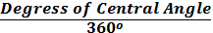.C  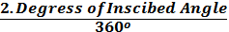.C  Arc + 2 radius  To find either the Arc Length or the perimeter of a sector, all you need is the radius + the angle of the sector
Rectangular Solids | Formula
Surface Area  Volume  Total Surface  Diagonal  Area of Front & Back Faces  Area of Top & Bottom Faces  Area of Front & Back Faces | 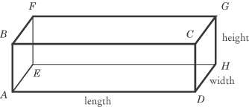The SUM of the areas of all of the faces  L.W.H  2(LH+LW+WH)  2(L.H)  2(L.W)  2(W.H)
Cube | Formula
Area of Cube  Volume  Diagonal | 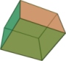6  Root 3 (a)
Cylinder | Formula
Lateral Surface Area  Total Surface Area  Volume  To find either the surface area or the volume, you only need the radius and the height. | 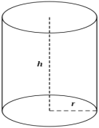.  +.  .
Coordinate Geometry | Formula
Distance  Mid-Point  General form  Slope  When a line is parallel to another line, then both the lines share same slope | 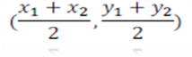  Y = mx+b  The coordinates of any point on the circle, along with the radius will always form a right triangle. So any point a, b the sum of square of the coordinates will be radius square(phytha theorem). Equation of circle with center at origin is x^2+y^2=r^2
Polygon | Formula
Sum of interior angles of a polygon with n sides = (n-2)*180

Arithmetic & Algebra formulas:
Number Properties | Formula
- The product of an even number of negative factor is positive
- The product of an odd number of negative factor is negative
- The reciprocal of any nonzero a is 1/a
- The product of any number and its reciprocal is 1: a x (1/a)=1
- The number of integers from “A to B inclusive” is =B-A+1
- An integer is any number in the set (-2-1, 0,1,2)
- The average consecutive numbers. Ex: from 14 to 26=(14+26)/2=20
- The numbers -2, -1, 0, 1, 2, 3 are consecutive integers..can be represented n, n+1, n+3
- The numbers 0,2,4,6 are consecutive even integers can be written 2n, 2n+2, 2n+4….
- The numbers 1,3,5,7 are consecutive odd integers can be written 2n+1, 2n+3, 2n+5..
Permutations & Combinations | Formula
Combinations: nCk = n!/((n-k)k!)!
Permutations: nPk = n!/(n-k)!
Circular: (n-1)!
k = number of objects selected from a pile of n objects
n = total number of objects from which k objects can be selected

Interest | Formula
The most basic:  S.I (simple interest)  Interest paid Annually  Interest paid Quarterly  Interest paid Monthly  Half yearly | FV=PV(1+i)^{n}  Principal × Interest × Time  P (1 + r)^{n} (n=number of years)  P (1 + r /4)^{4 x t} (t= number of years)  P (1 + r /12)^{12 X t} (t= number of years)  P (1 + r /m)^{nX m}
Speed, Distance and Time Rates & Work | Formula
Distance= Rate x time or Rate x Time = Work Average speed = Total distance / Total Time
Case1: When equal distances are covered in different speed then Average Speed = 2ab / (a + b)
Case 2: For Different distances in same time then Average Speed is = (a + b) / 2

Fractions & Decimals | Formula
There are two method of comparing fractions: 1) cross multiply 2) Convert them to decimals(by dividing)
- If a/b is the number of a whole that satisfies some property, then 1-(a/b) is the fraction of that whole that does not satisfy it.
The period or decimal point determines the place value of the digits. For example the digit number 7654.321 have the following place values or decimal points:
7 is thousands, 6 is hundreds, 5 is tens, 4 is ones or units. 3 is tenths, 2 is hundredths, 1 is thousandths
Example of decimal follow: .0321=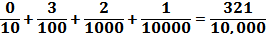
Percents | Formula
Part=Percent * whole. % increase or decrease =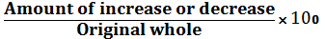

Quadratic Equations | Formula
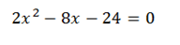 | 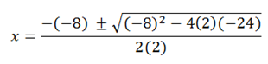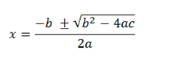  ,
Powers and roots of Numbers | Formula
For any numbers b & c & positive integers m & n:
b^{m}b^{n} = b^{m+n} , 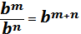, (b^{m})^{n} = b^{mn}, b^{m}c^{m} = bc^{m}

To square a number that is greater than, or, raising it to a higher power, results in a larger number. Squaring a number between 0 and 1 results in a smaller number

Properties of Prime Number |  |  | Formula
1) 2 and 3 are the lowest even and odd prime numbers respectively.
2) 2 is the only even prime number
3) Prime numbers between 1 and 100 are
2, 3, 5, 7, 11, 13, 17, 19, 23, 29, 31, 37, 41, 43, 47, 53, 59, 61, 67, 71, 73, 79, 83, 89, and 97.
There are 25 prime numbers between 1 and 100
4) All prime numbers above 3 are of the form 6n + 1, because all other numbers are divisible by 2 or 3 where n>=1.

Progression |  |  | Formula
Sum of squares of 1st n natural numbers = n (n+1)(2n+1) / 6 Ex: 1²+2²+3²+…..+n²
Sum of cubes of 1st n natural numbers =[n (n+1)/2]²
1+2+3………………………… ….n = n(n+1)/2

The arithmetic progression(t_{n}) = t₁ + (n - 1)d

Probability |  | Formula
Probability of Event E  E or F is the set of outcome  E and F is the set of outcome  The probability that E does  not occur is P(not E)  The probability that E or F occurs P(E or F)  If the event “E and F” is  impossible(that is Enf has no outcomes), then E and F are said to be mutually exclusive, and P(E and F)=0  Multiplication rule for independent event  General addition and mulitiplication  Rule if E and F are independent |  | P(E)=the number of outcome in E / the number of outcome  =EuF  =EnF  =1-P(E)  P(E)+P(E)-P(E and F)  Then the rule is: P(E or F)=P(E)+P(F)  P(E and F)=P(E)P(F)  P(E or F)=P(E)+P(F)P(F)
Set theory |  | Formula
All –none  All -- none  AuB  AuBuC  Total  Exactly 2 |  | =At least one  = AuB or AuBuC  = A + B- AnB  = A+B+C - AnB - AnC- BnC+ AnBnC  =G₁+G₂-Both+Neither  =A+B+C – (AnB + AnC+ BnC)+ AnBnC  =A+B+C – (X)+ AnBnC  =X-3Y

The Angles of a Triangle
(1) The sum of the three angles of a triangle equals 180  (2) Angles correspond to their opposite sides  If angle a = angle b, their opposite sides will be equal as well. Also, the biggest angle of a triangle will be opposite to the biggest side of this triangle.  (3) The sum of any two sides of a triangle MUST BE GREATER THAN the third side. So, if you are given two sides of a triangle, the length of the third side must lie between the difference and the sum of the two given sides..Ex. 2, 5, 8  The other side: 11 < x < 73 (supposing this is not a right triangle)  42-31<X<31+42…less than addition, more than minus | 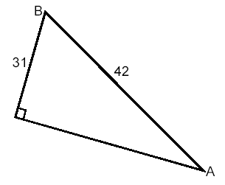

Number line:
- If k is halfway between m and n on the number line. This can be expressed as: (m+n)/2=k
- Distance between x and y can be expressed as /x-y/
Exp: If m and r are two numbers on a number line, what is the value of r?
(1) The distance between r and 0 is 3 times the distance between m and 0.
(2) 12 is halfway between m and r.
Solution: 1. /r-0/=3/m-0/
/r/=3/m/
R=3m, -3m
2. (m+r)/2=12, m+r=24
SO E

Lines and Angles
Lines and Angles  - Straight Line: Shortest distance between 2 points. Angle: 180°  - Parallel lines never intercept  Intersecting Lines: Properties  - The sum of interior angles is 360  - Interior angles that combine to form a line sum 180°  - Angles found opposite each other where two lines intersect are equal  These properties apply to more than two lines that intersect at a point  GMAT can disguise the lines, by not drawing them completely. Extending them can help you to find out whether they are transversal or parallel. GMAT uses the symbol II to indicate 2 lines are parallel. MN II OP means those segments are parallel | Parallel lines cut by a transversal:  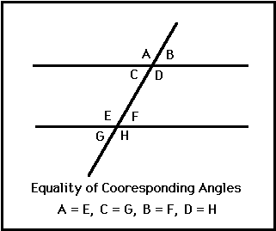  - (In this figure, we have only two angles, A and B. All the other acute angles equal B, and the obtuse angles equal A)  - The eight angles in the diagram above are actually 2, and a+b = 180  - All the acute angles (<90°) are equal.  - All the obtuse angles (90°<x<180°) are also equal  - Any acute angle is supplementary to any obtuse angle (a+b = 180)

Coordinate Plan
    - (a,b): a = x-coordinate, and b = y-coordinate
The Slope of a Line
    - The slope is defined as “rise over run”: (Y₁ – Y₂) / (X₁ – X₂)
    - In a line, any two other points have different “rise” and different “run”, but the slope will always be the same.
The intercepts of a line
    - An intercept is a point where the line intersects a coordinate axis
    - X-Intercept = (x,0)
    - Y-Intercept = (0,y)
    - To find x-intercepts, plug in 0 for y. To find y-intercepts, plug in 0 for x
Slope-intercept Equation: y = mx + b
      - m = slope
      - b = y-intercept

Horizontal and vertical lines
      - Horizontal: y = some number
      - Vertical: x = some number

Step by Step: from 2 points to a line
(1) Find the slope with rise over run
(2) Plug in the Slope
(3) Solve for b by plugging the coordinates of one point
(4) Write the equation in the form y = mx + b

Example: Point 1 = (5, -2) - Point 2 = (3,4)
(1) Rise over run: (-2 - 4) / (5 – 3) = -3
(2) y = -3x + b
(3) 4 = -3.3 + b --- b = 13
(4) y = -3x + 13
    - If GMAT gives you one point and one intercept, don’t forget: an intercept is also a point, so you are able to find the equation

Distance between two points
(1) Draw a right triangle connecting points
(2) Find the lengths of the 2 legs of the triangle
(3) Use pythagorean theorem
      - Example: what is the distance between (1,3) and (7,-5)?
      - First leg = 6 (7-1); second leg = 8 (3- (-5)).
      - Pythagorean: x² = 6² + 8² --- x = 10

Quadrants
    - If you are required to find out which quadrant a given line passes two and you have the equation, set x and y to zero to find the two intercepts and draw the line. This is the fastest way
Parallel and perpendicular lines
Parallel lines have equal slopes. Perpendicular lines have negative reciprocal slopes!!! (VERY IMPORTANT PROPERTY)
The intersection of 2 lines
    - If lines intersect, both equations at the intersect point are true. That is, the ordered pair (x,y) solves both equations
      - At what point lines y = 4x + 10 and 2x + 3y = 26 intersect?
      - To quickly solve this, replace y = 4x + 10 in the second equation.
      - x = 4, y = 6.
    - If two lines in a plan do not intersect, they are parallel, no pair of numbers (x,y) will satisfy both equations. Another possibility: both equations are the same. Then, infinitely many points will solve both equations.
    - To test whether a point lies on a line, just test it by plugging the numbers into the equation.

Absolute Value Equations
Three steps to solve absolute value equations:
(1) Isolate the abs expression: 12 + |w – 4| = 30 |w – 4| = 18
(2) Once you have a |x| = a equation, you know that |x| = +/- a. So, remove the brackets and test both cases: w – 4 = 18, w = 22; w – 4 = -18, w = -22.
(3) Check in the original equations if both solutions are valid.

It is very important to check both values. Some data sufficiency problems may seem insufficient as you would have 2 answers. Although, when you check both, you may find that one solution is invalid, so the alternative is sufficient.

Exponential Equations
    - Even exponents are dangerous, because they hide the sign of the base. For any x, √x² = |x|. The equation x² = 25 is the same as |x| = 5.
    - X² = 0 has only one solution. X² = -9 has no solutions, as squaring cannot produce a negative number.
    - If an equation has even and odd exponents, treat it as dangerous. It probably has more than 1 solution.
    - Same base or same exponent: Try always to have the same base or the same exponent on both sides of an equation. This will allow you to eliminate the bases or exponents and have a single linear equation.
    - This rule does not apply when the base is 0, 1 or -1. The outcome of raising those bases to power is not unique (0 = 0³ = 0²³).

Eliminating roots
    - The most effective way to eliminate roots is to square both sides. Don’t forget: whenever you do that, you need to check both solutions in the original equation

Quadratic equations
    - A quick way to work with quadratics is to factor them. If you have the equation ax² + bx + c, when a=1:
-Find two integers whose product equals c and whose sum equals b
-Rewrite the equation in the form (x + k)(x + w), where k and w are those two numbers which resulted in the product of c and in the sum of b.

Disguised Quadratics
-When you find an equation similar to 3w² = 6w, don’t forget that dividing both sides by 3w will cause you to miss one solution! If you factor, you get w(3w – 6) = 0, so w = 0 is also a solution!

Disguised Quadratics
    - 36/b = b – 5: This is a quadratic, as if you multiply both sides by b you get 36 = b² - 5b.
    - The equation x³ + 2x² - 3x = 0 can be solved. Factoring will result on x(x² + 2x – 3) = 0, so 0 is one solution and the factored quadratic will have two roots. The equation has 3 solutions.
    - If you have a quadratic equation equal to 0 and you can factor an x out of the expression, x=0 is one of the solutions.
    - You are only allowed to divide an equation by a variable/expression if you know that this variable/expression does not equal 0.

Factoring / Distributing
    - If you encounter a quadratic equation, factoring may help you. If you encounter a factored equation, try distributing it. Never forget that (x + k) (x – m) = 0 means x = -k and x = m.
    - Zero in the denominator: Undefined
    - For the equation (x² + x – 12) / (x – 2) = 0, you cannot multiply both sides for x – 2, and also, x – 2 cannot be zero. So, the solution will be the solution of the equation in the numerator: x = -4 and x = 3.
    - Be careful when the denominator has x!!

  - The 3 special factors
Those appear very often on GMAT. Recognize them instantly!
1) x² - y² = (x + y)(x – y)
2) x² + 2xy + y² = (x + y)² = (x + y)(x + y)
3) x² - 2xy + y² = (x - y)² = (x - y)(x - y)

Advanced factoring and distributing | Factored Form
x² + x | x(x + 1)
X⁵ – x³ | X³(x² - 1) = x³(x + 1)(x – 1)
6⁵ – 6³ | 6³(6² - 1) = 35.6³
4⁸ + 4⁹ + 4¹⁰ | 4⁸ + (1 + 4 + 4²) = 21.4⁸
p³ - p | p(p² - 1) = p(p – 1)(p + 1)
a^{b} + a^{b+1} | a^{b}(1 + a)
m^{n} – m^{n-1} | m^{n}(1 – m⁻¹) = m^{n-1} (m-1)
5⁵ - 5⁴ | 5⁵(1 – 1/5) = 5⁴(5-1)
xw + yw + zx + zy | (w + z) (x + y) = w(x + y) + z(x + y)

Sequence Formulas
    - You must be given the rule in order to find a number in a sequence. Having two terms of the sequence is not enough.
    - Linear sequences are also called arithmetic sequences. In those, the difference between two terms is constant. S = kn + x
    - Exponential sequences: S = x(k^{n})
    - If you are given that the first two terms of a sequence are 20 and 200, you know that k = 200/20 = 10. So, replacing: S = x.10^{n}. Now, you can find x: 20 = x.10¹, so x = 2, and the sequence is 2.10^{n}
    - Other sequence problems: If each number in a sequence is 3 more than the previous and 6th number is 32, what is the 100th?
    - We know that we have 94 jumps of 3 between the 6th and the 100th, so the answer is: 94.3 + 32
    - Sequences and patterns: If S_{n} = 3^{n}, what is the units digit for S₆₅?
    - There is a pattern: 3¹ = 3, 3² = 9, 3³ = 27, 3⁴ = 81, 3⁵ = 243. So, the units digit for 365 will be 3 again (64 is a multiple of 4)

Formulas and Functions – Advanced
    - Recursive formulas for sequences
    - A recursive formula looks like this: A_{n} ^{= A}_{n-1} ⁺ ⁹
    - To solve a recursive sequence, you need to be given the recursive rule and also the value of one of the items.
    - ^{1) Linear sequence: S}₁ = k + x x is the difference between two terms, and k is the value of the sequence for S₀.
    - ^{2) Exponential sequence: S}_{n} ^{= S}_{n-1}k you can find k by having 2 terms of the sequence.
    - ^{Exponential growth}
The formula for exponential growth is: Y_{(t)} ^{= Y}₀.kt – y0 is the quantity when t = 0.

Functions
Compound Functions
    - If f(x) = x³ + √x and g(x) = 4x – 3, what is f(g(3))?
    - First, solve g(3): 4.3 – 3 = 9. Now, plug-in 9 on f(x): 9³ + √9 = 729 + 3
    - If f(x) = x³ + 1 and g(x) = 2x, for what value f(g(x)) = g(f(x))?
    - f(2x) = g(x³ + 1) = (2x)³ + 1 = 2(x³ + 1) = 8x³ + 1 = 2x³ + 2 x³ = 1/6
    - Proportional and inversely proportional functions
    - For direct proportionality, set up ratios for the “before case” and the “after case” and equal them (regra de 3). The proportionality is defined by y = kx, where k is the proportionality constant.
    - For inverse proportionality, set up products for the “before” and “after” cases and equal them. The inverse prop. formula is y = k/x
Example: amount of current and resistance are inversely proportional. If current was 4 amperes and resistance is cut to one-third the original, what will be the current? x1y1 = x2y2 – 3.4 = 1.x x = 12
  - Linear Growth or decay
    - They are defined by the function y = mx + b. m is the constant rate at which the quantity grows. b is the quantity at time zero.
    - Example: a baby weighs 9 pounds at birth and gains 1.2 pounds per month. The function of his weight is: w = 1.2t + 9 (t = nº of months)

  - Equations for Exponential Growth or Decay
    - Problems like: How long does it take to double the population?
    - Formula: Population = S.2^{t/I}, where S is the starting value, t is the time and I is the Interval, or the amount of time given for the quantity to double.
    - If the quantity triples: Population = S.3^{t/I}.
    - If the quantity is cut by half: Population = S.(0.5)^{t/I}
      - Example: If a population of rabbits double every 7 months and the starting population is 100, what will be the population in 21 months?
      - Answer: Population = 100 . 2^{21/7}, = 100.2³ = 800

Symmetry
GMAT has difficult symmetry problem, such as:
For which of the following f(x) = f(1/x) ?

Symmetry
    - For those problems, you can either pick each alternative or substitute for the 2 variables (here, x and 1/x) or pick numbers. Normally, picking numbers is easier.

    - The same is valid for problems like: for which of the following f(x-y) does not equal f(x) – f(y)? For which of the following f(a(b+c)) = f(ab) + f(ac)?

Optimization problems
    - Maximizing linear functions: since linear functions either rise or fall continuously, the max/min points occur at boundaries: at smallest or largest possible x as given in the problem.

    - Maximizing quadratics: The key is to make the squared expression equal to 0. Whatever value of x makes the squared expression equal 0 is the value of x that maximizes/minimizes the function
Inequalities
    - If you multiply or divide an inequality by a negative number, you have to flip the inequality sign.
    - You cannot multiply or divide an inequality by a variable, unless you know the sign of the variable. The reason is you wouldn’t be able to know whether you have to change the inequality sign.

Combining Inequalities
    - Example: x > 8, x < 17, x + 5 < 19
    - (1) Solve any inequality that needs to be solved: x + 5 < 19 = x < 14

Combining Inequalities
(2) Make all the inequality symbols point in the same direction:
      - 8 < x
      - x < 17
      - x < 14
(3) Eliminate the less limiting inequalities:
      - x < 14 is more limiting than x < 17, so ignore x < 17
      - The final answer is: 8 < x < 14
  - Manipulating compound inequalities
If you perform an operation on a compound inequality, be sure you do it on every term.
  - Combining inequalities
First, make all the inequality signs face the same direction. Them, add them up.
  - Combining Inequalities
Example: Is a + 2b < c + 2d?
(1) a < c (2) d > b
a < c
+ b < d
+ b < d
= a + 2b < c + 2d

    - You can always add inequalities. However, you can only multiply inequalities if both sides and both inequalities are positive. We can never subtract or divide inequalities!!
  - Using extreme value: LT and GT
    - If 2h + 4 < 8 and g + 3h = 15, what is the possible range for g?
      - Since h<2, let’s say h = LT2 (Less Than 2).
      - g + 3.LT2 = 15 g = 15 – LT6
      - g = Greater than 9 g > 9
  - Square-Rooting inequalities
    - If x² < 4, then |x| < 2. This means x > -2 and x < 2. So, -2 < x < 2.
    - You can only square-root an inequality if you know x is not negative

  - Inequalities and Extreme Values
    - Take care with the ones with *
Operation | Example | Procedure
Addition | 8 + LT2 | LT10
Subtraction | 8 – LT2 * | GT6
Multiplication | - 8 . LT2  - -7 . LT2 * | LT16  GT14
Division | 8 / LT2 | GT4
Multiply 2 extreme values | LT8 . LT2 | LT16, but only if both are positive

Optimization problems
    - On problems involving minimization or maximization, focus on the largest and smallest possible values of each variables.

Optimization problems
    - If x ≥ 4 + (z + 1)², what is the minimum value for x?
    - You have to recognize that a square value is minimized when set to zero.
Testing Inequality cases
    - Is bd < 0?
(1) bc < 0 (2) cd > 0
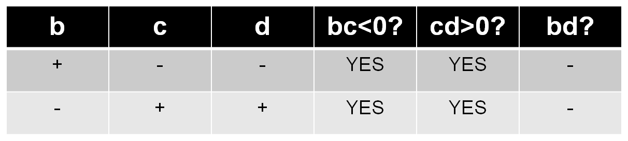

    - bd must be < 0 , as b and d will have different signs
    - Whenever you need to proceed with a positive/negative analysis, building a table like the one above may be a good idea.

Testing Inequality cases
    - It is important to know the following:
Statement | Implication
xy > 0 | X and y are both positive or both negative
xy < 0 | X and Y have different signs
x² - x < 0 | x² < x, so 0 < x < 1 (x is a proper fraction)

Equations – Advanced
    - Complex Absolute value equations: If the equation contains only one variable, use algebra. If it contains 2 variables, go conceptual (positive/negative analysis).
Example: |x – 2| = |2x – 3|
You have to test 2 scenarios: the first with both equations positive, and the second with one of them negative. After finding the solutions, you have to check all the answers.

    - Multiplying or dividing two equations:
      - If xy² = 96 and 1/xy = 1/24, what is y?
      - We can easily solve by multiplying both equations: xy² . 1/xy = 96 . 1/24 : y = -4

    - If you see similar/inverse equations, dividing/multiplying them may be a good idea to cancel variables.

  - Inequalities and absolute value
    - You should interpret some inequality problems with absolute value expressions as a range on the number line.
    - For more complicated problems, like |x + 2| < 5, a good method is to shift the entire graph down by 2. The center point will then change from 0 to 2
    - Standard formula: when |x + b| <c, center point is –b, and “less than” symbol tells us x is less than c units away from –b

  - Inequalities – Advanced
    - You cannot multiply or divide an inequality by a variable unless you know the sign of the variable!!
    - Reciprocals of inequalities: If we do not know the sign of both x and y, we cannot take reciprocals
    - If x<y, then:
      - 1/x > 1/y when both x and y are positive
      - 1/x > 1/y when both x and y are negative
      - 1/x < 1/y when x is negative and y is positive
If ab < 0 and a>b, which is true?
      - (1) a>0 (2) b > 0 (3) 1/a > 1/b
    - A good way to solve those problems is with a positive/negative analysis. We will see that 1 and 3 are true

Squaring inequalities:
    - You cannot square both sides unless you know the signs of both sides.
    - If both sides are negative, the inequality sign will flip when you square.
    - If both sides are positive, the sign will remain.
    - If one side of the inequality is positive and the other is negative, you cannot square!

VICs(variables in the answer choices)
  - VIC Problems
    - Picking number to solve VICs:
      - (1) Never pick 0 or 1
      - (2) Make sure all the numbers you pick are different
      - (3) Pick Small numbers
      - (4) Try to pick prime numbers
      - (5) Don’t pick numbers that appear as a coefficient in several answer choices
    - Direct Algebra
      - Break the problem down into manageable parts
      - Write every step, as it may be difficult to verify the answer
    - Common Translations:
    - “y percent less than z” = z – yz/100

  - VIC Problems – Common translations

      - X is what percent of y, in terms of x and y?
      - Answer: x = w/100 . y x = wy/100 100x/y = w
      - If Cecil reads T pages per minute, how many hours does it take for her to read 500 pages?
Answer: 500/60T
      - X percent of Y percent of Z is decreased by Y percent. What is the result?
Answer: XYZ/10,000 – (Y/100)*(XYZ/10,000) = (100XYZ – XY²Z ) / 1,000,000

Word Translations
    - Algebraic Translation: Translating correctly
      - A is half the size of B: A = 1/2B
      - A is 5 less than B: A = B – 5
      - Jane bought twice as many apples as bananas: A = 2B

      - P is X percent of Q: P = xq/100 OR P/Q = x/100

      - Pay $10 for the first 2 cds and 7 for additional CD: T = 10.2 + 7.(n-2)

*** 1 year ago, Larry was 4 times older than John: L – 1 = 4J – 4 ***
    - Be ready to use expressions such as (n – x), where x will be the number of units with a different price
    - Using Charts
      - 8 years ago, George was half as old as Sarah. Sarah is now 20 years older than George. How old will be George in 10 years from now?
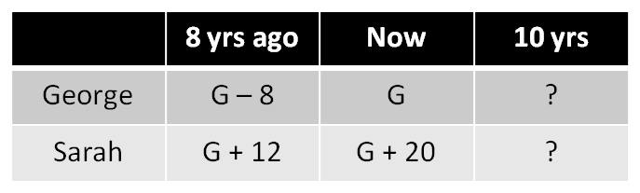
After building this table, it is easy to solve:
2 .(G – 8) = G + 20
2G – 16 = G + 12, G = 28
Word Translations
    - Hidden Constraints
    - When the object of the problem has a physical restriction of being divided, such as votes, cards, pencils, fruits, you must realize the problem has told you the variable is an integer.
      - Example: Jessica bought x erasers for 0.23 each and y pencils for 0.11 each. She has spent 1.70. What number of pencils did she buy?
      - 23x + 11y = 170 -- 11y = 170 – 23x -- y = (170 – 23x)/11
      - Since the number of pencils is an integer, y = (170 – 23x)/11 must be an integer as well. Test the values for x to find the answer.

    - GMAT can also hide positive constraints. Sides of a square, number of votes, etc will always be positive. When you have a positive constraint, you can:
      - Eliminate negative solutions from a quadratic function
      - Multiply or divide an inequality by a variable
      - Cross-multiply inequalities: x/y < y/x x² < y²
      - Change an inequality sign for reciprocals: x<y; 1/x > 1/y
    - Positive Constraints (cont.)
      - Multiply inequalities (but not divide them)
      - Square/unsquare an inequality: x < y ; x² < y². x < y ; √x < √y

Rates and Work
    - Rate x Time = Distance or Rate x Time = Work
    - RTD Chart: R x T = D, or R = D/T, or any other equation
    - Always express rates as “distance over time”. If it takes 4 seconds for an elevator to go up one floor, the rate is 0.25 floors / second.
    - Translations:
      - Train A is travelling at twice the speed of train B: A = 2r, B = r.
      - Wendy walks 1 mph slower than Maurice: W = r-1, M = r
      - Car A and car B are driving toward each other: Car a = r₁, Car b = r₂ – Shrinking distance = r₁ + r₂ (if they are driving away, this is growing distance)
      - Car A is chasing car B and catching up: a < b, and shrinking distance = a – b

Word Translations – Rates & Work
  - Rates and Work - Translations
      - Sue and Sarah left the office at the same time, but Sue arrived 1h before: Sue’s time = t-1, Sarah’s time = t
    - Table Samples
      - Car A and Car B start driving toward each other at the same time:
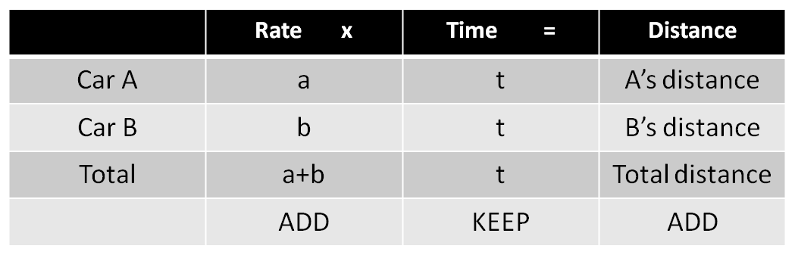
Jan drove from home to work. If she drove 10mph faster…
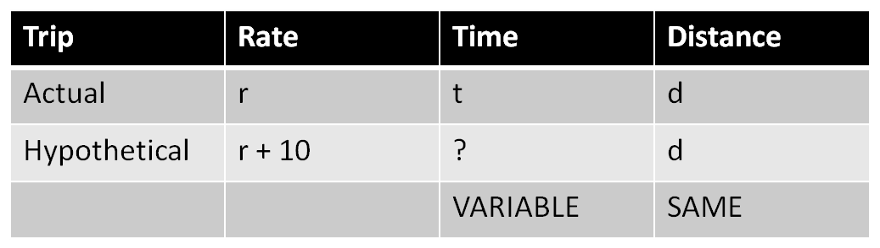
Rates and Work - Translations
    - Average Rate = Total Distance / Total time
    - Work Problems
      - Normally, you will have to convert the rate. This is the only difference to the RTD problems. Example: Oscar can perform one surgery in 1.5 hours. You have to convert it to: Oscar can perform 2/3 surgeries per hour. This is the actual rate.

      - If two or more agents are performing simultaneous work, add the work rates. (Typical problems are: “Machine A, Machine B”).
      - Exception: one agent undoes the other’s work, like a pump putting water into a tank and another drawing water out. Rate will be a – b.

      - Example: Larry can wash a car in 1 hour, Moe can wash it in 2 hours, and Curly washes it in 4 hours. How long does it take for them to wash 1 car?
      - Answer: Rate is 1/1 + 1/2 + 1/4 = 7/4 cars/ hour. To find the rate for 1 car, just take the reciprocal: 4/7 hours to wash 1 car (34 minutes)

Population problems
In such problems, normally a population increases by a common factor every time period. You can build a population table to avoid computation errors.

Rates and Work - Population problems
      - Example: the population of a bacteria triples every 10 minutes. If the population was 100, 20 minutes ago, when will it reach 24,000?
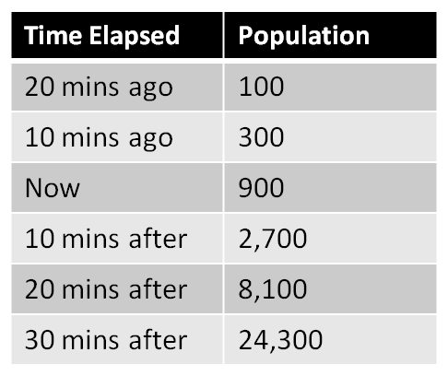

This population table can be very useful to avoid mistakes doing the right computation but forgetting that the population right now is 900 and not 100, which was 20 minutes ago. Population problems are just an exponential sequence since the bacterias grow by a constant factor. If something grows by a constant amount, you have a linear sequence.

Rates and work – Advanced
    - Advanced rates and work problems involve either more complicated language to translate, more complicated algebra to solve or trickier Data Sufficiency logic to follow

    - Be ready to break rate or work problems into natural stages. Likewise, combine workers or travelers into a single row when they work or travel together.

      - Example: Liam is pulled over for speeding just as he is arriving at work. He explains that he could not afford to be late today, and has arrived at work only 5 minutes before he is to start. The officer explains that if he had driven 5mph slower for his whole commute, he would have arrived on time. If his commute is 30 miles, how fast was he actually driving?
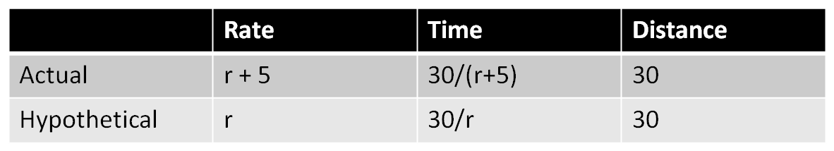
      - Since the slower trip takes 4 minutes more, 30/r = 30/(r+5) + 1/15 30/r = (r + 455)/(15(r+5)) 450r + 2,250 = r² + 455r r² + 5r – 2,250 = 0 r = 45

Ratios: The unknown multiplier
This technique can be used for complicated problems, such as: the ratio of men to women is 3:4. There are 56 people in the class. How many are men?
      - Introducing the unknown multiplier: 3x + 4x = 56. x = 8, so we have 24 men.

      - You can use this technique for 3 ratios as well.
    - Multiple ratios: Make a common Term
      - If C:A = 3:2, and C:L = 5:4, what is A:L?

C : A : L C : A : L
3 : 2 : Multiply by 5 15 : 10 :
5 : : 4 Multiply by 3 15 : : 12

Once you have converted C to make both ratios equal (15), you can combine the ratios. Combined Ratio C:A:L = 15:10:12, and ratio A:L = 10:12 or 5:6
    - The combined ratio will normally be asked as “the least number” of a population. The least number is the sum of common minimum denominator. In the situation above, the least number is 15 + 12 + 10 = 37.

Productivity ratio
For productivity ratios, you should invert the time. Example: If Machine A works for 80 minutes to produce X and has a productivity ratio of 4:5 to Machine B, how long does machine B take to produce X?
- 5/4 = x/1/80 5.(1/80) = 4x 4x = 1/16 x = 1/64, so machine B takes 64 minutes to produce X.

Combinatories

- Fundamental counting principle: if you must make a number of separate decisions, then multiply the number of ways to make each individual decision to find the number of ways to make all decisions together.

- Example: If you have 4 types of bread, 3 types of cheese and 2 types of ham and wish to make a sandwich, you can make it in 4.3.2 = 24 different ways.
- For problems where some choices are restricted and/or affect other choices, choose most restricted options first (slot method):

- Example: you must insert a 5-digit lock code, but the first and last numbers need to be odd, and no repetition is allowed. How many codes are possible?

Combinatories
    - Combinations x Permutations
You have to be ready to see the difference between the 2 statements below:
If seven people are going to sit in 3 seats (with 4 left standing), how many different seating arrangements can we have?

If three of seven standby passengers are to be selected for a flight, how many different combinations can we have?

In the first problem, order matters. So, it is a permutation, and the formula is: n! / (n – r)!, where r! is the number of chosen items from a pool. For the second problem, all it matters is if the passenger is flying or not. Since the order of chosen passengers doesn’t matter, the problem is a combination, and the formula is: n! / (n-r)! r!

Combinatories
      - Permutation formula: n! / (n – r)!
      - Combination formula: n! / (n-r)! r!
    - Multiple arrangements
      - In a group with 12 seniors and 11 juniors, you need to pick 3 seniors and 2 juniors. In how many different ways can you do that?
      - For these problems, you have to calculate the arrangements separately and then multiply both. Answer: 220 . 55 = 12,100

    - Arrangements with constraints
      - When the problem presents you a constraint, such like “Jan won’t sit next to Marcia”, you should first calculate the arrangement without considering the constraint and then using a method for the constraint.

      - Example 1: Greg, Mary, Pete, Jan, Bob and Cindy are to sit in 6 adjacent seats, but Mary and Jan won’t sit next to each other. How many combinations?

      - Without the constraint, you have 6!, which is 720. Now, use the glue method: consider that an and Marcia are one person. The combination would then be 5!, which is 120. You have to multiply this by 2, as Marcia could sit next to Jan OR Jan could sit next to Marcia. So, the number of total restrictions is 120 . 2 = 240, and the number of combs is 720 – 240 = 480

Arrangements with constraints
      - Example 2: Gnomes and Dwarfs
      - Example 3: Six friends are to sit in a line, but Joey doesn’t want to sit behind Paul. What is the total number of possibilities for this to happen?
      - The total number of arrangements is 6!, which is 720. Now, you have to realize that Joey would be sitting behind Paul in half of the possibilities. This would happen with any friend, as half of the combinations would have one of them sitting behind, and the other combination would have him sitting in front. So, the answer is 360, as half of the combinations is restricted.

Probability
    - Probability = N of desired results / N of possible outcomes
    - More than one event: “and” vs “or”
      - And means multiply probabilities. Or means sum probabilities.
Example: Molly needs to roll a 1 in a die and she has 3 tries. What is the probability that she will succeed?
      - Probability to roll a 1 at the first try: 1/6
      - Probability to roll a 1 at the second try: 5/6 * 1/6 = 5/36
      - Probability to roll a 1 at the third try: 5/6 * 5/6 * 1/6 = 25/216
      - Since she can succeed with one OR two OR three tries, we sum it: 91/216

    - When you have an OR problem where events cannot happen together, just add the probabilities (as above). When the events can happen together, use the formula: P(a or b) = P(a) + P(b) – P(a AND b)

Example: What is the probability of getting either a 3 in a die or a head in a coin?
P(a) = 1/6. P(b) = 1/2. P(a AND b) = 1/12. P(a or b) = 1/6 + 1/2 – 1/12 = 7/12

Probability
    - The 1 – x probability trick
      - If on a GMAT problem it’s too complicated to calculate “success”, you can calculate the probability that success does not happen. The probability of success will be 1 – x, where x is the failure probability.
    - The domino effect (actions that affect the next probability)
      - In a box with 10 blocks (3 are red) what is the probability of picking a red block on each of your first 2 tries if you discard a block after picking it?
      - Answer: 3/10 . 2/9 = 6/90 = 1/15
    - Probability trees
      - Renee has a bag of 6 candies, 4 of which are sweet and 2 are sour. Jack picks two candies at random. What is the probability that he got exactly 1 sour?
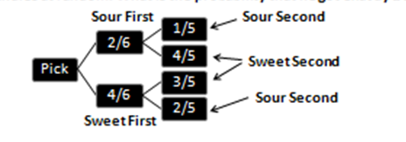

Probability and Statistics
      - The scenarios that interest us are: Sour first and sweet second (2/6 * 4/5 = 8/30) and Sweet First and Sour second (4/6 * 2/5 = 8/30). The probability of getting exactly one sour candy by picking 2 candies is: 8/30 + 8/30 = 16/30

Statistics
    - Evenly spaced sets
      - The average of an evenly spaced set is: (FIRST TERM + LAST TERM) /2
    - Weighted averages
If 94 weighs 40%, 88 weighs 30%, 98 weighs 20% and 85 weighs 10%, what is the average?
Answer: 94 * 0.4 + 88 * 0.3 + 98 * 0.2 + 85 * 0.1 = 92.1

Properties of weighted averages:
      - You do not need concrete weight values. Having the ratio is enough.

      - A weighted average will fall closer to whichever value is weighted more heavily. If the computation is difficult, you can try to eliminate alternatives.

Word Translations – Statistics
  - Median
      - Given the set {x,x,y,y,y,y}, where y>x. Is the median bigger than the mean?
      - Mean = (2x + 4y) / 6
      - Median = y
      - y > (2x + 4y) / 6? 6y > 4y + 2x? 2y > 2x? y > x, so median is bigger
  - Standard Deviation
    - If each data point in a set is increased by a number, the standard deviation won’t be affected. If the whole set is increased by a factor of 7 (“multiply by 7”), the standard deviation will increase by a factor of 7.
  - Overlapping sets
    - The double-set matrix
Columns must represent opposite information from each other, and the same is required for the rows. For example: if you have students that study either spanish or english, columns can contain “spanish/not spanish”, while rows can contain “french/not french”.

Overlapping Sets
Example: Of 30 integers, 15 are in set A and 22 are in set B. If 8 are In both, how many are out of both?
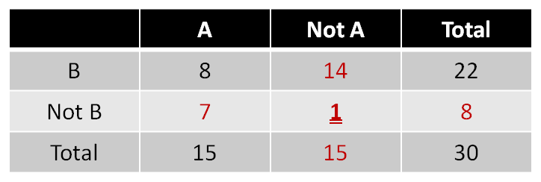

      - You were only given the numbers in black, but it is very easy to find any other number in the matrix. You have to focus in the following: If you are given that x belong to group A and the total of members is y, then the number of members who do not belong to group A are y – x. This is mandatory to solve most of the problems.

  - Overlapping sets and algebraic representation
      - Example: 10% of the children have been good during the year, but do not celebrate xmas. 50% of the ones that celeb. xmas have been good. If 40% of all children have been good, how much % of children do not celebrate xmas?
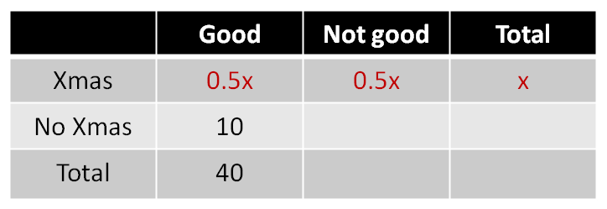

    - You know that 50% of the ones that celebrate xmas have been good, so 50% haven’t. If the number of children that celebrate xmas is x, then 0.5x have been good. Looking at table we can easily see that 0.5x = 30. So, x = 60. If 60% of the children celebrate xmas, 40% do not celebrate it.

For problems with 2 sets and 3 choices, you should also use the double-set matrix. For problems with 3 sets, use the venn diagram
  - Overlapping sets and the Venn Diagram
    - A Venn Diagram has 7 sections: Section A, where the 3 circles overlap, sections B, C and D, where 2 circles overlap and sections E, F, G, where none overlap.
    - The main rule for a Venn Diagram is: work from the inside out!!

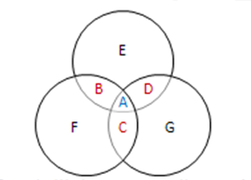

      - Example: Workers are grouped by teams in a company. 20 workers are on marketing, 30 are on sales, 40 are on vision. 5 workers are both on marketing and sales, 6 workers are both on sales and vision, and 9 are both on marketing and vision. 4 are in all teams. How many workers in total?

  - Overlapping sets and the Venn Diagram
      - Answer: 4 + 2 + 3 + 6 + 21 + 27 + 8 = 71 workers

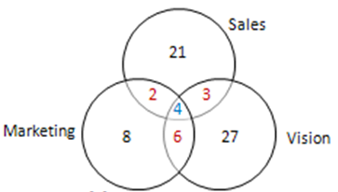

  - Minor problem types
The general approach for optimization, grouping and scheduling problems is to focus on extremes.

    - Optimization problems
      - The guests of a banquet consumed 401 pounds of food. If no one consumed more than 2.5 pounds of food, what is the minimum number of guests?
      - Answer: since 401 / 2.5 = 160.4 and no guests ate MORE than 2.5 pounds of food, the minimum number of guests will be 161. If no one ate LESS than 2.5 pounds, the MAXIMUM number of guests would be 160.
  - Grouping Problems
You need to group 1 person from division A, 2 from division B and 3 from division C. Division A has 20 people, division B has 30, and C has 40. What is the smallest number of people who will not be assigned to a group?
A: 20/1 = 20 groups are possible
B: 30/2 = 15 groups are possible
C: 40/3 = 13 groups are possible.
The limiting factor is group C, as they have the smallest number of groups to be formed. Therefore, we can only form 13 groups, and this is when the smallest number of people will be left over: 12 people in total.

Comb / Prop / Stats Advanced
  - Scheduling
How many days does the standard warranty of product X last?
(1) Marck purchased in jan 97. Warranty didn’t expire until march
(2) Santos purchased in May 94. Warranty expired in may.

Answer: Statement (1) tells us the warranty lasts from 29 days (if the product was purchased by jan 31st and warranty finished by march 1st) to 89 days (if the product was purchased by jan 1st and warranty finished by march 31st). INSUFFICIENT
Statement (2) tells us the warranty lasts 1 to 30 days . INSUFFICIENT

      - Both statements together are INSUFFICIENT, as the warranty could last 29 or 30 days.

      - Jane needs to walk 3 blocks south and 3 blocks east. What is the probability that she will walk south for the first 2 blocks?
      - Answer: the total number of ways she can walk 6 blocks being 3 in one way and 3 in another way are: 6! / 3!3! = 20. If she will walk the first 2 blocks south, use the reducing pool/glue technique. Since you already know she has walked the first 2 blocks to south, she needs to walk 4 blocks, being one to south and 3 east. Number of possible way is 4! / 3!1! = 4. So, the probability she will walk south for the first 2 blocks is 4/20 = 1/5

  - Combinations vs Permutations

If switching the elements in a chosen set creates a different set, it is a permutation. If not, it is a combination.
Combinatorics and Domino Effect
If you have a symmetrical problem, you can calculate the probability of one case and multiply by the number of cases.
Example: A machine contains 7 blue, 5 green and 4 red gumballs. If machine dispenses 3 balls at random, what is the prob. of being 1 each color?

Answer: 7/16 * 5/15 * 4/14 = 1/24. This can happen in 6 different ways, as we have 3 balls to be taken out and there are 3 possible outcomes. So, you just find one probability (1/24) and multiply by 3!, which yields 1/4.

Factors and Multiples

    - Method 1: building table with factor pairs:
      - Example: How many factors does 72 have?
      - We can see that 72 has 12 factors
      - Any integer has a limited number of factors
but infinite number of multiples.
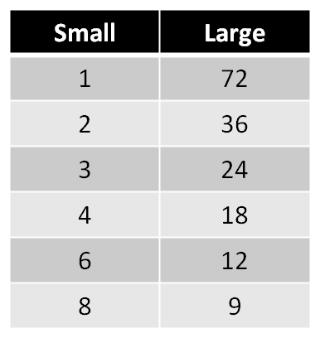

    - Method 2 (Recommended):
    - If a number has prime factorization a^{x} . b^{y} . c^{z}, where a, b and c are primes, then the number has (x+1)(y+1)(z+1) total factors.
      - Example: How many total factors does the number 2,000 have?
      - With prime factorization we find that 2,000 = 2⁴ . 5³. So, 2,000 has 5.4 = 20 total factors

Prime Factorization
Use prime factorization to:
- Determine whether a number is divisible by another
- Determine the GCF / LCM of 2 or more numbers
- The prime box
- If n is divisible by 3, 7 and 11, what other numbers are divisors of n?
- 3.7 = 21, 3.11 = 33, 7.11 = 77, 3.7.11 = 231. If a number has the primes 2, 3 and 7 in its prime box, this number will also be divisible by any combination of them.

- Finding GCF and LCM using Venn Diagrams
(1) Factor the numbers into primes
(2) create a venn diagram
(3) Place common factors in shared areas
(4) place the remaining factors in non-shared areas

GCF is the product of primes in the overlapping region
LCM is the product of all primes in the diagram

    - Finding GCF and LCM using Venn Diagrams
      - Example: Find GCF and LCM for 24 and 30:

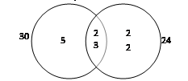
GCF = 2 . 3 = 6 . LCM = 2 . 2 . 2 . 3 . 5 = 120
If 2 numbers have no primes in common, their GCF is 1
    - Remainders
      - On simpler remainder problems, the best technique is to pick numbers.
    - Advanced remainder techniques
      - If you need a number that leaves a remainder of R when divided by N, simply take any multiple of N and add R.
      - The remainder of any number MUST be non-negative and smaller than the divisor.

Divisibility and primes
    - Advanced remainder techniques
      - You can add, subtract and multiply remainder, as long as you correct the final result by dividing the resultant number by the divisor.
      - Common GMAT problem: If A/B yields 4.35, what could be the remainder?
(A) 13 (B) 14 (C) 15 (D) 16 (E) 17
      - Answer: First, convert .35 to a fraction: .35 = 35/100 = 7/20. Now, compare this fraction with B (the divisor on this problem):
      - 7/20 = R/B From this equation, we know that the remainder must be a multiple of 7. The correct answer is 14.

    - Odds and Evens
      - Addition/subtraction: If you add/subtract 2 odds or 2 evens, the result will be even. If you add/subtract an odd with an even, result will be odd.
      - Multiplication: If any of the integers in a multiplication is even, result is even.
      - If 2 even integers are multiplied, result is divisible by 4, and if 3 even integers are multiplied, result is divisible by 8. If many even integers are multiplied, the result is higher and higher powers of 2, as 2 is the only prime integer.

    - Odds and Evens: Division
      - An even divided by another even can yield an even, odd or non-integer result.
      - An even divided by an odd cannot yield an odd number (either even result or non-integer result)
      - An odd divided by an even will always yield a non-integer.
      - An odd divided by another odd cannot yield an even number.
    - Prime numbers: Since 2 is the only even prime number, the sum/difference of two primes can only result an odd number if one of them is 2. In this case, the product will be even. For all other cases, the product will be odd and the sum/difference will be even. Conversely, knowing that the product of two prime numbers is even OR that the sum/difference is odd is sufficient to know that one of the prime numbers is 2.
Example: If x>1, what is x?
(1) There are x unique factors of x (2) x plus any prime larger than x is odd.
Statement (1) is sufficient as this property holds only for 1 and 2. Statement 2 only tells us that x is even, as it is not stated in the problem that x is prime.

    - Testing odd and even cases
      - Example: If a, b and c are integers and a.b + c is odd, what is true?
      - I. a + c is odd
      - II. b + c is odd
      - III. a.b.c is even
      - Either a and b are odd and c is even, or c is odd and a, b or both are even. Therefore, a + c can be odd or even, and the same happens for b + c. So, the only necessarily true statement is III.
    - Positives and Negatives
      - When you multiply or divide a group of nonzero numbers, the result will be positive if you have an even number of negative numbers. If not, the result will be negative.
      - Example: Is the product of all elements in set S negative?
      - (1) All the elements in set S are negative
      - (2) There are five negative elements in S.
      - This is a trap, as statement 2 seems sufficient, but it is not as we don’t know whether there is a 0 on set S or not. Both statements together are sufficient.
    - Testing positive and negative cases
      - Example: If ab > 0, which of the following is negative?
      - (a) a + b (b) |a| + b (c) b – a (d) a/b (e) –a/b
      - To solve these problems, build a positive/negative table and if necessary, pick numbers:
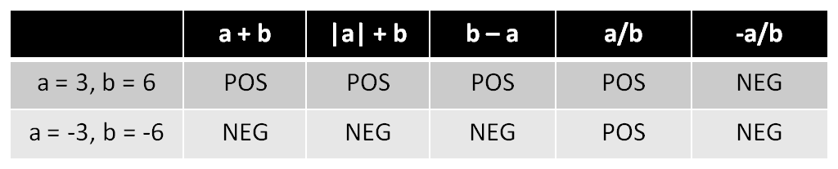
      - Picking 2 sets of numbers was sufficient to solve. Answer: E

    - Consecutive Integers
      - Consecutive integer sets are a special type of evenly spaced sets, as the distance between each term is always 1.
      - Properties of evenly spaced sets:
      - The arithmetic mean and the median are always equal
      - Mean and median are equal to the average of FIRST and LAST terms
      - The sum of all elements is equal to the mean times the number of items

    - Consecutive Integers: Counting Integers
      - Example: How many integers are there from 14 to 765, inclusive?
      - Formula: Last Term – First Term + 1
      - Example 2: How many even integers are there from 12 to 24?
      - Formula: ((Last Term – First Term)/Increment) + 1
      - Example 3: How many multiples of 7 are there from 100 to 150?
      - First, find the first and last multiples of 7: The first is 105, and the last is 147. Now, apply the formula: (147 – 105)/7 + 1 = 7

    - The sum of consecutive integers
Common on GMAT: What is the sum of all integers from 20 to 100, inclusive?
(1) Count the number of terms: 100 – 20 + 1 = 81
(2) Find the average: (100 + 20)/2 = 60
(3) Multiply the average by the number of terms: 60 * 81 = 4,860

    - Important properties
      - The average of an odd number of consecutive integers will be an integer
      - The average of an even number of consecutive integers will not be an integer

    - Important properties of consecutive integers
      - Example: Is k² odd?
      - (1) k-1 is divisible by 2
      - (2) The sum of k consecutive integers is divisible by k
      - Answer: Statement (1) tells us k is odd, so k² is also odd. Sufficient
Statement (2) tells us the average of a set with k consecutive integers is an integer, so k must be odd and k² is also odd. Sufficient. Answer: D

    - Product of consecutive integers and divisibility
      - The product of n consecutive integers is divisible by n!
      - The sum of n consecutive integers is divisible by n IF n is odd, and IS NOT divisible by n if n is even.

Exponents
      - Even exponents hide the sign of their base. GMAT uses this trick constantly.
      - Fractional base: When the base is between 0 and 1, if the exponent increases, the value of the expression decreases.

    - Compound bases
      - You can distribute the exponent to each number in the base and also decompose the base:
(2.5)³ = 10³ = 2³. 5³. It is essential to master this technique!!! This CANNOT be done to a sum.
    - The exponent
      - When multiplying 2 terms with the same base, add the exponents. When dividing, subtract the exponents.
      - Nested exponents: (3²)³ = 3⁶
      - An expression with negative exponent is the reciprocal of what that expression would be with positive exponent.

    - Rules of exponents
      - (a/b)^{x} = a^{x}/b^{x}
      - 3³ + 3³ + 3³ = 3.3³ = 3⁴
      - a^{x}b^{x} = (ab) ^{x}
      - x^{-a} = 1/xª

- Simplifying exponential expressions
Always try to simplify exponential expressions when they have the same base or the same exponent. When expressions with the same base are linked by a sum, you cannot simplify but you can factor the expression:
7² + 7³ = 7².(7 + 1) = 49.8
Example: what is the largest prime factor of 4²¹ + 4²¹ + 4²³?
Answer: 4²¹ + 4²¹ + 4²³ = 4²¹(1 + 4 + 16) = 4²¹.(21) = 4²¹(3.7).
The largest prime factor of 4²¹ + 4²¹ + 4²³ is 7

- Simplifying a root
GMAT very often tries to trick you by giving a root linked by addition where it is tempting to simplify the terms, for example: √(25 + 16). It is tempting to think that this will result into 5 + 4, but you can only simplify roots when the terms inside/outside are linked by multiplication or division

    - Simplifying roots
      - Examples of roots simplification:
      - √25.16 = √25 . √16 = 5.4
      - √50 . √18 = √50.18 = √900 = 30
      - √144:16 = √144 : √16 = 12/4 = 3
      - √25+16 = √41 you cannot simplify this one

    - Knowing common roots
      - GMAT requires you to know all the perfect square roots from 1 to 30 and also the following imperfect rules:
      - √2 ≈ 1.4
      - √3 ≈ 1.7
      - √5 ≈ 2.25
    - Roots
      - Main difference between exponents: even roots have only one solution. √4 can only be 2, and not -2.
      - Negative roots can only exist if they are odd: ³ √-27 exists.
    - Divisibility and addition/subtraction
      - If you add or subtract multiples of an integer, the result is also a multiple.
      - If you add/subtract a multiple of N to a non-multiple of N, result is non-multiple of N
      - When you add two non-multiples of 2, the result is a multiple of 2

    - Advanced GCF and LCM techniques
Finding GCF and LCM of 3 or more numbers:
(1) calculate the prime factors of each integer
(2) create a column for each prime factor found and a row for each integer
Raise each prime to a power, which is the number of times it appeared on that integer

    - Order of operation: PEMDAS
      - PEMDAS = Parentheses, Exponents, Multiplication & Division, Addition & Subtraction
      - Most common mistake with computations: not distributing the subtraction sign to all the terms. TAKE CARE.
      - Example: (3x – 3) – (4x – 2) = 3x – 3 – 4x + 2

    - Advanced GCF and LCM techniques
      - Example: Find the GCF and LCM of 100, 140 and 250
      - Prime factors: 100 2,2,5,5. 140 2,2,5,7. 250 2,5,5,5
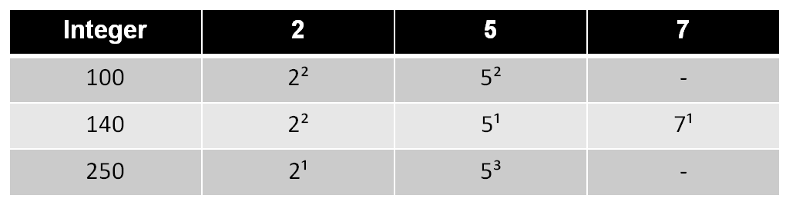

      - GCF is the smallest count in any column: 2¹. 5¹ = 10
      - LCM is the largest count in any column: 2². 5³. 7¹ = 3,500
    - Three important properties of GCF and LCM:
(1) (GCF of m and n) . (LCM of m and n) = m.n
(2) GCF or m and n cannot be larger than the difference of m and n
(3) Consecutive multiples of n have a GCF of n. Example: the GCF of 84 and 88 is 4.

    - Combinations of GCF or LCM
      - Very common on GMAT
      - Example: Is z divisible by 6?
(1) the GCF of z and 12 is 3
(2) the GCF of z and 15 is 15

      - If the GCF of z and 12 is 3, we know that z is divisible by 6 but not by 2. Therefore, z is not divisible by 6. (1) is SUFFICIENT
      - If the GCF of z and 15 is 15, we know that z is divisible by 3 and 5, but we do not know if z is divisible by 2 or not, so (2) is INSUFFICIENT. Answer: A

      - Example 2: If the LCM of a and 12 is 36, what are the possible values for a?
      - The prime factorization of 12 results into 2,2,3. The prime factorization of 36 results into 2,2,3,3. Therefore, a must have one non-shared 3 with 12 in its prime factorization, and no other non-shared prime. So, a could be:
      - 3.3 = 9, OR 2.3.3 = 18, OR 2.2.3.3 = 36
    - Counting total factors
      - If you are asked “how many different prime factors” a number or a product has, you don’t need to consider how many times each prime is repeated.

    - Counting total factors
      - If you are asked “how many total prime factors” or “what is the length” of a number, then you need to count repeated prime factors as well.
      - If you are asked “how many total factors”, use the technique showed on slide 82.

    - Perfect squares, cubes, etc
      - All perfect squares have an odd number of total factors. Conversely, any integer that has an odd number of total factors is a perfect square. This happens because this number will have a factor pair with 2 repeated numbers.
      - The prime factorization of perfect squares contains only even powers of primes. This rule extends to cubes and other powers.
      - Advanced question: if k³ is divisible by 240, what is k’s least possible value?

    - Counting total factors
      - Advanced question: if k³ is divisible by 240, what is k’s least possible value?
      - The prime factorization of k³ results AT LEAST on 2,2,2,2,3,5. So, since k³ = k.k.k, each k has at least two 2’s, one 3 and one 5. So, k’s least possible value is 2.2.3.5 = 60

    - Factorials and divisibility
      - N! is multiple of all integers from 1 to N
      - 10! + 11! Is a multiple of any integer from 1 to 10, as both terms include every integer from 1 to 10.

    - Odd/Even, Pos/neg, Consec Integers Advanced
Property: odd integers leave a remainder of 1 when divided by 2
Example: If x, y and z are integers and xyz is divisible by 8, is x even?
(1) xy is divisible by 4
(2) x, y and z are all not divisible by 4
(1) is not sufficient, as y could be divisible by 4 and x could be odd.
(2) is SUFFICIENT, as if neither x, y and z are divisible by 4, all of them must be divisible by 2 in order to let xyz be divisible by 8. Answer: B

    - Representing Evens and Odds algebraically
      - Even numbers are multiple of 2, so an arbitrary even number can be written as 2n. Odd numbers are one more or one less than multiples of 2, so they can be written as 2n+1 or 2n-1
      - Advanced question: What is the remainder of a/4?
      - (1) a is the square of an odd integer
      - (2) a is a multiple of 3
      - Answer: if we square (2n+1) we have 4n² + 4n + 1, so it is clear that any odd number, when squared and further divided by 4 will leave a remainder of 1. So, (1) is SUFFICIENT. Statement (2) is INSUFFICIENT, as a could be an even number, like 6 or 12.

    - Absolute value
      - The absolute value |x – y| must be interpreted as the distance between x and y. If you see the expression |x – 3| < 4, think that “the distance between x and 3 is less than 4 units”.
      - When you have 2 variables in absolute value equations, you should pick numbers to eliminate answer choices.
    - Absolute value
      - Example: |x| - |y| = |x + y|, and xy ≠ 0. Which must be true?
      - (A) x – y > 0 (B) x – y < 0 (C) x + Y + 0 (D) xy > 0 (E) xy < 0
      - First, picking x = 3 and y = -2, we eliminate B and D. Then, picking x = -3 and y = 2, we eliminate A and C. Hence, answer is E.

    - Consecutive integers and divisibility
      - Advanced question: if x³ - x = p and x is odd, is p divisible by 24?
      - Factoring x³ - x: x(x² - 1). Factoring (x² - 1): (x + 1)(x – 1). So, the expression is x(x+1)(x-1), or (x-1)x(x+1), which denotes a consecutive integers expression. If x is odd, x-1 and x+1 are even. So, p is at least divisible by 4. Also, one of them will at least be divisible by 2 twice, so p is at least divisible by 8. Finally, the product of any 3 consecutive numbers is divisible by 3, so p is divisible by 24.

    - Using conjugates to rationalize denominators
      - 4 / √2 = 4/ √2 * √2/ √2 = 4 √2/2 = 2√2
      - 4 / (3 - √2) = 4 / (3 - √2) * (3 + √2) / (3 + √2) = (12 + 4 √2)/(9 + 3 √2 - 3 √2 – 2) = (12 + 4 √2)/7
      - To rationalize conjugates like a + √b, multiply by a - √b.

    - Important exponents properties
      - If x, z and y are integers and 2^{x}.5^{x} = 2²^{y}.5^{z}, then x = 2y and x = z, as each side of the equation must have the same number of prime factors.
    - Exponents and roots Advanced
      - Whenever two or more terms with exponents are added or subtracted, consider factoring them.
      - Whenever possible, break the bases into prime factors and distribute the exponents.

- Fractions, Decimals, Percents
      - Rounding to the nearest place value:
      - You must memorize tenths, hundredths, thousandths and ten thousandths.
      - Decimal operations: what is 10 – 0.063?
      - The key is to add zeroes to the bigger number to avoid confusions: 10.000 – 0.063. Now they have the same length and it is easier to do the subtraction.
      - Multiplication: ignore decimal point until the end. Multiply as if numbers were whole. Then, count the number of digits to the right of the decimals in both numbers and apply it to the product.
      - Example: 1.4 . 0.02 14 x 2 = 28, and we had 1 decimal on 1.4 and 2 decimals on 0.02, so number is 0.028
      - The same rules apply for division.

    - Decimals on Powers and roots
      - Always use the integer. If necessary, convert the decimal into powers of ten.
      - Example: (0.5)³ 0.5 = 5.10⁻¹ 5³.10⁻³. = 125 . 10⁻³ = 0.125
    - Decimals on Powers and roots
Always use the integer. If necessary, convert the decimal into powers of ten.
Example 2: ³√0.000027 = (27 . 10⁻⁶) ^{1/3} = 27 ^{1/3} . (10⁻⁶) ^{1/3} = 3.10⁻² = 0.03
This technique is very important and can help you answering questions that seem complicated but become very easy when we use this.

Shortcut: the number of decimal places in the result of a x-numbered decimal is x times the number of decimals of the original decimal:
(0.04)³ = 0.04 * 0.04 * 0.04 = 0.000064 2 decimals powered to 3 yield 6 decimals.
³√0.000000008 = 0.002. A number with 9 decimals cube-rooted yields a number with 3 decimals.

    - Fractions
      - If you add the same number to both the numerator and denominator of a fraction, the fraction gets closer to 1, regardless of its original value. This means a proper fraction will increase its value, while an improper fraction will decrease. This rule is very important to denominate which fraction is bigger, as you can add numbers to compare. 3/2 > 4/3 > 13/12 > 1,013/1,012

    - Fractions
      - To divide fractions, use the reciprocal and then multiply. If you see double decker fractions (1/2/3/4), this is the same as 1/2 * 4/3 = 2/3
      - To compare fractions, cross-multiply and then compare the numerators. The numerator’s fraction is bigger for the bigger fraction.
      - Example: 7/9 or 4/5? 7.5 = 35, 9/4 = 36. 36 is bigger, so the fraction 4/5 is bigger.
      - Take care when simplifying fractions. The denominator may never be splitted.
      - Example: (5x – 2y) / (x – y) cannot be simplified further
      - (6x – 15y) / 10 = 6x/10 – 15y/10 = 3x/5 – 3y/2

    - Percents
      - Take care with the difference between “what is 30% of 80?”, “75% of what number is 21?” and “90 is what percent of 40?”
      - 30% of 80? = x/80 = 30/100, x = 24
      - 75% of what number is 21? 21/x = 75/100 = 3x = 84, x = 28
      - 90 is what percent of 40? 90/40 = x/100, x = 225

Percent increase and decrease
      - If a quantity is increased by x percent, then the new quantity is (100 + x)% of the original. Thus, to find a 15% increase, multiply by 1.15
      - If a quantity is decreased by x percent, then the new quantity is (100 – x)% of the original. To find a 15% decrease, multiply by 0.85
      - Original +/- change = NEW

    - Successive percents
      - Those are very common on GMAT. A price which is increased by x% and then decreased by y%, for example, is the same as ORIGINAL. (1 + x %). (1 – y %)

    - Chemical mixtures
      - A 500 mL solution is 20% alcohol. If 100mL of water is added, what is the new concentration of alcohol?
      - The original ratio 1:5 will become 1:6, so the concentration is 1/6 or 16,67%

    - FDPs – Mixed
      - You will be often required to work with decimals, percents and fractions by the same time. You have to be able to switch between them and understand the main advantages. Fractions are good for calculations as we can cancel factors. Decimals are good for comparing sizes and for addition/subtraction.

    - FDPS and word translations
      - You must remember the most common:
      - X percent = X/100
      - Y is X percent of Z = Y = XZ/100 or Y/Z = X/100
      - G is 30% less than F G = 0.7F
    - FDPs – Advanced
      - Terminating decimals only have 2’s and 5’s as prime factors in their denominators.
      - If the denominator has a power of 10 minus 1 (9, 99), you will have repeating decimals

    - Percents and weighted averages
      - Cereal K is 10% sugar and Cereal B is 2% sugar. What should be the ratio of them to produce a 4% sugar cereal?
      - Technique: Pick a smart number for one of the quantities and call the other quantity x. For example, picking 100 grams for Cereal K:
      - 100*0.1 + 0.02*x = 0.04(100 + x) 10 + 0.02x = 4 + 0.04x
      - 0.02x = 6 x = 300
      - So, the ratio is 3 parts of Cereal B to each part of Cereal K, or 1:3

    - Percent Change and Weighted Averages
      - The revenue from pen sales was up 5%, but the revenue from pencil sales declined 13%. If the overall revenue was down 1%, what was the ratio of pen and pencil revenues?
      - 105 + 0.87x = 0.99(100 + x) 6 = 0.12x x = 50
      - So, the ratio is 2:1
      - Advanced question: A store sold 300 hammers and 12,000 nails on year 0 and 375 hammers and 18,000 nails on year 1. By approximately what percent did the ratio of hammers sold to nails sold decrease?

    - Percent Change and Weighted Averages
      - The ratio was 1/40 and now is 1/48. This may look like a 20% decrease but it is not! Take care!!
      - 1/40 * 48 = 48/40 = 6/5
      - 1/48 * 48 = 5/5
      - Therefore, the decrease was from 6 to 5, or 1/6 (16.7%)
      - Alternative method:
      - 375/18,000/300/12,000 = 375/18,000 * 12,000/300 375/18 . 12/300
      - 750/900 = 5/6. So, if NEW/ORIGINAL = 5/6, the decrease was 1/6.
      - 1 million=10,00000
      - 1 billion=1000 million

