Sentence Correction- Points to Remember

- Noun modifiers must be placed as close as possible to the entities they modify to convey clearly the intended logical meaning of the sentence.
Example: The committee chose Mr. Smith of Left Block, who was the most experienced member, to lead all the management-related operations.
Here, “who” correctly modifies “Mr. Smith”. Compare this with the following sentence:
- The committee chose Mr. Smith in the last meeting, who was the most experienced member, to lead all the management-related operations.
If you notice, structurally there is no difference between sentences 1 and 2. In both, “Mr. Smith” is followed by prepositional phrase. However, the second sentence is not correct. Here “who” ends up modifying immediately preceding noun “the last meeting”, resulting in modifier error.
This is so because “in the last meeting” does not modify “Mr. Smith”. It rather modifies the action “chose”. When did the committee choose? It did in the last meeting. This prepositional phrase can actually be placed right in the beginning of the sentence, after “The committee”, or before “Mr. Smith” to convey the intended meaning. Hence, here “who” cannot jump over the preceding noun. Notice how per the context of this sentence, the expression “Mr. Smith in the last meeting” is not a noun phrase. Contrast this with the noun phrase in the original sentence “Mr. Smith of Left Block”.
- Since verb-ing modifiers are made from verbs, they denote action.
- When a verb-ing modifier appears after a clause preceded by a comma, then it modifies the entire preceding clause. It presents either additional information or result of the preceding clause.
Ex1(Addnl. Info). Mary made a beautiful bouquet, arranging rare exotic flowers in certain symmetry.
Ex2.(Result) Mary made a beautiful bouquet, winning accolades from every one.

- The verb-ing modifier must make sense with the subject of the preceding clause.
Ex. (Incorrect) Joe became the CFO of the company, increasing his pay significantly.

- The noun + noun modifiers can modify the entire preceding clause, the preceding noun entity, or a noun in the middle of the sentence. The modification done by these modifiers is completely driven by the context of the sentence. The modification of noun + noun modifiers completely depends on the context of the sentence.

Whatever it is modifying- Just ensure that there is no ambiguity.
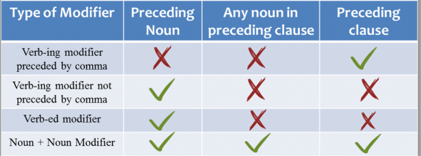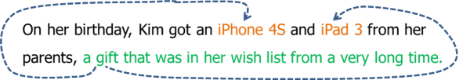
In the above sentence, “a gift that was in her wish list from a very long time” is the noun + noun modifier.
> A gift = noun
> that was (can refer to only one of iphone or ipad) in her wish list from a very long time = noun modifier
Now, in this sentence, there are two equally strong contenders for the modification of this noun + noun modifier – iPhone 4S and iPad 3. Hence incorrect, as it is ambiguous.
Correct:
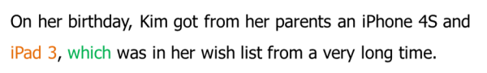
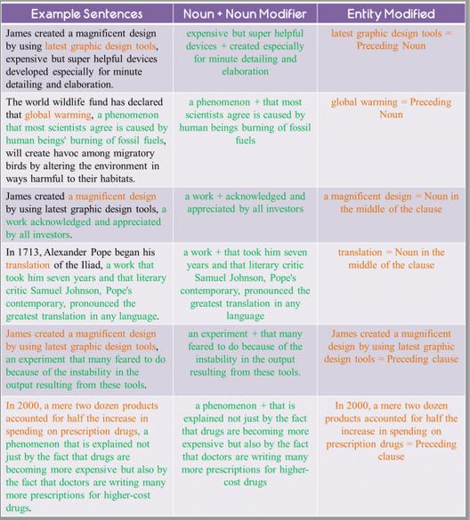
> verb-ing without comma and verb-ed are same (Modify preceding nouns)
- Discouraged by the long hours and low pay, my sister finally quit her job. Correct.
- My sister, discouraged by the long hours and low pay, finally quit her job. Correct.

- My sister finally quit her job, discouraged by the long hours and low pay INCORRECT. Here the verb-ed modifier is modifying the preceding noun “her job” which does not make sense.

- NUTSHELL-
1.When verb-ing modifier is separated from the clause using a comma, then this modifier modifies the preceding clause.
2. When verb-ing modifier is not separated from the clause using a comma, then it modifies the preceding noun.
3. When verb-ing modifier is placed in the beginning of the sentence followed by a comma, then it may modify either the subject of the clause or the entire clause, depending upon the context of the sentence.
4. Verb-ed modifier (with or without comma) modifies the immediately preceding noun or the noun phrase.
5. When verb-ed modifier is placed in the beginning of the clause followed by a comma, then it modifies the subject of the clause.

EXAMPLE:
Based on accounts of various ancient writers, scholars have painted a sketchy picture of the activities of an all-female cult that, perhaps as early as the sixth century B.C., worshipped a goddess known in Latin as Bona Dea, “the good goddess.”
(A) Based on accounts of various ancient writers
(B) Basing it on various ancient writers’ accounts
(C) With accounts of various ancient writers used for a basis
(D) By the accounts of various ancient writers they used
(E) Using accounts of various ancient writers (Correct answer)
Choice A is incorrect here because “Based”, the opening verb-ed modifier must refer to the Subject of the following main clause. The Subject of the main clause is “scholars”. It is evident that “based” does not logically modifies the Subject. We need a proper modifier in the beginning of the sentence to refer to “scholars”. This is the reason why Choice E is correct answer.
Let’s take another example where the usage of verb-ed modifier is NOT TESTED. This is the correct version of OG13#98:
Ranked as one of the most important of Europe’s young playwrights, Franz Xaver Kroetz has written forty plays; his works—translated into over thirty languages—are produced more often than those of any other contemporary German dramatist.
In this sentence, without any confusion, “ranked”, the verb-ed modifier modifies the Subject of the following clause “Franz Kroetz”. Because “ranked” is meant to modify “Franz Kroetz”, it has been placed in the beginning of the clause and not after the clause.
To reiterate the point I made earlier, because the verb-ed modifier is meant to modify the Subject of the main clause, “Ranked…” has been placed in the beginning of the clause and not after the clause.

Example:
Many of the earliest known images of Hindu deities in India date from the time of the
Kushan empire, fashioned either from the spotted sandstone of Mathura or Gandharan
grey schist.
A. empire, fashioned either from the spotted sandstone of Mathura or
B. empire, fashioned from either the spotted sandstone of Mathura or from
C. empire, either fashioned from the spotted sandstone of Mathura or
D. empire and either fashioned from the spotted sandstone of Mathura or from
E. empire and were fashioned either from the spotted sandstone of Mathura or from
- Due to Vs Because of

RULE 1: The expression ‘due to’ can only be used to modify nouns. Thus, you cannot use this expression to present reason for an action in the clause
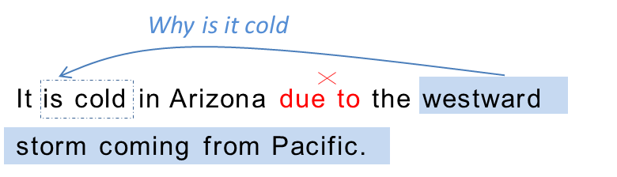 In sentence 1, use of ‘due to’ is incorrect because it is used to explain ‘why it is cold’. In other words, it is used to explain the reason behind the “verb” or “action” in the clause. This is not idiomatically correct.
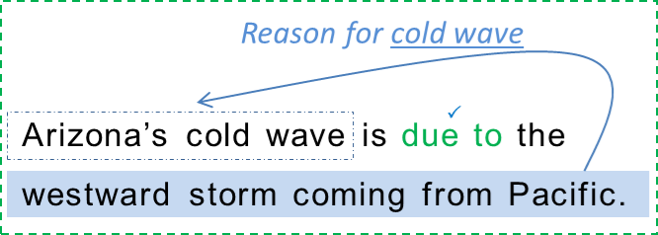
RULE 2: ‘Due to’ is correct if the sentence makes sense when you replace ‘due to’ with ’caused by’. If, it does not, then use of ‘due to’ is not correct
“Because of”
Rule 3: The expression ‘because of’ is used to modify entire clauses. Thus, you can use this expression to present reason for an action in the clause. Use ‘because of’ to modify verbs.
The parent-teacher meeting was canceled due to heavy rains. – INCORRECT
‘Due to’ modifies the action in the preceding clause and hence is not used correctly.
The parent-teacher meeting was canceled caused by heavy rains. – INCORRECT
Note how when “due to” is replaced with “caused by”, the sentence no longer makes sense.
The parent-teacher meeting was canceled because of heavy rains. – CORRECT
‘because of’ modifies the action in preceding clause, indicating why the meeting was canceled.
The cancellation of parent-teacher meeting was due to heavy rains. – CORRECT
‘Due to’ modifies the noun – cancellation.
The cancellation of parent-teacher meeting was caused by heavy rains.- CORRECT
Note how when “due to” is replaced with “caused by”, the sentence makes complete sense.
> Both “due to” and “because of” are followed by noun entities. “Due to” refers only to a noun entity while “because of” presents reason.

- VERB-ING MODIFIERS PART 2
Function of the verb-ing modifier when the modifier is placed after the clause and is NOT preceded by a comma
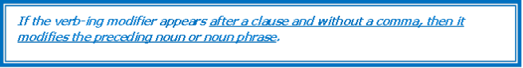

• Mary made a beautiful bouquet releasing divine aroma.
In this sentence “releasing…” is a verb-ing modifier that is not preceded by a comma. In this construction, “releasing…” modifies the preceding noun “bouquet”.
Understanding Intended meaning is the key: As you would have noticed, the key to deciding whether to use a verb-ing modifier, and if to use one, whether to use one with a comma depends on the intended meaning of the sentence. If the logical intended meaning is such that the verb-ing modifier should modify the preceding noun or noun phrase, then we should use the verb-ing modifier without a comma. On the other hand, use the verb-ing modifier with the comma if the author’s intention is to express additional information about the preceding clause or the result of the preceding clause.

- “ED FORMS” – VERBS OR MODIFIERS
Verb-ed forms can be used in two ways –One as verb in simple past tense and the other as modifier (also called Verb-ed modifiers)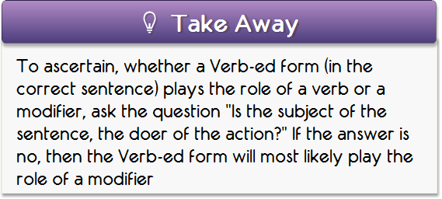
Scientists have recently discovered what could be the largest and oldest living organism on Earth, a giant fungus that is an interwoven filigree of mushrooms and root like tentacles spawned by a single fertilized spore some 10,000 years ago and extending for more than 30 acres in the soil of a Michigan forest.
Now let us apply this test on the “giant fungus”. After cutting the flab, this is the core that we get:
…a giant fungus… spawned by a single fertilized pore some 10,000 years ago…
So let’s ask, did “a giant fungus” do the action of “spawning”? The answer is “no” because it is clearly mentioned in the sentence that the action of spawning was done by “a single fertilized pore”. Hence, the litmus test confirms that “spawned” is a verb-ed modifier.
Therefore, to maintain parallelism we need to use a form of “extend” that is used as a modifier. Note that “extended” CAN be a verb-ed modifier. However, we need to find out if this form works in this sentence as a modifier:
…a giant fungus… extended for more than 30 acres in the soil of a Michigan forest.
Did “a giant fungus” do the job of extension? Yes, it did. It is the giant fungus that extends for more than 30 acres. This means that “extended” will work as simple past tense verb in this sentence and not as a modifier. This is the reason why “extended” cannot be used since a verb CANNOT be parallel to a verb-ed modifier.
Let’s once again quickly look at the answer choices:
A. extending
B. extends
C. extended
D. it extended
E. is extending
A quick scan of these choices will tell you that all the answer choices B, C and E are verbs in different forms while Choice E is a clause. Choice A “extending” is the only modifier that describes one of the characteristics of “a giant fungus”. Hence, verb-ed modifier “spawned” and verb-ing modifier “extending” are parallel entities because they both perform the same function, although they differ structurally.

- LIKE AND AS
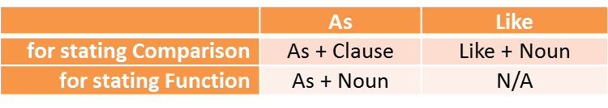
Both ‘like’ and ‘as’ are used to state comparisons. For example:
• Amy takes care of the children in the day care like a mother. ⎫
• Amy takes care of the children in the day care as a mother does.⎫
Both sentences are correct. Both the sentences above convey the meaning that Amy takes care of the children “in the same way” as a mother takes care of her children.
But notice the usage here – ‘like’ is followed by a noun and ‘as’ is followed by a clause. This grammatical construction should be kept in mind.

AS - CAN ALSO PRESENT FUNCTION
Apart from stating comparison, “as” can also be used to state “role” or “function”. For example:
John has joined the organization as a researcher.
In this sentence, ‘as’ does not show a comparison. This sentence implies that John is indeed a researcher in the new organization. Notice that per this sentence John has not been compared to a researcher. John is indeed a researcher. So his role has been presented. And hence ‘as’ is used to present role or function of a person.
Notice the grammatical construction – ‘as’ has been followed by a noun. This should always be kept in mind.

STEPS
Most sure shot way of resolving this confusion is to understand from the context of the sentence whether a comparison needs to be presented or function needs to be presented. Once you determine this, then you may use like and as appropriately to state the intended meaning.

- MARKERS FOR PARALLEL LIST
Laws of Parallelism:
1. A parallel list always contains a marker.
2. The list contains the appropriate marker to convey the intended meaning through the list.
3. The entities in the list are grammatically as well as logically parallel.

- Single word markers:
  - And
  - Or
  - But

- Dual Word Markers:
  - either… or…
  - both… and…
  - from… to…
  - not only… but also…
  - Whether… or…
  - Between… and…
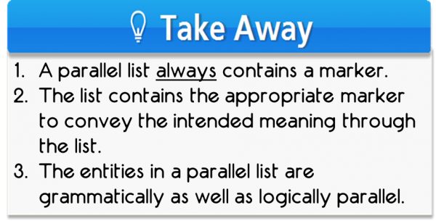

- Use ‘THAT’ to demystify a sentence.
- Always break the sentence into simpler structure after having understood the meaning. Then, for each of the parts, start identifying subject-verb pairs. Check that the verb and subject agree in number (singular/plural).
- That can be used
  - simply as a connector for 2 clauses
  - or as a modifier of the preceding noun acting as the subject of the 2nd clause

- Many- a-times, a sentence may appear wordy but it is the correct answer. Wordiness may even be due to some new words which never featured in the original sentence. This is because they help convey the correct meaning. Always remember, meaning >> concision.

- “While” has two functions. It presents either simultaneous action or contrast.

- Inuits of the Bering Sea were in isolation from contact with Europeans longer than Aleuts or Inuits of the North Pacific and northern Alaska.
(A) in isolation from contact with Europeans longer than
(B) isolated from contact with Europeans longer than
(C) in isolation from contact with Europeans longer than were
(D) isolated from contact with Europeans longer than were
(E) in isolation and without contacts with Europeans longer than
in this problem, (b) is ambiguous. it could mean one of the following 2 things: ("BI" = bering inuits, "E" = europeans, "A" = aleuts etc.)
* BI were isolated from E longer than BI were isolated from A
* BI were isolated from E longer than A were isolated from E
we can't tell.
if you add the "were", then the meaning is narrowed down to the latter of these two possibilities.
--
* if you have 2 ANSWER CHOICES THAT DIFFER ONLY IN THE PRESENCE/ABSENCE OF A LITTLE WORD, then CHANCES ARE THAT THE LITTLE WORD IS NECESSARY. i can't guarantee this 100%, but LOOK FOR AN AMBIGUITY that arises if the little word is omitted.
13. General Guidelines
1. Understand the intended meaning of the sentence and then select the choice that correctly communicates that meaning. Understand the role of each modifier in the sentence and note for any changes in the placement of these modifiers.
2. Use appropriate verb tense to communicate the intended logical meaning. This implies that you should understand two things
a. The function of each verb tense – grammatical knowledge
b. The intent of the sentence – What does the sentence want to communicate? – meaning
3. Ignore choices that may be grammatically correct but change the meaning. A seemingly correct grammatical choice may also communicate an illogical meaning.
13) 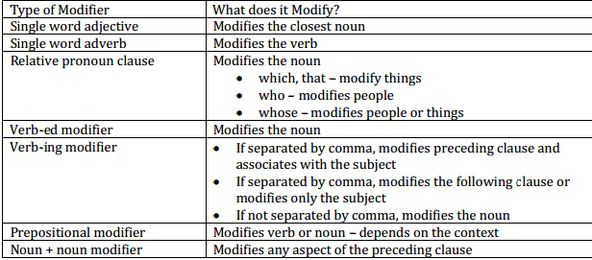

14. Sound can travel through water for enormous distances, prevented from dissipating its acoustic energy as a result of boundaries in the ocean created by water layers of different temperature and densities
B. prevented from having its acoustic energy dissipated by
C. its acoustic energy prevented from dissipating by
D. its acoustic energy prevented from being dissipated as a result of
E. preventing its acoustic energy from dissipating by
Similarities:-
- With surface temperatures estimated at minus 230 degrees Farenheit, Jupiter's moon Europa has long been considered far too cold to support life, and with 60 square miles of water thought to be frozen from top to bottom
A) Europa has long been considered far too cold to support life, and with
B) Europa has long been considered far too cold to support life, its
C) Europa has long been considered as far too cold to support life and has
D) Europa, long considered as far too cold to support life, and its
E) Europa, long considered to be far too cold to support life, and to have

- John, his arms flailing in the wind, called out desperately for help

15) Use “to verb” to present intention.
Ex: ‘Agreed to sign’ and not ‘agreed for signing’.
16. 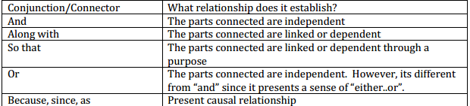
17. Meaning Analysis is very very important.
The largest trade-book publisher in the US has announced the creation of a new digital imprint division, under which it will publish about 20 purely digitalworks to be sold online as either electronic books or downloadable copies that can be printed upon purchase.
A) works to be sold online as either electronic books or
B) works to sell them online, either as electronic books or
C) works and it will sell them online as either electronic books or as
D) works, and selling them online as either electronic books or as
E) works, and it will sell them online as either electronic books or (wrongly suggests that the publisher will sell)

18. Recently discovered fossil remains strongly suggest that the Australian egg-laying mammals of today are a branch of the main stem of mammalian evolution rather than developing independently from a common ancestor of mammals more than 220 million years ago.
A. rather than developing independently from
B. rather than a type that developed independently from
C. rather than a type whose developments was independent of
D. instead of developing independently from
E. instead of a development that was independent of

19. Parallelism
4. The new lamp decorated with pink flowers and that resembles a star brought a large smile on the child’s face.
Here, “decorated” is a verb-ed modifier and “that resembles” is also a modifier. They perform the same function. But there grammatical structure is not parallel. “Decorated” is a verb-ed modifier and “that resembles” is a clause. A word/phrase CANNOT be parallel to a clause.
In this case, even if the list makes logical sense, grammar does not approve it as parallel because the clause can be written in the form to make it parallel to “decorated”. “that resembles” can be written as “resembling” and this will make the list parallel.
5. The new lamp that is decorated with pink flowers and that resembles a star brought a large smile on the child’s face.
This sentence rectifies the error of sentence 4. and turns single-word verb-ed modifier “decorated” into “that is decorated”, a “that clause”. Now the entities in the list are absolutely parallel.
TAKE AWAY: PARALLELISM - GO BY LOGIC
A.John prepared for impending currency crisis, storing enough food and water for future and posting his pictures online.
B. John prepared for impending currency crisis, storing enough food and water for future and posted his pictures online.
20. ‘TO VERB’ (read as ‘in order to’, hence, intention/purpose/aim) VS. ‘FOR VERB-ING’
Correct:
1. Joe wrote a book to share his experiences with others.
2. Joe got acclaims for writing the book.
Incorrect:
- Joe wrote a book for sharing his experiences with others.
2. Joe got acclaims to write the book.

Use of “to verb" – This phrase is used when we need to present the purpose or the intention of an action. This phrase is actually a shorter way of “writing” “in order to verb”. Let’s take the simple sentences with this phrase we mentioned in the beginning of the article.
1. Joe wrote a book to share his experiences with others.: This sentence correctly uses “to share” because it presents the purpose why Joe wrote the book. It is explicit from the context that Joe wrote the book because he wanted to share his experience with others.
2. Joe got acclaims to write the book.: This sentence does not use “to write” correctly because writing the book is certainly not the purpose of Joe getting acclaims.
Use of “for verb-ing” – Since “for” is a preposition, it can modify either a noun or a verb. Prepositional phrase “for verb-ing” can modify the verb or the noun in that it denotes some relation to the entity it modifies. Let’s understand this through the previously mentioned simple sentences.
1. Joe got acclaims for writing the book.: This sentence correctly uses “for writing” because this prepositional phrase logically modifies the verb “got”. Here, there is no question of presenting any purpose. The sentence rather explains “what for” Joe got acclaims. Hence, use of “for writing” is correct.
2. Joe wrote a book for sharing his experiences with others.: This sentence incorrectly uses “for sharing” to denote Joe’s intention of writing the book.
Confusing example:
New genetic evidence - together with recent studies of elephants’ skeletons, tusks, and other anatomical features - provide compelling support for classifying Africa’s forest elephants and its savanna elephants as separate species.
A. provide compelling support for classifying
B. provide compelling support for the classification of
C. provides compelling support to the classification of
D. provides compelling support for classifying
E. provides compelling support to classify
MEANING ANALYSIS:
The sentence says that New genetic evidence together with some other things provide compelling support. Support for what? Support for classifying Africa’s forest elephants and savanna elephants as separate species.
PoE:
Again, the error analysis helps us eliminate the first three choices for errors we are not discussing here. Again the only difference between D and E is “for classifying” and “to classify”.
D. provides compelling support for classifying: Per the meaning, new genetic evidence provides support. Most certainly, the new genetic evidence does not have any purpose for providing such support. Rather we can ask what is this support for? This support is for doing something else. Hence this choice correctly uses “for classifying”.
E. provides compelling support to classify: This choice is clearly incorrect because there cannot be any purpose here per the context of this sentence.
P.S: Also, this sentence involves usage of correct idiom. “provide support or help” is always followed a preposition + Noun. Hence, choice E is incorrect idiomatically as well.
21.
Replace the pronoun in the sentence by the all the possible nouns in the sentence and see if the result is logical. If 2 or more nouns are logical antecedents, then the sentence is incorrect.
EXAMPLE:
The UV radiation emitted by the Sun is highly dangerous because it has a very low wavelength.
There are three nouns in this sentence. “UV radiation”, “Sun” and “wavelength”.
Now keeping our above mentioned principle in mind, let us see which one among these three can be a logical antecedent.
i. Is “UV radiation” a logical antecedent of the pronoun “it” in this sentence?
In other words, does the statement “UV radiation has a very low wavelength” make sense in this context?
Yes. It does. It is perfectly logical to talk about the wavelength of radiation. The sentence “UV radiation has a very low wavelength and so the UV emitted by the Sun is highly dangerous” makes sense in this context. So “UV radiation” is a logical antecedent of the pronoun “it”.
ii. Is “Sun” a logical antecedent of the pronoun “it” in this sentence?
Again, ask yourself the following.
Does the statement “Sun has a very low wavelength” make sense in this context?
No. The statement isn’t logical. The sentence “Sun has a very low wavelength” doesn’t make sense at all. So “Sun” isn’t a logical antecedent of the pronoun “it”.
iii. Is “wavelength” a logical antecedent of the pronoun “it” in this sentence? To answer this question, ask yourself the following.
Does the statement “wavelength has a very low wavelength” make sense in this context?
No. It doesn’t. It isn’t logical at all. So “wavelength” isn’t a logical antecedent of the pronoun “it”.
So we have only one logical antecedent of the pronoun “it” in this sentence. So this sentence is correct.
c. A solar flare emitted by the Sun can destroy a communication satellite because scientists estimated that its temperature is high enough to accelerate further damage.
There are four possible antecedents in this sentence. They are “solar flare”, “Sun”, “communication satellite” and “temperature”.
Now following a similar approach as in the previous example
i. Does the statement “Solar flare’s temperature is high enough to accelerate further damage to a communication satellite” make sense in this context?
Yes. It is perfectly logical. So “Solar flare” is a logical antecedent of the pronoun “it”.
ii. Does the statement “Sun’s temperature is high enough to accelerate further damage to a communication satellite” make sense in this context?
Yes! Therefore “Sun” is a logical antecedent of the pronoun “it”.
iii. Does the statement “Communication Satellite’s temperature is high enough to accelerate further damage to a communication satellite” make sense in this context?
Yes. A satellite might have high temperature. It does make sense. So “Communication satellite” is a logical antecedent of the pronoun “it”.
iv. Does the statement “Temperature’s temperature is high enough to accelerate further damage to a communication satellite” make sense in this context?
NO! It is not at all logical to say so. Therefore “temperature” is not a logical antecedent of the pronoun “it”.
The pronoun “it” in this sentence has more than one logical antecedent. So there is pronoun ambiguity in this sentence.
In the above examples, wherever a pronoun is used, we replaced the pronoun with the possible antecedents and checked if the sentences made sense.
If no antecedents make sense, we say there is no logical antecedent to the pronoun.
If more than one antecedent makes sense, we say that there is pronoun ambiguity in the sentence

22.
1. Relative pronouns CANNOT refer to the preceding clause. They can only refer to the preceding noun entity. So when the function of the modifier is to modify preceding clause, then relative pronoun modifiers cannot be used.
2. Comma + Verb-ing modifier presents the result of the preceding clause.
EXAMPLE:
President Clinton spent significant money on the “No Child Left Behind” program in several school districts throughout the country, which led to a boom in the school construction industry and also added thousands of jobs for teachers and support staff.

• President Clinton spent significant money on the “No Child Left Behind” program in several school districts throughout the country,
• which led to a boom in the school construction industry and also added thousands of jobs for teachers and support staff.
President Clinton spent money on a particular program in several schools. This spending has resulted in two things:
o Boom in the school construction industry
o Addition of jobs for teachers and support staff.

Error Analysis
• President Clinton spent significant money on the “No Child Left Behind” program in several school districts throughout the country,
• which led to a boom in the school construction industry and also added thousands of jobs for teachers and support staff.
Error 1 – Per the meaning of the sentence, the action of spending resulted into two things. Here relative pronoun “which” has been used to mention the results of the action in the preceding clause. This is incorrect because “which” can only refer to a noun entity and not a clause.
PoE
A. which led to a boom in the school construction industry and also added: Incorrect for the reasons stated above.
B. which not only led to a boom in the school construction industry, but also added: Incorrect. Repeats the same error as in choice A.
C. not only leading to a boom in the school construction industry but also adding: Correct Answer
D. leading to a boom in the school construction industry, which also added: Incorrect.
Error 1 – Use of “which” is incorrect because it illogically modifies the preceding noun entity “the school construction industry”. Per this choice, the sentence means that the school construction industry added jobs for teachers and support staff.E. more on simplistic design and is more functional than are: Incorrect.
E. leading to a boom in the construction industry of school, which added: Incorrect. Repeats the same error as in choice AD
23) Like used to show similarity; such as used to give examples
24) ‘Should’ used to indicate moral obligation NOT LIKELIHOOD.
25) Everyone is singular.. Does everyone has his/her book?
26) ‘Being’ is wrong most of the times.
27) Joe as well as/in addition to (modifiers/additional) his (for Joe) friends is going to play
28) Joe and his friends (AND makes the subject plural) ARE playing.
29) SANAM- some any none all more/most ---- plural or singular, depending upon the usage
30) Not one, each, every.. all singular (Each of these shirts is pretty; every dog & cat has paws)
-> They each are players (Here each comes after the subject ‘they’ and hence ‘are’ is used)
31) In the senate, the majority HAS voted; The majority of students ARE players (where is the emphasis- majority or the component?)
32) There IS (has to be are.. flip and check…’and’ in the sentence is an indicator) a young man and woman at the bus stop.
33) Wrong: She argues that the agency acts with disregard for human life and property AND reckless abandon AND it should therefore be shut down.

Analysis: She argues
(i) that the agency acts with disregard for human life AND property AND with reckless abandon AND
(ii)that it should therefore be shut down.

Right: She argues THAT the agency acts WITH reckless abandon AND WITH disregard for human life AND property. AND THAT it should therefore be shut down.

34) PARALLELISM SHOULD BE IN TERMS OF BOTH MEANING AND STRUCTURE, not just structure.
Parallel markers... and, or, but, not only... but also, appealed to X…. As well as to Y etc

35) WRONG: The band chosen for the annual spring concert appealed to both the student body as well as to the administration.
Analysis

Here the parallel marker is BOTH…AND(not as well as… as well as doesn’t come with both… and does). Further, the structure of the parallel marker is … BOTH X AND Y…

Correct answer: 11. The band chosen for the annual spring concert appealed to [(both) the student BODY AND the
ADMINISTRATION].

36) Do not use this or these in place of nouns. Also, do not use that or those in place of nouns (unless you modify that or those). Use it, they, or them instead.

Wrong: Her products are unusual; many consider THESE unique.
Right: Her products are unusual; many consider THEM unique.

-> List of tenses:
a. Simple present – Permanent situations
b. Simple past – Describe an event that happened at a specific time in the past
c. Simple future – Uses “will” or “be going to” where “will” is voluntary, and “be going to” refers to a plan of action.
d. Present Perfect – Used to denote an event that happened at an unspecified time before the present : [Has/Have] + Present Participle
e. Past Perfect - Used to denote the event that happened in the far past when referring to two things that happened in the past. The near past event is referred to using the simple tense: [Had] + Past Participle
f. Present Perfect Continuous – Used to denote something that started in the past and has continued into the present : [Has/Have] + Been + Present participle
g. Past Perfect Continuous – Denote something that started in the past and continued till some other time in the past : [Had] + Been + Past Participle

-> Relative pronouns such as "which", "when" or "where," which, when preceded by a comma, refer to the noun immediately prior to the comma. For example:
I enjoy watching the Olympic Games, which take place every for years.

-> Rate of is used when we have to express "measure"
For example: Rate of change in commodity prices is indicative of a highly volatile market.
Here we are using "rate of" to express "measure".
The sentence implies that the measure of change in commodity prices is indicative...
Rate for is used when we have to express "price"
For example: Rates for gold have been consistently increasing.
Here it is clear that we are talking about price of gold.
So when you see the word - rate, see if you can replace it with price. If yes, then you must use "for" with rate.
However, when it makes sense to replace "rate" with "measure", you must use "of" with rate.

- The apples are more than the oranges. AND The number of apples is greater than the number of oranges.

-> USE ‘GREATER THAN’ FOR COUNTABLE THINGS… NOT ‘MORE THAN’
Now coming to the sentences in your post:
1: Rates of liability insurance have risen.
Clearly here we are are talking about prices of liability insurance. So the correct idiom is "rates for"
2: Prices of beach side properties fell drastically
Yes this is correct. But we have to use "rates" here, we will use the idiom "rates for". This is just idiomatic usage that you will need to remember.
Rates for beach side properties fell drastically.
3: The rate of fluid loss is under control
Yes this is correct. Here we are using rate in the capacity of fluid loss. Measure of fluid loss is under the specification limit.
4: The interest rates of government bonds are very high.
Yes this is correct. Now note here that you are using "Rates". You are infact using "interest rates" which does not function like "rates". You are talking about a characteristic of government bonds - interest rate.

37) Who, Whom, Whose
The following is a mini-tutorial on the uses of "who," "whom," and "whose." If you already know how to use these words, you can skip the explanation and go directly to the exercises.

Subjects, Objects and Possessive Forms
To understand how to use "who," "whom," and "whose," you first have to understand the difference between subjects, objects, and possessive forms.
Subjects do an action:
- He loves movies.
- She goes to school.
- We enjoy Chinese food.
Objects receive an action:
- The teachers like him.
- Thomas knows her.
- The actor smiled at us.
Possessive forms tell us the person something belongs to:
- His bike is broken.
- I like her new book.
- The teacher graded our homework.

"Who" is a Subject Pronoun
"Who" is a subject pronoun like "he," "she" and "we" in the examples above. We use "who" to ask which person does an action or which person is a certain way.
Examples:
- Who made the birthday cake?
- Who is in the kitchen?
- Who is going to do the dishes?

"Whom" is an Object Pronoun
"Whom" is an object pronoun like "him," "her" and "us." We use "whom" to ask which person receives an action.
Examples:
- Whom are you going to invite?
- Whom did he blame for the accident?
- Whom did he hire to do the job?

"Whose" is a Possessive Pronoun
"Whose" is a possessive pronoun like "his," "her" and "our." We use "whose" to find out which person something belongs to.
Examples:
- Whose camera is this?
- Whose dog is barking outside?
- Whose cell phone keeps ringing?
EXAMPLE: Caroline receives e-mail from~(whom she knows well from acquaintances (whose) names are only vaguely familiar, and from strangers about (whom) she knows nothing at all.

38) Pronoun Usage… The antecedent must always be a noun. Example:
INCORRECT: Oil traders have profited handsomely from the recent rise in its price.

CORRECT: Oil traders have profited handsomely from the recent rise in the price of oil.

This new, correct version of the sentence contains no pronouns.
The original sentence is incorrect because its has no antecedent. Oil is an adjective in the expression oil traders, and therefore cannot be the antecedent of its.

INCORRECT: A few Shakespearean scholars maintain that he borrowed some of his most memorable lines from Christopher Marlowe.

CORRECT: A few Shakespearean scholars maintain that Shakespeare borrowed some of his most memorable lines from Christopher Marlowe.

Shakespeare is the antecedent of his.
The original sentence is incorrect because he has no antecedent. Shakespearean is an adjective, and therefore cannot be the antecedent. We are thus forced to replace he with Shakespeare in the correct sentence.

39) That or whom can be dropped when the modified noun is the object of the modifying clause.

Wrong: The movie THAT we watched last Friday was scary.
RIGHT: The movie we watched last Friday was scary.

40) Use WHICH (and commas) if the modifier is non-essential (additional info, not needed).
Use THAT (and no commas) if the modifier is essential(info needed for identifying the noun).

Non-essential: This mansion. WHICH HAS BEEN RECENTLY PAINTEDRED.is owned by the tees;
Essential: The mansion THAT HAS BEEN PAINTE DRED is owned by the Lees.
41) The usual sequences are EITHER
Present + Future OR Past + Conditional.

Right: The scientist BELIEVES that the machine will BE wonderful. Present Future

Right: The scientist BELIEVED that the machine WOULD BE wonderful. Past Conditional

Wrong: The scientist BELIEVES that the machine WOULD BE wonderful. Present Conditional

Wrong: The scientist BELIEVED that the machine WILL BE wonderful. Past Future

42) USE SIMPLE PRESENT TENSE ALWAYS EXCEPT FOR WHEN AN ACTION HAPPENED IN THE PAST AND CONTINUES(OR ITS EFFECT CONTINUES) IN THE FUTURE (USE PRESENT PERFECT – HAS/HAVE + VERB-ED(PAST TENSE) )

43) USE PAST ALWAYS EXCEPT FOR CASES WHEN SEQUENCE OF EVENTS NEEDS TO BE PRESENTED. (PAST AND PAST OF PAST)
STRUCTURE: HAD+VERB-ED(PAST OF PAST)… + VERB-ED(PAST)

44) Subjunctive mood… try to think about the perspective of the writer.

EXAMPLE: IF Sophie ATE pizza tomorrow, THEN she WOULD BECOME ill.
Here the perspective is on the time when she would have already fallen ill. So for that time she would have already eaten pizza and consequently fallen ill.

COMMAND SUBJUNCTIVE:

  - Bossy Verb (demand, dictate, insist, mandate, propose, recommend, request, stipulate, suggest)+ THAT + subject + Command Subjunctive (verb without the ‘S’… be, disband, etc.)

  - Also used with adjectives like Other adjectives conveying urgency include advisable, crucial desirable, fitting, imperative, important, mandatory; necessary, preferable, urgent, and vital.

We PROPOSE THAT the school board DISBAND.
Wrong: We PROPOSE the school board DISBAND(That is not optional.)
Wrong: We PROPOSE THAT the school board DISBANDS.
Wrong: We PROPOSE THAT the school board IS TO DISBAND.
Wrong: We PROPOSE THAT the school board WILL DISBAND.
Wrong: We PROPOSE THAT the school board SHOULD DISBAND.
- Infinitive (advise, allow, forbid, persuade, want)
Example: We allow HIM TO BE here.

- Verbs that take EITHER the Command Subjunctive OR the Infinitive
- ask, beg, intend, order, prefer, urge, require (pay particular attention to require

EXAMPLE: We require THAT HE BE here. OR We require HIM TO BE here.

:
- A few Bossy Verbs, most notably prohibit, take other constructions altogether
Right: The agency PROHIBITED Gary FROM WORKING on weekends.

- Avoid the use of the Command Subjunctive after whether.
Wrong: I like ice cream, WHETHER it be chocolate, vanilla, or any other flavor.
Right: I like ice cream, WHETHER it is chocolate, vanilla, or any other flavor.

- Countable Modifiers
MANY hats
NOT MANY hats
FEW hats
FEWER hats
FEWEST hats
NUMBER of hats
FEWER THAN 10 hats
NUMEROUS hats

- Uncountable Modifiers
MUCH patience
NOT MUCH patience
LlTILE patience
LESSpatience
LEAST patience
AMOUNT of patience
LESSTHAN a certain AMOUNT
of patience
GREAT patience
GREATER patience

44) If “either … or”, “neither … or” or “or” are used, then the verb has to agree with the word closest to it. If just “either” or “neither” are used, then they are singular.
a. Either John or his friends are coming for dinner.
b. Neither John’s friends nor John is coming for dinner.

45) The question you should be asking is when you should eliminate "being".
the answer to that question is, ROUGHLY, that you should avoid "being" when expressing the IDENTITY or CHARACTERISTICS of some individual or thing. this is because "being" is usually unnecessary in such cases; there are simpler modifiers (such as appositives) that, while absolutely impossible to use in spoken language, are better in written language.
example:
being a cigar aficionado, john has strong opinions on when to use single-guillotine cigar cutters rather than double-guillotine cutters. --> bad.
a cigar aficionado, john has strong opinions on when to use single-guillotine cigar cutters rather than double-guillotine cutters. --> good. notice that we can simply omit the "being" here.
you don't want to omit "being" here, because it's not expressing identity: in the context of (e), it's a necessary verbal. (nice litmus test: try omitting it and see whether the sentence is still viable, perhaps with minor modifications. here, it isn't.)
so, to sum up:
if "being" expresses IDENTITY or CHARACTERISTICS, then kill it.
otherwise, evaluate it on the same merits as you would any other verb

Heavy commitment by an executive to a course of action, especially if it has worked well in the past, makes it likely to miss signs of incipient trouble or misinterpret them when they do appear.
A. Heavy commitment by an executive to a course of action, especially if it has worked well in the past, makes it likely to miss signs of incipient trouble or misinterpret them when they do appear.
B. An executive who is heavily committed to a course of action, especially one that worked well in the past, makes missing signs of incipient trouble or misinterpreting ones likely when they do appear.
C. An executive who is heavily committed to a course of action is likely to miss or misinterpret signs of incipient trouble when they do appear, especially if it has worked well in the past.
D. Executives’ being heavily committed to a course of action, especially if it has worked well in the past, makes them likely to miss signs of incipient trouble or misinterpreting them when they do appear.
E. Being heavily committed to a course of action, especially one that has worked well in the past, is likely to make an executive miss signs of incipient trouble or misinterpret them when they do appear.

-------------------------------------------READ NOTES AFTER THIS-------------------------------------------

LEARNINGS FROM QUESTIONS OF OG AND VERBAL REVIEW:
Question:
Because an oversupply of computer chips has sent prices plunging, the manufacturer has announced that it will cut production by closing its factories for two days a month.

Here why can't I rewrite the underline part as
Due to plunging computer chip prices from an oversupply:
"Because" and "due to", by themselves, ARE NOT modifiers. (If you understand that a "modifier" is an additional description that explains or describes something, then you'll already know this -- it's clear that these words by themselves can't describe anything.)
"Because xxxxx", where xxxxx is a sentence, is a single modifier.
"Because of xxxxx", where xxxxx is a noun (possibly with some modifiers of its own), is a single modifier.
"Due to xxxxx", where xxxxx is a noun (possibly with some modifiers of its own), is a single modifier.

If you replace the underlined thing with this thing, then you're obliged to describe the following noun, which is "the manufacturer". The manufacturer is not due to plunging chip prices, so that's nonsense.

Another Example:
I was two hours late to the meeting due to the six mile traffic.
The ENTIRE GREEN THING is a modifier.
It has to describe the noun "meeting".
Nonsense. A meeting is not "due to traffic".Quote:
I was two hours late to the meeting because of the six mile traffic.
Again, the ENTIRE GREEN THING is a modifier
This time, it describes the entire preceding sentence/action/idea
That makes perfect sentence, because the green thing is the reason why I was late to the meeting.
2) The Olympic Games helped to keep peace among the pugnacious states of the Greek world in that a sacred truce was proclaimed during the festival's month.
(A) Same
(B) world, proclaiming a sacred truce during the festival’s month
(C) world when they proclaimed a sacred truce for the festival month
(D) world, for a sacred truce was proclaimed during the month of the festival
(E) world by proclamation of a sacred truce that was for the month of the festival

In answer choice B, the subject of the initial clause is "The Olympic Games." The Games themselves could not have done the "proclaiming," since only some type of human entity has the capacity to proclaim. Using the passive construction a truce was proclaimed in choice D eliminates the necessity of mentioning a particular proclaimer. Additionally, one can correctly infer that the truce was proclaimed among the pugnacious states of the Greek world.

  - Announced plans Wednesday is correct… no ‘on’ needed before Wednesday
>Defense attorneys have occasionally argued that their clients' misconduct stemmed from a reaction to something ingested, but in attributing criminal or delinquent behavior to some food allergy, the perpetrators are in effect told that they are not responsible for their actions.
(A) in attributing criminal or delinquent behavior to some food allergy
(B) if criminal or delinquent behavior is attributed to an allergy to some food
(C) in attributing behavior that is criminal or delinquent to an allergy to some food
(D) if some food allergy is attributed as the cause of criminal or delinquent behavior
(E) in attributing a food allergy as the cause of criminal or delinquent behavior
Not ‘A’ because perpetrators are not attributing, defense lawyers are.

1. A 1972 agreement between Canada and the United States reduced the amount of phosphates that municipalities had been allowed to dump into the Great Lakes.
(A) reduced the amount of phosphates that municipalities had been allowed to dump
(B) reduced the phosphate amount that municipalities had been dumping
(C) reduces the phosphate amount municipalities have been allowed to dump
(D) reduced the amount of phosphates that municipalities are allowed to dump
(E) reduces the amount of phosphates allowed for dumping by municipalities
Quickest approach:
In C and E, reduces should be in the past tense because the agreement was made in 1972. Eliminate C and E.
In A and B, the past perfect tense of had been makes no sense. The past perfect implies an action completed before another past action. How could the 1972 agreement have reduced an action that had already been completed?
The correct answer is D.
To the original poster: this question is very confusingly transcribed. Unlike the Official Guide, which uses an em-dash (the big dashy looking thing) to separate the parenthetical phrase beginning '...they are often green', your question uses an em-dash (which you interpreted as a hyphen) to separate two independent clauses, a grammatical nicety that would lead straight to answer is (D). The answer was (B) however, and my head was spinning trying to figure out how that could be the case. Surely, joining a dependent clause to an independent clause is verboten. What I did not see was the hyphen hidden, without any intervening spaces, between bruises and heirlooms.
Only after I hunted down question #132 in the OG did I realize that the sentence was very different from the one transcribed here. There are two distinct em-dashes, as I've faithfully recapitulated below :
Although appearing less appetizing than most of their round and red supermarket cousins, heirloom tomatoes, grown from seeds saved during the previous year--they are often green and striped, or have plenty of bumps and bruises--heirlooms are more flavorful and thus in increasing demand.
(A) Although appearing less appetizing than most of their round and red supermarket cousins, heirloom tomatoes, grown from seeds saved during the previous year
(B) Although heirloom tomatoes, grown from seeds saved during the previous year, appear less appetizing than most of their round and red supermarket cousins
(C) Although they appear less appetizing than most of their round and red supermarket cousins, heirloom tomatoes, grown from seeds saved during the pervious year
(D) Grown from seeds saved during the previous year, heirloom tomatoes appear less appetizing than most of their round and red supermarket cousins
(E) Heirloom tomatoes, grown from seeds saved during the previous year, although they appear less appetizing than most of their round and red supermarket cousins
Explanation:
A good way to attack this question is to ignore the parenthetical phrase, "they are often green and striped...". Instead we need to focus on the two parts of the sentence, i.e. the part that comes before the first dash and the part that comes after the second dash. Notice the subordinating conjunction, 'although...' This suggests that the first clause needs to be a dependent clause that connects grammatically to the independent clause, "heirlooms are more flavorful..."
(A) Here is an attempt to make the underlined part a combination of a dependent clause ("Although appearing...") and an independent clauses ("heirloom tomatoes). However 'heirloom tomatoes' an independent clause does not make.
(B) "Although...appear less appetizing..." is a dependent clause. This matches up well with the independent clause following the second dash (the non-underlined part). The Answer.
(C) Same problem as (A).
(D) This answer choice forms an independent clause. Two independent clauses cannot be joined by a parenthetical comment (regardless of whether that comment is separated by em-dashes--as seen here--commas, or even parentheses). On the other hand, you can use just one em-dash to separate independent clauses (which is how I originally interpreted the question, and was thus drawn to (D)).

