Sentence Correction Guide
02/10/2015

Illogical Meaning
- Make sure to run through the test as a last ditch effort. Make sure that there is nothing with an answer choice. Diction is the only exception (only way to have an idiom). Often no true grammatical issues unless it is an idiom.
- Always consider illogical meaning before moving on. Is there some alternative meaning?
- Faulty Predication
  - The subject and predicate must be logically linked to each other
- Improper Diction / Improper Idiomatic Usage
  - To properly convey certain meanings, it is necessary to use accepted constructions and be efficient in writing
  - Method:
    - Spot the suspect idiomatic expression
    - Extract the various forms of the idiom
    - Replace the corrected idiom in the sentence
  - Common Idioms: Between X and Y, Consider X Y, In contrast to X, Y, Distinguish X from Y, Estimate X to be Y, Mistake X for Y, Think of X as Y, View X as Y, Whether X or Y, As…As, Both…And, Not…But, Not only…But also, Either…Or, Neither…Nor, From…To, So…As To, So…That, Like / Unlike, Than
- Redundancy
  - A specific error of diction. If the wrong words are chosen to express something, redundancy may occur
  - If you see two options that look similar, but one has more words than the other, ask “Are the words necessary?”
    - Are there extra words?
    - What do these words really mean?
    - What would it mean without the words?
    - All else equal, shorter is always better

Modifiers
- Put it as close as possible to the thing it is modifying. However, it will not always be that way. NOT AN AIR TIGHT RULE.
- When starting a sentence with a modifier, the next thing should be the noun that is being modified. However, if its some sort of short phrase its not a killer. But always look for a better choice. Keep it unless the thing following is a different noun!
- When at the end, all bets are off. Could be the noun or entire clause
- In the middle, generally you want it next to the thing it modifies.
- LOOK FOR COMMAS!!!
- Possessive nouns are not nouns
  - Incorrect: Happy about his raise, Bill’s celebration included taking his friends out to dinner.
  - Correct: Happy about his raise, Bill celebrated by taking his friends to dinner.
- “Comma –ing” modifiers refer to the entire clause to which they are attached
  - Incorrect: The CEO declared that everyone had to work every day through the holidays to make the production deadline, but in calling for such an extreme measure, the company’s employees were upset to the point of mutiny.
  - Correct: In an extreme measure, the CEO declared that everyone had to work every day through the holiday’s to make the production deadline; her employees were upset to the point of mutiny.
  - Correct: the CEO declared that everyone had to work every day though the holidays to make the production deadline, but in calling for such an extreme measure, she upset her employees to the point of mutiny.
- Prepositional Phrase
  - Modifiers that start with a preposition and contain an object (noun or pronoun)
  - Can be adjectival or adverbial
  - Two Rules:
- When prepositional phrases are serving as adjectives, they are almost always beside the noun, noun phrase, or pronoun that they are modifying
  - The house on the corner belongs to John Smith.
- When prepositional phrases are serving as adverbs, their locations can vary, and this adverbial prepositional phrases are much more complicated. These modifiers have freedom of location and must be assessed carefully.
  - Visitors to the zoo have often looked up into the leafy aviary and seen macaws resting on branches, with tails trailing like brightly colored splatters of paint on a green canvas.
  - Common prepositions: of, in, to, for, which, by, at, from, as, into, about, like, after, between, through, over, against, under, out of, next to, upon
- Participial Phrase
  - A participle is a verb form used as an adjective
  - Present participles end in –ing (acting as a verb, a noun, a noun modifier, or a verb modifier) and indicate ongoing action
  - Past participles end in –ed (acting as a verb or a modifier) and indicate a completed action
    - The crying baby finally fell asleep.
  - A participial phrase is a longer modifying phrase starting with a participle
    - Bombarded by bullets, the troops retreated.
    - Dogs trained by professionals are much more obedient.
    - Kit Carson roamed the Rockies and the Southwest, working as a trapper and establishing a reputation as one of the most able mountain men of his time.
  - Three Rules:
- If you start a sentence with a participle phrase, that participial phrase must logically modify the noun that follows the comma
  - Alarmed by the recent decline of the stock market, many investors…
- If participial phrases are used in the middle of a sentence, they follow the noun they are modifying and are either set off by commas or not, depending on whether the information is essential to the meaning of the sentence
  - Dogs trained by professionals are generally more obedient. (Essential info, no commas)
  - The city’s oldest church, recently destroyed by the fire, has not yet been rebuilt. (Non-essential info, need commas)
- When participial phrases are put at the end of a sentence with a comma, they are confusing because they can modify the subject of the sentence or the subject of the clause preceding it, even though they are not beside it.
  - Nadal beat Federer in five sets, shocking the tennis world.
  - Kit Carson roamed the Rockies and the Southwest, working as a trapper and establishing a reputation as one of the most able mountain men of his time.
  - While most adjectival modifiers should be beside the nouns they are modifying, participial phrases can be far from the nouns they are modifying when attached with a comma at the end of a sentence or clause
- Appositive Phrase
  - A noun phrase that serves the role of an adjective
    - John, the lead singer of the band, has laryngitis.
  - Almost always non-essential information, so they need to be set off by commas.
  - Apply the same rules as for participial phrases.
  - APPOSITIVE PHRASES CANNOT BE FAR AWAY FROM THE NOUN THEY ARE MODIFYING
  - Often can be removed from the sentence via Slash & Burn.
- Relative Phrase
  - A subordinate clause that starts with a relative pronoun and is used to modify a noun
    - Key Words: who, which, that, those, where, whose, whom, when
      - A noun followed immediately by the word that signals a noun modifier. A verb followed immediately by the word that signals the more complex sentence structure: subject-verb-THAT-subject-verb-object
      - Who and whom must modify people
      - Which cannot modify people
      - Whose can modify either people or things
      - Which or whom sometimes follow prepositions
      - Where can be used to modify a noun place (area, site, country, etc…) It cannot modify a “metaphorical” place (condition, case, circumstance, arrangement), in these cases use in which rather than where
      - When can be used to modify a noun event or time (period, age, decade). Can also use in which
  - Use comma if non-essential information. No comma if essential to sentence
  - Most common mistake is when the clause is placed too far from the noun it modifies.
  - On the exam, look at the noun before the relative pronoun and ask, “Is this logically modifies by the relative clause?”
  - “, which” must touch the noun immediately before the comma
  - “which” usually refers to some noun
    - You can use –ing to replace “which” if “which” is incorrect in the sentence
  - Pay attention to relative modifiers even if outside the underline. Need parallelism with relative pronouns
  - WHOLE SENTENCE MATTERS! Watch out for “that” and “which”
- Subordinate Clause
  - Subordinate clauses are not complete sentences. Subordinate clauses modify the main clause to which they are attached. It will often provide more information about the main clause.
  - Common Subordinators: Although, Before, Unless, Because, That, So that, If, Yet, After, While Since, When
  - If the word indicates a contrast, make sure that one exists
  - Must logically connect two pieces of information

Pronouns
- Pronouns in play: in the underlying portion, guarantee that you have to be on the lookout
- Whole sentence matters: when outside the underline, could hint at agreement issues, help to conjugate verbs
- Reference Errors
  - A pronoun should clearly refer to a specific noun (its antecedent)
  - Reference errors can be subtle and tricky, use Decision points analysis between answer choices to recognize the error type
  - Correct reference errors by removing a pronoun and replacing it with a noun, or by completely restructuring a sentence
  - Trigger: pronoun could refer to multiple nouns
- Agreement Errors
  - AIR-TIGHT. Singular v. Singular and Plural v. Plural
  - A pronoun must also agree in number with their antecedents (either singular or plural)
  - Can correct by changing the antecedent
  - Trigger Words: It, Its, Them, Them, Their, He, She, His, Her, This, That, These, Those, There, Itself, Themselves, one Another, Each Other, One
    - That of, Those of could also be included but often comparison issues
    - Each other refers usually to 2 people
    - One another often refers to more than 2 people and implies a mutual relationship
- Indefinite Pronouns: Usually Singular
  - An indefinite pronoun is not specific about the thing to which it refers
    - Singular: anyone, anybody, anything, each, every, everyone, everybody, everything, either, neither, no one, nobody, nothing, someone, somebody, something, whatever, whoever
      - Note: all pronouns that end in –one, -body, -thing are considered singular and require singular verb forms
    - Either Singular or plural depending on context (SANAM): some, any, none, all, more / most
      - To determine whether singular or plural, look at the of phrase that usually follows the pronoun
      - None of and any of followed by a plural noun can be singular
- Each and Every: Singular Sensations
  - Each or every requires a singular verb form
  - The same is true for any subject preceded by the word each or every
    - Every dog has paws.
    - Every dog and cat has paws.
    - Each of these shirts is pretty.

Agreement (Subject-Verb)
- AIR-TIGHT
- Agreement in play: pick up immediately when the verb is underlined. Identify subject and then begin to eliminate.
- Whole Sentence Matters: a verb outside the underline can hint at consistency. Can also hint at singular v. plural
- Subject far away needs Slash & Burn
- Must identify subject and verb for every single sentence
- Subject-Verb inversion sounds like Yoda. Sounds awkward but do not eliminate immediately. Can be legit, so you need to rearrange by putting subject in front of verb. Do subject and verb match up? Does it make logical sense?
  - Does it have leftover parts? If it does, then you didn’t reconstruct properly.
- Four Distinct Cases:
  - When the subject is very far away from the verb that it is commanding
    - The test makers will try to obscure the proper agreement by separating the subject and the verb with other modifying structures
    - Remember: Nouns that are objects of prepositions can never be the simple subject of the sentence
    - Use Slash & Burn to cross out all modifiers and extraneous words to isolate the simple subject and check Subject-Verb Agreement
  - When the subject is in the form “X or Y,” “either X or Y,” or “neither X nor Y,” Subject Verb Agreement is trickier
    - In sentences with the structures noted above, the verb should agree with whatever noun is closest to the verb. This is called “agreement by location”
    - Note: When the subject is in the form “X and Y,” the subject is compound and will almost always tae the plural verb
  - When the verb comes before the subject
    - Sometimes the subject and verbs can be inverted. Subject-Verb inversion is common to create confusing sentences
    - Note: reread the sentence with the subject first in order to check proper S-V A
      - Incorrect: Sitting at the far end of the bar is a local TV reporter and one of the town’s leading candidates for mayor
      - Correct: Sitting at the far end of the bar are a local TV reporter and one of the town’s leading candidates for mayor
      - Read the sentence as: A local TV reporter and one of the town’s leading candidates for mayor are sitting at the far end of the bar
  - When confusing or unusual nouns / subjects are used
    - Often it is fairly easy to isolate the proper subject, but it is difficult to determine whether that subject is really singular or plural
      - Incorrect: A number of my friends is going to the movies
      - Correct: A number of my friends are going to the movies
      - Note: “A Number” is plural. “The Number” is singular.
    - When in doubt, guess singular!
      - Singular Subjects: A singular subject linked to other nouns by something other than and, most indefinite pronouns, subjects preceded by each or every, subjects preceded by the number of, subject phrases or clauses
      - Plural Subjects: Subjects joined by and, subjects preceded by a number of
      - It Depends: Subjects joined by or or nor, collective nouns, SANAM pronouns, other numerical words and phrases
      - GMAT likes to use words that refer to multiple people but in fact are singular. Ex. “group, committee, team, etc…”
- Collective Nouns: Find the Clue
  - A collective noun is a noun that looks singular but can refer to a group of people or objects
    - People: agency, army, audience, class, committee, crowd, orchestra, team
    - Items: baggage, citrus, equipment, fleet, fruit, furniture
  - Whole Sentence Matters: the sentence will contain a clue that tells you which is singular and plural
  - Some words can be singular or plural depending on context
- Subject Phrases and Clauses: Always Singular
  - Sometimes the subject of a sentence is an –ing phrase or even a whole clause. This sort of subject is always singular and requires a singular verb form
    - Having good friends IS a wonderful thing.
    - Whatever they want to do IS fine with me.

Comparison
- Comparison errors can be subtle and are also common in writing. The comparison must be logical and equivalent in form
  - Error occurs when the sentence compares noncomparable things
- Make sure to avoid action to noun comparisons
  - Incorrect: Software X crashes more often than Software J.
  - Correct: Software X crashes more often than does Software J
  - Correct: Software X crasher more often than Software J does
- Need equivalency of form. Comparisons must be logical – proper noun-to-noun, or action to action, comparisons of like things – and they should be in the same form grammatically
  - Forms of nouns: Gerunds (-ing verbs that are used as nouns, e.g. running or swimming), Infinitives (verb forms that can be used as nouns, e.g. to run or to play), Traditional nouns (floor, car, wood, table, etc…)
- Numerical Agreement
  - Singular (Uncountable, e.g. water): Much, Less, Little, Amount, Lease, Great
  - Plural (Countable, e.g. gallons): Many, Fewer, Few, Fewest, Number, Numerous
  - Both: More, Most, Enough, All
- Numerical Comparisons
  - Two (-er, e.g. better): Between, The Other, Each Other
  - More Than Two (-est, e.g. best): Among, Another, One Another
- Comparison Markers
  - As many / much as…
  - So many / much that…
  - More / less than…
  - Like / unlike…
  - Similar to / Different from…
  - Same as…
  - In contrast to / in comparison to
  - That of / those of
  - Greater / Less than Use if making comparison with the word numbers
  - THAN
- Those of v. Apostrophe are mutually exclusive
  - Only need one or the other.
    - Ex. Some scientists contend that many species of dinosaur had a metabolism more like a warm-blooded mammal’s than a cold-blooded reptile’s.
    - Above is correct
    - Can also say: Some scientists contend that the metabolisms of many species of dinosaurs were more like those of a warm-blooded mammal than a cold-blooded reptile.
    - Never combine “those of” and an apostrophe in the same comparison
- Like vs. As
  - Like is used to compare nouns, pronouns, or noun phrases. Never put a clause or a prepositional phrase after like
    - Only nouns or pronouns can follow like
  - As can be used to compare two clauses
    - As can be used either as a conjunction or a preposition, depending on the context
      - Duration as: As I strolled to the store, I smelled the air.
      - Causation as: I will not tell you, as you already know.
      - Comparison as: You should walk as she wants you to walk.
        - Comparison as is the most important conjunction use of as on the GMAT
  - There is no difference between the two as any comparison can be restructured to fit either construction
- Numbers in Comparisons
  - There are a few options to indicate how much larger one quantity is than another
- Relate the quantities by multiplication: use times and as…as together
- To indicate direct multiplication: use times without as or them
- Relate two quantities by addition or multiplication: use more than or less than
- More and less are flexible. They can be used as nouns (or pronouns), adjectives, or adverbs
- High and low, as well as higher and lower, should only be used as adjectives

Tense (Timelines)
- What are the hints for perfect tense?
  - Have + past participle
  - Perfect tense happens immediately before past tense
  - When would you want to use each tense?
  - Two sentences and ask which is the better of the two?
  - Which tense properly belongs?
- Important when underlined
- Also important when out of underline. Need to match for parallelism. Beware of making parallel when it doesn’t have to be. Make sure that the parallelism matches up to the right verb

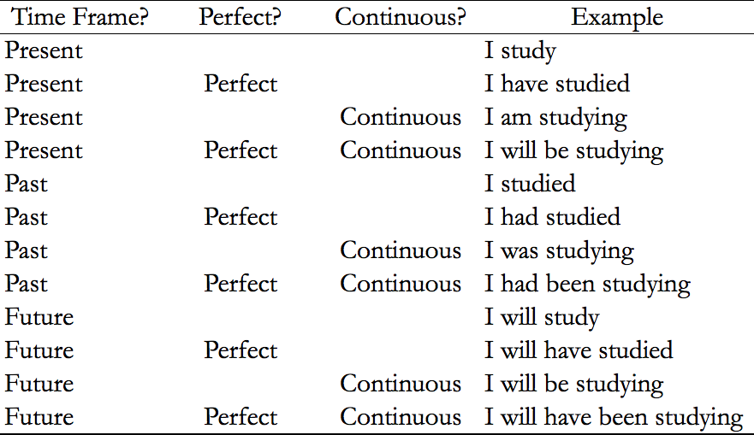

- Simple Present Tense: used to express “eternal” states or frequent events
  - Simple Present: Sandy plays well with her friends
  - Simple Past: Sandy played well with her friends yesterday
  - Simple Future: Sandy will play well with her friends tomorrow
- Perfect Tense: used to indicate an event happened before an event in the simple tense
  - Past Perfect: The Earlier Action
    - Use past perfect tense for an event before another event in the past
      - Jo discovered that Leslie had lied to her
      - As Mary shook Mr. Morgan’s hand, she realized she had seen him before
    - Never use the past perfect (I had studied) when you are simply talking about a single event in the past; always use the past simple (I studied). Also use the past simple with two events that happened at the same time in the past or with only one event in the past
      - Joe discovered Leslie’s lie.
      - As Mary shook hands with Mr. Morgan, she recognized him.
    - If two actions occurred at different times in the past, you can use the past perfect tense for the earlier action and simple past for the later action
      - Past Perfect = HAD + Past Participle
      - In order to make past perfect, the sentence must also contain either a verb in the simple past tense or a time market that occurred in the past but later than the past perfect action
    - Don’t necessarily need to use past perfect when you can use it. The words before and after indicate the sequence of events clearly and thus the simple past can be used.
  - Present Perfect: Bridging Past and Present
    - The present perfect tense is used for actions that started in the past but continue into the present or remain true in the present. The present perfect tense has one foot in the past and one foot in the present
      - The Millers have lives in a hut for three days
      - Present Perfect = Have / Has + Past Participle
        - Past participle is often the –ed form of the verb
    - Present perfect indicates either continued action or continued effect of a completed action up to the present.
    - “Since” hints at present perfect
      - Use the present perfect to indicate an action or effect that continues to the present time
      - Use Present perfect with “within the past” or “in the last” phrases
    - Present perfect can be used in certain circumstances to clarify an ambiguous sequence in time
      - She will pay you when you have taken out the garbage
- -ing Modifiers: Follow the main verb
  - “Comma –ing” modifiers follow on from the tense of the main working verb to which they are attached
    - Peering out of the window, she watched her dog frolic on the lawn
      - Main verb (watched) is in the past tense
      - The modifier (peering) picks up the time frame of the main verb
- Present to Future or Past To Conditional
  - The conditional tense is formed by combining would with the base form of the verb
    - Ex. Ewould provide
  - This construction expresses the future from the point of view of the past
  - Typical sequences for these types of sentences:
    - Present + Future
      - The scientist believes that the machine will be wonderful
    - Past + Conditional
      - The scientist believed that the machine would be wonderful
- Active and Passive Voice
  - Active Voice: the subject of the sentence performs the action
    - The hungry students ate the pizza
  - Passive Voice: the subject of the sentence has an action performed on it by someone or something else
    - The pizza was eaten by the hungry students
  - Both can be correct. Make sure that the structure of the non-underlined portion matches what you choose as your answer.
- Progressive Tenses
  - Progressive tenses emphasize the ongoing nature of an action: it takes place over some period of time. These tenses are formed using the verb to be and the present participle (-ing) form of the desired verb
    - Present Progressive: Sandy is playing soccer.
    - Past Progressive: Sandy was playing soccer yesterday.
    - Future Progressive: Sandy will be playing soccer tomorrow.
  - Present progressive indicates that the action is happening right now, whether the sentence contains words such as right now or not
    - In contrast, the simple present version (sandy plays soccer), means that she frequently plays or that she knows how to play but she may not be necessarily playing right now
  - Do not use present progressive for general definitions. Instead, use the simple present.
  - Do not use the present progressive to indicate future actions. Instead, use the simple future.
  - Verbs that express general states do not normally take progressive forms
    - Ex. Know or Signify
    - This inscription signifies the emperor’s birth.
- If… Then Constructions
  - Sentences with an if condition and a then outcome can follow several tense / mood patterns
  - Five common patterns:
    - General Rule with Certainty:
      - If Sophie eats pizza, then she becomes ill.
      - This pattern is equivalent to whenever: Whenever Sophie eats pizza, she becomes ill
    - General Rule with Some Uncertainty:
      - If Sophie eats pizza, then she may become ill.
      - The helping verbs can or may can be used to allow for a somewhat uncertain outcome
    - Particular Case (in the future) with Certainty:
      - If Sophie eats pizza tomorrow, then she will become ill.
      - Another possibility for this case (in the present) is present perfect: If Sophie has eaten pizza, then she will become ill.
    - Unlikely Case (in the future):
      - If Sophie ate pizza tomorrow, then she would become ill.
      - Conditional tense (would) shows the hypothetical result of an unlikely or untrue condition. Could can also be used to indicate improbability as well.
    - Case That Never Happened (in the past):
      - If Sophie had eaten pizza yesterday, then she would have become ill.
      - To form the conditional perfect, use would have + past participle
- The Command Subjunctive
  - Bossy verbs tell people to do something
    - The agency required that Gary be ready before noon.
  - Use the bare form of the verb: the infinitive (to be, to disband, etc…) without the to
  - Subjunctive construction with a bossy verb:
    - Bossy Verb + THAT + subject + Command Subjunctive
      - We propose that the school board disband
  - Not every bossy verb uses the command subjunctive. With some of the most common bossy verbs, such as want, you cannot use the command subjunctive; instead, you must use an infinitive (to + the bare form)
    - The vice-president wants her to go to the retreat
  - These verbs take ONLY the command subjunctive when indicating desire:
    - Demand, indicate, insist, mandate, propose, recommend, request, stipulate, suggest
      - Note that propose can take an infinitive when there’s no second subject
  - These verbs take ONLY the infinitive:
    - Advise, allow, forbid, persuade, want
  - These verbs take EITHER the command subjunctive OR the infinitive:
    - Ask, beg, intend, order, prefer, urge, require
      - We require that he be here
      - We require him to be here
- Helping Verbs
  - Be generates the progressive tenses and the passive voice
  - Have generates the perfect tenses
  - Do is used with simple present or past to negate verbs, emphasize verbs, or ask questions
  - The first instance of the verb should usually match the helping verb in tense. If you need to change tenses, repeat the whole verb in the new tense
    - I have never seen an aardvark, but last year my father saw one

Sentence Construction
- Commas, semicolons, and colons outside the underline don’t make much of a difference
- Sentence Construction in play: when underlined, commas, semicolons, and colons are important and have meaning
- Punctuation and Linking Clauses
  - Commas should be used when linking together independent clauses with a coordinating conjunction
  - Commas should not be used when linking together two subordinate clauses, phrases, or words with a coordinating conjunction
  - In a comma splice error, a comma is used to join two independent clauses without a necessary conjunction
  - Note: pay attention to whether a proper coordinating conjunction has been used to link clauses together
  - Semicolon: used to link together independent clauses (or sometimes for linking things in a series)
    - Each statement must be able to stand alone as an independent clause
  - Colon: used to introduce something that gives more information or clarifies what precedes the colon
    - What comes before the colon must be able to stand alone as a sentence
    - What comes after the colon does not have to be able to stand alone
    - You can put a main clause after a colon as well
  - Dash: when a single dash is used to end a clause, its usage is nearly identical to that of a colon; when two dashes are used in the middle of the sentence, their use is nearly identical to that of parentheses
    - Use a dash as an emphatic comma, semicolon, or colon
    - Can use a dash to restate or explain an earlier part of the sentence
    - Does not need to be immediately preceded by the part needing explanation
  - Conjunctions (FANBOYS): For, And, Nor, But, Or, Yet, So
    - Independent Clause + Comma + Conjunction + Independent Clause
- Parallelism in a Series
  - Super low hanging fruit for the most part
  - Trigger: multiple commas
  - Whenever series are presented in a sentence, strict rules of parallelism apply
  - Do not insert a new predicate in the series
  - Make sure to link all part of a series together with the same grammatical structures and that they are all in the same form
  - Infinitives cannot be mixed and matched with other noun forms
  - Pick the answer that keeps all elements parallel and in the same form
  - Parallelism Markers:
    - And
    - Or
    - Rather Than
  - And is the most common parallelism market. Use and to connect any two similar structures
    - Compound Subject: The manager AND her team were praised by the CEO.
    - Compound Verb: In one terrible day, the account manager lost a client AND greeted the CEO of her company by the wrong name.
    - Two Clauses: New data indicate that, over the course of the past week, the stock market jumped AND the unemployment rate decreased.
    - Prepositional Phrase: A rapid improvement in motor function AND vision was observed.
    - Adverbial Modifier: Historians have uncovered new evidence, confirming several theories AND giving rise to new hypotheses.

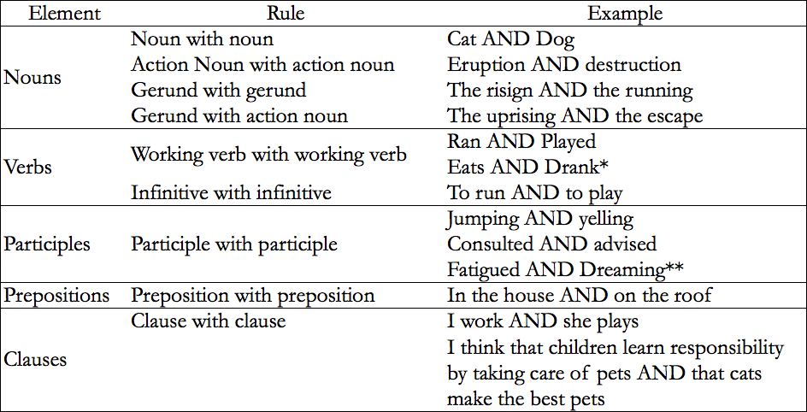
*She eats apples all the time AND drank some apple juice yesterday.
** The cat slept in the dun, fatigued by play and dreaming of the mouse that got away.

- Parallelism in Common Structures
  - Common structures that demand exacting parallelism:
    - Both / And
    - Either / Or
    - Neither / Nor
    - Not / But
    - Not Only / But Also
    - Just As / So
    - Range From / To
  - Whenever you encounter these common expressions, make sure that the structure that follows the first portion of the expression is identical with the structure that follows the second portion
    - Role must be the same
      - “Either in X or on Y” is totally acceptable

