Usage - Parallel Structure
Sentence elements that are alike in function should also be alike in construction. These elements should be in the same grammatical form so that they are parallel.
Using parallel structure in your writing will help with
1) economy 2) clarity 3) equality 4) delight.

Here are five parallelism rules.
1. Use parallel structure with elements joined by coordinating conjunctions.
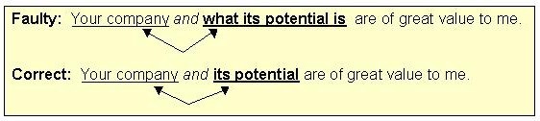

2. Use parallel structure with elements in lists or in a series.
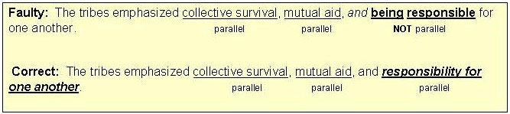

3. Use parallel structure with elements being compared. (X is more than / better than Y)
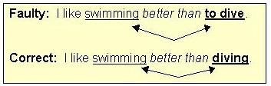

4. Use parallel structure with elements joined by a linking verb or a verb of being.
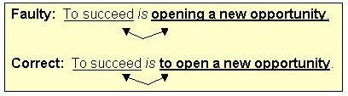

5. Use parallel structure with elements joined by a correlative conjunction.


