This is NOT an official score report

Overall GMAT Exam Performance

YOUR GMAT TOTAL SCORE:
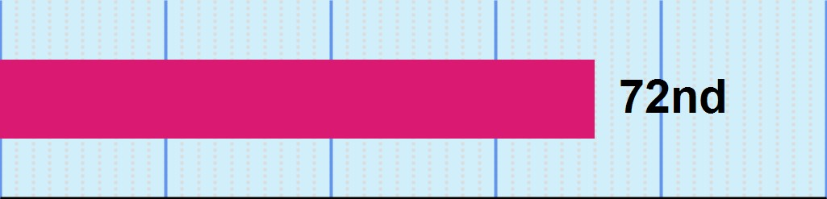640

PERCENTILE RANKING 0 20 40 60 80 100

YOUR IR SCORE:
7
YOUR VERBAL SCORE:
37
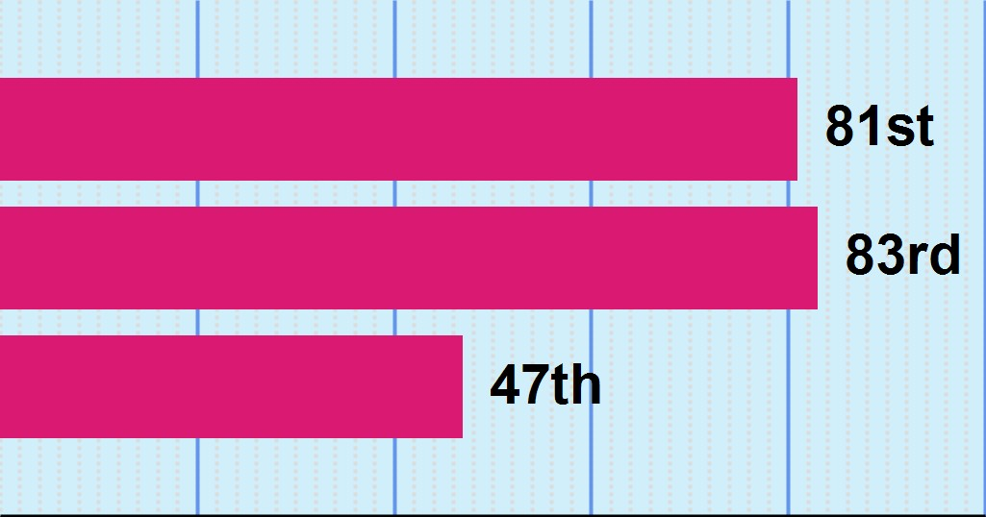YOUR QUANTITATIVE SCORE:
40

PERCENTILE RANKING 0 20 40 60 80 100
PERCENTILE RANKINGS COMPARE YOUR PERFRORMANCE TO 3 YEARS OF GMAT EXAMS SAMPLE SIZE: 782458

TIME MANAGEMENT BY SECTION

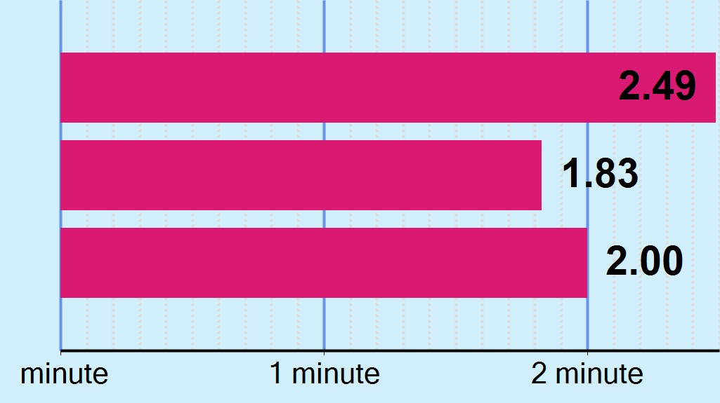YOUR MEAN RESPONSE TIME PER QUESTION

INTEGRATED REASONING
7
VERBAL
37
QUANTITATIVE
40
MEAN SCORE

MEAN SCORE:
547.3
(42nd percentile)

Definition

The three year mean GMAT Total score is 547.3. This score is better than 42% of GMAT
Exam scores recorded in the past three years.

Note: GMAT scores are valid for five years. Even though your score won't change, your percentile ranking may change when compared with a newer pool of applicants. Shifts tend to be gradual over long periods of time.

MEAN TIME

MEAN TIME FOR ALL TEST TAKERS:
1.87 minutes

Definition
For all GMAT Exam scores recorded in the past three years the mean time to complete a question in the Integrated Reasoning, Verbal, and Quantitative sections is 1.87 minutes. Use this number to evaluate how well you managed your time.

SUMMARY - OVERALL

 Your GMAT Total score of 640 is higher than 72% of GMAT Exam scores recorded in the past three years.
ƕ Your Integrated Reasoning score of 7 is higher than 81% of GMAT Exam scores recorded in the past three
years.
ƕ Your Verbal score of 37 is higher than 83% of GMAT Exam scores recorded in the past three years.
ƕ Your Quantitative score of 40 is higher than 47% of GMAT Exam scores recorded in the past three years.
 Your Quantitative score of 40 and your Verbal score of 37 were used to calculate your GMAT Total score. Especially
strong or weak scores on either section significantly impacts the GMAT Total score.
 Time management is an important factor in the GMAT Exam scoring. Failing to complete all questions can impact your
final score.

This is NOT an official score report

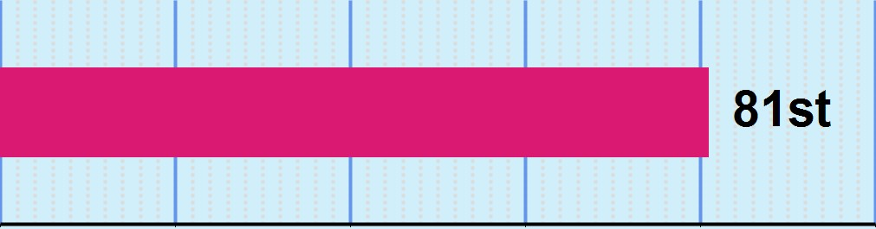Integrated Reasoning (IR) Performance
YOUR OVERALL IR SCORE:

7
PERCENTILE RANKING | 0 | 20 | 40 | 60 | 80 | 100
PERCENT OF QUESTIONS YOU ANSWERED CORRECTLY
PERCENTILE RANKING | 0 | 20 | 40 | 60 | 80 | 100

MEAN SCORE

MEAN SCORE:
4.33
(37th percentile)

Definition

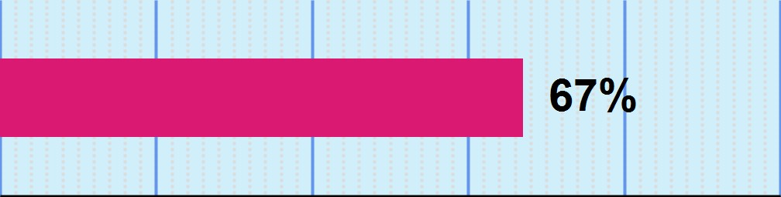The three year mean GMAT Integrated Reasoning score is
4.3. This score is better than
37% of GMAT Exam scores recorded in the past three years.

PERCENTILE RANKINGS COMPARE YOUR PERFRORMANCE TO 3 YEARS OF GMAT EXAMS

TIME MANAGEMENT - INTEGRATED REASONING

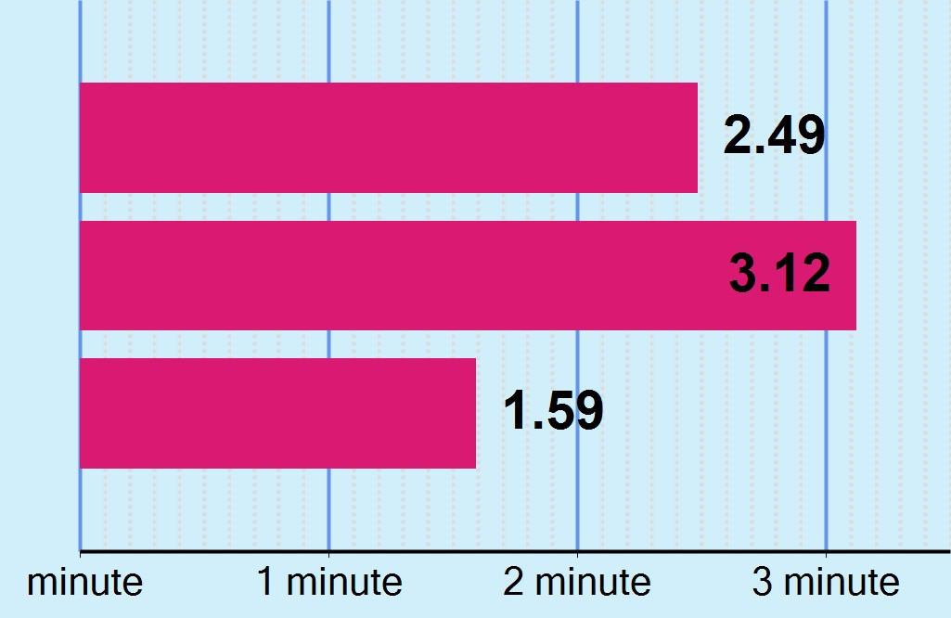YOUR MEAN RESPONSE TIME PER QUESTION
five years. Even though your score won't change, your percentile ranking may change when compared with a newer pool of applicants. Shifts tend to be gradual over long periods of time.

OVERALL SECTION CORRECT INCORRECT

MEAN TIME

MEAN TIME FOR ALL TEST TAKERS:
2.46 minutes

Definition
For all GMAT Exam scores recorded in the past three years the mean time to complete a question in the Integrated Reasoning section is 2.46 minutes. Use this number to evaluate how well you managed your time.

SUMMARY - INTEGRATED REASONING

 Your Integrated Reasoning score of 7 is higher than 81% of GMAT Exam scores recorded in the past three years. The mean score for this section is 4.33.
 Lack of familiarity with the format of the four item types may negatively impact performance in this section.
 You completed 12 of the 12 questions in the Integrated Reasoning section.
 Time management is an important factor in the GMAT Exam scoring. Failing to complete all of the questions can
significantly reduce your Integrated Reasoning score.

This is NOT an official score report

Verbal Section Performance

YOUR OVERALL VERBAL SCORE:
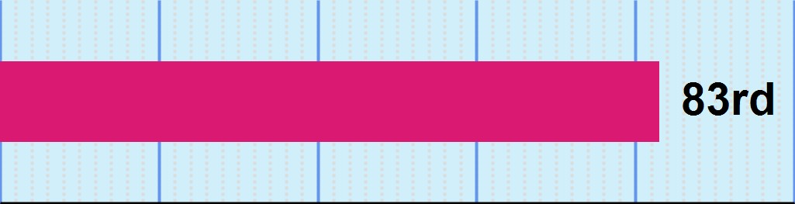37
PERCENTILE RANKING 0 20 40 60 80 100

SUB-SECTION RANKINGS
CRITICAL REASONING READING
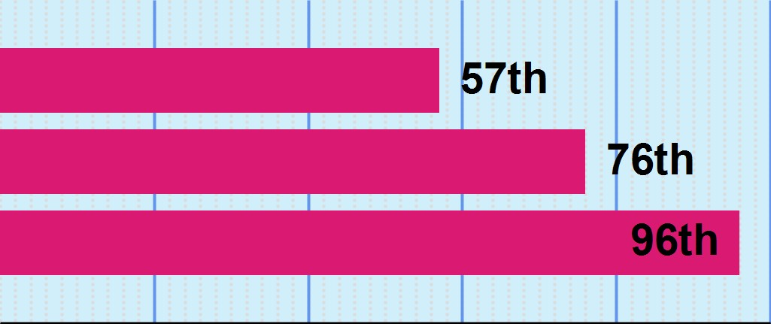COMPREHENSION

SENTENCE CORRECTION

PERCENTILE RANKING 0 20 40 60 80 100
PERCENTILE RANKINGS COMPARE YOUR PERFRORMANCE TO 3 YEARS OF GMAT EXAMS SAMPLE SIZE: 782458

TIME MANAGEMENT - VERBAL

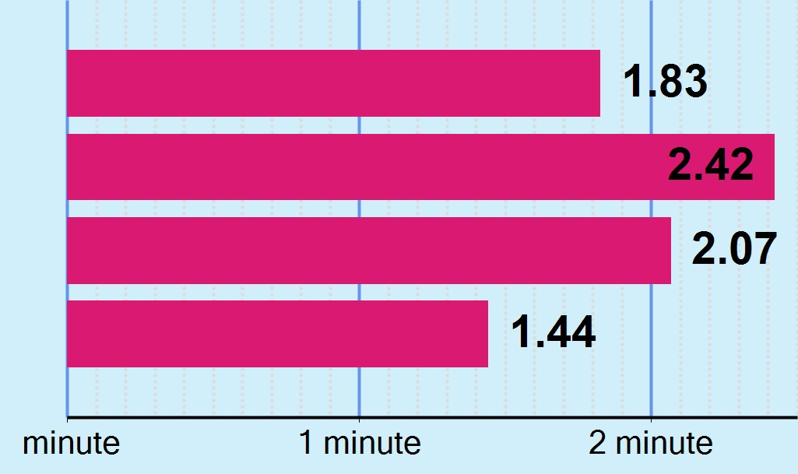YOUR MEAN RESPONSE TIME PER QUESTION
OVERALL VERBAL CRITICAL REASONING READING
COMPREHENSION

SENTENCE CORRECTION
MEAN SCORE

MEAN SCORE:
27.04
(46th percentile)

Definition

The three year mean GMAT Verbal score is 27.0. This score is better than 46% of GMAT
Exam scores recorded in the past three years.

Note: GMAT scores are valid for five years. Even though your score won't change, your percentile ranking may change when compared with a newer pool of applicants. Shifts tend to be gradual over long periods of time.

MEAN TIME

MEAN TIME FOR ALL TEST TAKERS:
1.71 minutes

Definition
For all GMAT Exam scores recorded in the past three years the mean time to complete a question in the Verbal section is
1.71 minutes. Use this number to evaluate how well you managed your time.

SUMMARY - VERBAL

 Your Verbal score of 37 is higher than 83% of GMAT Exam scores recorded in the past three years. The mean score for this section is 27.04.
 Your performance on Critical Reasoning questions was equivalent to a score of 31, which is better than 57% of GMAT
Exam scores recorded in the past three years. The mean score for this sub-section is 27.61.
 Your performance on Reading Comprehension questions was equivalent to a score of 36, which is better than 76% of
GMAT Exam scores recorded in the past three years. The mean score for this sub-section is 27.32.
 Your performance on Sentence Correction questions was equivalent to a score of 44, which is better than 96% of
GMAT Exam scores recorded in the past three years. The mean score for this sub-section is 27.21.
 You completed 41 of the 41 questions in the Verbal section.
 Time management is an important factor in the GMAT Exam scoring. Failing to complete all of the questions can
significantly reduce your Verbal score.

This is NOT an official score report

Quantitative Section Performance

YOUR OVERALL QUANTITATIVE SCORE:
40

PERCENTILE RANKING 0 20 40 60 80 100

SUB-SECTION RANKINGS

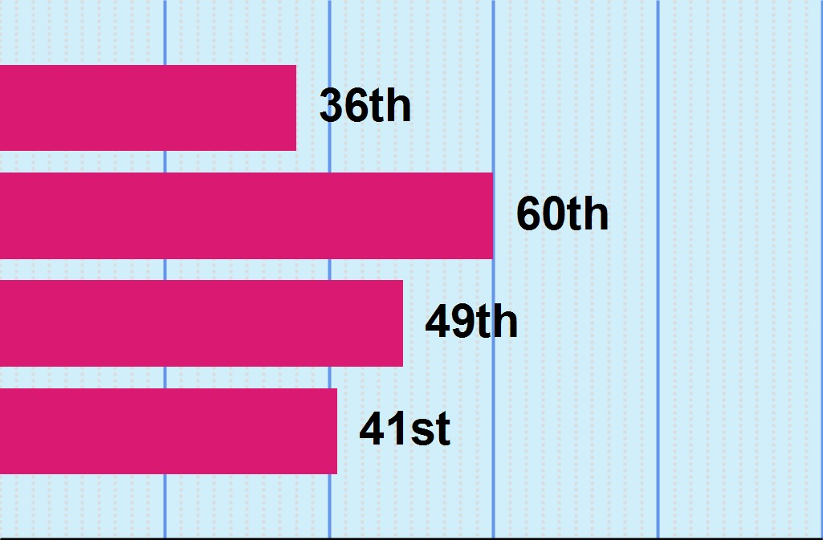PROBLEM SOLVING DATA SUFFICIENCY ARITHMETIC
ALGEBRA/GEOMETRY
MEAN SCORE

MEAN SCORE:
38.03
(41st percentile)

Definition

The three year mean GMAT Quantitative score is 38.0. This score is better than 41% of GMAT Exam scores recorded in the past three years.

Note: GMAT scores are valid for five years. Even though your score won't change, your percentile ranking may change when compared with a newer pool of applicants. Shifts tend to be gradual over long periods of time.

PERCENTILE RANKING 0 20 40 60 80 100
PERCENTILE RANKINGS COMPARE YOUR PERFRORMANCE TO 3 YEARS OF GMAT EXAMS SAMPLE SIZE: 782458

TIME MANAGEMENT - QUANTITATIVE

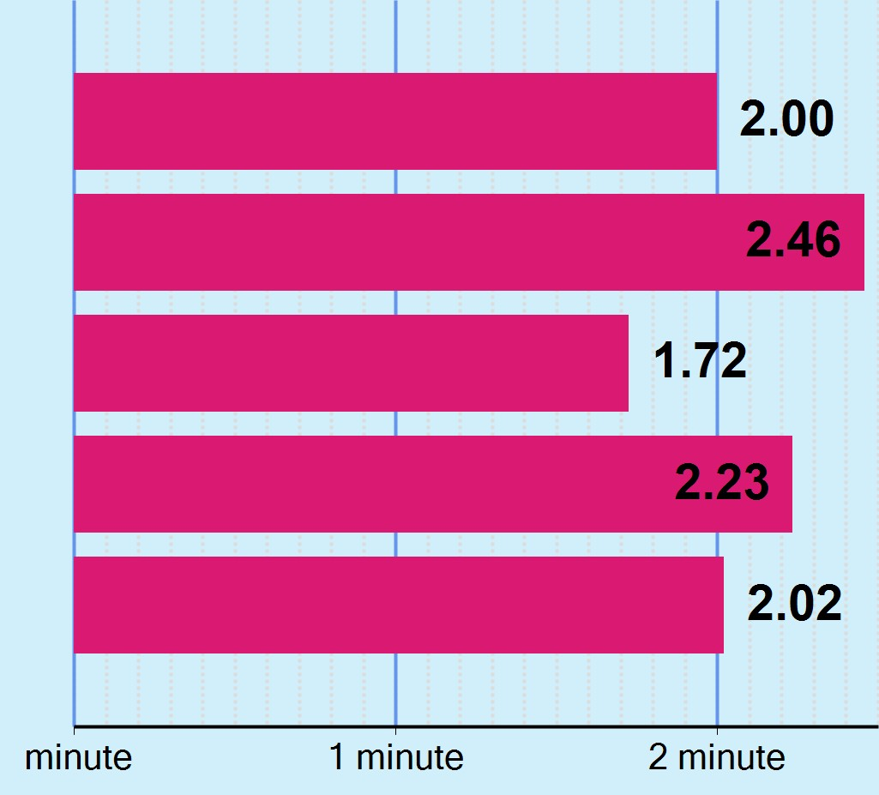YOUR MEAN RESPONSE TIME PER QUESTION

OVERALL QUANTITATIVE PROBLEM SOLVING
DATA SUFFICIENCY

ARITHMETIC ALGEBRA/GEOMETRY
MEAN TIME

MEAN TIME FOR ALL TEST TAKERS:
1.94 minutes

Definition
For all GMAT Exam scores recorded in the past three years the mean time to complete a question in the Quantitative sections is 1.94 minutes. Use this number to evaluate how well you managed your time.

This is NOT an official score report

SUMMARY - QUANTITATIVE

 Your Quantitative score of 40 is higher than 47% of GMAT Exam scores recorded in the past three years. The mean score for this section is 38.03.
 Your performance on Problem Solving questions was equivalent to a score of 36, which is better than 36% of GMAT
Exam scores recorded in the past three years. The mean score for this sub-section is 38.18.
 Your performance on Data Sufficiency questions was equivalent to a score of 45, which is better than 60% of GMAT
Exam scores recorded in the past three years. The mean score for this sub-section is 38.07.
 Your performance on Arithmetic questions was equivalent to a score of 42, which is better than 49% of GMAT Exam
scores recorded in the past three years. The mean score for this sub-section is 38.33.
 Your performance on Algebra and Geometry questions was equivalent to a score of 38, which is better than 41% of
GMAT Exam scores recorded in the past three years. The mean score for this sub-section is 37.97.
 You completed 37 of the 37 questions in the Quantitative section.
 Time management is an important factor in the GMAT Exam scoring. Failing to complete all of the questions can
significantly reduce your Quantitative score.

This is NOT an official score report

Analytical Writing Assessment

This report is created before your Analytical Writing Essay is scored. Please refer to your Official
GMAT Score Report to find your AWA score.

The following information will help you interpret your AWA score:

An AWA score of 6 reflects an outstanding essay. A cogent, well-articulated critique of the argument, demonstrating mastery of the elements of effective writing, and displaying the following characteristics: - Clearly identifies and insightfully analyzes important features of the argument - Develops ideas cogently, organizes them logically, and connects them smoothly with clear transitions - Effectively supports the main points of the critique - Demonstrates superior control of language, including diction and syntactic variety and the conventions of standard written English
6

An AWA score of 5 reflects a strong essay. A well-developed critique of the argument, demonstrating good control of the elements of effective writing, and displaying the following characteristics: - Clearly identifies important features of the argument and analyzes them in a generally thoughtful way - Develops ideas clearly, organizes
5
them logically, and connects them with appropriate transitions - Sensibly supports the main points of the critique - Demonstrates clear control of language, including diction and syntactic variety - Demonstrates facility with the conventions of standard written English, but may have minor flaws

An AWA score of 4 reflects an adequate essay. A competent critique of the argument, demonstrating adequate control of the elements of effective writing, and displaying the following characteristics: - Identifies and capably analyzes important features of the argument - Develops and organizes ideas satisfactorily, but may not always connect them with transitions - Supports the main points of the critique - Demonstrates adequate control of language, including diction and syntactic variety, but may lack syntactic variety - Displays control of the conventions of standard written English, but may have some flaws
4

An AWA score of 3 reflects a competent but clearly flawed critique of the argument, demonstrating some control of the elements of effective writing, and displaying the following characteristics: - Does not identify or analyze most of the important features of the argument, although some analysis is present - Is limited in the logical development and organization of ideas - Offers support of little relevance and value for points of the critique - Uses language imprecisely and/or lacks sentence variety - Contains occasional major errors or frequent minor errors in grammar, usage, and mechanics
3

An AWA score of 2 reflects a seriously flawed essay, demonstrating significant weakness in analytical writing skills, and displaying the following characteristics: - Fails to show an understanding of and does not identify or analyze the main features of the argument - Does not develop ideas or is disorganized - Provides few, if any, relevant or reasonable supports - Has serious, frequent problems in the use of language and sentence structure - Contains numerous errors in grammar, usage, or mechanics that interfere with meaning
2

An AWA score of 1 reflects a fundamentally deficient essay, demonstrating fundamental deficiencies in analytical writing skills, and displaying the following characteristics: - Provides little evidence of the ability to understand and analyze the argument or to develop an organized response to it - Has severe and persistent errors in language and sentence structure - Contains a pervasive pattern of errors in grammar, usage, and mechanics thus resulting in incoherence
1

An AWA score of 0 reflects an essay that was not scored. The essay is either totally illegible or obviously not written on the assigned topic.
0

