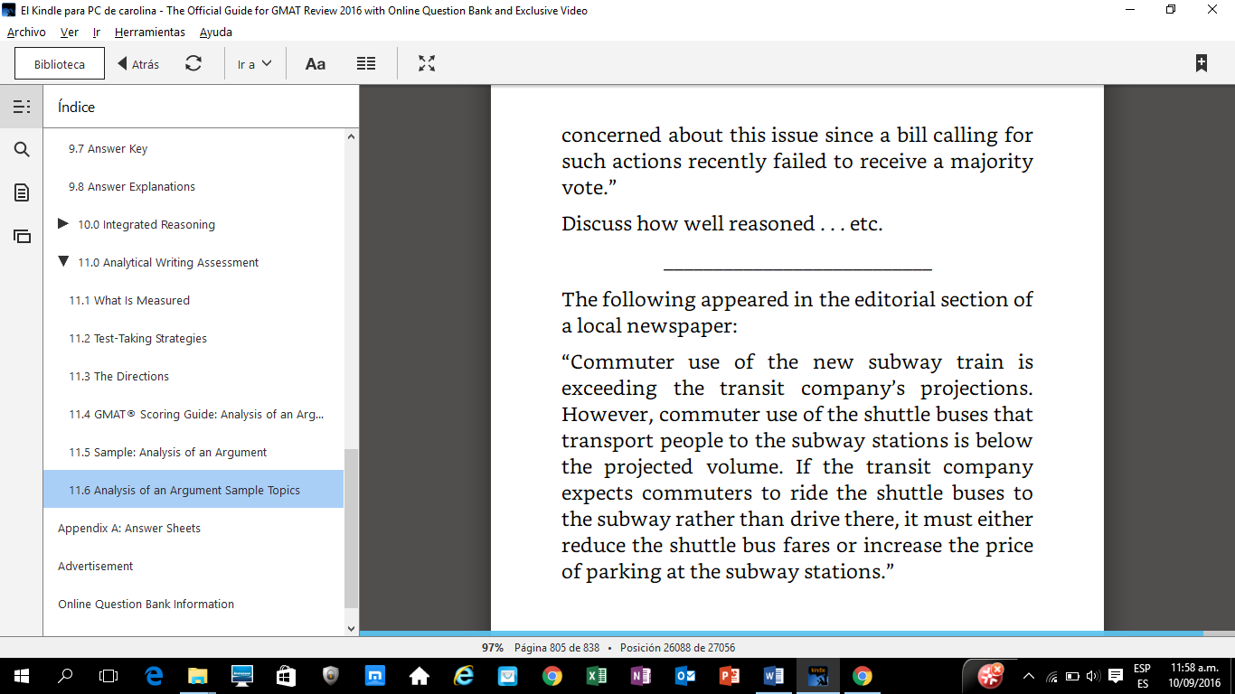

The argument above, provides options for the transit company in order to increase the number of people who use the shuttles buses. This argument is flawed in many parts, it has some vague language and it is also assuming that the only other option for people to get to the subway station is either by the shuttle or by driving.
The subway train is new, therefore the affirmation that the use of it is exceeding the transit company`s projections is vague. The argument could be strengthened by showing what was the projected number of passenger and by how much it is now being exceeded. It is one thing if the initial projection was 10000 passengers per day, and the actual number being transported is 10,100, or if it is 20000. The same flaw is showed when it is stated that the commuter use of the shuttle is below the projected volume, it should provide numbers or percentages that show by how much is this difference.
Moreover, the argument should also specify the range of hours in which these observations are made. It could be the case that the exceeding number of people in the subway is only during rush hours; while with the shuttle busses, it could be referring to hours that are not as required by passengers.
An important assumption that the author is making is that the only way for people to get to the subway station is either by taking the shuttle buses or by driving their own cars. This is clearly missing other options. For example, the citizens who take the subway and live near the station may walk, or ride a bike. If the argument had shown that according to a study all of the subway passengers, or a significant percentage, like 90%, of them only drive or take the shuttle, it would strengthen the options of reducing the fares or increasing the price of parking in the subway stations.

