Quant Tricky Questions

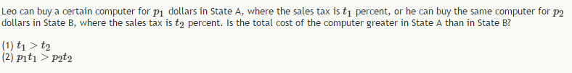
http://gmatclub.com/forum/leo-can-buy-a-certain-computer-for-p1-dollars-in-state-a-28957.html

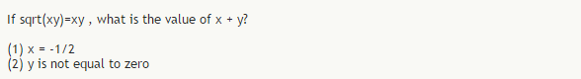
http://gmatclub.com/forum/if-sqrt-xy-xy-what-is-the-value-of-x-y-1-x-83550.html

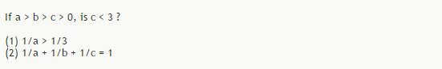
http://gmatclub.com/forum/if-a-b-c-0-is-c-82506.html
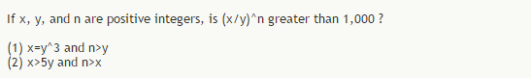
http://gmatclub.com/forum/if-x-y-and-n-are-positive-integers-is-x-y-n-greater-102031.html
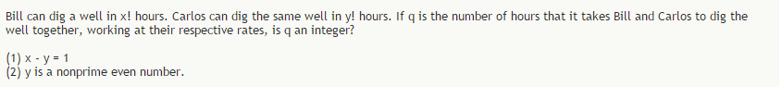
http://gmatclub.com/forum/bill-can-dig-a-well-in-x-hours-carlos-can-dig-the-same-97693.html
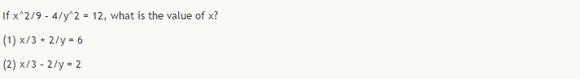
http://gmatclub.com/forum/if-x-2-9-4-y-2-12-what-is-the-value-of-x-87052.html
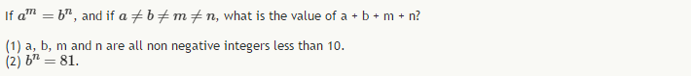
http://gmatclub.com/forum/if-a-m-b-n-and-if-a-b-m-n-what-is-the-value-of-a-b-m-n-89925.html

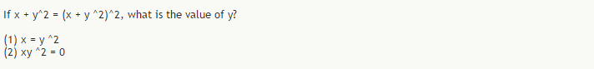
http://gmatclub.com/forum/if-x-y-2-x-y-2-2-what-is-the-value-of-y-98481.html

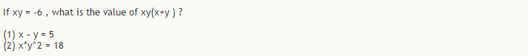
http://gmatclub.com/forum/if-xy-6-what-is-the-value-of-xy-x-y-102400.html

http://gmatclub.com/forum/p-and-q-are-different-two-digit-prime-numbers-with-the-same-98912.html
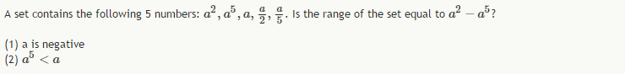
http://gmatclub.com/forum/a-set-contains-the-following-5-numbers-a-2-a-5-a-a-2-a-5-is-the-212387.html
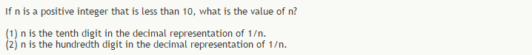
http://gmatclub.com/forum/if-n-is-a-positive-integer-that-is-less-than-10-what-is-the-24342.html
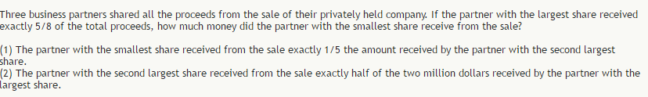
http://gmatclub.com/forum/three-business-partners-shared-all-the-proceeds-from-the-sale-of-their-186385.html

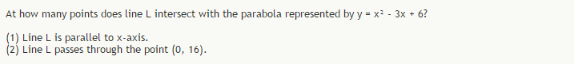
http://gmatclub.com/forum/at-how-many-points-does-line-l-intersect-with-the-parabola-126942.html

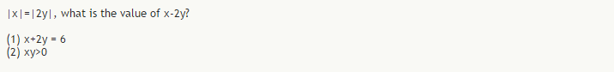
http://gmatclub.com/forum/x-2y-what-is-the-value-of-x-2y-133307.html

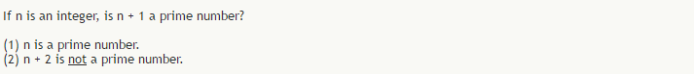
http://gmatclub.com/forum/if-n-is-an-integer-is-n-1-a-prime-number-189050.html

What is the value of x?
(1) x^3 is a 2-digit positive odd integer.
(2) x^4 is a 2-digit positive odd integer.
http://gmatclub.com/forum/what-is-the-value-of-x-107195.html

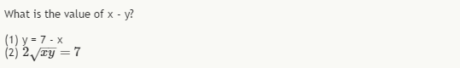
http://gmatclub.com/forum/what-is-the-value-of-x-y-199526.html
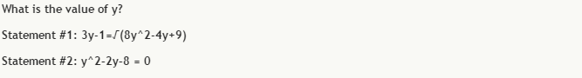
http://gmatclub.com/forum/what-is-the-value-of-y-220857.html

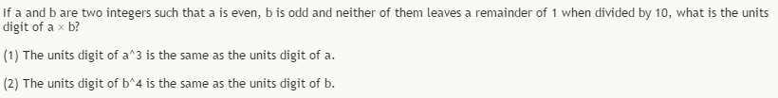
http://gmatclub.com/forum/if-a-and-b-are-two-integers-such-that-a-is-even-b-is-odd-an-166650.html
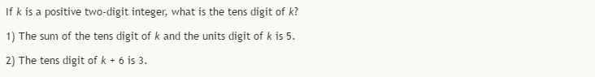
http://gmatclub.com/forum/if-k-is-a-positive-two-digit-integer-what-is-the-tens-digit-of-k-217769.html
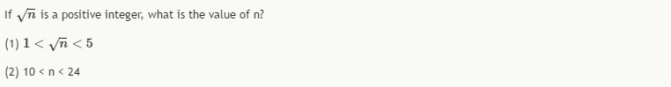
http://gmatclub.com/forum/if-sqrt-n-is-a-positive-integer-what-is-the-value-of-n-13240.html
http://gmatclub.com/forum/if-the-total-revenue-at-company-k-and-company-m-decreased-by-d-from-222415.html

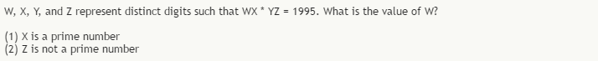
http://gmatclub.com/forum/w-x-y-and-z-represent-distinct-digits-such-that-wx-yz-1995-wha-222363.html
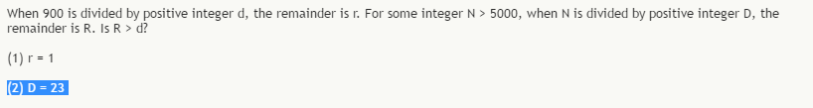
http://gmatclub.com/forum/when-900-is-divided-by-positive-integer-d-the-remainder-is-r-for-so-196001.html
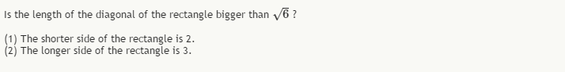
http://gmatclub.com/forum/is-the-length-of-the-diagonal-of-the-rectangle-bigger-than-root-104052.html

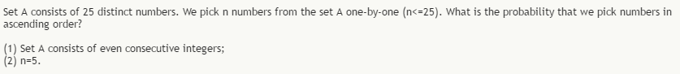
http://gmatclub.com/forum/set-a-consists-of-25-distinct-numbers-we-pick-n-numbers-89035.html
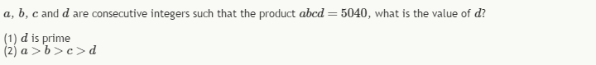
http://gmatclub.com/forum/a-b-c-and-d-are-consecutive-integers-such-that-the-product-141920.html

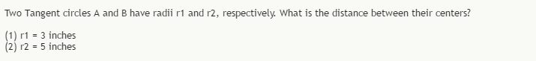
http://gmatclub.com/forum/two-tangent-circles-a-and-b-have-radii-r1-and-r2-respectively-what-191917.html

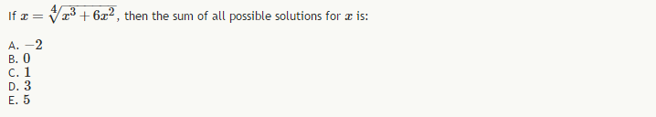
http://gmatclub.com/forum/m25-184415.html
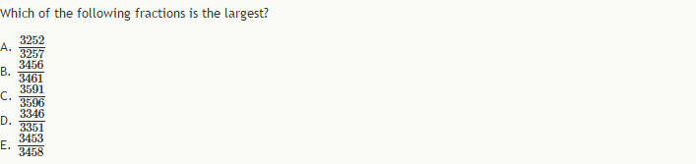
http://gmatclub.com/forum/m25-184417.html

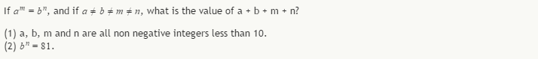
http://gmatclub.com/forum/if-a-m-b-n-and-if-a-b-m-n-what-is-the-value-of-a-b-m-n-89925.html
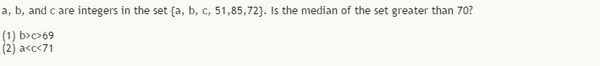
http://gmatclub.com/forum/a-b-and-c-are-integers-in-the-set-a-b-c-160222.html
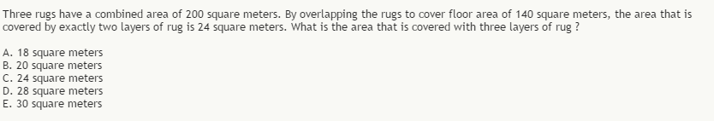
http://gmatclub.com/forum/three-rugs-have-a-combined-area-of-200-square-meters-by-overlapping-t-102326.html

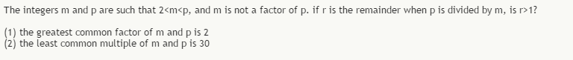
http://gmatclub.com/forum/the-integers-m-and-p-are-such-that-2-m-p-and-m-is-not-a-101360.html
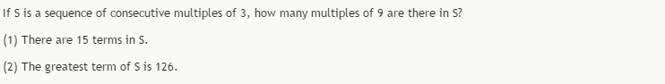
http://gmatclub.com/forum/if-s-is-a-sequence-of-consecutive-multiples-of-172766.html

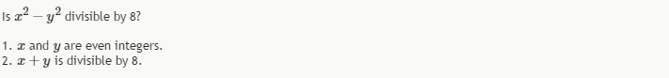
http://gmatclub.com/forum/is-x-2-y-2-divisible-by-8-1-x-and-y-are-even-integers-87688.html

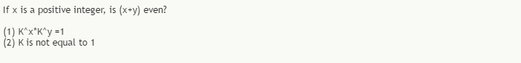
http://gmatclub.com/forum/if-x-is-a-positive-integer-is-x-y-even-136866.html
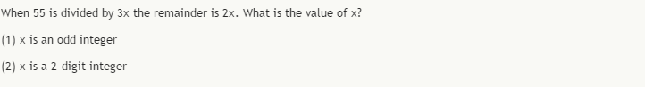
http://gmatclub.com/forum/when-55-is-divided-by-3x-the-remainder-is-2x-what-is-the-value-of-x-192038.html

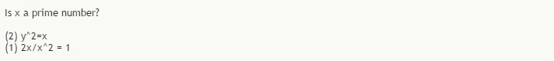
http://gmatclub.com/forum/is-x-a-prime-number-193267.html

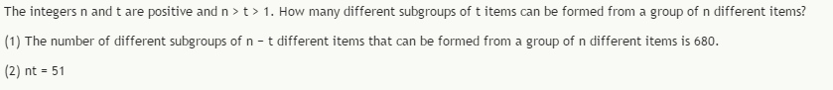
http://gmatclub.com/forum/the-integers-n-and-t-are-positive-and-n-t-1-how-many-129944.html

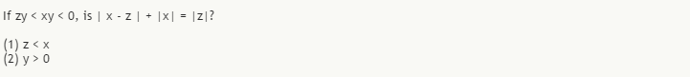
http://gmatclub.com/forum/if-zy-xy-0-is-x-z-x-z-101210.html

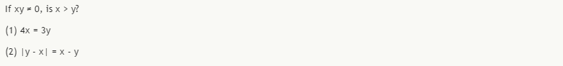
http://gmatclub.com/forum/if-xy-0-is-x-y-1-4x-3y-2-y-x-x-y-86758.html
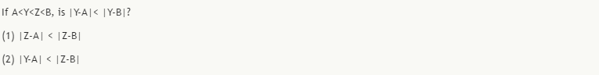
http://gmatclub.com/forum/if-a-y-z-b-is-y-a-y-b-82673.html
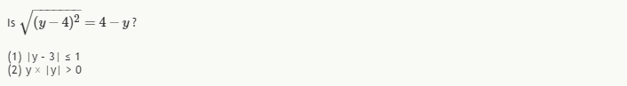
http://gmatclub.com/forum/is-1-2-4-y-199560.html

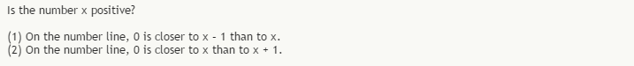
http://gmatclub.com/forum/is-the-number-x-positive-160021.html

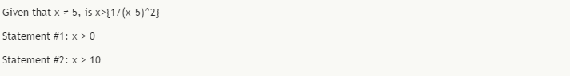
http://gmatclub.com/forum/given-that-x-5-is-x-1-x-221970.html

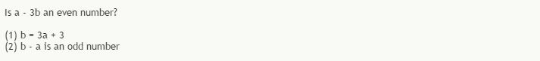
http://gmatclub.com/forum/is-a-3b-an-even-number-88276.html?sid=90f194148cdc4385683a52ce956c24f7

http://gmatclub.com/forum/is-the-positive-integer-y-a-prime-number-224642.html?sid=90f194148cdc4385683a52ce956c24f7

http://gmatclub.com/forum/if-sets-a-and-b-have-the-same-number-of-terms-is-the-132987.html

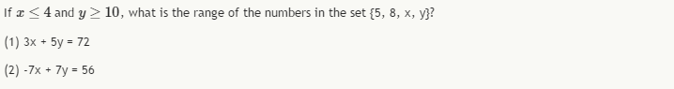
http://gmatclub.com/forum/if-x-4-and-y-10-what-is-the-range-of-the-numbers-in-173893.html

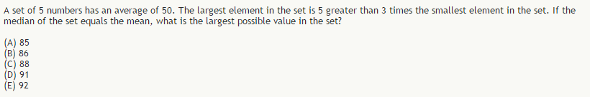
http://gmatclub.com/forum/a-set-of-5-numbers-has-an-average-of-50-the-largest-element-in-the-199644.html

Questions I must definitely redo

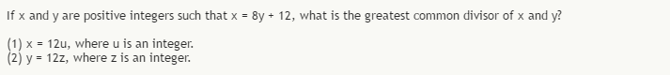
http://gmatclub.com/forum/if-x-and-y-are-positive-integers-such-that-x-8y-12-what-is-the-126743.html

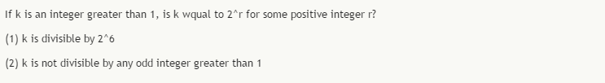
http://gmatclub.com/forum/if-k-is-an-integer-greater-than-1-is-k-wqual-to-2-r-for-20226.html

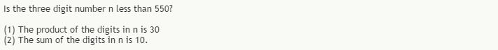
http://gmatclub.com/forum/is-the-three-digit-number-n-less-than-44121.html

http://gmatclub.com/forum/if-n-is-a-positive-integer-is-n3-n-divisible-by-4-1-n-60486.html

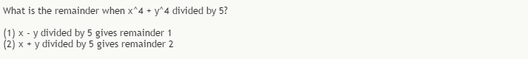
http://gmatclub.com/forum/what-is-the-remainder-when-x-4-y-4-divided-by-80528.html
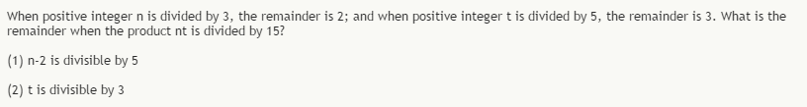
http://gmatclub.com/forum/when-positive-integer-n-is-divided-by-3-the-remainder-is-76666.html

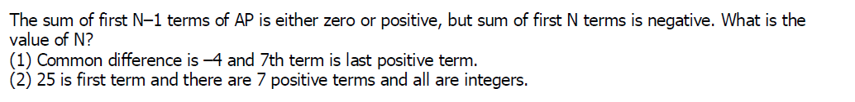
http://www.beatthegmat.com/ap-t72018.html

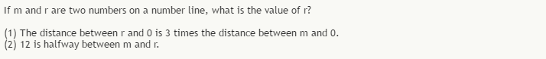
http://gmatclub.com/forum/if-m-and-r-are-two-numbers-on-a-number-line-what-is-the-64756.html

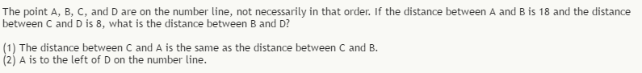
http://gmatclub.com/forum/the-point-a-b-c-and-d-are-on-the-number-line-not-necessa-23188.html

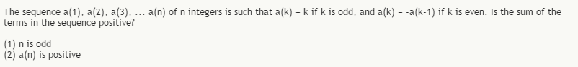
http://gmatclub.com/forum/the-sequence-a1-a2-a3-an-of-n-integers-is-such-that-51526.html

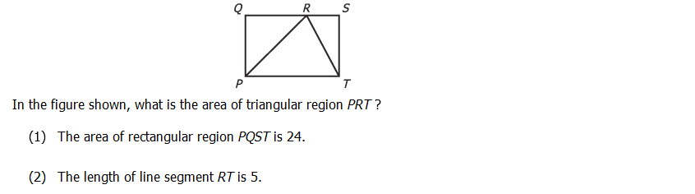
http://gmatclub.com/forum/in-the-figure-shown-what-is-the-are-of-the-triangular-162366.html
http://gmatclub.com/forum/on-the-number-line-the-distance-between-x-and-y-is-greater-127014.html

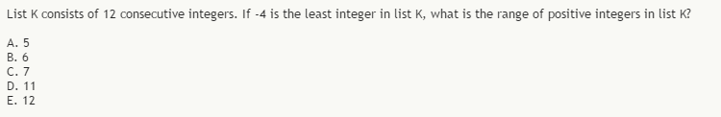
http://gmatclub.com/forum/list-k-consists-of-12-consecutive-integers-if-4-is-the-22424.html

If the drama club and music club are combined, what percent of the combined membership will be male?
(1) Of the 16 members of the drama club, 15 are male.
(2) Of the 20 members of the music club, 10 are male.
(Beautiful Question: Stumped me Hands down!!!)
http://gmatclub.com/forum/if-the-drama-club-and-music-club-are-combined-what-percent-63261.html

In a demographic study, the population and total income of a certain region were estimated from other data, and both estimates had lower and upper limits. At the time of the estimates, was the per capita income for the region greater than $16500?
(1) The lower limit for the estimate of the population was 330,000
(2) The lower limit for the estimate of the total income was $5,500,000,000
(Note the question!!!! and its solution)
http://gmatclub.com/forum/in-a-demographic-study-the-population-and-total-income-of-a-68090.html

The table gives three factors to be considered when choosing an Internet service provider and the percent of the 1,200 respondents to a survey who cited that factor as important. If 30 percent of the respondents cited both "user-friendly" and "fast response time", what is the maximum possible number of respondents who cited "bargain prices", but neither "user-friendly" nor "fast response time"?
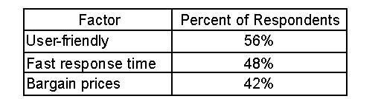
A. 312
B. 336
C. 360
D. 384
E. 420
http://gmatclub.com/forum/the-table-gives-three-factors-to-be-considered-when-choosing-98936.html

A construction company was paid a total of $500,000 for a construction project. The company’s only costs for the project were for labor and materials. Was the company’s profit for the project greater than $150,000?
(1) The company’s total cost was three times its cost for materials.
(2) The company’s profit was greater than its cost for labor.

http://gmatclub.com/forum/a-construction-company-was-paid-a-total-of-500-000-for-a-co-80974.html

In a certain bathtub, both the cold-water and the hot-water fixtures leak. The cold-water leak alone would fill an empty bucket in c hours and the hot-water leak alone would fill the same bucket in h hours, where c<h. If both fixtures began to leak at the same time into the empty bucket at their respective constant rates and consequently it took t hours to fill the bucket, which of the following must be true?
I. 0 < t < h
II. c < t < h
III. c/2 < t < h/2
A) I only
B) II only
C) III only
D) I and II
E) I and III

http://gmatclub.com/forum/in-a-certain-bathtub-both-the-cold-water-and-the-hot-water-127878.html

If M=4√+4√3+4√4M=4+43+44, then the value of M is:
A. Less than 3
B. Equal to 3
C. Between 3 and 4
D. Equal to 4
E. Greater than 4

(VV-IMP: Concept Learnt/Revised)
http://gmatclub.com/forum/if-m-root-4-cube-root-4-fourth-root-4-then-the-93340.html

A certain military vehicle can run on pure Fuel X, pure Fuel Y, or any mixture of X and Y. Fuel X costs $3 per gallon; the vehicle can go 20 miles on a gallon of Fuel X. In contrast, Fuel Y costs $5 per gallon, but the vehicle can go 40 miles on a gallon of Fuel Y. What is the cost per gallon of the fuel mixture currently in the vehicle’s tank?
(1) Using fuel currently in its tank, the vehicle burned 8 gallons to cover 200 miles.
(2) The vehicle can cover 7 and 1/7 miles for every dollar of fuel currently in its tank

http://gmatclub.com/forum/a-certain-military-vehicle-can-run-on-pure-fuel-x-pure-fuel-y-or-any-75289.html
https://www.manhattanprep.com/gmat/forums/weighted-averages-t5534.html

