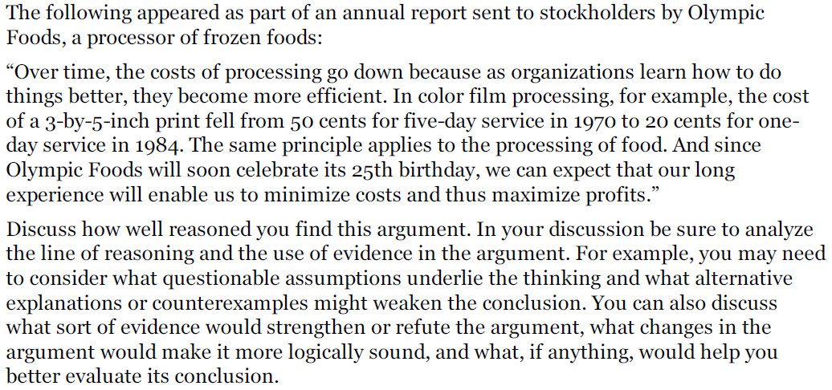

In the annual report Olympic Foods sent to its stockholders, it is claimed that as time goes by, companies learn how to do things better and as a result, the cost of processing goes down and the companies become more efficient. The argument has several flaws in it.

One assumption made by Olympic Foods is that due to the fact color film processing became cheaper and faster within a 14-year period, the same will happen in the food industry. The two industries have very little in common, therefore, drawing a conclusion that a process in the film processing industry can reflect the same process in the food industry, is lacking. Had Olympic Foods showed some similarities between the industries, establishing a foundation to the assumption that the same process will occur in both, the argument would have been much more sound.

It can also be inferred from Olympic Food's statement that processing time goes down solemnly due to the experience a company has, regardless of the technology available in the market. The example given, of color film processing going down in price from $0.5 and five days to $0.2 and one day, could easily be a result of technological improvements that took place between 1970 and 1984. To demonstrate, it is more than likely that a random company established in 1984 took less time to process a color film than a company operating in the 1970's, simply because the industry as a whole advanced during those years and it became faster and cheaper for everyone to process color films. This argument would have been considerably stronger had Olympic Foods stated that the longer companies are active, the better the technology they can acquire.

Another dubious claim made in the report is that lowering prices indicates a rise in efficiency. Very often companies that operate in a very non-efficient way, try to lower prices to attract more customers and generate revenue that would help save the company. This is one case out of many, that shows lowering prices does not necessarily mean higher efficiency.

The argument made in the report is neither sound nor persuasive. Olympic Foods has failed to present any convincing evidence that the longer a company is operating, the more efficient it can be.

