Foundation Concepts
3 step process to solve all CR questions –
- Understand meaning of the sentence.
- Conduct error analysis of the sentence.
- Process of Elimination.

Types of errors to check for –
SV
Verb
Pronoun
Modifier
Parallelism
Idiom
Meaning
Other

Foundations of GMAT Grammar
Nouns
- Concrete & Abstract Nouns
Concrete Nouns – One can identify with 5 senses – sight, touch, smell, taste & sound.
Abstract Nouns – One cannot identify with senses – love, truth, pain, skill.
- Proper & Common Nouns
Proper Nouns – Name specific persons, places or things – Tom, California, Cairo.
Common Nouns – Name generic things – World, Ship.
- Singular & Plural Nouns
- Countable & Uncountable Nouns
Countable Noun – Word that can be counted (1 noun, 2 nouns, 3 nouns) and has a plural form. Quantity adjectives such as few, many can be used with them. Ex - Few songs, many songs.
Uncountable Noun – Word that cannot be counted and do not have a plural form. Quantity adjectives such as less, amount can be used with them. Ex - Less music, Amount of music.
Pronouns
They take the place of the noun to avoid repetition.
Types of Pronouns
- Personal Pronoun – Refer to specific people or things. Ex – He, She, they etc.
- Subject Case Pronouns – Personal Pronouns used as a subject in a sentence.
- Object Case Pronouns – Personal Pronouns used as an object in a sentence.
- Possessive Case Pronouns – Use when you need to show ownership. Ex – My, His, Her, Their, Its.
- Relative Pronouns – Pronouns which connect a group of words to specific nouns. Ex – that, which, where, whose.
- Indefinite Pronouns – Refer to people and things that are not specific. Ex – All, Everyone, Each, Everything, Anyone, Anything.
- Demonstrative Pronouns – Refer to the nouns that follow them. Ex – These shoes, this box.
- Reflexive Pronouns – Used when the subject of the sentence does something to itself. Usually end in –self or –selves. Ex – I cut myself, They themselves.
Like nouns, pronouns can also be singular or plural.

Verbs
Typically these denote the action performed by the subject.
- Linking Verbs – Verbs which connect or link the subject to additional information about the subject. Ex – My mother is a great cook. Richard seems sad today.
How to recognize - If you can replace a verb in the sentence with is, am, or are and the sentence still makes sense, then those verbs are linking verbs.
- Base form of the verb – Used like ‘to + verb’ forms.
Note: All tenses are created from the base form of the verb.
Note: Base verbs are also used with pronouns I and you and all plural subjects.
Note: Singular form of verbs can be formed by adding “s” or “es” to the base verb.
- Helping Verbs - A verb can consist of more than one word. In such cases, there is one main verb and the rest are called the auxiliary or the helping verbs. Ex - is, are, am, was, were, has, have, had, has been/have been/had been, can/could, may/might, will/would, shall/should.

Verb Tenses
The tense of the verb denotes the time of the action.
- Present Tense – The verb that refers to the present time is said to be in the Present Tense. Ex- Harry goes to a wizard school. Ria is working on her project.
- Simple Present Tense – Used to denote –
- General Information – The Company gives handsome perks to diligent employees.
- Universal Truths – Ex - The sun rises in the east.
- Habitual Actions – My mother always prepares breakfast for me.
- Present Progressive/Continuous Tense - This tense is used to show an action that has begun, is still happening, and is not finished yet.
Note: Generally not always the present continuous tense is derived by adding
“ing” to the base verb.
Note: Hence, in present continuous tense, the verb-ing word must be preceded by is/are/am (The helping verbs).
- Present Perfect Tense – Used to denote action which –
- has finished in the immediate past. Ex - She has just finished her breakfast.
- has finished in the past but the effect of which continues in the present. Ex - The recession has made many people jobless.
- shares experiences, an action whose time is not given and is not known. Ex - Johnny has visited Europe.
- started in the past and is continuing up to the current moment. Such
sentences are generally written with “since” or “for” phrases. Ex - I have known him since 1987. He has been sick for the last two weeks.
Note: So “Has” or “Have” together with the past participle form of the verb makes the present perfect tense.
Present Perfect Tense = Has/Have + past participle
- Present Perfect Continuous Tense – This tense is used to present an action that started sometime in the past and is still continuing in the present. This tense is a mix of present continuous and present perfect tense. Ex - Joe has been sleeping since morning.

- Past Tense – The verbs that denote that the actions took place in the past are said to be in the past tense. Ex – John went to school yesterday.
- Simple Past Tense – This tense is used to present general information about the actions that started in the past and finished in the past as well. Also used to talk about past habits. Ex – Many freedom fighters gave their lives, fighting for the independence of their country.
- Past Progressive/Continuous Tense - This tense is used to show an action that was happening in the past.
Note: Past Continuous Tense = Past Tense Helping Verb + Verb-ing word
Ex – The power went off when I was reading.
Note: Hence, in the past continuous tense, the verb-ing word must be preceded by was/were.
- Past Perfect Tense – This tense describes an action that was completed before a certain moment in the past. Ex – I had finished my dinner before my parents came back home.
Note: “had” plus the past participle form of the verb makes the past
perfect tense.
- Past Perfect Continuous Tense – This tense is used to present an action that started sometime before a certain point in the past and continued up to that time. Ex – By November 2011, he had been working on his fifth book for three
months.

- Future Tense – In order to talk about the events that are to take place sometime in the future, we use Future Tense.
- Simple Future Tense – Used to talk about the general events that will take place in future. Used for events that we think or believe will take place in the future.
Ex – Mary will perform well in her singing recital.
- Future Progressive/Continuous Tense – This tense is used to show an action that will begin sometime in the future and will continue in the future as well.
Note: Future Continuous Tense = Future Helping verbs + Verb-ing (will/would + verb-ing)
- Future Perfect Tense – This tense is used to denote a continuous action in the future with reference to a particular time/event set in the future.
Ex – When he finishes his English language course, he will have been living
in the UK for five months.

Adjectives
Adjectives are words that describe or modify nouns or pronouns.
Apart from words, even phrases and clauses can act as adjectives.
Ex – The books with the black and white photographs have been missing since last
week.
Adjectives can also be used to present comparisons. (comparative or superlative form).
Adjectives used for comparison in comparative form – When used to compare 2 entities.
- Either add “er” to the end of the adjective. Ex – My cat is certainly lazier than my dog.
- Or more/less before it. Ex – The salary offered in corporate organizations is more handsome than that offered in governmental firms.
Note: Both cannot be used together on the same adjective.
Adjectives used for comparison in superlative form – When used to compare more than 2 entities.
- Either add est/iest to the end of the adjective. Ex – Jason has the biggest villa in this block
- Or add most/least before it. Ex – Kim selected the crispiest bacons for her breakfast.

Adverbs
Adverbs are words that describe or modify verbs, adjectives, other adverbs or clauses. They generally answer one of the following 4 questions about the entity they modify – How? When? Where? and Why?
Note: Most of the single-word adverbs end with “ly”.
Adverbs used for comparison in comparative form – When used to compare 2 entities use more/less before the adverb. Ex – Jack goes to swim more frequently than his sister Jill.
Adverbs used for comparison in superlative form – When used to compare more than 2 entities use most/least before the adverb. Ex – The quality of the project showed that Amy’s was the most hastily done project in the class.

Prepositions
They generally describe place (in, out, above), time (during, by, at), and movement (to, towards).
Ex – Generally, the family sits by the fire place
Note: Notice that “to” is sometimes followed by a verb. For example: I like to sing. In this usage, “to” is NOT a preposition; it is an infinitive.
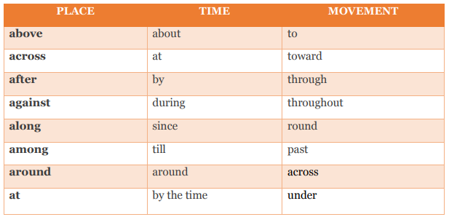

Conjunctions
Conjunctions are words that join different parts of sentences together.
- Coordinating Conjunctions – These conjunctions join together nouns, pronouns, verbs, adjectives, clauses, and propositional phrases. These conjunctions are – For, And, Nor, But, Or, Yet, So. The popular acronym for these conjunctions is FANBOYS.

- Subordinating Conjunctions – These conjunctions join a clause to another to communicate the full meaning of the sentence. They may provide a necessary transition between the two ideas in two clauses in the sentence. This transition can indicate a time, a place or a cause and effect relationship.
Ex – John watched his favorite TV show after he finished his project.
Note: They may also reduce the importance of one clause to make the more important
idea of the two obvious. The more important idea lies in the main clause, while the
less important idea lies in the clause followed by the subordinating conjunction.
Ex – Although the day is pleasant, it does not look apt for picnic.

- Correlative Conjunctions – Some conjunctions are used in pairs. They connect two equal grammatical entities. These conjunctions are Either…Or, Neither…Nor, Not Only…But Also, Both…And, etc. Always make sure that the entities following the two conjunctions are grammatically and logically parallel to each other.

Sentence Structure
Clause – Features
- A clause must contain a subject and a verb.
- A clause must communicate an idea.
Ex – Mary is playing.
Phrase – Features
- Related group of words appearing together. Does not contain subject and verb together.
- Gives additional info about the entity in the clause.

Small clause + Phrase = Main Clause

Types of clauses
- Independent clause – Communicates a complete idea.
- Dependent clause – Communicates a partial idea.
Ex – Mary is playing in the park that has swings
Mary is playing in the park – Independent clause
That has swings – Dependent clause
Mary is playing in the park that has swings – Independent clause

Why identify clauses and phrases?
Helps to
- Understand the meaning
- Identifying SV pairs
- Verb sequencing
- Understanding modifiers and modified entities
- Identifying parallel structures
- Identify punctuation errors

Independent clause markers –
Hence,
Therefore,
Nevertheless,
However,
For example,
In addition etc.
Ex – Moreover, Sally is an active member of the local dance club.

Dependent clause markers –
- Dependent clause begins with relative pronoun.
Ex – Sally participates in the marathon that occurs on 1st of every month

Some markers – Which, that, when, who etc.

- Dependent clause begins with relationship words.
Ex – Sally participates in the marathon since she believes physical exercise is good for her health.

Some markers – since, because, as, after, until, while, even, though, although, if, whether, unless.

Structure of complex sentences
Connecting 2 independent clauses
- 1 way of connecting 2 independent clauses is by using a semi-colon as in the example below –
Ex – Tom loves his job in the corporate office; his job is challenging.
- 2nd way of connecting 2 independent clauses is by using , FANBOYS

Complex sentence = Independent clause + , FANBOYS (Co-ordinating conjunctions) + Independent clause

Connecting 2 dependent clauses
- Can be done with or without a comma.
Ex – Tom loves his job in the corporate office since his job is so challenging.
Tom loves his job in the corporate office, which is so challenging.

- When a dependent clause is followed by an independent clause, the 2 clauses need to be connected by a comma

Ex – Because his job is so challenging, Tom loves his job in the corporate office.

Note: A sentence must contain at least 1 independent clause.

Words that look like verbs but are not verbs
- Verb-ing forms.
- Verb-ed forms.
- To Verb forms.

- Verb-ing forms (as Verbs) – without the helping verbs like is/was/are/am/were/be do not act as verbs.
Note: The helping verbs here denote the timing of the action without which the entire action behaves like denoting a habit or something.
Ex – Mary is learning about plants.

- Verb-ing forms (as Nouns) – No presence of a form of the verb ‘to be’ and the word replaces “something” in the sentence.
Ex – Mary loves learning about plants. (Mary loves something)
Ex – Eating balanced diet is crucial for weight management.
Ex – Practicing any of the fine arts sharpens analytical thought process.

Note: These words are also called as “Gerunds”.

- Verb-ing forms (as Adjectives) – Provide extra information about a noun.
Ex – Mary has many learning tools to become a botanist.
Ex – A startup must keep it’s marketing costs in check.
Ex – Tom enjoyed a relaxing weekend.

Note: These are not preceded by any form of the verb ‘be’.
- Verb-ed verbs –

- As verb in past tense.
Ex – The cat frightened the mouse.

- As adjectives before a noun.
Ex – The frightened mouse ran as fast as it could.

- To Verb – These verbs “To + Verb” present a sense of intention

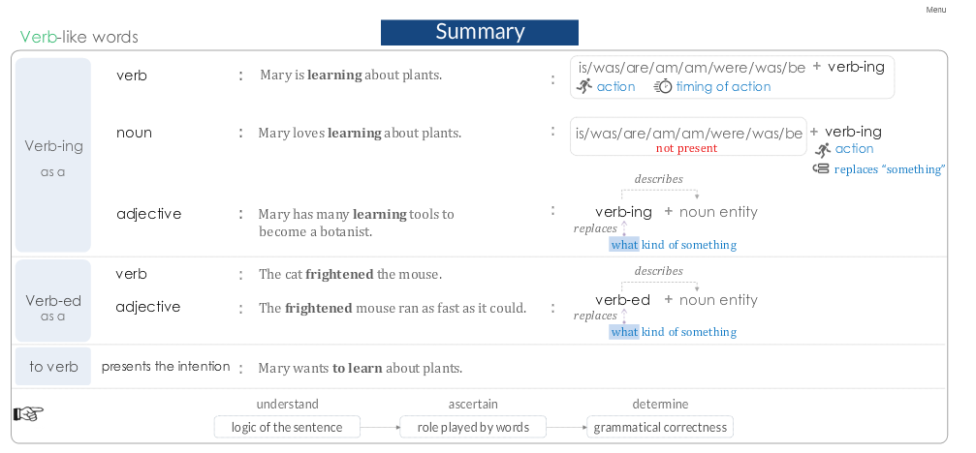

Subject – Verb pair must exist
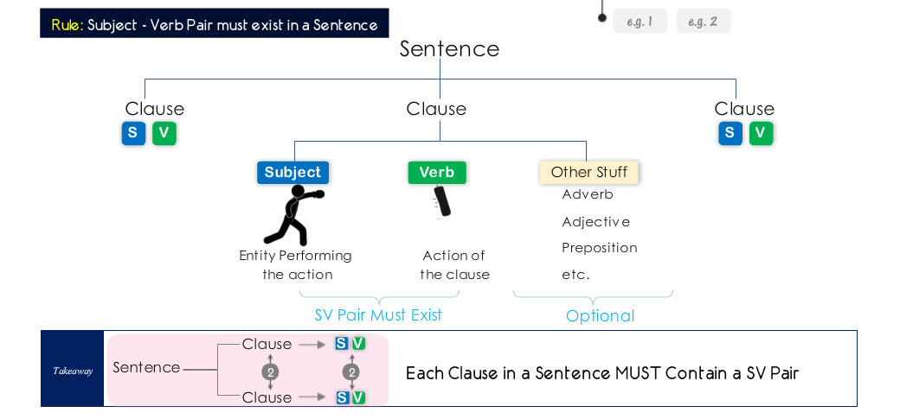

Note: Every clause should contain at least 1 subject – verb pair.

Identifying and ignoring the unnecessary prepositional phrases in a sentence
Identify the prepositional phrases and ignore them to get your subject-verb pairs.

Note: To avoid Subject – Verb Must Exist Error we need to be aware of the words that appear to be verbs but are not verbs – Example – Verb-ing words.
Note: There are no Subject – Verb pairs in a prepositional phrase.

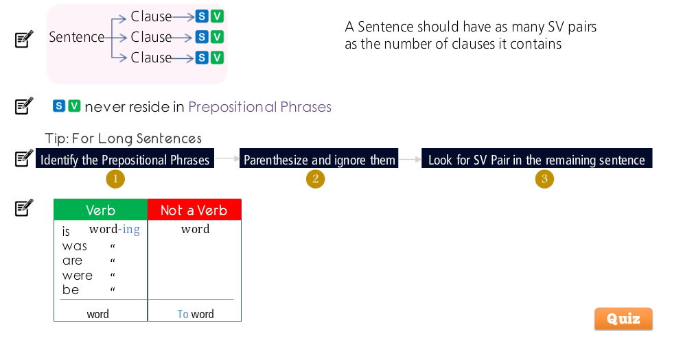

How the word “THAT” can help us to demystify a long sentence

Uses of “THAT”
- “THAT” acts as a subject of the clause
Ex – Mary made claims THAT pertain to her achievements in high school.
Ex – Retailers do not approve of the apps THAT allow shoppers to perform immediate price-comparison by scanning a product on the shelf.

Note: “THAT” modifies the preceding noun through this modifying clause and acts as the subject of this clause.

- “THAT” acts as the connector between 2 clauses
Ex – Mary claims THAT she won several awards in her high school.

Note: “THAT” connects 2 clauses. It acts as a connector. Each clause connected by ‘that’ requires its own subject and verb pair.

Steps to use the above 2 uses of “THAT” to understand the sentence better –

- On seeing “THAT”, know right away that there is another clause.
- Then when you get to identifying the Subject – Verb pairs of each clause, keep in mind that depending upon how “THAT” is used, it could act as a subject or it could simply be a connector.

Subject - Verb

Subject – Verb rules
- SV Pair must exist.
- SV Pair must agree in number.
- SV Pair must make sense.

SV Pair Must Make Sense –
Ex – Incorrect Sentence – After being shut down, the production plant in a small town of Memsburg resulted in a severe loss of jobs and hence severe economic degradation of the local community.

Ex – Correct Sentence – Shut down of the production plant in a small town of Memsburg resulted in a severe loss of jobs and hence severe economic degradation of the local community.

Note: Often, the subject becomes a part of the prepositional phrase and it’s adjective becomes the subject thus leading to the SV pair not making sense. The correction here is to remove the preposition from the prepositional phrase.

SV Pair Must Agree In Number –
Rule 1: Singular Subject – Singular Verb
Rule 2: Plural Subject – Plural Verb

SV Pair Errors –
Certain words are always singular but difficult to identify as singular in the usual reading.
- Pronouns ending in –one, -body, -thing, -ever are always singular. All the pronouns shown in the table below are singular
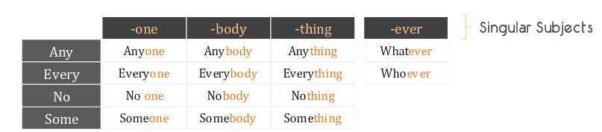

- “Each” as a Subject is Always Singular
Ex 1 – Each of the students is supposed to be attentive in the class.
Each + Plural Subject Singular Verb

- Plural Subject + Each Plural Verb

- Phrases & Clauses Whenever phrases and clauses act as subjects in a sentence, they need a singular verb.

Ex – Eating healthy foods is good for physical wellbeing – Phrases example
Ex – Whoever wants this book is welcome to take it from the stage – Clause example

- Collective Nouns: A group of items (people/thing) are always singular –

Ex – Because of lack of sufficient evidence, the jury has given its verdict as “not guilty”.
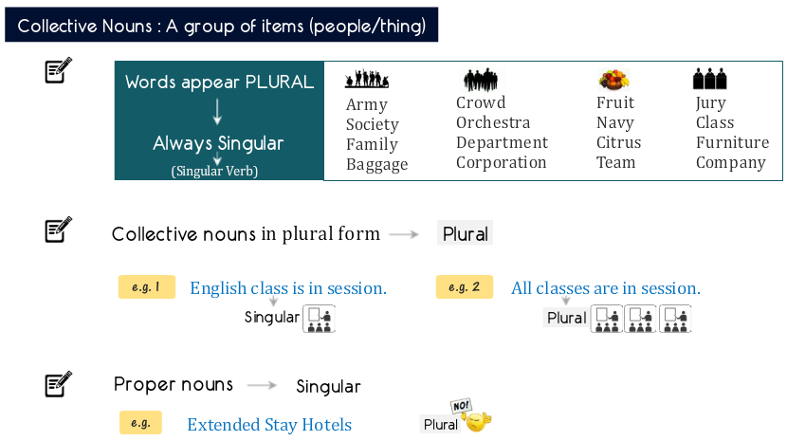

Words that change Number of the Subject –

- Change Singular Subject to Plural – The word ‘And’
Whenever the word ‘And’ is used for 2 entities, it changes the subject and hence the verb to plural.

- Change Plural Subject to Singular – The words, Each, Every/ Either, Neither/ One of the, The number of -- change a plural subject to be singular.

- Each/Every + Subject Singular Subject and Verb
- Subject + Each/Every No change in the number of the Subject and Verb.
- Either/Neither + Subject Singular Subject and Verb
- One of the/The number of These phrases whenever used for a Subject, make it and the Verb as Singular.

- Words with no impact –

- Additive Phrases When these are used in a sentence, the number of the Subject and hence the Verb does not change.

- In addition to
- Together with
- As well as
- Along with
- Accompanied by

- Or, Nor, Either….Or, Neither….nor
For these, the verb agrees with the closest subject.
Note: Neither alone is singular.

- Quantity Prepositional Phrases
Always the subject never resides in the prepositional phrases except only for one case of quantity prepositional phrases.

Ex – Some of the stones
Ex – Most of the students
Ex – Two of the five medals

Verbs

Verb Tenses – I
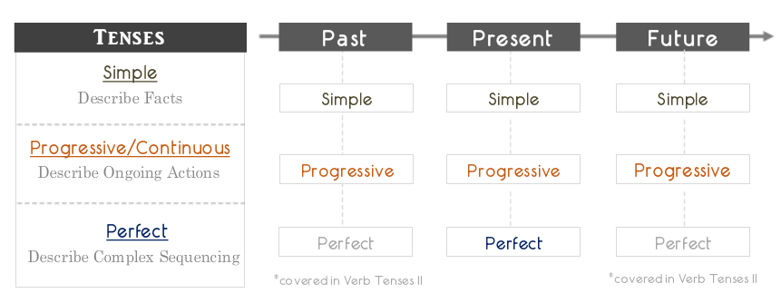

- Simple Present Tense – Describes facts or actions of general practice that are currently in present.

Verb + -‘s/-es’

Ex – He lives in this house.
Ex – Everyday Amy eats breakfast at 08:00 AM.
EX – Water boils at 100C.

- Simple Past Tense – Describes facts or events that happened in the past.

Verb + ‘-ed’

Ex – He lived in this house last year.
Ex – Last Friday, Amy visited the local zoo.

- Simple Future Tense – Describes facts or events that will happen in the future.

‘Will/can/may/shall’ + Verb

Ex – He will live in this house next year.
Ex – Amy will visit the local Zoo next Friday.

- Present Progressive Tense – Describes an ongoing event that is happening now.

‘is’/’am’/’are’ + VERB + ‘-ing’

Ex – Amy is studying for her exams.
Ex – Water is boiling in the kettle.

- Past Progressive Tense – Describes an ongoing event that was happening in the past when another action occurred.

‘was’/’were’ + VERB + ‘-ing’

Ex – Amy was sleeping when the phone rang.
Ex – I was listening to music yesterday when the power went off.

- Future Progressive Tense – Describes ongoing action that will happen in the future when another action occurs.

‘will be’ + VERB + ‘-ing’
Ex – Amy will be studying in the class when Mary’s concert begins.

Describes currently ongoing action that will continue in future.
Ex – The teachers will be taking training classes throughout the summer.

- Present Perfect Tense – Used to express certain complex sequencing of events

- Continuing Action
- Continuing Effect
- Indefinite Time

Helpful Tip: Use Present Perfect Tense when “Since” and “Within” and “for phrases” are used in context of time.

- Present Perfect – Continuing Action: Describe actions that started sometime before the current time and continue in the current time.

‘has/have’ + VERB + ’ed’

Ex – I have practiced yoga for 2 years now.
Ex – The doctors have found cure for many diseases.

- Present Perfect – Continuing Effect: Describe actions started sometime before the current time and whose effects continue in the current time.

‘has/have’ + VERB + ’ed’

Ex – The maid has cleaned the kitchen very thoroughly.
Ex – The teacher has posted the solutions on the bulletin board.

- Present Perfect – Indefinite Time: Describes actions that occurred at indefinite time in the past.
Ex – Amy has seen entire Europe.

Helpful Tip: Use Present Perfect Tense when “Since” and “Within” are used in context of time.
Ex – Since the last time Amy met her friends, none of them has seen her.
Ex – Within the last one year, Sam has participated in 50 marathons.
Helpful Tip: If the intended meaning is to express an action that is in progress at the current time, then DO NOT use simple present tense, use present progressive tense instead.

Ex – Sam is living with his sister – Preferred.
Ex – Sam lives with his sister – Not preferred.

Helpful Tip: Simple Past Tense is typically used for events of past that have a definite time period. If definite time period is not specified, Present Perfect Tense is preferred.

Ex – Amy saw Europe last month. – Definite time period.
Ex – Amy has seen Europe. – Indefinite time period.

Verb Tenses – II

- Past Perfect Tense – Is used when 2 related events occurred in the past. The first event here uses the ‘Past Perfect’ tense and the second event uses the ‘Simple Past’ tense.

had + Verb + ‘ed’/or something else

Ex – She had slept (Past Perfect) when the phone rang (Simple Past).
This means that the phone rang after she had slept.
Ex – She slept (Simple Past) when the phone rang (Simple Past).
This means that both actions happened at the same time.

Note: Whenever there are 2 events in the past, ask yourself if it makes logical sense for the 2 events to occur at the same time in the past. If it doesn’t then use ‘Past Perfect Tense’ for the sequencing of the events.

Note: Both events concurrent – Use Simple Past Tense for both.
Both events are not concurrent – Use Past Perfect and Simple Past Tense for both in that order as per sequencing of the events.

Ex – By the end of World War II (Event 1), America had dropped (Event 2) two atomic bombs on Japan.

Very Important: If there are sequencing marker words like ‘Before’ or ‘After’ used in the sentence having multiple events then the related events can use both ‘Past Perfect’ and ‘Simple Past’ Tense.

Ex – The scientists learned about the changes in Earth that happened (Simple Past) after the last ice age had destroyed (Past Perfect/Simple Past) the life on Earth.

Exceptions:
Rule 1: Usage of Past Perfect Tense is incorrect for sequencing if the 2 events are unrelated.
Ex – Recently scientists learned about the changes in Earth that had happened during the last ice age.
This is incorrect as the 2 events here are not related to each other.

Rule 2: Do not use ‘Past Perfect’ tense when only one event is present.
Ex – The football team had practiced well for the playoffs.
This is incorrect as there is only 1 event.

Rule 3: ‘Past Perfect’ tense is used to express earlier of the 2 related events.
Ex – By the time the conference had ended, all participants left for the club.
This is incorrect as the logical sequencing of the events and hence usage of the tenses is reversed here.

- Future Perfect Tense – Whenever there are 2 events in future, the first event is described in ‘Future Perfect’ tense and the second event is described in ‘Simple Present/Simple Future’ tense.

Will + have + Verb + ‘ed’

Ex – By the time ‘Amy’ turns three, she will have started going to school.
Ex – By the time ‘Amy’ starts going to school, she will have turned three.

Note: Always check the logical meaning of the concurrence of 2 related events.

Verb Sequencing

To answer GMAT like questions on verb sequencing,

- We first understand the meaning of the sentence.
While doing this, we can try to answer the following questions –
- What is the time frame of the event – past, present or future?
- Has the event completed or still continuing?
- Is the event continuous or at a point in time?
- Is there any sequencing of events?

- We then use the appropriate verb tense such that the intended meaning is communicated.

Note: Multiple verbs must be PARALLEL = Same Verb Tense, unless verbs are used to demonstrate sequencing of events.

Note: timeline indicators like, After, Before, By 1973 etc indicate presence of an event.

Somesh’s steps to solve these questions –

- Break the sentence and identify all it’s clauses.
- Identify all the verbs in all the clauses.
- Plot the verbs in all the clauses on a time line as per their sequence.
- Identify if any events or not.
- Analyze if the tense used for all the verbs/events is appropriate.
- Chose the correct option.

Based on the topics covered so far, below are the possible error reasons to check for first in a SC question –

- Check if the clauses (dependent and/or independent) are connected to each other correctly.
- Check for verb words which are not behaving as verbs.
- Check if all Subject-Verb pairs exist as needed.
- Check if all Subject-Verb pairs make logical sense.
- Check if all Subject-Verb pairs agree in number.
- Verb tenses.
- Check if all verbs in a sentence are in the appropriate sequential tense.

Conditional Verbs

If….Then constructions – Used to express conditions
3 types

- If “condition”, then “outcome”

Ex 1: If you exercise regularly, then you will stay healthy.

- If “condition”, “outcome”
Note: In this construction, the word ‘then’ gets dropped which is allowed.

Ex 1: If you exercise regularly, you will stay healthy.

- “Outcome”, if “condition”
Note: In this construction, the order of the condition can be reversed.

Ex 1: You will stay healthy, if you exercise regularly.
Note: The “If……..Then” constructions will always have 2 clauses
Clause 1: If condition
Clause 2: then outcome

The “If……..Then” clauses allow only the below mentioned “Verb Tenses”. Please refer the table below for this.

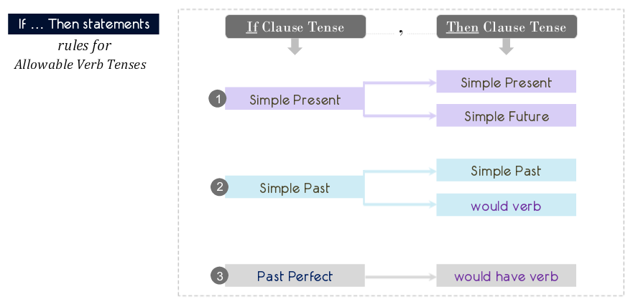

Note: The verb tense in the THEN and the IF clauses can only be as per the table above.
When “Simple Present” tense is used in the IF clause.

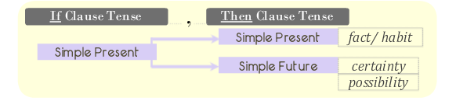

Also please note that the context of the sentence also drives the verb tense to be used in the THEN clause.

FACT/HABIT -> IS, DINES etc.
CERTAINTY -> WILL DINE
POSSIBILITY -> MAY DINE

When “Simple Past” tense is used in the IF clause.

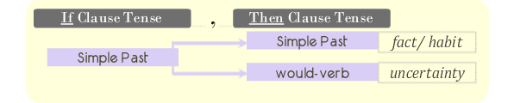

Also please note that the context of the sentence also drives the verb tense to be used in the THEN clause.

FACT/HABIT -> DINED
UNCERTAINTY -> WOULD DINE

When “Past Perfect” tense is used in the IF clause.

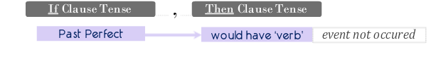

Also please note that the context of the sentence also drives the verb tense to be used in the THEN clause.

EVENT NOT OCCURRED -> WOULD HAVE DINED.

Special Case

‘Would’ to demonstrate future actions

In non “If……..Then” clause sentences, whenever ‘would’ is used, it should be used to express ‘Uncertainty’
This ‘Uncertainty’ should be only from one of the 3 below mentioned types
- Expectation
- Hypothetical
- Assumption

Ex1: Expectation The analysts expected that after the appointment of new CEO, the profit margins of the company would increase.

Ex2: Hypothetical In order to stimulate her child’s senses, she would need to learn more engaging activities.

Ex3: Assumption When the student arrived late in the class, the teacher gave him detention slip based on the assumption that he would not have a valid reason for the tardy behavior.

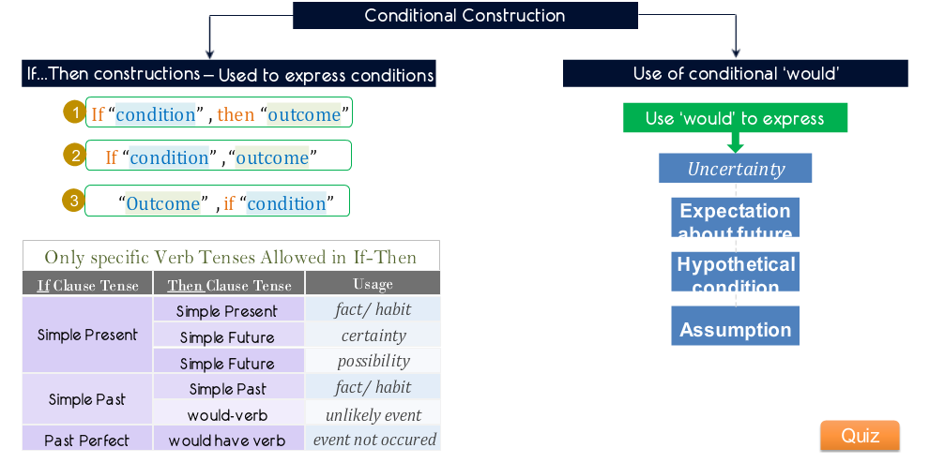

Subjunctive Verbs

What are Subjunctive Verbs?

Note: Subjunctive Verbs are always plural.
Ex: The company board of directors demanded that CEO resign immediately.
Note: Subjunctive of verb ‘-be’ = BE
Note: ‘is’, ‘am’, ‘are’ are not Subjunctive

Subjunctive VERB is ALWAYS used with ‘THAT’

Format: Demand/Request/Recommended Word + THAT + SUBJECT + SUBJUNCTIVE VERB

Ex: The recommendation that each division submit the sales figures by the end of each month will be provided in next division meeting.

Cases when the subjunctive verbs are mandatorily needed to be used or mandatorily not to be used.

- ‘Subjunctive verbs’ are mandatorily required for certain Demand, Recommendation or Request verbs. Below is a list of verbs which when present in a sentence always need a subjunctive verb to follow or pre-cede.

- Demand
- Dictate
- Insist
- Mandate
- Propose
- Recommend
- Request
- Stipulate
- Suggest

Ex: He recommended that each division submit the sales figures by the end of each month.

Note: A noun form or any other form of a Demand, Recommendation or Request verb will follow the same rules as above.

Ex: The recommendation that each division submit the sales figures by the end of each month will be given in next division meeting.

- Certain ‘Subjunctive verbs’ are mandatorily not required for certain Demand, Recommendation or Request verbs. Instead they require a form of the ‘To Verb’. Below is the list of such verbs –

- Advise
- Allow
- Forbid
- Persuade
- Want

Ex: Amy’s colleagues persuaded her to invite her boss for her wedding.

Note: A very important note to remember here is that in such cases it is absolutely correct and ok if the word ‘THAT’ is not there in the sentence.

- Certain ‘Subjunctive verbs’ can use Demand, Recommendation or Request verbs or can also use ‘To Verb’. Below is a list of such verbs –

- Ask
- Beg
- Desire
- Intend
- Order
- Prefer
- Require
- Urge

Ex: The law requires that everybody provide his/her loan approval document before formally putting an offer of purchase on the prospective real estate property.

Final Note: For subjunctive verb usage, it may appear that a singular subject is taking a plural subjunctive verb which is against the Subject – Verb rules but it is okay in this case of ‘Subjunctive Verbs’.

Pronouns

A Pronoun is used in place of a Noun which referred to by a pronoun is basically the Antecedent.

Ex: Amy (Antecedent) likes to keep fit, so she (Pronoun) goes for jogging every morning.

Rule 1: Pronoun Must refer to ONE Antecedent.
Rule 2: Pronoun-Antecedent Pair Must Agree in Number.

Pronoun Must refer to ONE Antecedent.

- A Pronoun refers to ONLY ONE Antecedent.
- A Pronoun – Antecedent Pair Must make sense. (By understanding the context of the sentence we can determine the logical antecedent of the pronoun and the Pronoun-Antecedent pair makes sense.)
- A Pronoun should always refer to a Noun only.

Pronoun-Antecedent Pair Must Agree in Number.

Ex: The French handed the information to the Poles because they believed it to be of no value.
Ex: France handed the information to Poland because it believed the information to be of no value.

Note: A pronoun can refer to a “Phrase” instead of a noun. A “Phrase” as a subject is always singular and hence the pronoun in these cases should also be singular.

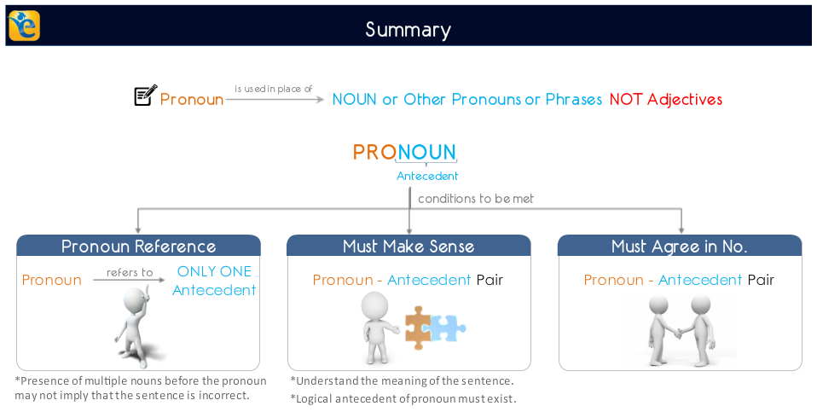

Note: If a sentence has multiple pronouns in it and only one of them makes logical sense with the pronoun then it is a correct sentence. However if more than one noun makes sense individually with the pronoun then there is pronoun ambiguity in the sentence.
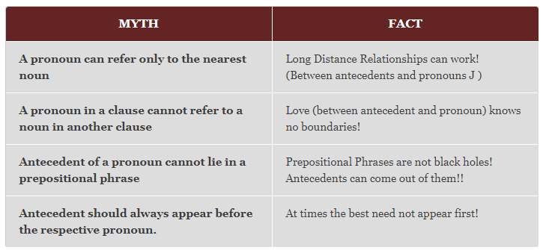

Summary: Wherever a pronoun is used, we replace the pronoun with the possible antecedents and check if the sentence makes sense.
- If no antecedents make sense, we say that there is no logical antecedent to the pronoun.
- If more than one antecedent makes sense, we say that there is pronoun ambiguity in the sentence.

Grammatical affinity of pronouns causing pronoun ambiguity

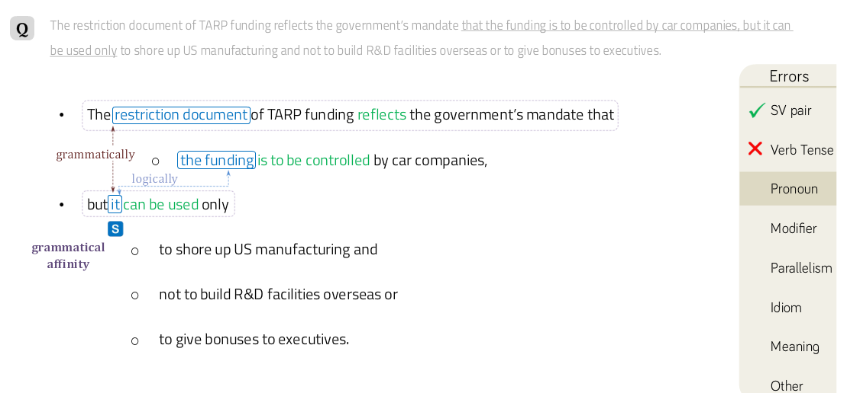

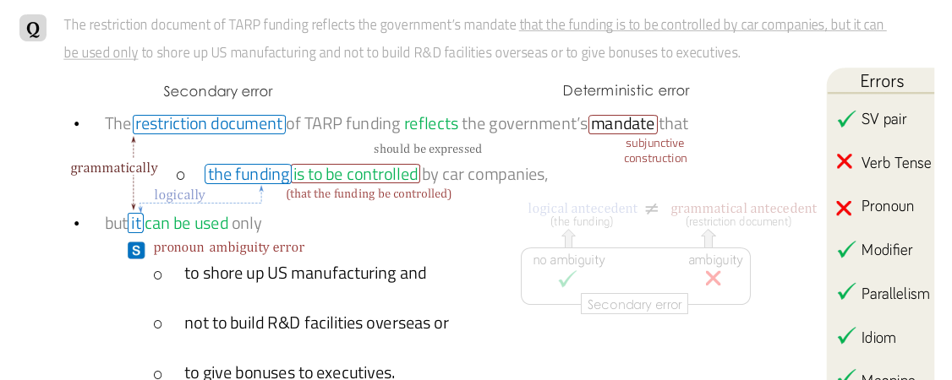

Modifiers

A modifier in a sentence is anything (a word, a phrase or a clause) which modifies a noun, a verb or a main clause.
It is basically anything which gives any extra information and is anything other than the subject, the verb or the object in a sentence.
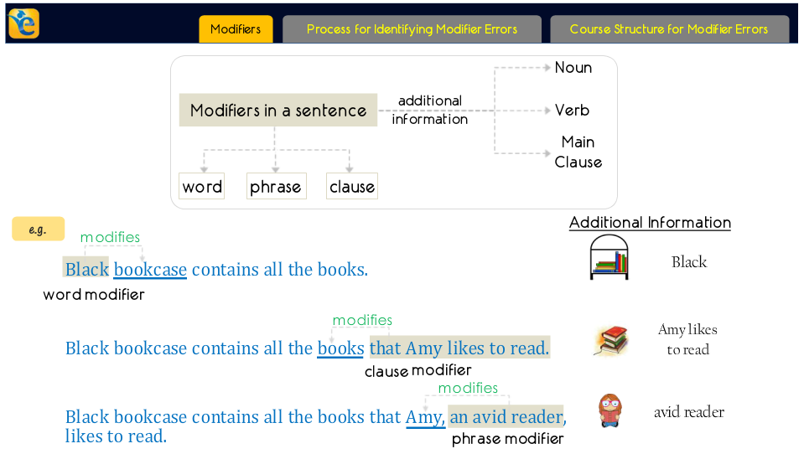

Process for identifying modifier errors
Follow the following steps to correct modifier errors –
- Spot the modifier.
- What is being modified?
- Is it placed correctly?
- Is it worded correctly?
- Correct modifier errors.
Note: Always place the Modifier close to the NOUN that it modifies.
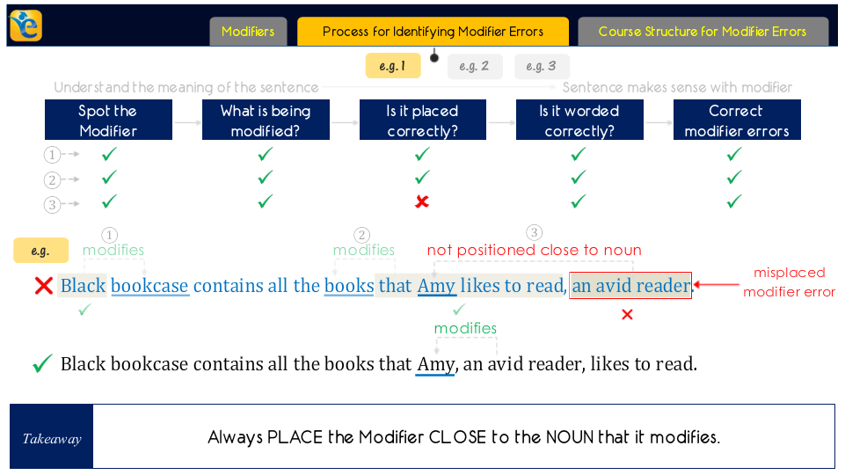

Note: The modifiers which modify verbs can be placed away from the verbs if they make perfect logical sense. Below is one such example for this case.

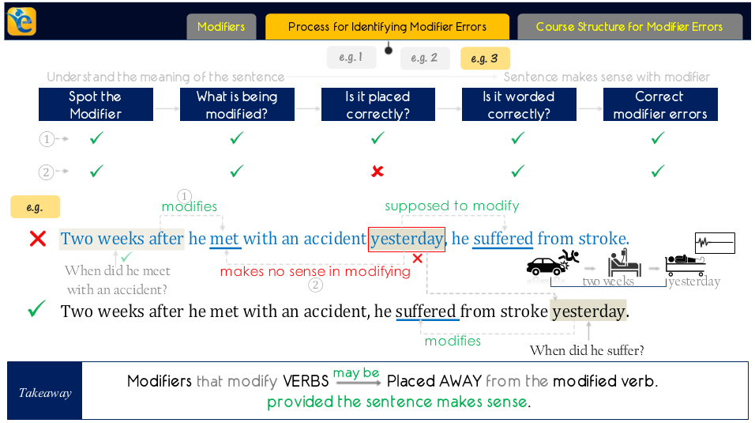

Types of Modifiers

- Modifier words which modify nouns are called adjectives.
- Modifier phrases which modify nouns are usually prepositional phrases.
- Modifier clauses which modify nouns begin with relative pronouns like that, which, when etc.
- Modifier words which modify verbs are called adverbs.
- Modifier phrases which modify verbs are usually prepositional phrases.
- Modifier clauses which modify verbs usually begin with because, if, when etc.
- Modifiers which modify clauses are either of the type ‘VERB-ing’ or ‘To Verb’ phrases.

Note 1: A modifier must be placed Close to the NOUN that it modifies.
Note 2: A modifier need not be placed close to the VERB that is modifies.
Note 3: A modifier must make sense with the ENTITY that it modifies.

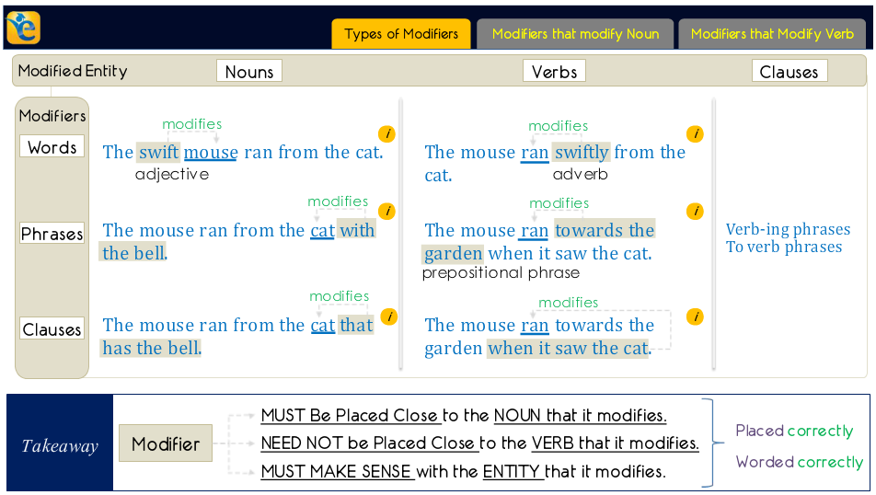

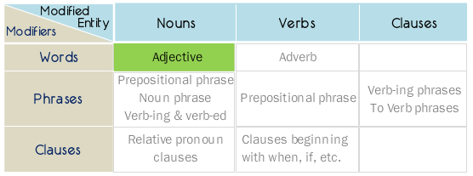

Examples –
- Modifier word (adjective) modifying a Noun –

- The swift mouse ran away from the cat.

- Modifier phrase (prepositional, noun, VERB-ing or VERB-ed phrase) modifying a noun –

- The book on the table is a text book. prepositional phrase
- The book, red in color, is a text book. noun phrase
- The painting, colored in red, matches with the furniture. Verb-ed phrase.
- The puppy eating food from his platter is the newest member. Verb-ing phrase.

- Relative pronoun clauses modifying nouns –

- The book that is kept on the table is red in color.

- Modifier adverbs modifying verbs –

Any additional information about the modified verb answers one of the following questions –
- How did the action happen?
- When did the action happen?
- Why did the action happen?
- Where did the action happen?

- The mouse ran away from the cat swiftly. How did it run?
- The mouse ran away swiftly from the cat. How did it run?
- The mouse swiftly ran away from the cat. How did it run?
- Mary completed her project yesterday. When did it complete?

Note: When there are multiple verbs in a sentence then the placement of the modifier defines the verb that it modifies. In such cases, the modifier must make sense with the verb that it modifies.

- The mouse ran away from the cat that was running behind the mouse swiftly.

- Prepositional phrases modifying verbs.

Any additional information about the modified verb answers one of the following questions –
- How did the action happen?
- When did the action happen?
- Why did the action happen?
- Where did the action happen?

- Mary goes to the gym class on Thursday evenings.
- On Thursday evenings, Mary goes to the gym class.

- Clauses beginning with when, if, because etc. modifying a verb.

- Because Mary was absent from class, she did not know the submission date of homework.
- The family will plan it’s vacation when the weather is slightly warmer.

Correcting Modifier Errors

The 3 most common methods to correct modifier errors are as below
- Reposition – Here we reposition the modifier or the modified entity to make more sense.
- Reword – Here we change the modifier or the modified entity to make more sense.
- Change Voice – Here we bring the modifier and the modified entity closer to each other by changing the voice.

- Reposition examples

- The hunter-gatherers who occupied the Americas during the Archaic period, began to live in more permanent settlements, and by 1400 BC, many of these settlements had evolved into socially stratified pottery-producing villages sustained by agriculture.

- Rural dwellers can get satellite internet, but with longer lag times, it is far slower than the ambitious satellite services that were being developed a decade ago.

- Reword examples

- Designed with extreme caution, the dresses were created by the fashion designer and, they appealed to the masses.

- Eating high calorie food, Joe gained 20 pounds.

- Seeing that the development is a threat to their prosperity, major oil corporations persuaded the federal authorities to abandon the project that converts coal into petroleum products.

Note: When ‘VERB-ed’ form modifiers are used, we check their correctness by reordering some parts of the sentence like – Modified entity (Noun – Subject) + Helping Verb + (VERB-ed) Modifier (word/phrase/clause). If this makes sense, then this is correct.

- Change Voice examples

- Kept on the topmost shelf of rock 11, these books were written by Keats.

- Extending the rules of classical drama, Shakespeare created an expressive dramatic form that would serve as a romantic alternative to the classical norm of order and balance and he also helped establish the tension between classicism and romanticism that defines modernism.

Note: In the following example –
A pioneer journalist, Nellie Blye’s exploits included circling the globe faster than Jules Verne’s fictional Phileas Fogg.

Nellie Blye is not a subject. Nellie Blye’s exploits is a subject and hence ‘A pioneer journalist’ which is intended to modify ‘Nellie Blye’ is incorrectly modifying ‘Nellie Blye’s exploits.’ This kind of error is a very common type on GMAT and hence should be checked for.

How VERB-ing modifiers modify

They can modify either
1 – A noun or
2 – An action
Below are some examples –
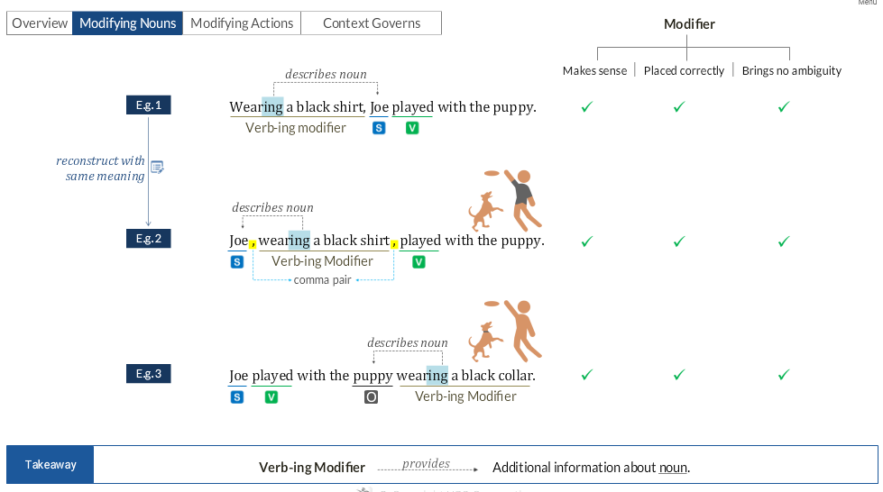

When VERB-ing modifiers modify a noun, they have to follow the following 3 rules

Rule 1: If the VERB-ing modifier comes before the NOUN that it modifies then it should be separated from that NOUN by a comma.
Ex – Wearing a black shirt, Joe played with the puppy.

Rule 2: If the VERB-ing modifier comes after the NOUN that it modifies then it can be encapsulated in a comma pair.
Ex – Joe, wearing a black shirt, played with the puppy.

Rule 3: If the VERB-ing modifier comes after the NOUN that it modifies and if it is not encapsulated in a comma pair, then it should not be separated from the NOUN that it modifies, with a comma.
Ex – Joe played with the puppy wearing a black collar.

When VERB-ing modifiers modify an action, they do it in the below mentioned ways

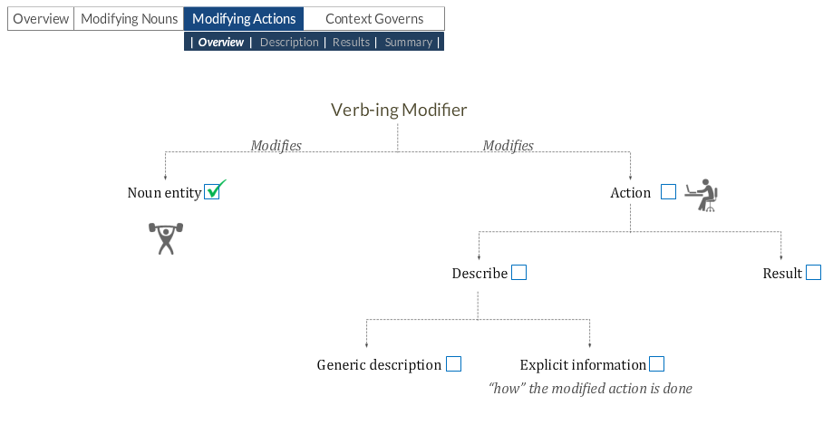

Case 1: VERB-ing modifier modifies an action by giving a generic description of the action

Ex 1: Amy skipped school, giving the excuse of stomach ache.
Ex 2: The startup closed all its operations, citing political instability as the primary reason.

Important Note 1: When a ‘VERB-ing’ modifier modifies a preceding action, the Doer of the Modified Action and the Modifier Action is the same.

Important Note 2: When a ‘VERB-ing’ modifier modifies a preceding action, it has to be preceded by a comma as seen in the 2 examples as above.

Case 2: VERB-ing modifier modifies an action by giving a ‘How’ aspect of the description.

Ex 1: Arranging rare exotic flowers in a symmetric pattern, Mary made a beautiful bouquet. How did she make the bouquet?
Ex 2: Singing a beautiful song, Sam mesmerized everyone present in the room. How did he mesmerize?

Important Note 3: When a ‘VERB-ing’ modifier modifies an action by describing the ‘How’ aspect of the action, the Doer of the modifier and the modified action is the same.

Case 3: VERB-ing modifier modifies an action by giving the results of the action.

Ex 1: Mary made a beautiful bouquet, winning accolades from everyone.
Ex 2: BP Corporation drilled deep sea oil wells, destroying the coral reefs.

Important Note 4: The sentence structure in this case follows the CAUSE – EFFECT sequence.

Important Note 5: The sentence structure will always be of the form –
Subject + Verb + Object + , (comma) + VERB-ing modifier
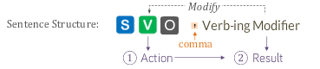

Important Note 6: When a ‘VERB-ing’ modifier modifies an action by describing it’s result then the Doer of the Modifier Action and the Modified Action is the same.

Outlier Important Note 7: When a VERB-ing modifier precedes the modified entity, the modified entity can be either a NOUN or a VERB. This is governed by the context of the sentence.

Ex 1: Wearing a black jacket, Joe played with the puppy. Here the VERB-ing modifier does not make sense to modify the action and hence it modifies the NOUN.
Ex 2: Arranging rare exotic flowers in a symmetric pattern, Mary made a beautiful bouquet. Here the VERB-ing modifier does not make sense to modify the NOUN and hence it modifies the ACTION.
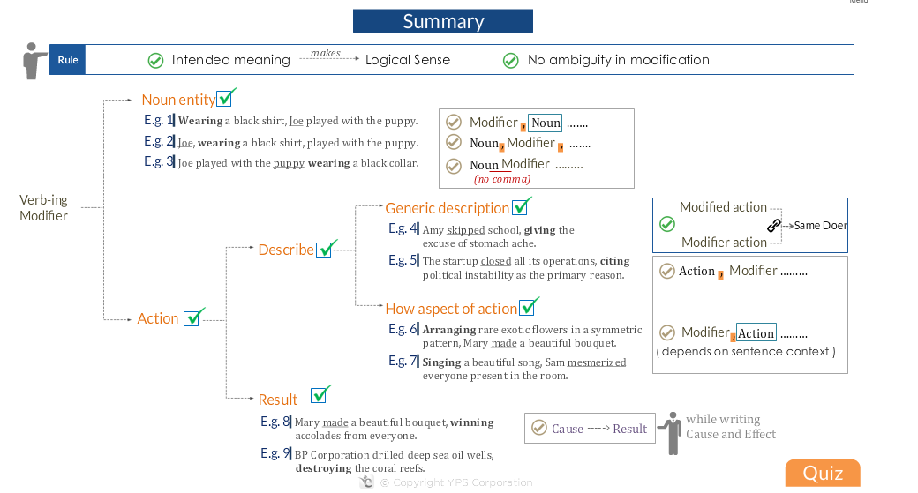
More special ‘VERB-ing’ modifier aspects

‘VERB-ing’ words can modify actions which are represented by words other than the verbs (Describe Action, ‘How’ aspect of Action, Action Result) seen till now like ‘To - VERB’ words depending on the context.

Ex 1: Mary’s father wants her to become a doctor, making a difference in people’s lives.

Important Note 1: Since, in these cases the modifier does not modify the verb of the sentence/clause but rather modifies a ‘To - VERB’, the Doer of the modified action may not be the subject of the sentence/clause as seen up until now.

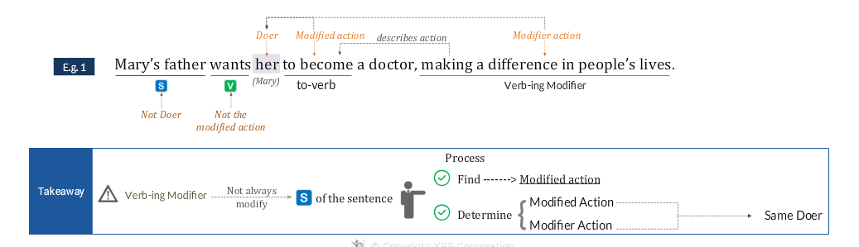

Ex 2: The integrated science projects in elementary schools motivate children to experience the “miracles” of nature, witnessing the changes that happen every day.



Note: If the Doer of the modified entity is not the same as that of the modifier, then we make the sentence correct by replacing the ‘VERB-ing’ form by what we call as the NOUN + NOUN Modifier.

VERB-ed Phrases – Verbs or Modifiers

Ex 1: The frightened mouse ran very fast

Just like in the above example where VERB-ed words act as modifiers and not verbs, there can be VERB-ed phrases which act as modifiers too.
In such cases the sentence construction is like – NOUN + Verb-ed Phrase
Here we need to know if the Verb-ed word/phrase acts as a Verb or a modifier.

Ex 1a: Marie (S) decorated (V) the poster with yellow stars. decorated by Marie makes sense.
Ex 1b: The poster (S) was decorated (V) with yellow stars by Marie. poster was decorated makes sense.
Ex 1c: The poster decorated with yellow stars by Marie. The poster did not perform the action of decoration. Here the Verb-ed phrase is a modifier.

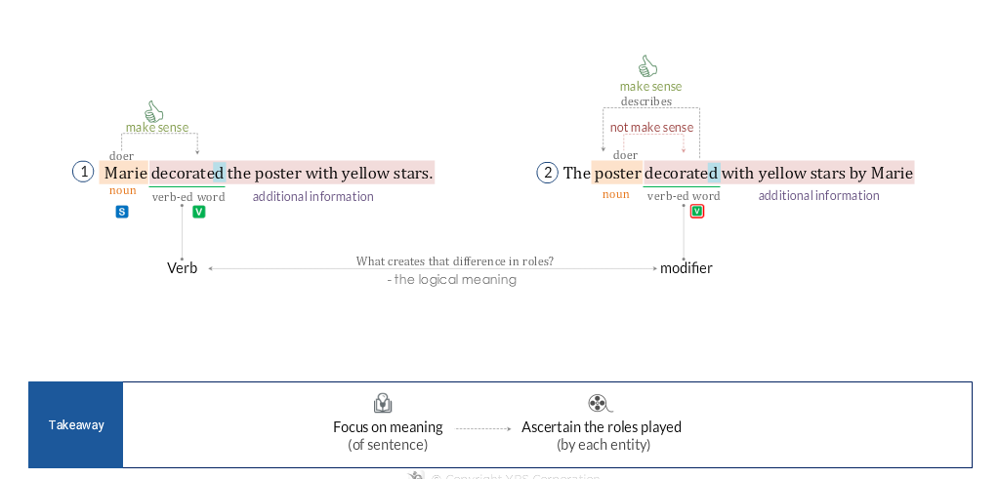

Ex 2a: The building constructed in less than 2 weeks. Here the building did not do the action of construction and hence the Verb-ed word constructed acts as a modifier here.
Ex 2b: A new construction company constructed the building in less than 2 weeks. Here it makes logical sense to say that the construction company did the action of constructed and hence the Verb-ed word here acts as a verb and not a modifier.
Ex 2c: The building constructed in less than 2 weeks has fallen. Here the subject of the building has got a verb called ‘has fallen’ and the Verb-ed word ‘constructed’ acts as a modifier.



Important Note 1: A way to identify if the VERB-ed word acts as a verb or a modifier is by asking and checking if the subject preceding the Verb-ed word is the Doer of the Verb-ed word. If it is then the Verb-ed word is a VERB and if it is not then the VERB-ed word is a MODIFIER.

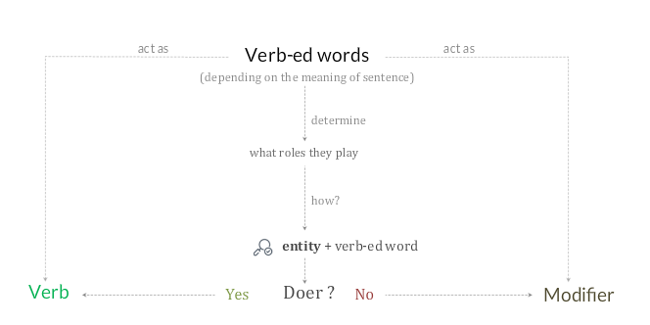

Ex 3: A company (S) founded (M) on sound business principles achieves (V) much higher success.
Ex 4: A singer (S) accustomed (M) to various singing styles usually possesses (V) a captivating voice.
Important Note 2: A helping verb if precedes VERB-ed word then the VERB-ed word becomes a VERB and not a MODIFIER.
Ex 5: The poster was decorated with yellow stars by Marie.
Ex 6: The movie that was made on one of the very controversial topics won accolades from critics.

How Verb-ed Modifiers modify

Case 1: VERB-ed modifiers modifying nouns
Ex 1: A company (S) founded on sound business principles (M) achieves (V) much higher success (O).
Ex 2: A singer (S) accustomed to various singing styles (M) usually possesses (V) a captivating voice (O).


Ex 3a: Designed to withstand radiation in ‘Low Earth Orbit (LEO)’ for 20 years, the space ship cannot be made with poor quality materials.
Ex 3b: The space ship, designed to withstand radiation in ‘Low Earth Orbit (LEO)’ for 20 years, cannot be made with poor quality materials.



Ex 4a: Maya polychrome vases (S), painted with courtly scenes (M), present (V) intimate glimpses into the Maya world (O).
Ex 4b: Painted with courtly scenes (M), Maya polychrome vases (S) present (V) intimate glimpses into the Maya world (O).

Important Note: A VERB-ed modifier following a NOUN that it modifies may or may not be separated from the noun by a comma. This is opposite for the VERB-ing modifiers which definitely should not have a comma before them in such cases unless they are encapsulated in a comma.

VERB-ed modifier modifying actions – more examples:
Ex 1: Motivated by the excellent performance of the marketing team (M), the CEO (S) decided (Action) to double it’s allotted financial goal for the quarter.


Ex 2: Excited about her first job, Joanne threw a big party for all her friends and family.
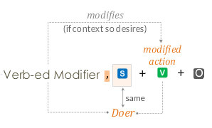

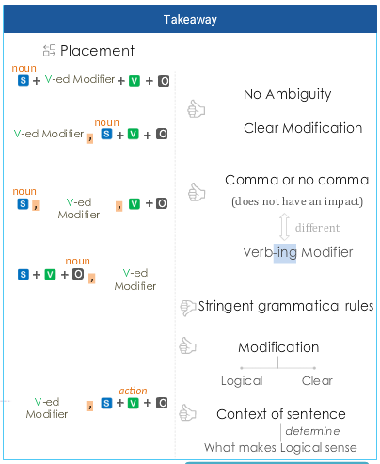

Short Summary on ‘VERB-ing’ modifiers and ‘VERB-ed’ modifiers (Important Summary)

- ‘VERB-ing’ modifiers never have a comma before them if modifying a preceding noun.
- ‘VERB-ing’ modifiers always have a comma before them if modifying a preceding verb/action.
- ‘VERB-ed’ modifiers may or may not have a comma if modifying a preceding noun or a verb/action.

Rules set for Relative Pronoun Modifiers

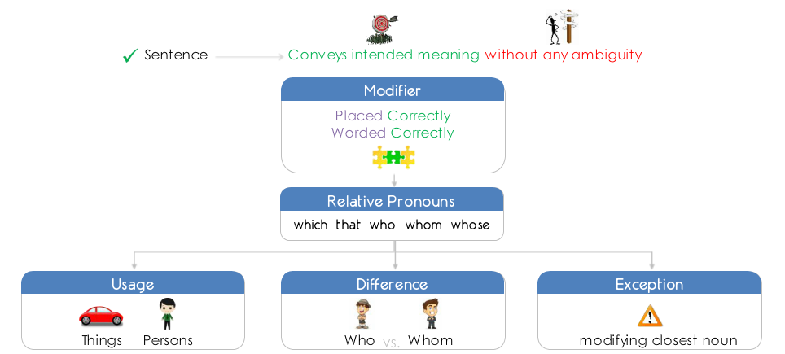

Below is a list of examples of modifiers beginning with relative pronouns and where they can be used.

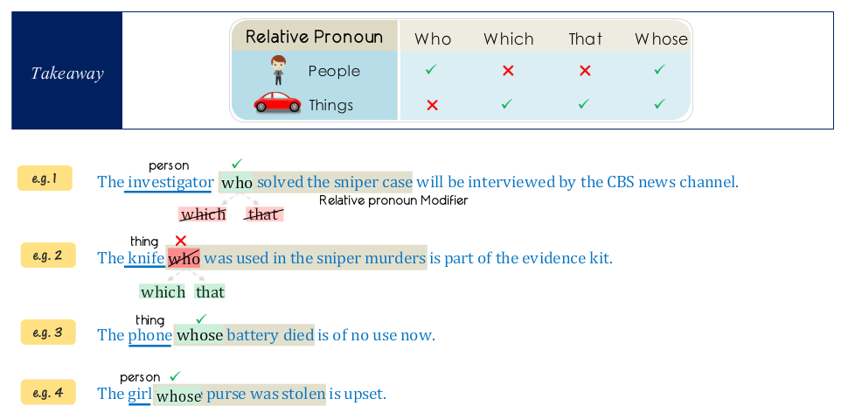

Below are the details of how to use relative pronoun modifiers which start with ‘Who’, ‘Whom’

Ex 1: Susie will offer employment to the girl who whom she interviewed last Friday.
Note that here in the modifier, whom is the object, she is the subject and interviewed is the verb.
Ex 2: Susie will offer employment to the girl who works in another department.
Note that here in the modifier, who is the subject, works is the verb.

The general rule is that ‘The Relative Pronoun Modifier’ modifies the closest Noun. However there are a few exceptions to this as we see below –

Exception:

Ex 1: I killed the snake with scales, which lived in the burrow behind my house.
Note that in this example, ‘with scales’ gives additional information about the snake and cannot be placed anywhere else. Also with this placement there is no ambiguity in the meaning of the sentence.
Ex 2: I killed the snake with eggs, which lived in the burrow behind my house.
Here again there is no ambiguity in the meaning as snake and not the eggs lived in the burrow.
Ex 3: I will kill the snakes with eggs, which lay in the burrow behind my house. X X
Here there is a problem due to ambiguity as the snakes and the eggs, both can lay in the burrow. Hence, this statement is incorrect.

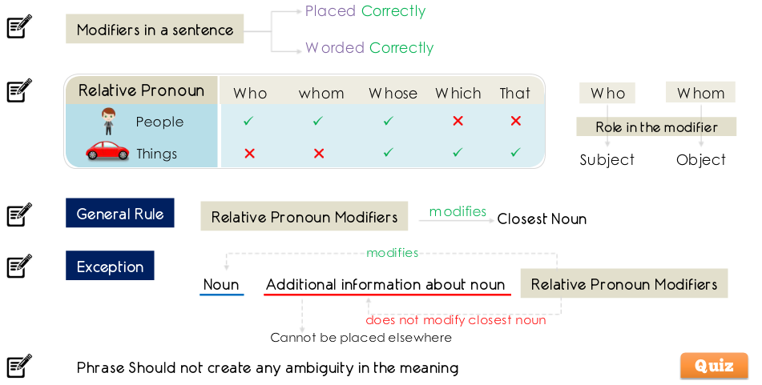

Important Note: A modifier modifying a preceding noun can have some prepositional phrase between itself and the preceding noun that it modifies only if
- That prepositional phrase modifies the preceding noun.
- That prepositional phrase cannot be placed anywhere else in the sentence.

Ex 1a: The committee chose Mr. Smith of Left Block, who was the most experienced member, to lead all the management – related operations.
Ex 1b: The committee chose Mr. Smith in the last meeting, who was the most experienced member, to lead all the management-related operations.
In the above 2 examples, Ex 1a is correct and Ex 1b is incorrect as the prepositional phrase between the noun and it’s modifier, does not modify the noun and can be placed anywhere else in the sentence.

NOUN + NOUN Modifiers
Can modify –
- The entire preceding clause.
- The preceding noun entity.
- Or a noun in the middle of the sentence.
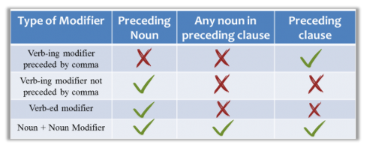

Important Note 1: Noun + Noun modifiers can modify only 1 entity in a sentence. If there is slightest of ambiguity on which noun it is modifying then the usage of the noun + noun modifier is not correct.
Ex 1a: On her birthday, Kim got an iPhone 4S and iPad 3 from her parents, a gift that was in her wish list from a very long time.
Here the highlighted modifier can modify ether iPhone 4S or iPad 3 hence it’s usage is ambiguous and hence this example is incorrect.
Ex 1b: On her birthday, Kim got from her parents an iPhone 4S and iPad 3, which was in her wish list from a very long time.
Here it is very clear that the highlighted modifier is modifying iPad3 only and hence the usage here is correct.
Also note that in this corrected example, the noun + noun modifier has been replaced by a relative pronoun clause.

A Noun + Noun modifier modifying a preceding noun

Ex 2: James created a magnificent design by using latest graphic design tools, expensive but super helpful devices developed especially for minute detailing and elaboration.
Ex 3: The world wildlife fund has declared that global warming, a phenomenon that most scientists agree is caused by human beings’ burning of fossil fuels, will create havoc among migratory birds by altering the environment in ways harmful to their habitats.

A Noun + Noun modifier modifying a noun in the middle

Ex 1: James created a magnificent design by using latest graphic design tools, a work acknowledged and appreciated by all investors.
Ex 2: In 1713, Alexander Pope began his translation of the Illiad, a work that took him seven years and that literary critic Samuel Johnson, Pope’s contemporary, pronounced the greatest translation in any language.

A Noun + Noun modifier modifying a preceding clause

In this case, the noun + noun modifier refers to only the subject and the verb of the preceding clause.

Ex 1: James created a magnificent design by using latest graphic design tools, an experiment that many feared to do because of the instability in the output resulting from these tools.
Ex 2: In 2000, a mere two dozen products accounted for half the increase in spending on prescription drugs, a phenomenon that is explained not just by the fact that drugs are becoming more expensive but also by the fact that doctors are writing many more prescriptions for higher-cost drugs.

Important Note 2: The modification of Noun + Noun Modifiers is completely context driven.

NOUN + NOUN Modifiers VS VERB-ING Modifiers

- The following 2 entities can modify a preceding clause –

- A VERB-ing modifier preceded by a comma.
- A NOUN + NOUN Modifier.

The difference in the way that both these modify a preceding clause is that –
- A VERB-ing modifier preceded by a comma, modifying a preceding clause always refers/associates itself to the subject and the verb in the preceding clause. It has to modify the subject and the verb in the preceding clause together.

- The NOUN + NOUN modifier in the preceding clause does not have any such restriction and can modify any aspect of the preceding clause.

Important Note 1: When a NOUN + NOUN modifier modifies the entire preceding clause, then it always presents additional information about the preceding clause.

Ex 1a: One manufacturer has announced plans to increase the average fuel efficiency of its sport utility vehicles by over 25 percent over the next five years, amounting to roughly five miles per gallon, and representing the first significant change in the fuel efficiency of any class of passenger vehicle in almost two decades.
Here, the VERB-ing modifiers modify the preceding clause with subject as ‘manufacturer’ and verb as ‘announced’. However this modifying is incorrect as the announcement by the manufacturer has not amounted to or represented something.
Ex 1b: One automobile manufacturer has announced plans to increase the average fuel efficiency of its sport utility vehicles by 25 percent over the next five years, an increase that would amount to roughly five miles per gallon and would represent the first significant change in the fuel efficiency of any class of passenger vehicle in almost two decades.
Here the NOUN (an increase) + NOUN modifier clause correctly modifies the entire preceding clause without focusing only on the subject and the object of the clause.

Parallelism

A list of nouns, phrases, clauses, verbs and modifiers in a sentence should be consistent.

Ex 1: Susie likes dancing, singing and cooking.
Ex 2: The teacher asked students to write the report quickly, neatly and accurately.
Ex 3: The teacher said that Sue was a good student because she prepared her course in time for exam, she completed her assignments properly, and she had great motivation.

Below is a list of some markers which indicate presence of lists.
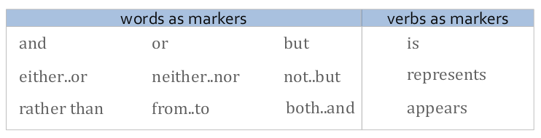

Ex 4: Vasella’s ablity to keep patients in mind may come from his experiences not only as a physician but also as a patient.

Important Note 1: All elements of a list must play the same role (verb or adjective or adverb) or should talk about the same topic.

There are 3 common types of parallelism errors as shown in the diagram below ->

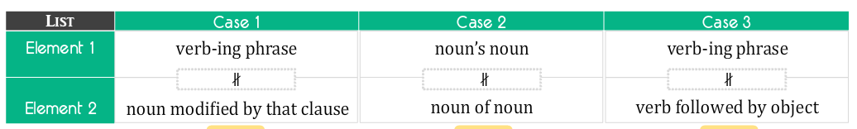

Case 1: List items are VERB-ing phrase and noun modified by that clause and hence need to be made consistent.
Ex 5: The spread between corporate borrowing rate and safe yields on Treasury Securities has narrowed greatly, indicating more desire for risk and rise that is reflected in Treasury yields reflecting rise in Treasury yields, although this spread has not yet returned to it’s level before the September crisis.
Case 2: List items are noun’s noun and noun of noun and hence need to be made consistent.
Ex 6: It’s a revenue stream that is almost pure profit, since the marginal cost of transporting a free passenger is basically a soda’s can a can of soda, a bag of peanuts, and the incremental cost of fuel – a little less than 3 cents a mile at current prices.

Case 3: List items are VERB-ing phrase and verb followed by object and hence need to be made consistent.
Ex 7: Even if the recession plays out as expected, the troubled investments will continue to sour, eroding bank’s profits and will hamper their ability to lend hampering their ability to lend.

Below is a summary

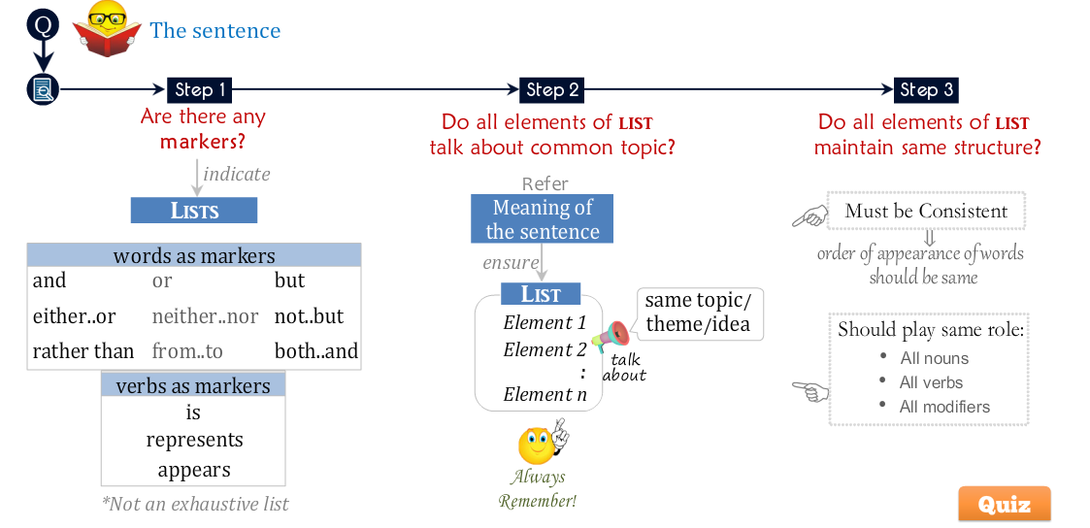

Markers in parallelism

- Single word markers – and, or, but, etc.

Ex 1: Like ants, termites have an elaborate social structure in which a few individuals reproduce and the rest serve the colony by tending juveniles, gathering food, building the nest, or battling intruders.

- Dual word markers – either….or, both….and, from….to etc, not just….but also.

Ex 2: With so many things to take care of, Sam can either prepare a speech or participate in the inaugural song.

Important Note 1: We cannot use dual-word markers for more than two entities in the list.

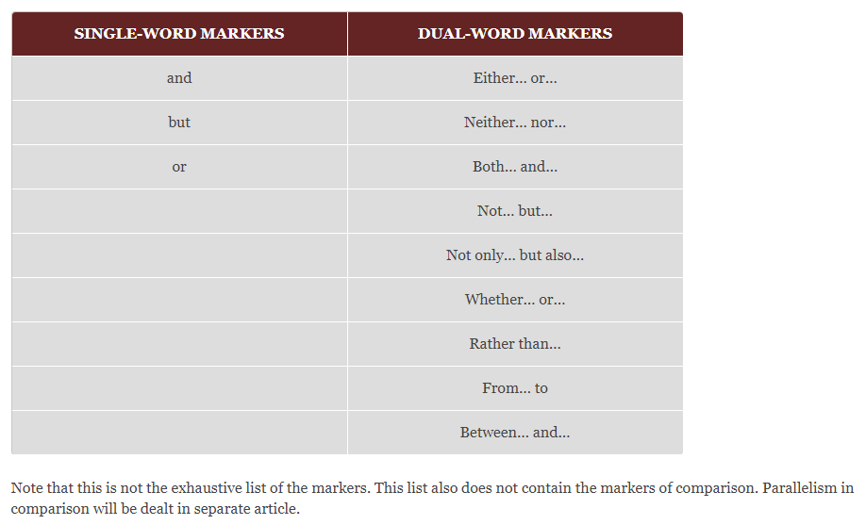

Important Note 2: Below are key points for parallel parts of a sentence –

- A parallel list always contains a marker.
- The list contains the appropriate marker to convey the intended meaning through the list.
- The entities in a parallel list are grammatically as well as logically parallel.

Parallelism – Helpful Tips

Tip 1: Parallel clauses must begin with same word.
Ex 1: In the end, regulators don’t have a choice about relaxing the ownership rules, in part that partly because they don’t have the funds to bail out every troubled bank and partly because only a few investors have the financial muscle of private equity firms.

Tip 2: Common words present in the list need not be repeated.
Ex 2: A few companies, big and small, have scoured the bankruptcy courts for deals, have become tough with suppliers on prices, and have muscled in on direct competitors and substitutes – all to gain advantage for the eventual upswing.

Tip 3: Parallel elements may be modified by different elements.
Ex 3: Employees who use deferred compensation plan will need to offset the effect of looming tax increases either by earning more in the plan or by investing over a long enough period that compounding will make up the difference.
Here the bolded statement is a modifier for the 2nd clause in the list and this is not an issue.

Tip 4: VERB-ing of noun is parallel to noun
Ex 4: The rise in greenhouse gases is not only due to the cutting of trees but also due to the pollution.
Ex 5: The main factors responsible for global warming are the growth of coal-based power plants and the releasing of greenhouse gases.

Parallelism – Imperfect List
Below lists are imperfect parallel lists –
- Noun forms and ‘ing’ Noun forms.
- Active and Passive voice entities (The verbs should have the same subjects here).
- Verb-ed and Verb-ing modifiers (Both modifiers should be modifying the same entity).

Ex 1: Scientists have recently discovered what could be the largest and oldest living organism on Earth, a giant fungus that is an interwoven filigree of mushrooms and root-like tentacles spawned by a single fertilized spore some 10,000 years ago and extending for more than 30 acres in the soil of a Michigan forest.
Ex 2: The new lamp decorated with ping flowers and resembling a star brought a large smile on the child’s face.

Note: Helping verbs – is, am, are, was, were.

Important Note 1: A word/phrase cannot be parallel to a clause. Example (Incorrect) – The new lamp decorated with ping flowers and that resembles a star brought a large smile on the child’s face.

Ex 3: The new lamp that is decorated with pink flowers (Passive Voice) and that resembles a star (Active Voice) brought a large smile on the child’s face.
Note: Passive voice usually starts with the object or has the subject missing and the active voice almost always starts with the subject.

Parallelism – Grammar Vs Logic
Logic always trumps Grammar on the GMAT.
Important Note 1: The grammatically parallel entities in the list must convey the LOGICAL INTENDED meaning of the sentence. If the grammatically parallel entities make the sentence illogical, then the list is not considered parallel.

Ex 1a: John prepared for impending currency crisis, storing enough food and water for future and posting his pictures online. [Incorrect as posting his pictures is not part of the preparation John did, as is implying here.]
Ex 1b: John prepared for impending currency crisis, storing enough food and water for future and posted his pictures online. [Correct as the meaning implied here is correct that the posting of the pictures was not part of John’s preparation.
Important Note 2: A grammatically parallel list will still be incorrect if it does not convey logical meaning.
Ex 2: John prepared for hurricane Sandy in advance, storing enough food and water, purchased flashlights and candles for possible power outages, and charging his cellphone to reach out to authorities in case of emergency.
- Storing enough food and water, purchased flashlights and candles for possible power outages, and charging. Reason similar to D.
- Storing enough food and water, purchased flashlights and candles for possible power outages, had charged. Reason similar to D.
- Storing enough food and water, purchasing flashlights and candles for possible power outages, and charging. Correct.
- Stored enough food and water, purchased flashlights and candles for possible power outages, and charged. Incorrect as all the 4 activities seem to be 4 independent activities.
- Stored enough food and water, and purchased flashlights and candles for possible power outages, being charged. Reason similar to D.

Comparison

Parallelism in Comparisons
- Comparison/Contrast sentences must be parallel.
- Elements should be logically parallel.

Steps
- Check if there are any comparison markers.
- Check if all elements are grammatically parallel.
- Check if all elements are logically parallel.

Some words that indicate presence of comparison/contrast –
- Like
- As
- Than
- Compared to
- Different from

Ex 1a: Like other smartphones, Palm made Pre which cannot handle the full-power Adobe Flash video used on sites such as Hulu.com Incorrect as smartphones is being compared to a manufacturer of a smartphone called Pre.

Ex 1b: Like other smartphones, Pre, made by Palm, cannot handle the full-power Adobe Flash video used on sites such as Hulu.com. Correct.

Ex 2a: Unlike the dry cleaning fluids that evaporate very easily, vaporization of lubricating oils is not possible at ambient temperatures. Incorrect as entities being compared are not logically parallel.
Ex 2b: Unlike the dry cleaning fluids that evaporate very easily, lubricating oils do not vaporize at ambient temperatures. Correct.
Ex 2c: Unlike evaporation of dry cleaning fluids, vaporization of lubricating oils is not possible at ambient temperatures. Correct.

Ex 3a: Because of their lack of negotiating clout, tiny outfits pay up to 18% more per worker than paid by larger employers for the same health insurance policy. Incorrect
Ex 3b: Because of their lack of negotiating clout, tiny outfits pay up to 18% more per worker than larger employers for the same health insurance policy.

Ellipses in Comparison – Use of Helping Verbs

Ex 1a: John has more love for money than his wife This is ambiguous comparison where we are not sure if the comparison is between ‘John’ and ‘his wife’ or ‘money’ and ‘his wife’. Hence this sentence is incorrect.
Ex 1ai: John has more love for money than for his wife. Correct.
Ex 1aii: John has more love for money that has for his wife Correct.
Ex 1b: John cooks better pizza than his wife This sentence is correct as there is no ambiguity here in the comparison and the comparison is between ‘John’ and ‘his wife’ only.
Ex 1bi: John cooks better pizza than does his wife. Correct also.
Ex 1c: John is scared of ghosts more than his wife This is ambiguous comparison where we are not sure if this comparison is between ‘John’ and ‘his wife’ or between ‘ghosts’ and ‘his wife’. Hence this sentence is incorrect.
Ex 1ci: John is scared of ghosts more than of his wife. Correct.
Ex 1cii: John is scared of ghosts more than is his wife. Correct.

Important Note 1: Many a times a word or words are not repeated and kept understood in a sentence. This omission is called Ellipses. We choose to omit those words that have already appeared in the sentence to keep the sentence short and precise. However, words must be omitted only to a point where the sentence does not become ambiguous.

Important Note 2:
a – Choose the answer choice that conveys intended unambiguous comparison.
b – When the sentence conveys ambiguous comparison, repeat either the preposition or the helping verb to convey the intended meaning.

Comparison Expressions

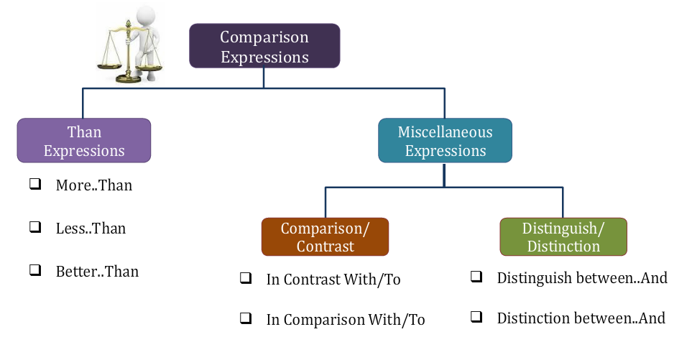

Than Expressions
Comparative words require use of THAN
Some examples are as below:
- Less….Than
- More….Than
- Smaller….Than
- Better….Than
- Larger….Than etc.

Ex 1a: She is taller than other girls in the class. Correct.
Ex 1b: She is taller as compared to other girls in the class. Incorrect.

Miscellaneous Expressions
- Comparison/Contrast
Refer the diagram below to know which are valid and which are invalid usages –

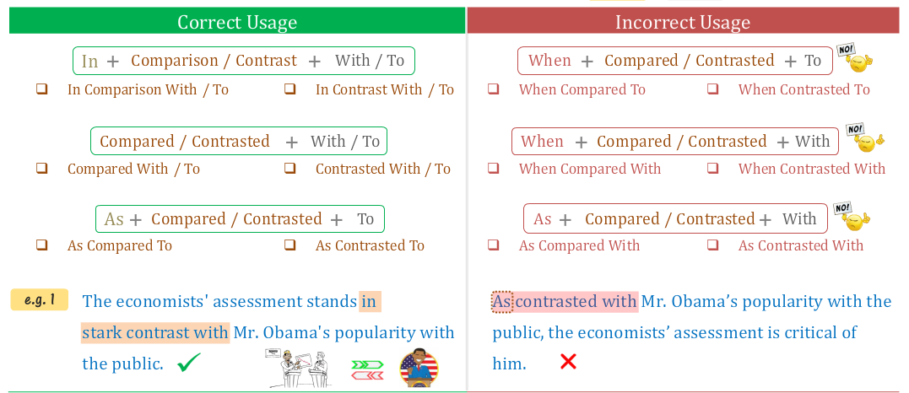

Correct Usage:
- In + Comparison/Contrast + With/To
- Compared/Contrasted + With/To
- As + Compared/Contrasted + To
Ex 1: The economists assessment stands in stark contrast with Mr. Obama’s popularity with the public. Correct.
Incorrect Usage:
- When + Compared/Contrasted + To
- When + Compared/Contrasted + With
- As + Compared/Contrasted + With

Note: We should not use ‘As’ and ‘When’ with Contrast.

Ex 2: As contrasted with Mr. Obama’s popularity with the public, the economist’s assessment is critical of him. Incorrect.
Ex 3: In the study conducted in Scotland, 44% of patients using essential oils showed improvement when compared to only 15 percent of patients in the control group. Incorrect.

- Distinguish/Distinction
Refer the diagram below to know which are valid and which are invalid usages –
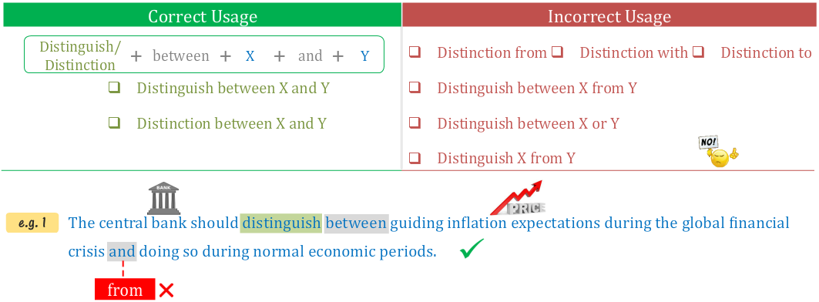

Correct Usage:
- Distinguish between X and Y
- Distinction between X and Y
Incorrect Usage:
Note here that any other usage (some samples as given below) from the above correct usage is not correct.
- Distinction from
- Distinction with
- Distinction to
- Distinguish between X from Y
- Distinguish between X or Y
- Distinguish X from Y

Ex 4: The central bank should distinguish between guiding inflation expectations during the global financial crisis and doing so during normal economic periods. Correct.
Ex 5: The placement industry needs to make clear the distinction of registered from regulated firms. Incorrect.

Uses of Like

Correct usages of ‘Like’:
- Shows similarity (comparison) between two entities.
- Presents logical comparison.
- Conveys intended meaning of sentence.
- Always followed by a Noun (phrase)/Pronoun (phrase).
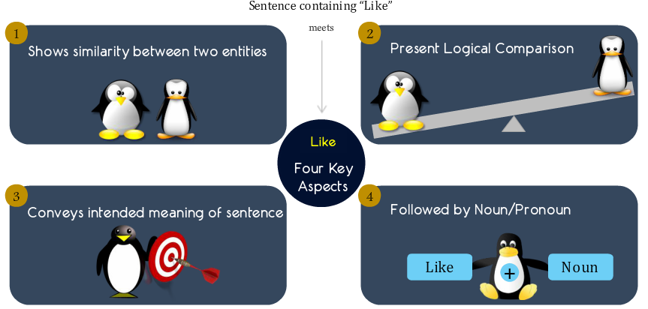
Ex 1: Amy takes care of the children in the day care like a mother.
Ex 2: Like a honeybee, a hummingbird collects nectar from flowers.
Ex 3: Like that of a snake, the sting of a scorpion can be painful and sometimes fatal too.
Ex 4: In the recital Ria sang children songs like her mother.
Ex 5: Mr. Roy teaches like Ms. Fey.

Incorrect usages of ‘Like’:
- ‘Like’ followed by a clause.
- ‘Like’ used to present examples.
- ‘Like’ presents illogical comparison.
- ‘Like’ presents ambiguous meaning.
- Incorrect placement of ‘like’ changes intended meaning.
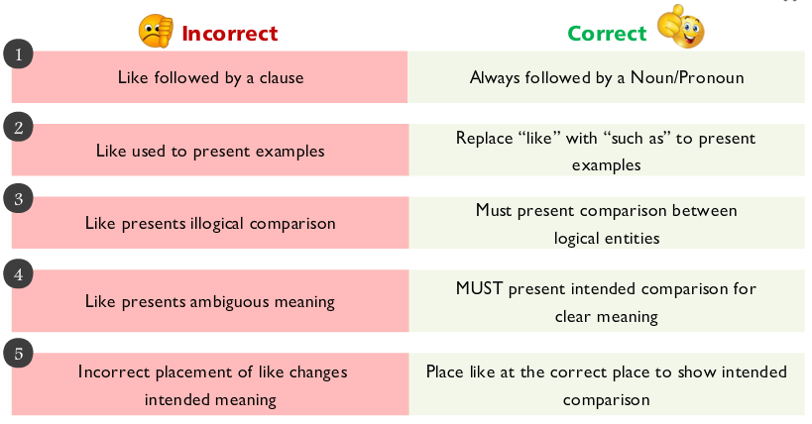

Ex 1: Amy takes care of the children in the day care like a mother does. Incorrect. Here ‘a mother does’ is a clause and this sentence will be corrected if we remove the word does.
Ex 2: Like a honeybee does, a hummingbird collects nectar from flowers. Incorrect. Here ‘a mother does’ is a clause and this sentence will be corrected if we remove the word does.
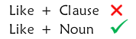
Ex 3: The modern world is coping with numerous issues like global warming, economic crisis, and wide-spread terrorism. Incorrect. Here like should be replaced with such as to make this sentence correct.
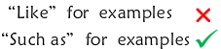
Ex 4a: Like many tragic characters, life of Macbeth had more circumstantial misgivings than personal flaws. Incorrect.
Ex 4b: Like many tragic characters, Macbeth had more circumstantial misgivings than personal flaws. Correct.
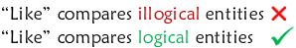
Ex 5: Kim needs a tennis trainer like her brother. Incorrect. Here the sentence is unambiguous as we are not sure if the comparison is between ‘Kim’ and her ‘brother’ or between ‘the tennis trainer’ and her ‘brother’. Refer the below diagram for correct options.
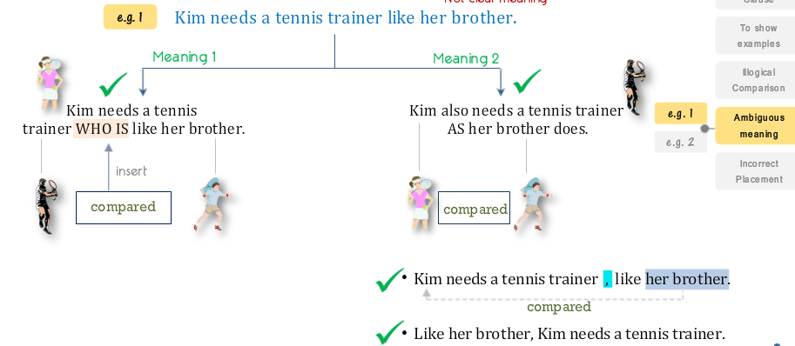

Very important Note 1: Note that whenever like is immediately preceded by a comma, the noun in the like clause is compared to the subject of the clause preceding like.

Ex 6: Joe wants to play guitar with innovative musicians like David Gilmour. Incorrect. Refer the below diagram for correct options.
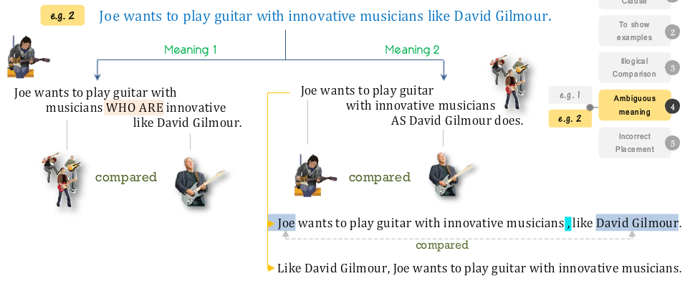
Ex 7: Mr. Roy teaches like Ms. Fey.
Ex 8: Ria sang children songs like her mother.
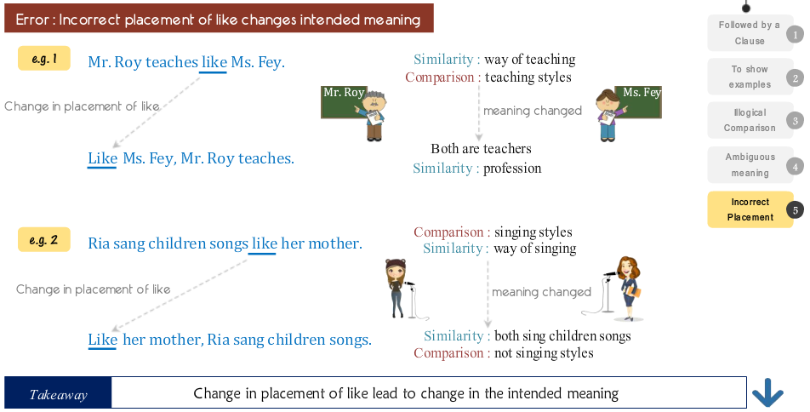

Uses of As
1 – Comparison.
2 – Show two simultaneous actions.
3 – Reasoning.
4 – Role/Function

- When AS is used for ‘Comparison’ it should always be followed by a clause or a prepositional phrase where ellipsis exist.
Ex 1: Amy takes care of the children in the day care as a mother does.
Ex 2: As a honeybee does, a hummingbird collects nectar from flowers.
Important Note 1: Note that AS can also be used for comparison with a prepositional phrase following it provided a logical comparison exists with Ellipsis (on adding the words omitted to create Ellipsis effect, the prepositional phrase becomes a clause).
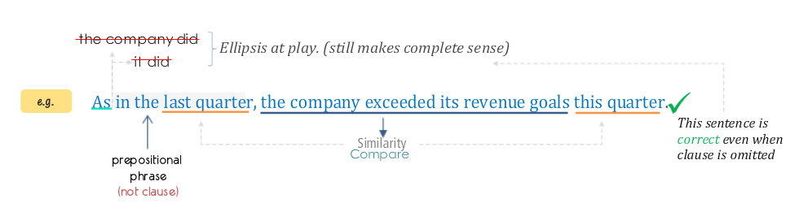

More Examples –
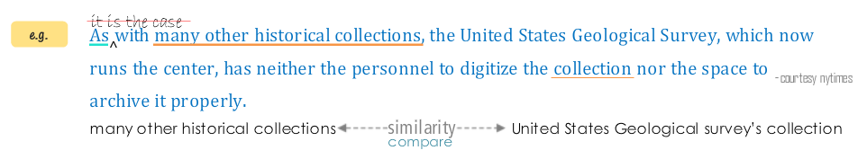
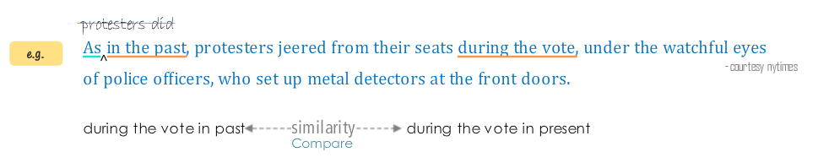

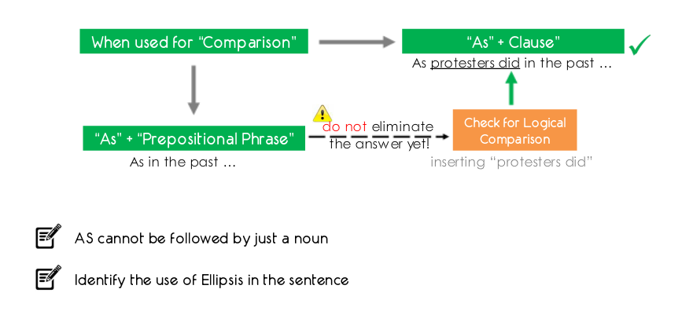

- AS is also used for cases where simultaneous actions are depicted.

Ex 1a: As I was travelling in the subway, I noticed unattended bags underneath the seat.
Ex 1b: While I was travelling in the subway, I noticed unattended bags underneath the seat.
Ex 1c: During my travel in the subway, I noticed unattended bags underneath the seat.

Important Note 2: When AS is used to depict simultaneous actions, AS can also be replaced by WHILE or DURING.

- AS can also be used to give a reason for a question.

Ex 1a: Mary has substituted green tea for coffee as she wants to cut down her caffeine consumption.
Ex 1b: Mary has substituted green tea for coffee because she wants to cut down her caffeine consumption.
Ex 1c: Mary has substituted green tea for coffee since she wants to cut down her caffeine consumption.

Question Why has Mary substituted green tea for coffee?

Important Note 3: When AS is used to give a reason for a question, it can also be replaced by because or since.

- AS can also be used to give the ROLE or FUNCTION of a person or a thing.
Ex 1: John has joined the organization as a researcher.
Ex 2: As an elder sister, Emma takes care of her siblings very well.

Important Note 4: When AS is used to state a role or a function, it is always followed by a NOUN.

Like VS AS

Below examples demonstrate the confusions often caused in the usages of LIKE and AS.
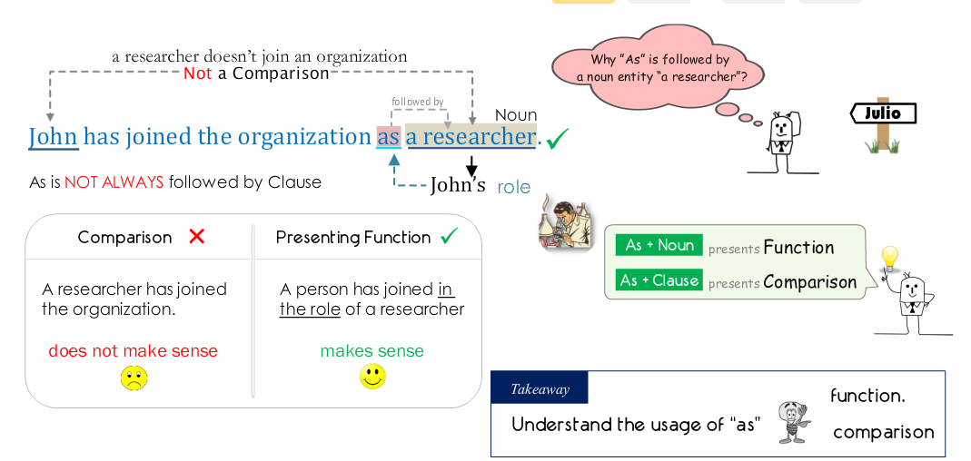

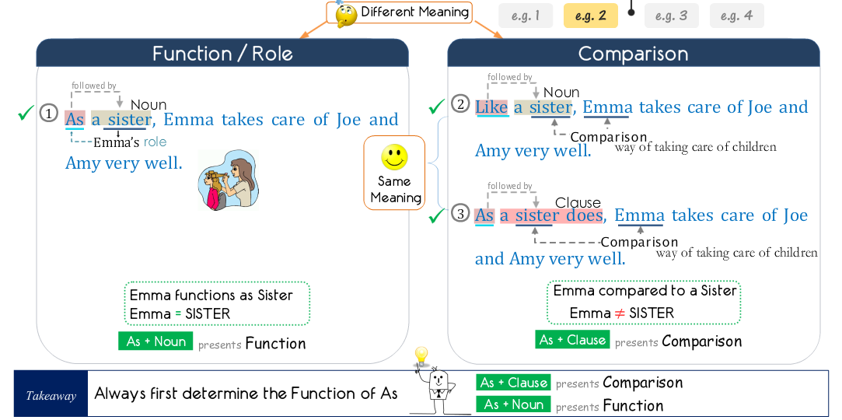
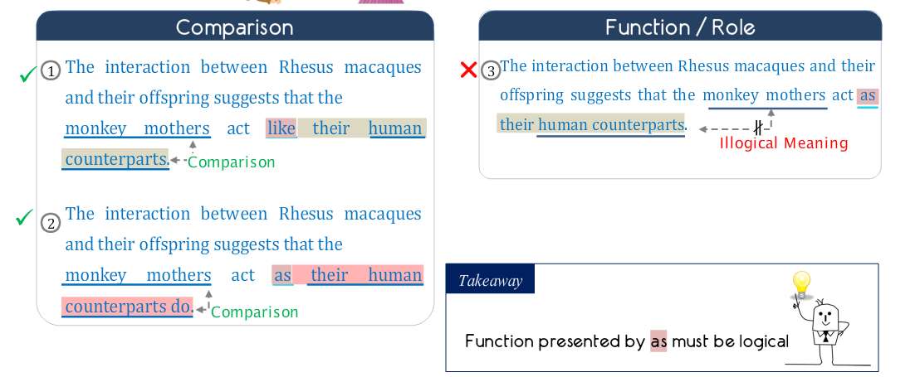

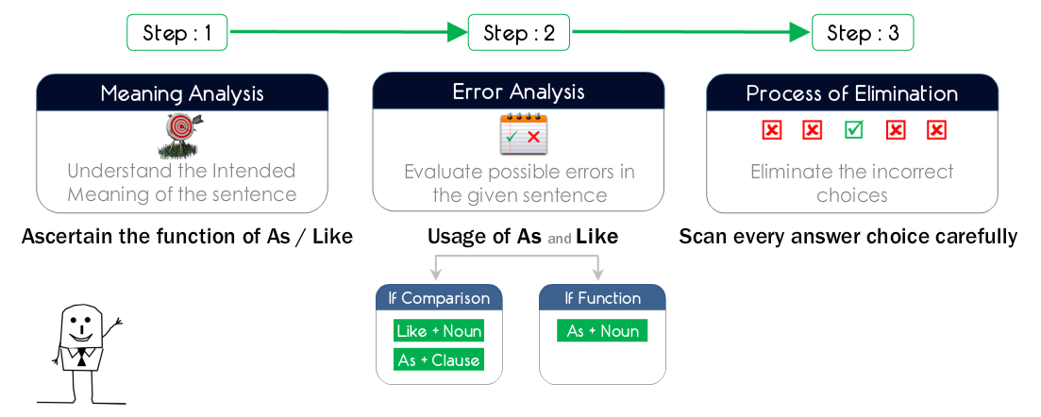

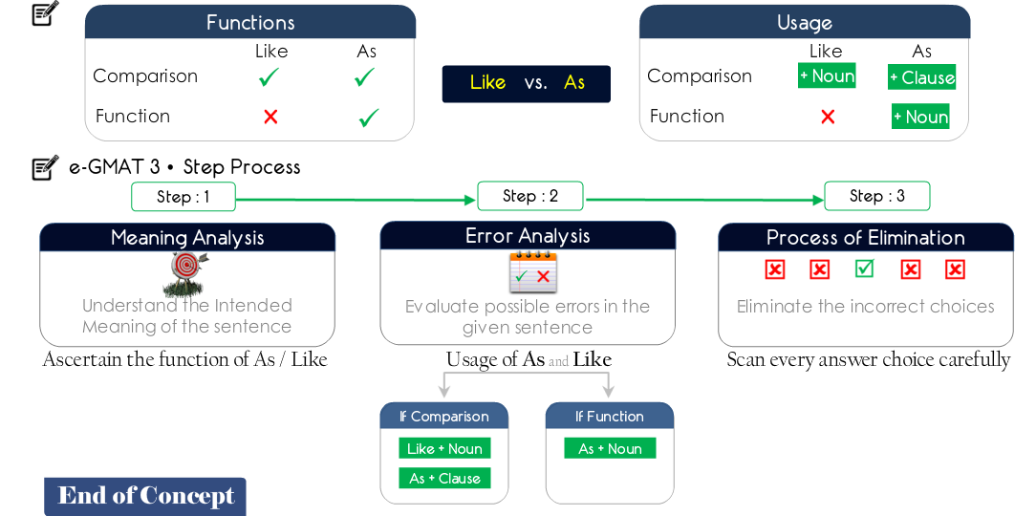

Important Note 1: Refer the below question which is very important –

The theory that sperm whales of the Southern Ocean act as carbon sinks may take significant research to be proven, but the belief that these whales act like thieves can be easily proven through the recently recorded video.

- as carbon sinks may take significant research to be proven, but the belief that these whales act like
- like carbon sinks may take significant research to be proven, but the belief that these whales act like
- like carbon sinks may take significant research to be proven, but the belief that these whales act as
- as carbon sinks may take significant research to be proven, but the belief that these whales act as

Note: Here option A is correct and not D. This is because between whales and thieves we cannot use AS because being a thief cannot be a role or a function that can be attributed to a whale. A whale can only be compared to a thief. Option D hence, logically does not make sense and hence option A is correct.

Idioms

Standard Expressions
Keywords used in these standard expressions are as below –
- AS
- SO
- AND
- OR/NOR
- NOT
- Miscellaneous words.
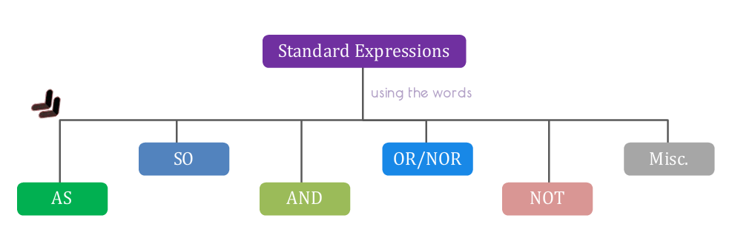

- AS
- AS X AS – Used to express ‘Comparison’.
Ex 1a: Life can be as fun as you want. Correct.
Ex 1b: Life is so fun as you want. Incorrect.

- AS much X as Y – Used to express ‘Comparison’.
Ex 1: Sam is depressed as much because he is away from his family as because he is not doing well in his job.

- AS long AS – Expression means ‘Provided That’.
Ex 1a: Marie will go on this cruise as long as it is not too expensive. Correct.
Ex 1b: Marie will go on this cruise so long as it is not too expensive. Correct.
Ex 1c: Marie will go on this cruise as long so it is not too expensive. Incorrect.

- AS X so Y – Expression means ‘In the same way’.
Ex 1: As you sow, so shall you reap.
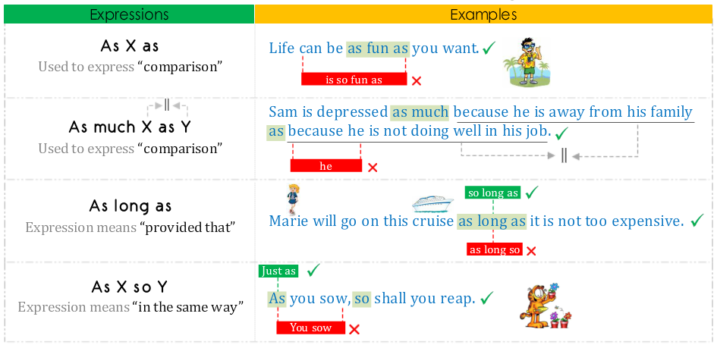

- SO
- SO X that Y – Y “explains or describes” X.
Ex 1: The test was so difficult that I could not even complete it.

- SO that – Expression conveys “purpose”.
Ex 1a: He spoke slowly so that the assistant could write everything down. Correct.
Ex 1b: He spoke slowly so the assistant could write everything down. Incorrect.

- SO long AS – Expression means “Provided That”.
Ex 1: Marie will go on this cruise so long as it is not too expensive.

- SO too – Expression means “as well”.
Note: A helping verb is always needed here after too.
Ex 1a: As Google grows, so too do its antitrust issues. Correct.
Ex 1b: As Google grows, so too its antitrust issues. Incorrect.
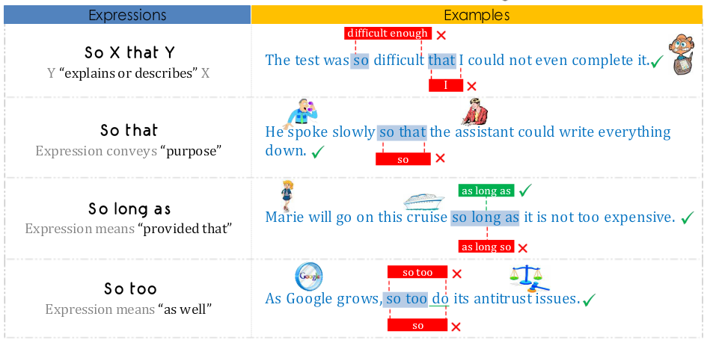

- AND
- Between X AND Y
Ex 1a: The competition is between the Republicans and Democrats. Correct.
Ex 1b: The competition is between the Republicans or Democrats. Incorrect.

- Both….AND….
Ex 1a: Both Mary and Sally are cooking in the potluck this weekend. Correct.
Ex 1b: Both Mary or Sally are cooking in the potluck this weekend Incorrect.

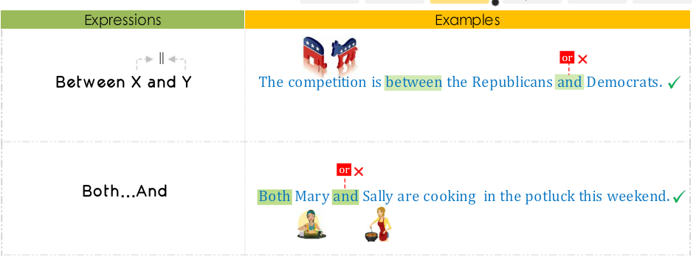

- OR/NOR
- Either X OR Y
Ex 1: Tonight, I can wear either black dress or white dress.

- Neither X NOR Y
Ex 1a: Tonight, I can wear neither black dress nor white dress. Correct.
Ex 1b: Tonight, I can wear neither black dress or/and white dress. Incorrect.

- Whether X OR Y
Ex 1: I have not decided whether I should wear black dress or I should wear white dress.

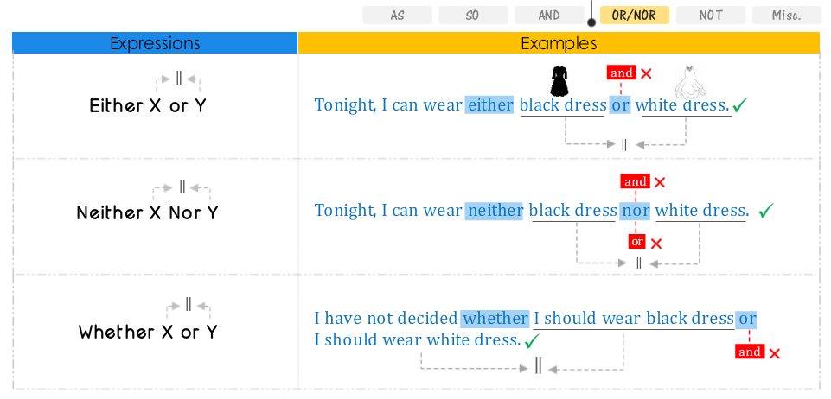

- NOT
- NOT X but Y
Ex 1: He is not a permanent teacher but a substitute teacher.

- NOT only X but also Y OR NOT only X but Y
Ex 1: Sally not only likes almonds but also likes pecans. Correct.
Ex 2a: Sally likes not only almonds but also pecans. Correct.
Ex 2b: Sally likes not only almonds as well/and also pecans. Incorrect.

- NOT X but rather Y
Ex 1: Tomato is not a vegetable but rather a fruit.

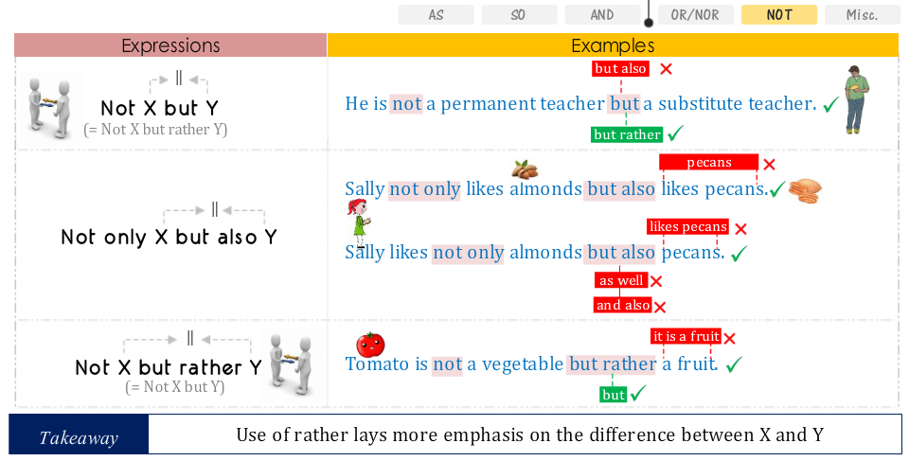

- Miscellaneous
- X rather than Y
Ex 1: Marie likes sleeping late rather than waking up early in the morning.

- X instead of Y
Ex 1: Marie likes sleeping late instead of waking up early in the morning.

- FROM X to Y
Ex 1: The stock market plummeted from 1000 points to 800 points today.

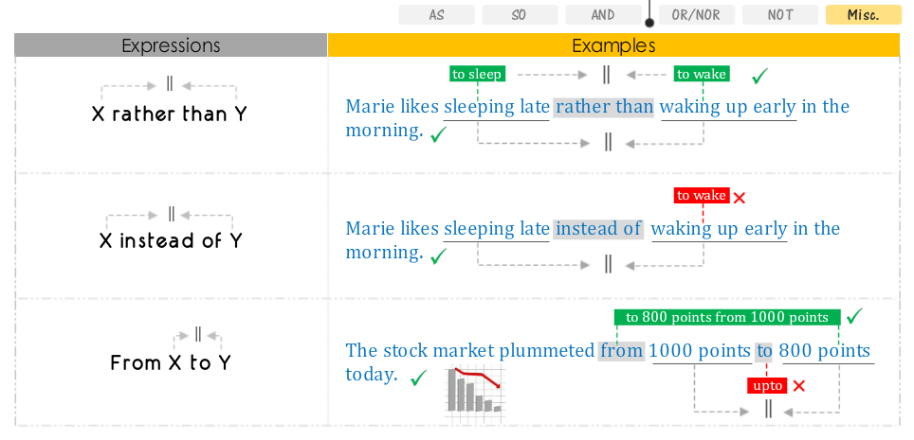

Important Note 1: “Rather Than” is used to show judgment or preference of one choice over the other. Moreover it can be followed by nouns or verbs.
Important Note 2: “Instead of” is used to show replacement of one thing by the other. Moreover it can be used only for nouns.

Quantities

Countable and Uncountable Nouns
Step 1: Check if a particular quantity is countable or uncountable.
Step 2: Use the appropriate words based on quantity.

Ex 1a: Fewer than 10 apples. Correct.
Ex 1b: Less than 10 apples. Incorrect.
Ex 2a: Number of apples. Correct.
Ex 2b: Amount of apples. Incorrect.

How to identify nouns as countable or uncountable?
2 ways for this –
- Countable Nouns –
- CAN be counted as discrete objects.
Ex: 1 apple, 2 apples etc.
- Plural form of VERB exits.
Ex: Apple – Apples, Person – Persons

- Uncountable Nouns –
- CANNOT be counted as discrete objects. (Need a unit to quantify)
Ex 1a: 1 Air, 2 Airs
Ex 1b: 1 cc of Air, 2 cc of Air
- Plural form of verb DOES NOT EXIST.
Singular – Air, Plural – Airs
Singular – Luggage, Plural – Luggages

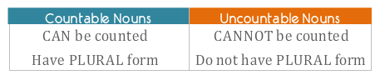
Some list of words:
- Words which can be used with Countable Nouns

- Few -- Few Songs.
- Number -- Number of songs.
- Numerous – Numerous songs.
- Many -- Many songs.

- Words which can be used with Uncountable Nouns

- Less -- Less music.
- Amount -- Amount of air.
- Much -- Much attention.
- Little -- Little attention.
- Great -- Great patience.
- Equal -- Equal justice.

- Words which can be used with both Countable and Uncountable Nouns

- More -- More songs.
- Most -- Most songs.
- Enough -- Enough songs.
- All -- All songs.

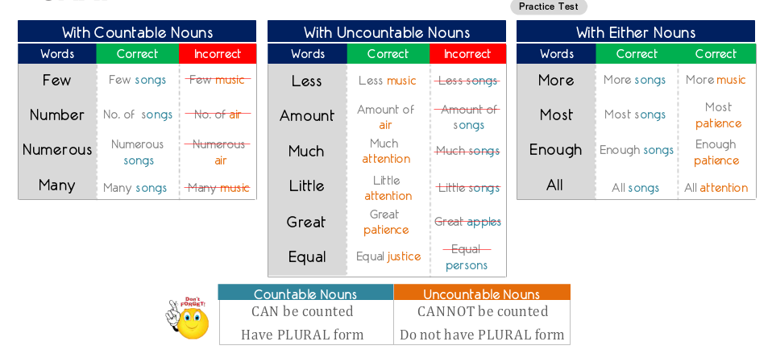

Comparing Quantities
- When 2 quantities are compared, we have a certain list of words which can be used as below –

- Between
- More
- Better
- Less

- When more than 2 quantities are compared, we have a certain list of words which can be used as below –

- Among
- Most
- Best
- Least

Ex: Among the five working days of the week, Friday is the most relaxing.

Increase/Decrease VS Greater/Lesser

Increase/Decrease Express change of same thing over time.
Ex 1: The price of gold has increased over the past 3 decades.

Greater/Lesser Express comparison between two different things.
Ex 1: The price of gold is several orders of magnitude greater than the price of silver.

Important Note 1: “Greater” when needs to be used with nouns, it should be used with nouns which indicate numbers. Examples as below –
- Likelihood – probability.
- Percent
- Interest rate
- Population
- Volume
- Distance
- Price
- Cost
- Number
- Height
- Length
- Population
Ex a: The population of Colombia is greater than that of Argentina. Correct.
Ex b: The population of Colombia is more than that of Argentina. Incorrect.
- If you are dealing with a word that describes things that you can actually count, then you should use “more”.
- If you are dealing with an uncountable noun that is NOT a numerical quantity, then you should use “more”.
Something like ‘Tulips’ can be quantified but ‘Tulips’ do not represent a mathematical entity or number. Hence, “Greater” cannot be used with ‘Tulips’.

set 1. many...more...most set 1 is used for countable nouns.
set 2. much...more....most set 2 is used for type b (other non-numeric uncountable nouns) uncountable nouns.
set 3. great...greater...greatest set 3 is used for type a (Quantity word / numbers) uncountable nouns.

Note: “Chance” is both countable and uncountable.

Functions of Words - I

- Such As VS Like
Such As – Used to show examples
Like – Never used to show examples

- Affect VS Effect
Affect – to have an influence on
It is always used as a VERB.
Ex – Hot weather affects my ability to enjoy outdoor activities.

Effect – the result
It is always used as a NOUN.
Ex – Hot weather has a huge effect on my outdoor activities.

Ex 1: When the professional tensions start affecting your personal life, the effects can be very damaging.

- Aggravate VS Aggravating
Aggravate – To make worse
Always used as VERB
Ex: Loud noises aggravate headaches.

Aggravating – annoying
Always used as ADJECTIVE
Ex: His aggravating temperament is no longer tolerable.

Ex 1: People in under-developed countries face the most aggravating diseases, which get aggravated by the sub-standard infrastructure.

Ex 2a: Even though several republicans claim that the financial bailout plans will be wasting taxpayers’ money and aggravating poverty, none of them can prove their claims with actual calculations. Incorrect.
Ex 2b: Even though several republicans claim that the financial bailout plans will waste taxpayers’ money and aggravate poverty, none of them can prove their claims with actual calculations. Correct.

Functions of Words – II

- Means
Means + Preposition

- As a means of
X as a means of Y
X is a type of Y
Ex: Walking is a means of Exercise.

- As a means to
X as a means to
X is a method to achieve Y
Ex: Some people use walking as the means to stay fit.

- Aid
Aid means Help
- When AID is used as a VERB it cannot be followed by a preposition.
Ex 1a: Red Cross aids underprivileged children. Correct.
Ex 1b: Red Cross aids for underprivileged children. Incorrect.
- When AID is used as a NOUN it has to be followed by a preposition.
Ex: Red Cross provides aid for underprivileged children.

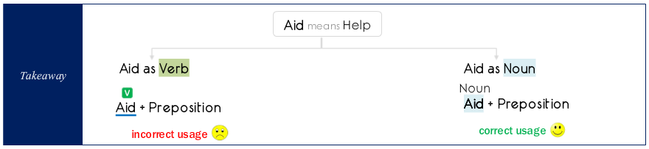

- Account
- Account as NOUN means narrative.
- Account as VERB means to be responsible for.

Ex 1: Per the account of firefighter, negligent bon fire in the campsite accounted for the raging forest fire.
Ex 2: Per the account provided by the head of AMA, Medicare and Medicaid account for the bulk of government spending on healthcare.

- Rate
- Rate for Means price charged.
Ex: Rate for insurance coverage has increased over the last two years.
- Rate of Means measure.
Ex: Rate of change of stock prices indicates the extent of volatility.

DUE TO VS BECAUSE OF
- DUE TO Used to modify NOUNS.
- BECAUSE OF Used to modify VERBS or actions.
Note 1: Both cannot be used interchangeably.

DUE TO
- “DUE TO” can only be used to modify NOUNS and not to present reason for an action.

Ex 1a: It is cold (Verb) in Arizona due to the westward storm coming from the Pacific. Incorrect.
Note: Trying to answer the question “WHY” it is cold hence trying to modify a verb.
Ex 1b: Arizona’s cold wave (Noun) is due to the westward storm coming from Pacific. Correct.

- Usage of “DUE TO” is correct if the sentence makes complete sense when “DUE TO” is replaced by “CAUSED BY”.

Ex 1c: Arizona’s cold wave is caused by the westward storm coming from the Pacific. Correct.

BECAUSE OF
- “BECAUSE OF” is used to modify entire clauses. This expression can be used to present reason for an action in the clause.

Ex 1d: It is cold in Arizona because of the westward storm coming from Pacific.

Ex 2a: The parent-teacher meeting was cancelled due to heavy rains. Incorrect.
“Due to” incorrectly modifies “was cancelled” here.
Ex 2b: The parent-teacher meeting was cancelled caused by heavy rains Incorrect.
“Caused by” incorrectly modifies “was cancelled” here.
Ex 2c: The parent-teacher meeting was cancelled because of heavy rains Correct.
“Because of” correctly modifies “was cancelled” here.
Ex 2d: The cancellation of parent-teacher meeting was due to heavy rains Correct.
“Due to” correctly modifies “the cancellation” here.
Ex 2e: The cancellation of parent-teacher meeting was caused by heavy rains. Correct.
“Caused by” correctly modifies “the cancellation” here.

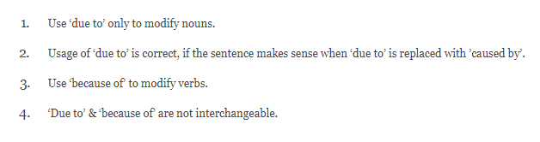

TO VERB VS VERB-ING

TO VERB – Used when we need to present the purpose or the intention of an action.
TO VERB in order to VERB
Ex 1: Joe wrote a book to share his experiences with others. Correct.
Ex 2: Joe got acclaims to write the book. Incorrect.
Note: TO VERB is used to answer the question WHY posed to the sentence or the other verb in it.

FOR VERB-ING – Used to modify either a Noun or a Verb.
FOR VERB-ING answers the question ‘WHAT FOR’
Ex 1: Joe got acclaims for writing the book. Correct.
Ex 2: Joe wrote a book for sharing his experiences with others. Incorrect.

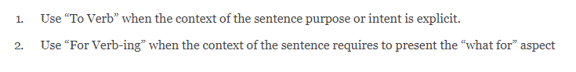

Usage of BEING

Correct uses of Being
1 – When Being is used as a noun.
Ex 1: Being disrespectful to elders is not an acceptable behavior.
Subject here is – being disrespectful to elders.
2 – When passive continuous verb tense is required to communicate the meaning.
Ex 2: The residents of this 100-year old apartment complex are being evacuated because of structural instability of the building.
“are being evacuated” – present continuous written in passive voice.

Note:
Active Voice: Subject is acting.
Passive Voice: Subject is being acted upon.

Miscellaneous Topics

5 ways in which GMAT introduces error in the sentences –
- Change placement of modifiers.
- Use different modifiers.
- Use different conjunctions.
- Change voice of the sentence.
- Remove/add words that provide context or use word differently.

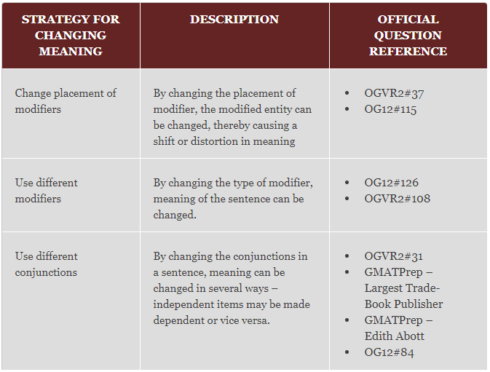
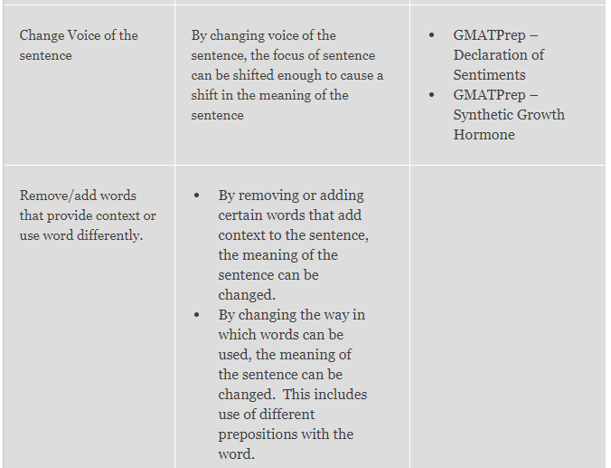

The peril of ignoring the non-underlined words

The non-underlined words should not be ignored as the intended meaning of the sentence will only be clear after reading the complete sentence.
Often errors like parallelism of Verb Tense error become clear on reading the complete sentence.

Introduction of alien words in an answer option

Alien words can be introduced in an answer choice to –
- Either enhance the overall meaning of the sentence. OR
- Enhance the sentence to make it more logical. OR
- Introduce a grammatical error in the sentence. OR
- Make the sentence illogical. OR
- Change meaning.


