Quant Notes
Weak areas: geometry, in/equalities/algebra, num properties (primes, factors), arithmetic
- Know combinatorics and probability, but not a big part of the exam
- ”study quant basics to death. Don't practice difficult combinatorics and probability questions unless you are 100% confident in your basic quant abilities. Things like number properties (even/odd, prime factors) and geometry (inscribed triangles, areas, perimeter) are way more common than combs/perms.”
Doesn't necessarily test how good math skills are, but how good you are at solving under time pressure.
- Before answering, CHECK WHAT QUESTION ASKS FOR—make sure you answer what is asked.
  - E.g. asks if n is median but you solve for specific sequences when in all possible sequences n is median
  - E.g. asks if n is divisible by m but you’re trying to solve for what n is
- Know when to make smart guesses
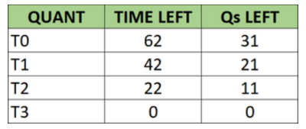
- But also PROVE each of two options in DS questions—don’t rush. May be trap
***DS is deciding factor***
- A/B-trap questions: if A or B looks too obvious, consider D via number plugging or algebra proof.***
- C-trap questions: if C looks too obvious, try to prove A or B alone.
  - In rarer cases, E may be the answer—try to prove C before assuming it’s true
- “didn’t plug in actual equations” trap
- “step back for a sec—are these values already past the max possible?” trap
- “X can also be 0” DS trap
- “Odd/even – didn’t specify they are integers” DS trap
- E-trap: not A, and B is obviously wrong—“why is this here?” Consider if C is possible
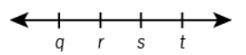
Integer Properties, Statistics, Probability, Inequality, Absolute Value: vital 100% correct
Assume values in diagrams are evenly spaced if it looks like so
Different variables x, y can represent same # unless GMAT specifies they are distinct
ALWAYS ALWAYS GO BACK AND CHECK WHAT SPECIFICALLY THE ANSWER IS SOLVING FOR. DON’T ASSUME
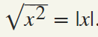
- Absolute Values/Modules
- For each scenario set +/- rule at top: |x+3| = 4x – 3, case 1: X+3<0 so X<-3 x=0 solution is invalid
- Absolute value charts: implicit assumptions, reconcile with equations
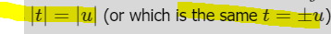
- Square root function cannot give negative result
- Algebra
- Keep track of all limits to equation. If multiple solutions, make sure they are consistent with all assumptions.
  - EG if x = | phrase |, x >= 0. |0| = 0
- Look for hidden quadratics and clever ways of solving for (X-Y)² and (X+Y)² algebra
- Quadratics: discriminant and roots
b² −4ac < 0 There are no real roots  b² −4ac = 0 There is one real root  b² −4ac > 0 There are two real roots  Roots $\frac{-b ±\sqrt{b^2-4ac}}{2a}$ | Sum of roots = -b/a  Product of roots = c/a  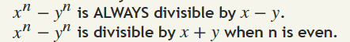
- Arithmetic
- When solving for hundreds, tens, units digits, remember implicit limits (0<x<10) or (x<10)
- For any set of consecutive integers with an even # of terms, sum is never a multiple of the number of terms.
For any set of consecutive integers with an odd # of terms, sum is always a multiple of the number of terms.
- sum of all items = # of items * average
- Combinations
- # of possible combo lists from X items = 2^{x} (each item is on or off)
- 0! = 1
- Treat “EE” as one letter
Permutations: nPk = n!/(n-k)!
Combinations: nCk = n!/((n-k)!k!)
- Permutation where x elements are identical: nPk/x!
How many unique combinations of the five letters L, E, V, E, L can be formed?
5! / 2!*2!
Where 2! Are the groups of letters where order doesn’t matter (E, L)
Unique combinations where the two occurrences of E are separated by at least one other letter?
(5! / 2!*2!) – (4! / 2!)
- Coordinate Geometry
- Careful with number lines +/- questions, consider cases where everything is negative
- Perpendicular lines: slopes are negative reciprocals (-1/2, 2)
- “Where (r,s) is on line y=___” is an algebra equation in disguise. May contain tricky quadratic questions.
- Distance/Rate Problems
- Divisibility/Multiples/Factors
- 0 is divisible by any # except itself, a multiple of every # except itself
- “Factor/multiple of” “even/odd/divisible by” express as even/odd, as a multiple w/ remainder algebraically
- If X/5, Y/5 have the same remainder, (X + Y)/5 remainder MUST be different
- If X is odd represent as X = 2k +1.
If X is even represent as X = 2k.
- If X is multiple of Y, X² is multiple of Y²
To prove that X is a multiple of 4, try to express x = 4Q where Q is an integer, or x² = 4*4, etc.
- If x*y is a multiple of Z, X and Y individually are not necessarily each multiples of Z (e.g. 4*3 is a multiple of 6)
- 1/6 = 0.166666 1/9 = 0.11111111
- Integers with an odd # of factors are ALWAYS perfect squares
exactly 5 factors MUST be the fourth power of a prime #
- Primes: 2, 3, 5, 7, 11, 13, 17, 19, 23, 29, 31, 37, 41, 43, 47, 53, 59, 61, 67, 71, 73, 79, 83, 89, 97, 101, 103, 107, 109, 113, 127, 131, 137, 139, 149, 151,
- Exponents/Powers
- Perfect squares: ODD number of factors. ODD sum of factors.
ODD number of odd factors (including 1)
EVEN number of even factors (excluding 1)
- Simple interest DOESN’T COMPOUND
- 0⁰=1 not tested; assume ruled out as a possible answer
- To compare which of two #s to X power is bigger, make exponents match
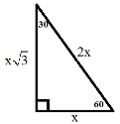
- Fractions/Ratios/Decimals
- For all terminating decimals: denominator contains only 2s and 5s as prime factors.
- Functions and Custom Characters
- Geometry
- Tangents are also points of intersection
- Consider shape dimensions as well as volume (e.g. area of slab vs covering Q, # of cans packed in a carton Q)
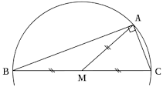
- Rhombus: parallelogram w/ equal sides
All parallelograms have opposite equal acute and obtuse angles
- Trapezoid area = ½ (h1+h2)(b)
- Pi ≈ 22/7
- median on the hypotenuse of a right triangle divides the triangle into two isosceles triangles; equals one-half the hypotenuse.
- **Area increases relative to perimeter for bigger shapes, while perimeter becomes bigger versus area for smaller shapes***
- Angles in a triangle correspond to their opposite sides
i.e., if a pair of corresponding angles are equal, the corresponding opposite sides are equal.

- Determining if Two Triangles are Similar
Three sides proportional
At least two angles equal
Side, Angle, Side
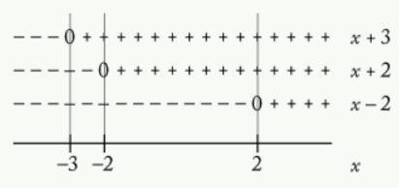
- Graphs and Illustrations
- Inequalities
- Number range tables
- can multiply both sides by positive #s without flipping sign
  - If multiplying both sides by negative #, flip sign
  - For reciprocal, flip sign if both numbers are + or -. If one neg one pos, don’t flip sign
If… | X, y <0 | 0< x,y < 1 | 1< x,y
X > Y² | Sometimes NT | T | --------
X³ > Y | T | Sometimes NT | T
Both | T | T | -------
- Min/Max Problems
- Mixture Problems
- Must or Could be True Questions
- Number Properties
E*E = E  O*O = O  E*O = E | E+E = E  O+O = E  O+E = O
At bigger #s, 3 consecutive odd #s can all not be prime (121, 123, 125)
Cube root of an integer can be non-integers too (e.g. cube root of 5)
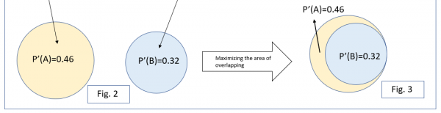
- Overlapping Sets
- Percents and Interest Problems
- Probability
- If X and Y are INDEPENDENT EVENTS (two coin flips)
P(X or Y) = P(X) + P(Y) – P(X and Y)
P(X and Y) = P(X)P(Y)
- If X and Y are at NOT INDEPENDENT EVENTS (stocks rising/falling)
Q: Given that there are 5 married couples. If we select only 3 people out of the 10, what is the probability that none of them are married to each other?
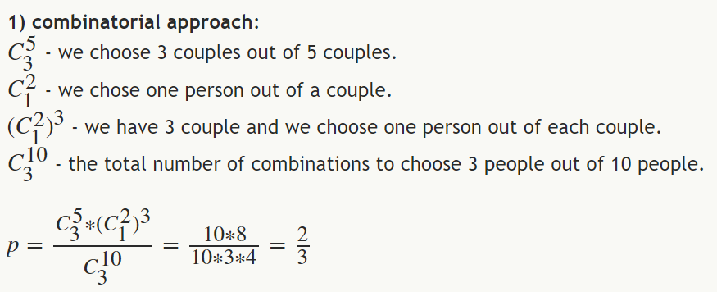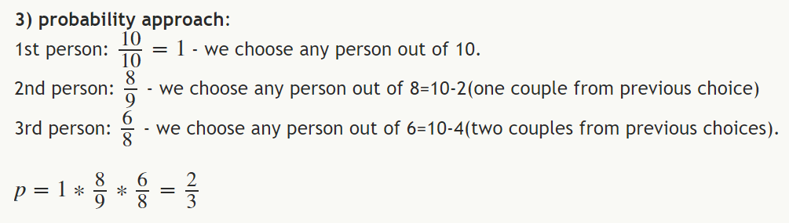
- Q: There are 8 employees including Bob and Rachel. If 2 employees are to be randomly chosen to form a committee, what is the probability that the committee includes both Bob and Rachel?
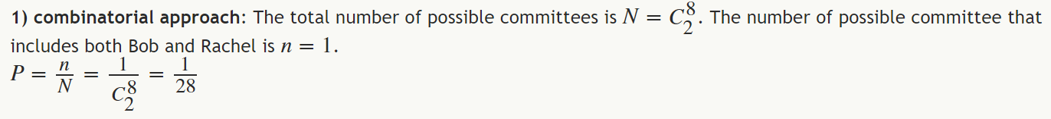
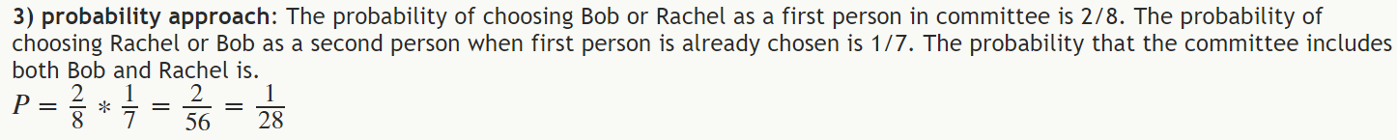
- Remainders
 | R | T | D
John
Mary
- Roots
- Sequences
- Statistics and Sets Problems
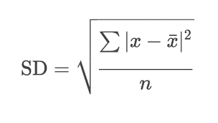
- Word Problems
- Work/Rate Problems

Overlapping sets
 | Undergrad | Grad | Total
Male
Female
Total

