Tricky

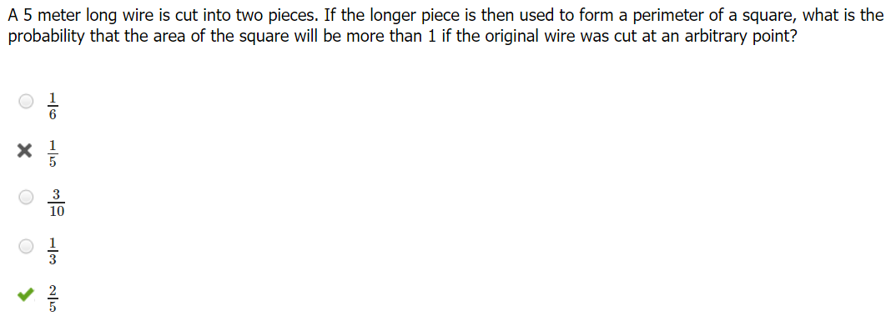
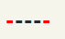

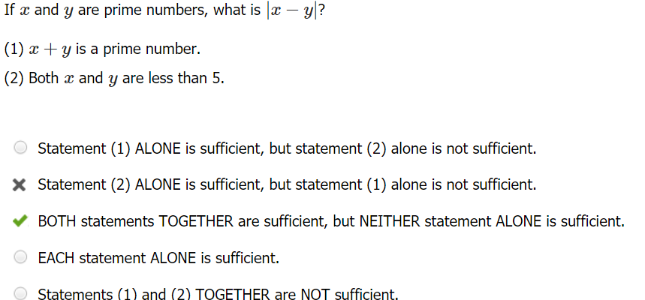

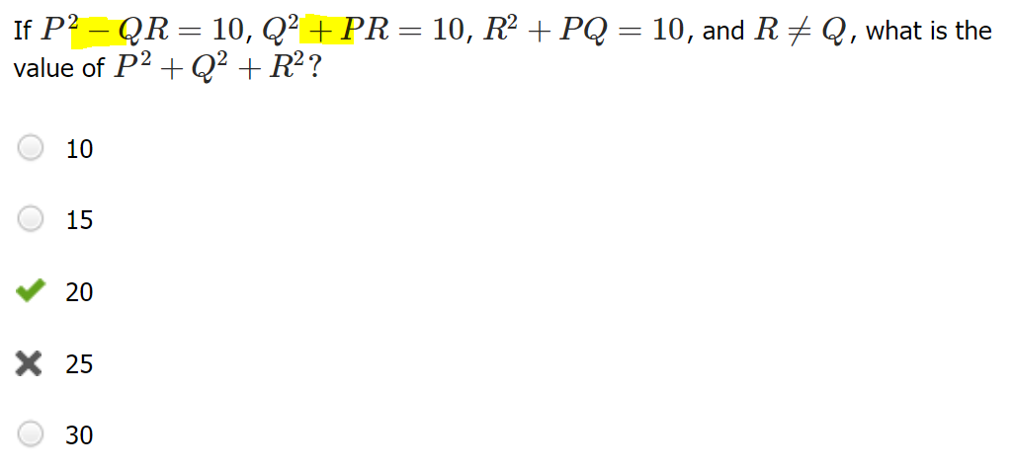
Q² + PR − P² + QR = 0
P = R + Q
Q² + PR = 10
R² + PQ = 10
Q² + R²+ P(R+Q) = 20 = Q² + R²+ P²

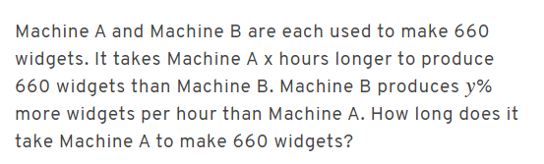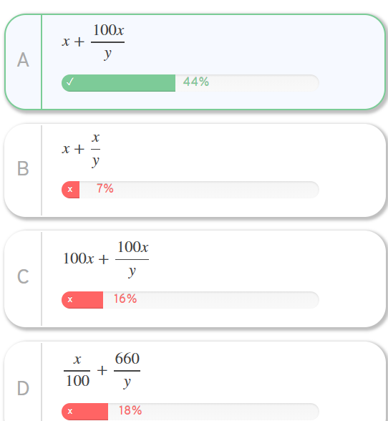
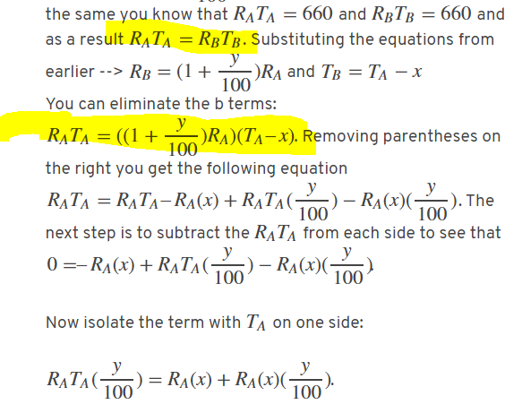

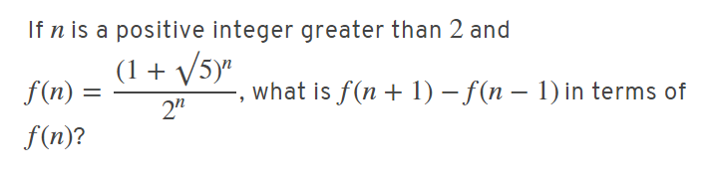
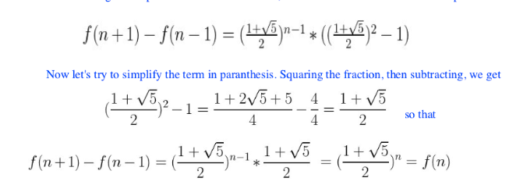

DS Traps
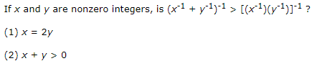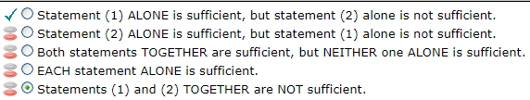
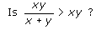
(1) 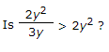
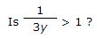
DS “not algebraic solution, test min values solution” trap. (1) it will never be greater than 1.
Algebra, MCMAT
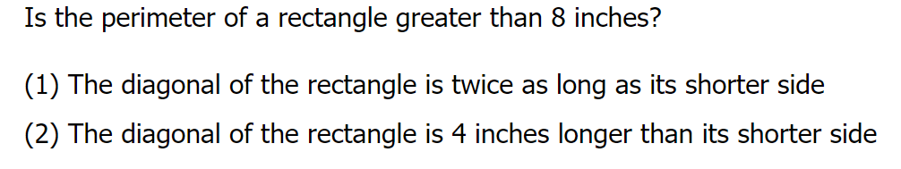
(2) is sufficient.
(2) d>4. Since the length of any side of a triangle must be smaller than the sum of the other two sides, then a+b>d, so a+b>4. Sufficient.
DS “not algebraic solution, test min values solution” trap. (1) it will never be greater than 1.
DS C-trap
Algebra, GMAT Club
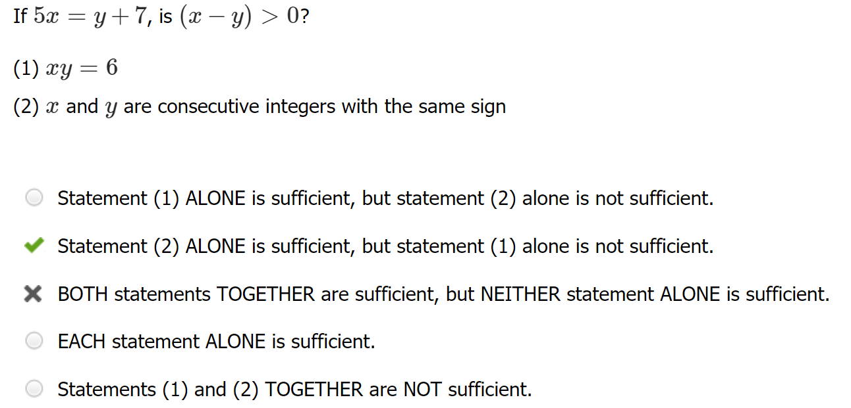
DS didn’t-check-actual-values trap. Rushed for time. Did not actually test out algebra of the 2nd.
GMATClub
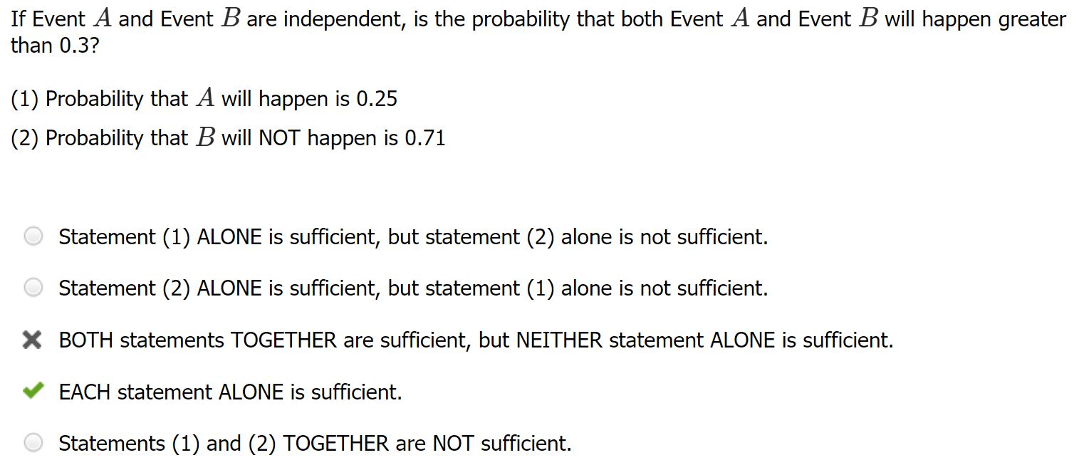
DS didn’t-check-actual-values trap: Did not test each case—each already less than 0.3
GMATClub
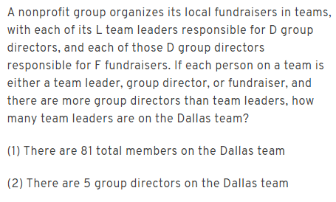
B
DS C-trap “only one integer answer” trap: (2) both must be integers and L < D so L = 1
Veritas

Absolute values

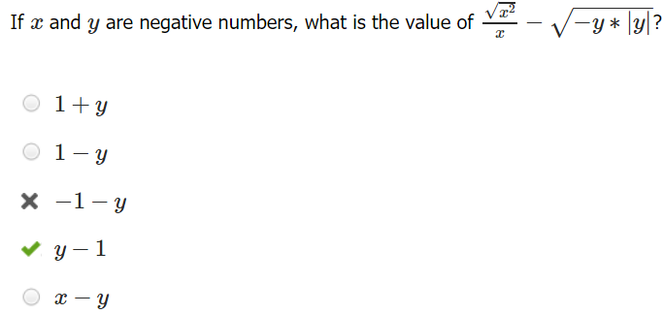
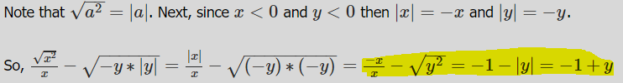

Number properties
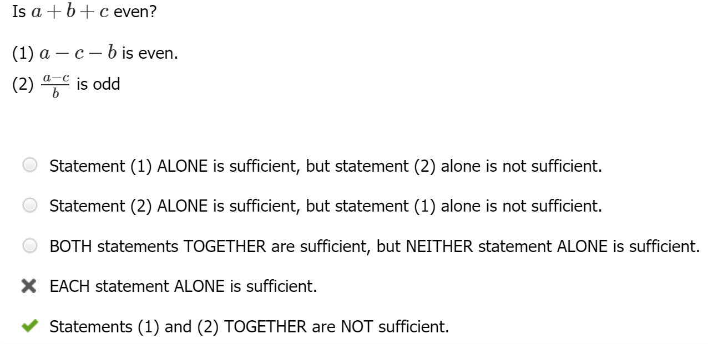
#s are not necessarily integers.
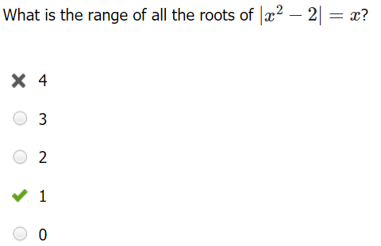
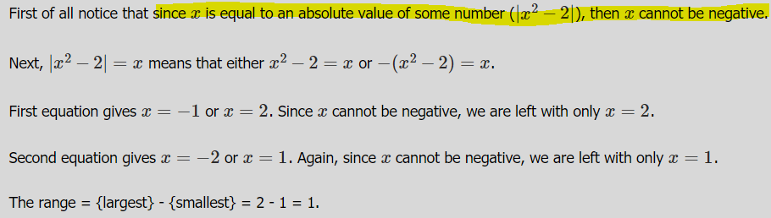
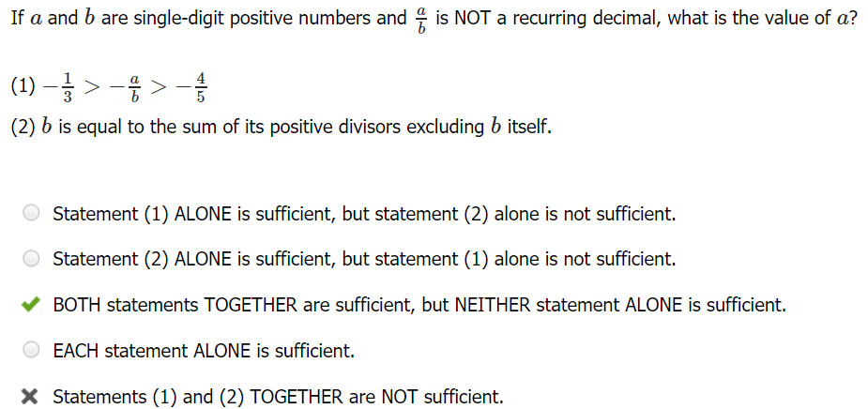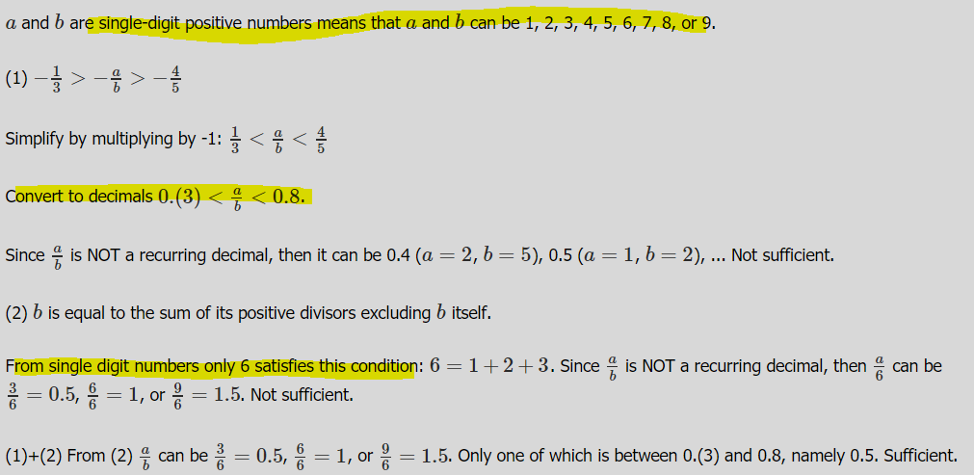
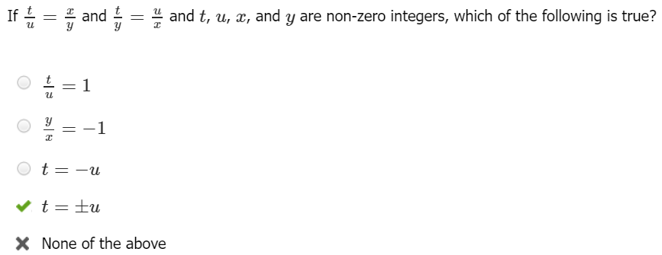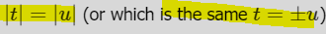
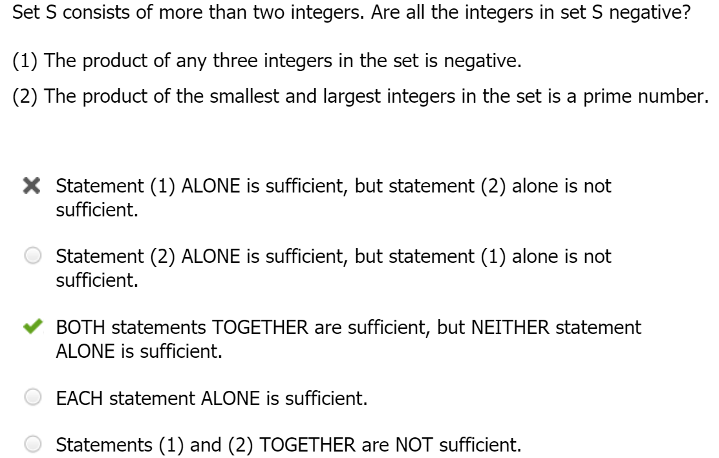
Neg/pos multiplication. Sloppy.
(1) Either {negative, negative, negative} OR {negative, positive, positive} OR all neg. Not sufficient.

(1)+(2) second statement rules out {negative, positive, positive}. Sufficient.
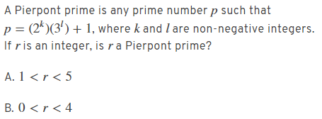
B Sloppy: did not calculate arithmetic (1)(1)+1=2 correctly.
Veritas
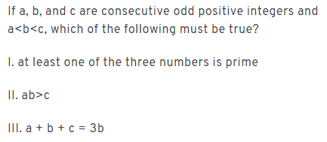
III only
Content error: I is not true for larger numbers, such as 121, 123, 125
Veritas
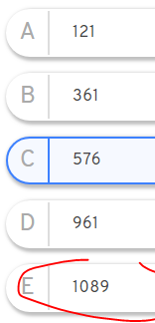
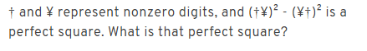

“Check all MC answers for criteria” problem. Only 1089 has factors 9, 11.
Veritas
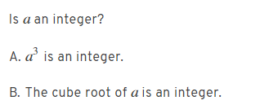
B only
Content error: (1) can be true for any cube roots of integers like cube root of 2
Veritas
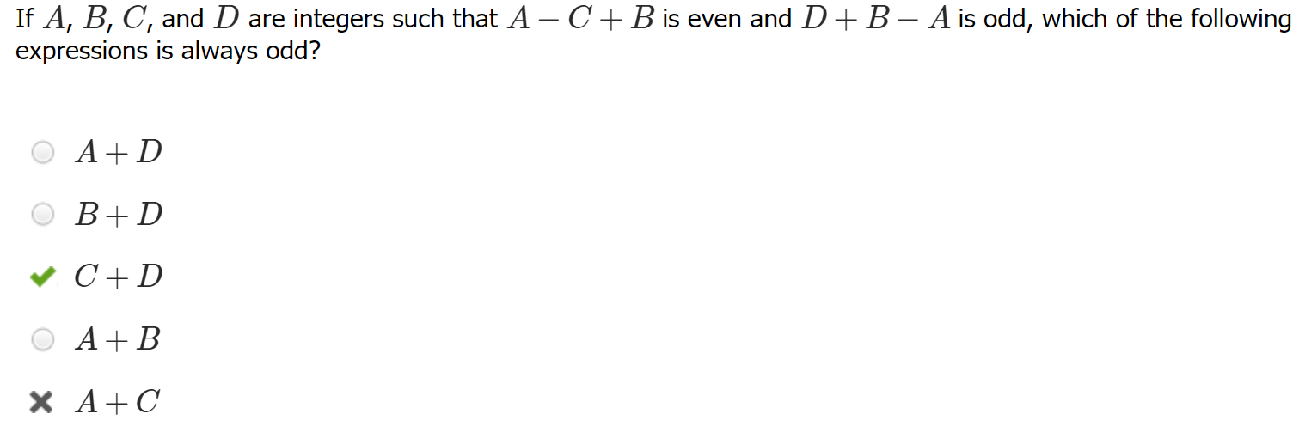
Algebra rusty: (1) A - C + B = even; thus, A - C + B = 2k (where k is an integer)
(2) D + B - A = odd; thus, D + B - A = 2k + 1 (where k is an integer)
D + B - A - 1 = 2k
A - C + B = D + B - A - 1 --> 2A + 1 = C + D
C + D = 2A + 1 (where A is an integer), C + D is ALWAYS ODD
GMATClub
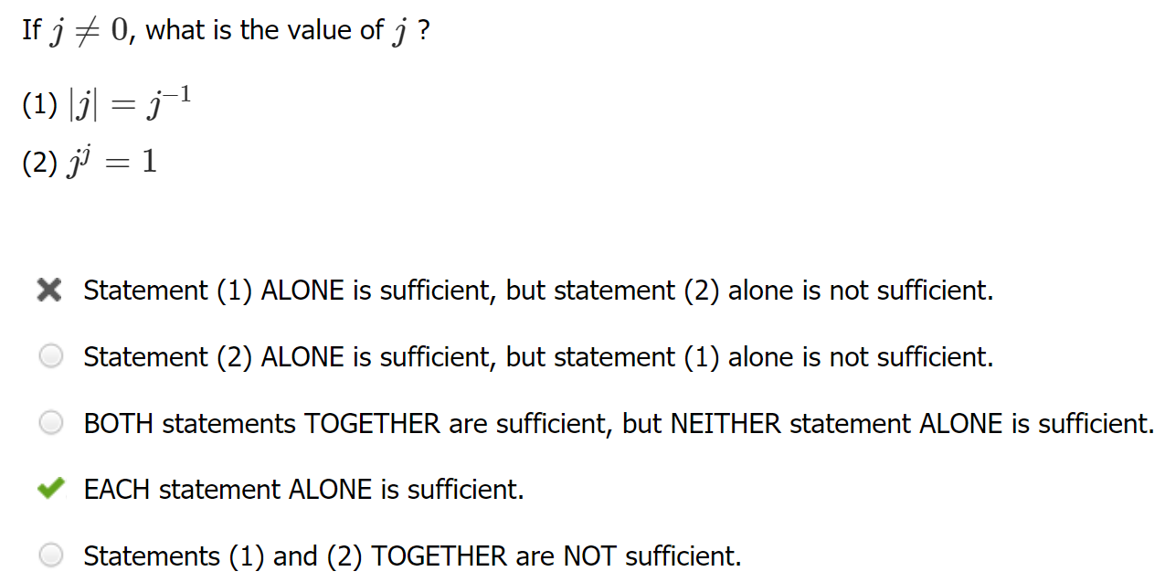
Content error. 0⁰ is undefined and not considered on GMAT.
GMATClub
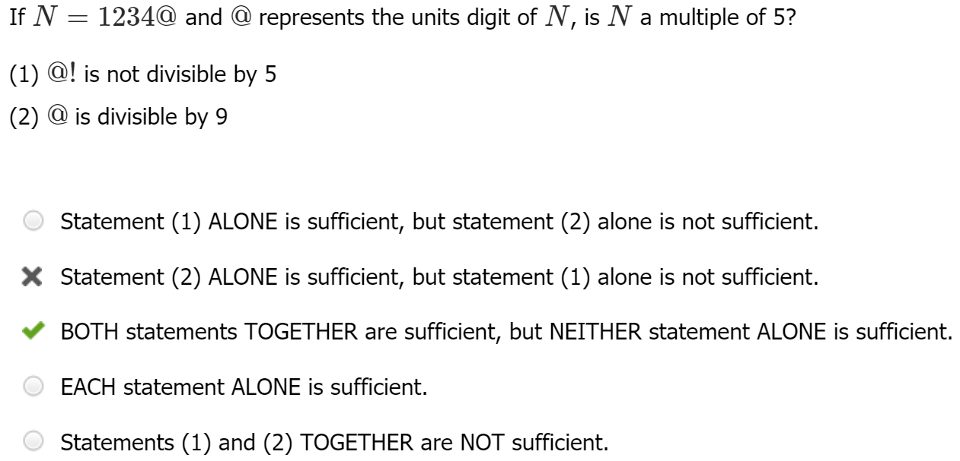
Content error. 0 is also divisible by 9 and any # other than itself.Hence (2) not sufficient
GMATClub
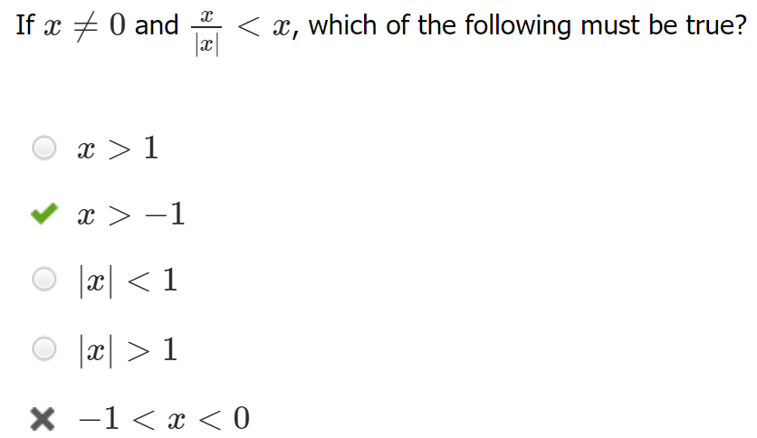
Sloppy algebra. Time pressure. Did not think through how 1 < X for all integers greater than 1

GMATClub

Exponents
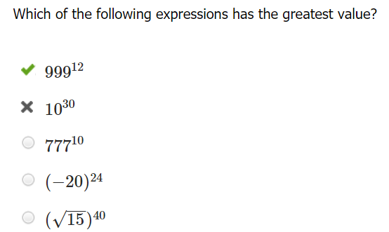Add exponents on exponents, not multiply
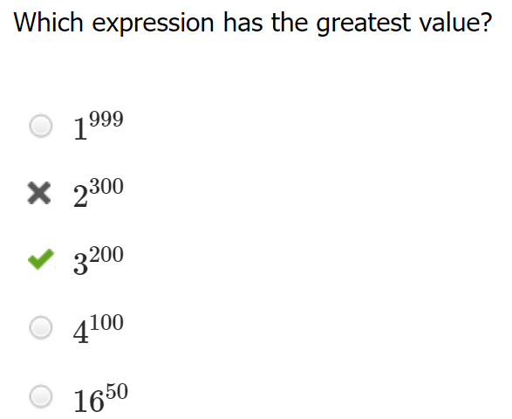
To compare, express both as to 100th power:
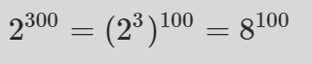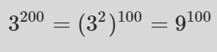

Content
GMATClub
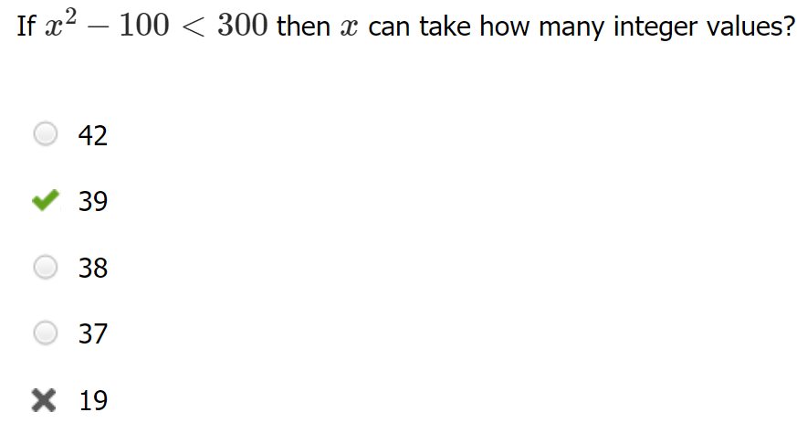
Absolute value content error. X can be negative.
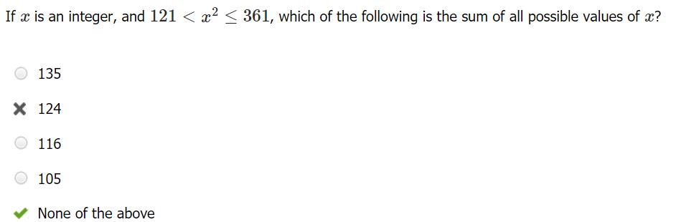GMATClub

Inequalities

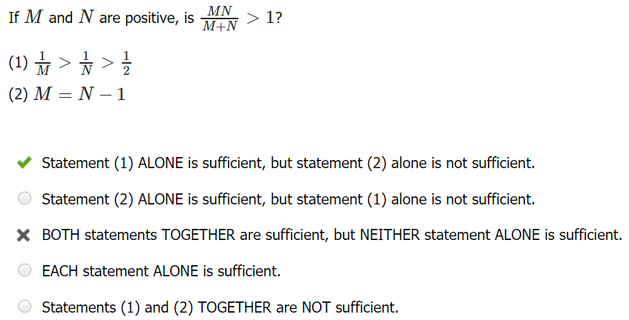
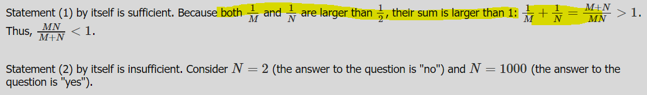
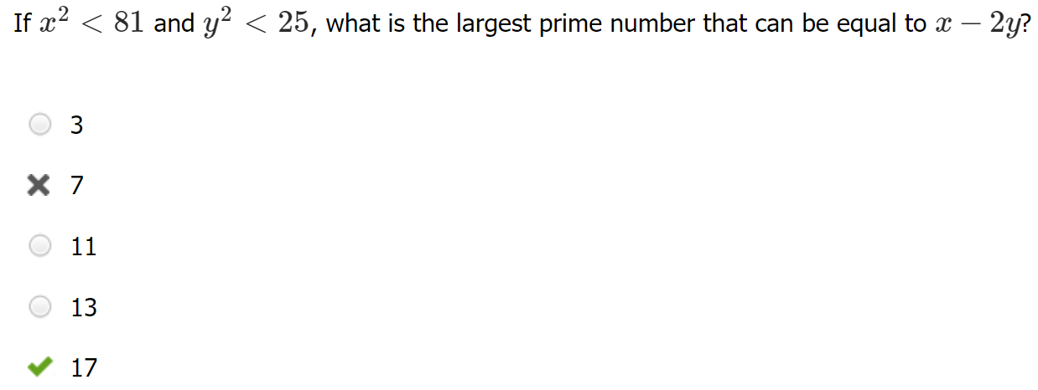
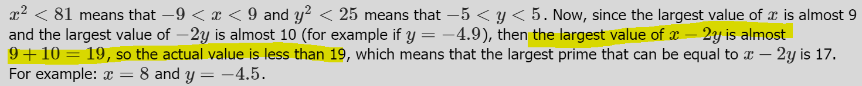

Content error: -9 < x < 9 and -5<y<5 so
10 > -2y > -10, flipping the inequality for x around the same way we get 9 > x > -9
19 > x - 2y > -19, and we see that the biggest prime number in this range is 17. Note x, y aren’t necessarily integers
GMATClub
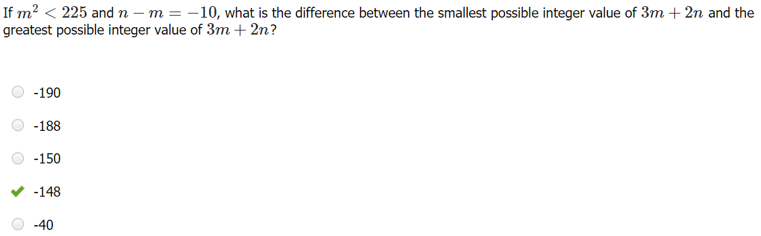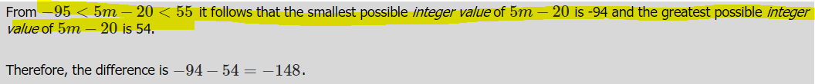
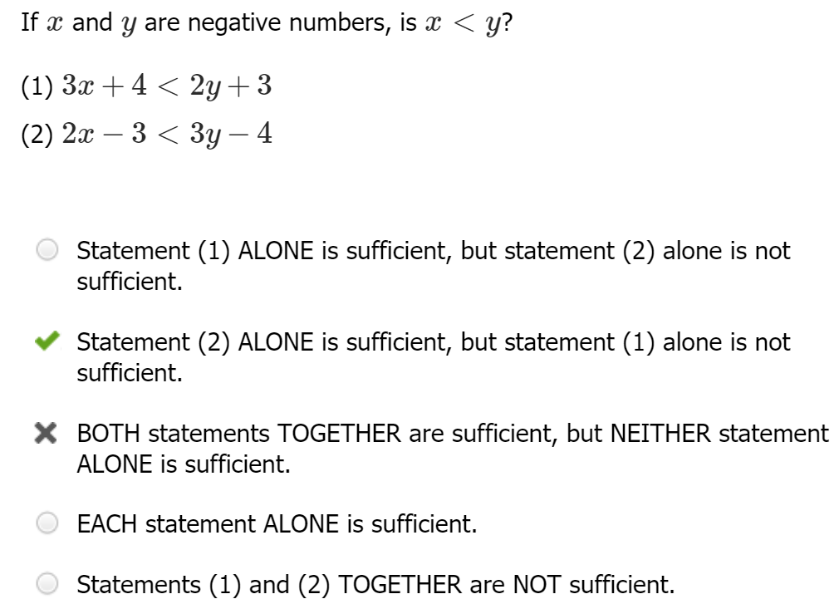
(1) 3x < 2y -1 can be true for infitessimally close #s where x < y e.g. -100 and -100.000001
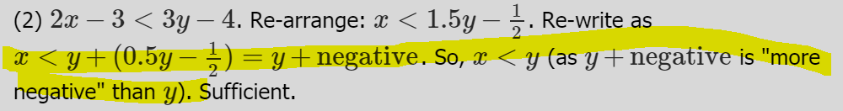
Felt rushed for time; spent too much on (1) and didn’t really check (2)

Probabilities
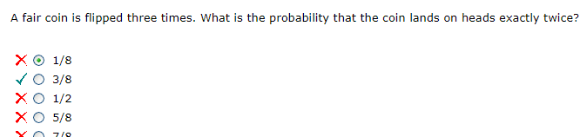
Content rusty. Must add up all different sequences HTH, HHT, THH
Number properties, MCMAT

Algebra
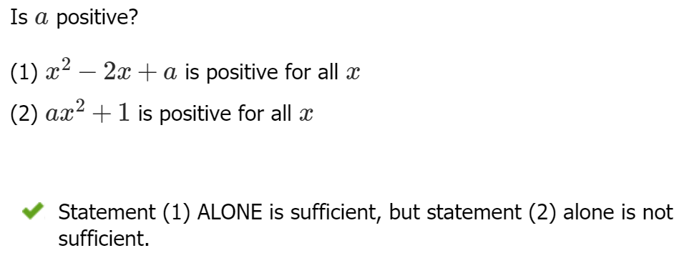
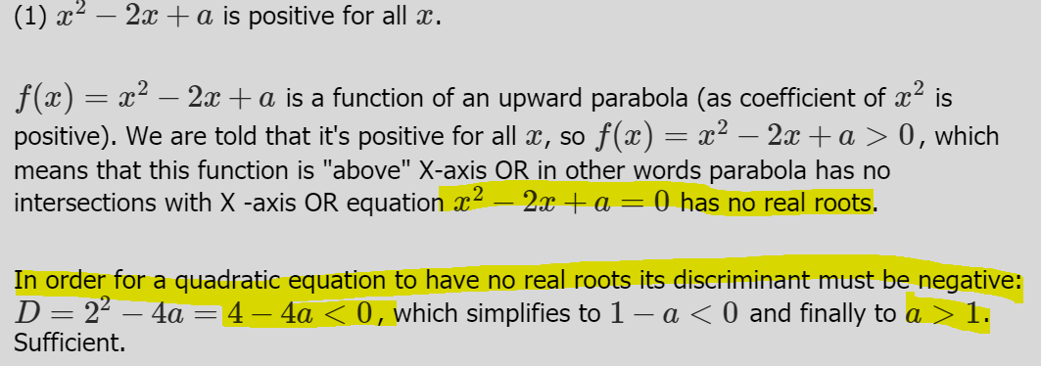
(2) a can be 0, insufficient.
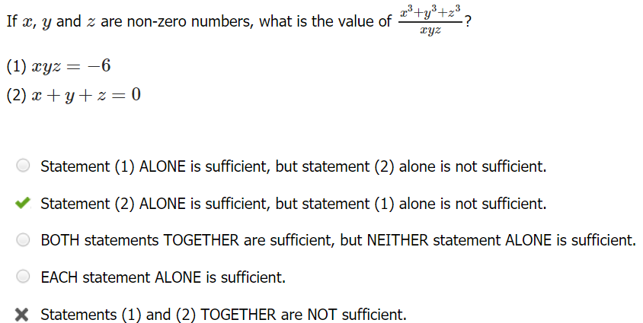
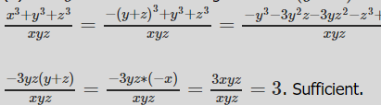
If 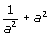 represents the diameter of circle O and 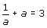, which of the following best approximates the circumference of circle O?

28
22
20
16
12

Hidden quadratic. multiply out second expression to derive value of first
Geometry, MCMAT
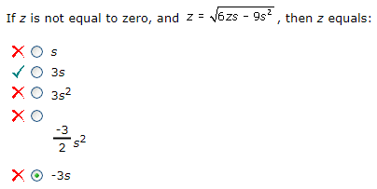
Hidden quadratic z² – 6zs + 9s² = 0
Algebra, MCMAT
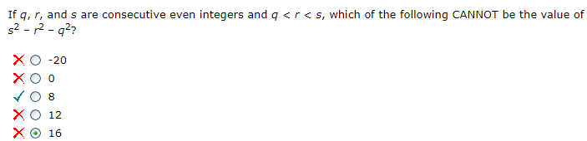
Sloppy. Remember to set the formula -s² + 12s – 20 = 8 as 8 BEFORE flipping it over from + to –
Algebra, MCMAT

Geometry
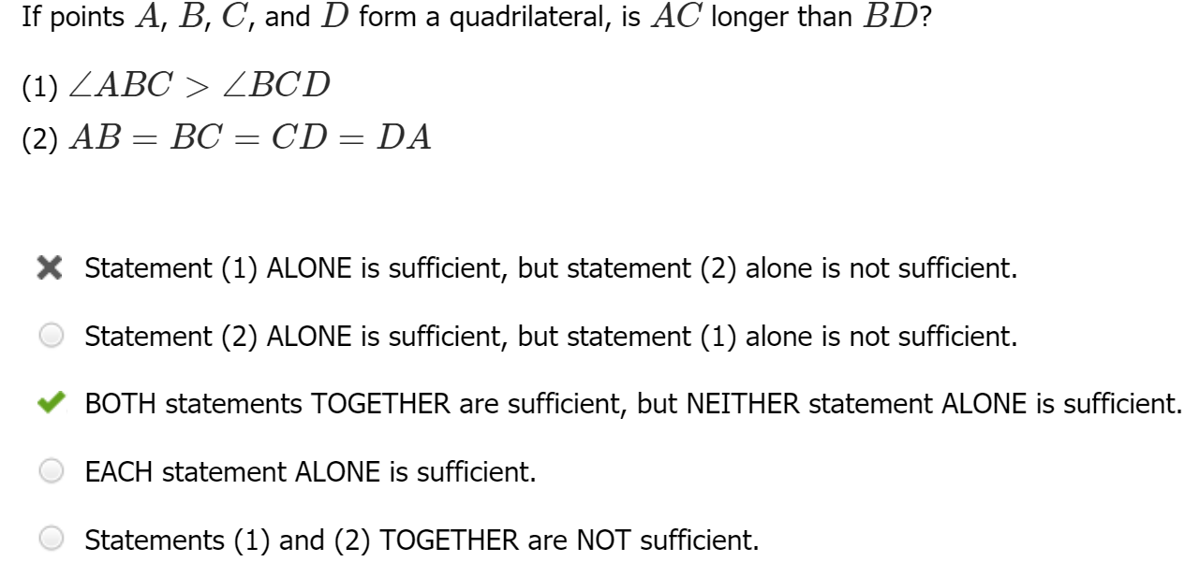
Quadrilateral kites error. (1) insufficient: example of AC < BD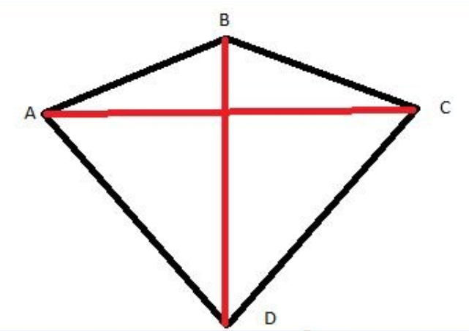
Both (1) and (2) rhombus, then 1 tells you which angle is bigger.
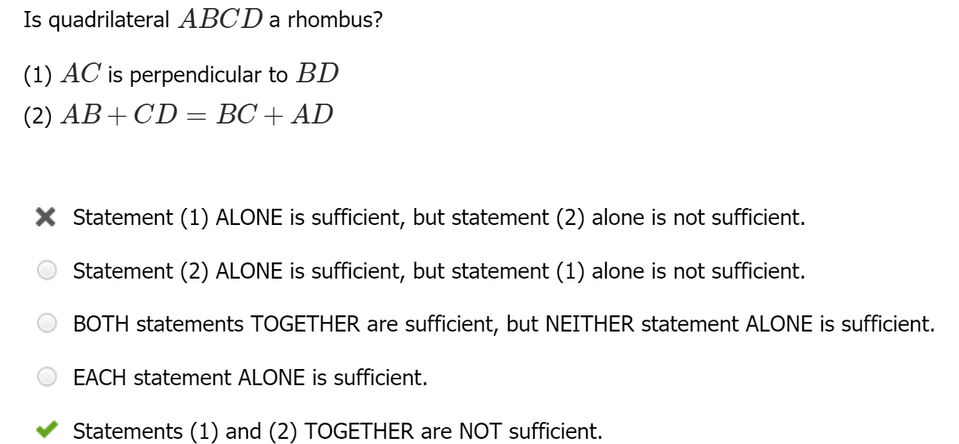
Quadrilateral kites error. (1) and (2) can still include non-rhombus kites.
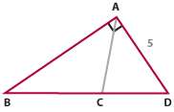
If angle BAD is a right angle, what is the length of side BD?
(1) AC is perpendicular to BD
(2) BC = CD
Statement (1) ALONE is sufficient, but statement (2) alone is not sufficient.
Statement (2) ALONE is sufficient, but statement (1) alone is not sufficient.
Both statements TOGETHER are sufficient, but NEITHER one ALONE is sufficient.
EACH statement ALONE is sufficient.
Statements (1) and (2) TOGETHER are NOT sufficient.
Content error. If both true, triangle is isosceles and BA = 5
Geometry, MCMAT
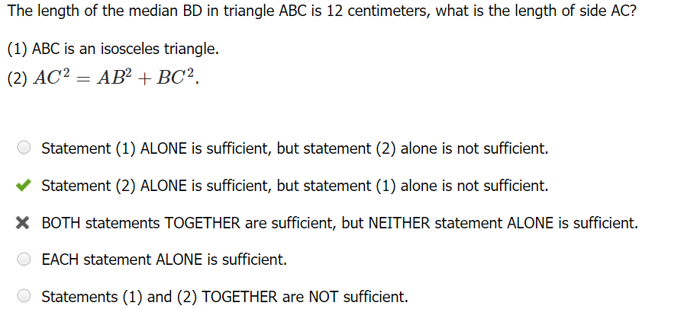
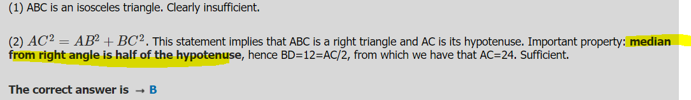
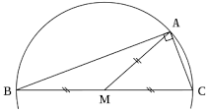
The median on the hypotenuse of a right triangle divides the triangle into two isosceles triangles, because the median equals one-half the hypotenuse.

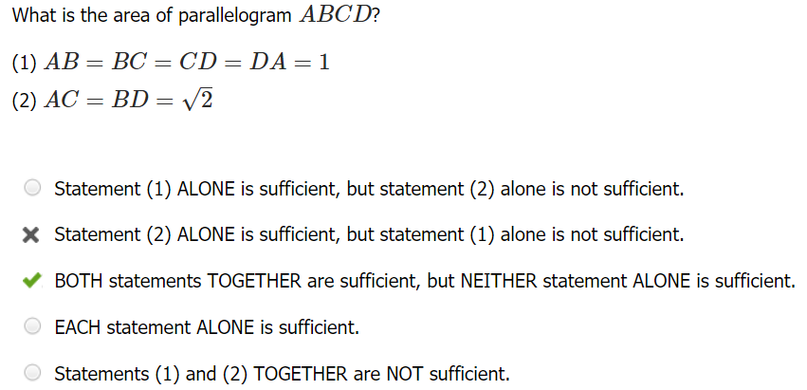
A cylindrical tank of radius R and height H must be redesigned to hold approximately twice as much liquid. Which of the following changes would be farthest from the new design requirements?
a 100% increase in R and a 50% decrease in H
a 30% decrease in R and a 300% increase in H
a 10% decrease in R and a 150% increase in H
a 40% increase in R and no change in H
a 50% increase in R and a 20% decrease in H

Sloppy arithmetic: asks for change in R² not R
Geometry, MCMAT
Cylinder A, which has a radius of x and a height of y, has a greater surface area than does Cylinder B, which has a radius of y and a height of x. How much greater is the surface area of Cylinder A than that of Cylinder of B?
xy( y – x)
xy( x – y)
2 ( y ² – x²)
2 ( x ² – y²)
xy(x – y)

Sloppy arithmetic: calculated volume difference, not surface area difference
Geometry, MCMAT

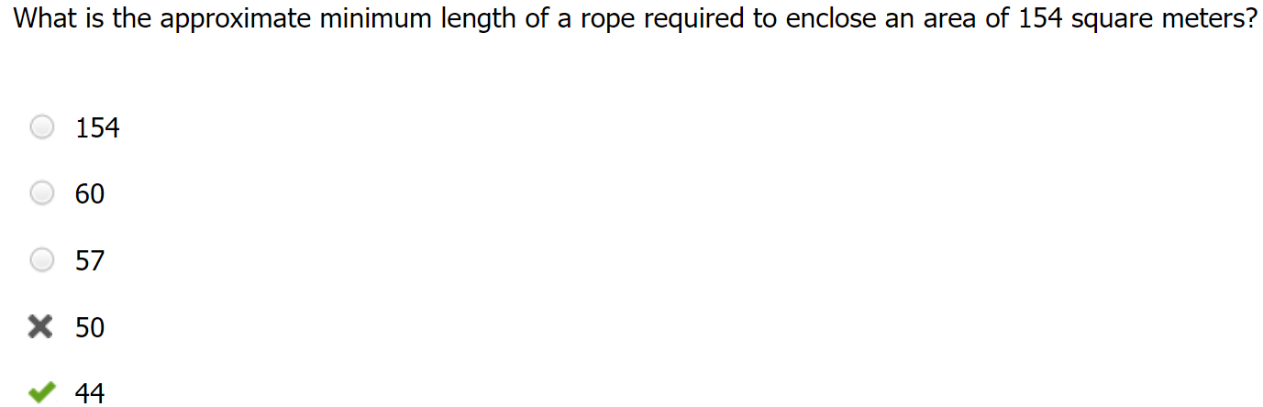
Content error. a circle has the minimum possible perimeter for a given area, then in order to minimize the length of a rope it should enclose a circle. Not a square
GMATClub
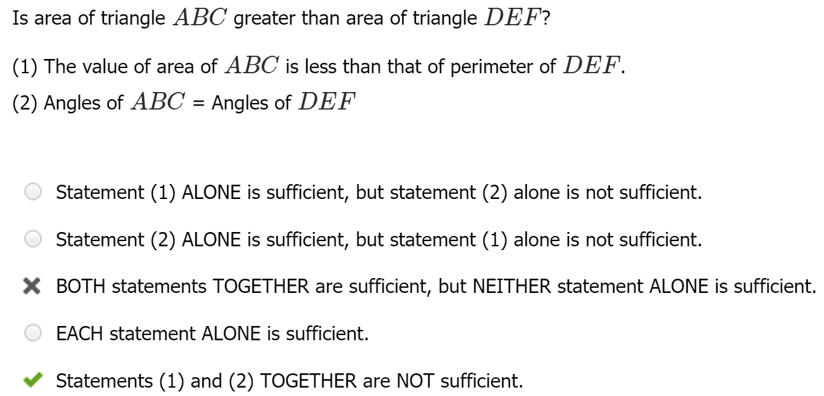
Combining the two statements, we still cannot determine whether the triangles have small values of their sides that yield greater perimeters or large values that yield greater area measurements. **Area increases relative to perimeter for bigger shapes, while perimeter becomes bigger versus area for smaller shapes***

Coordinate geometry
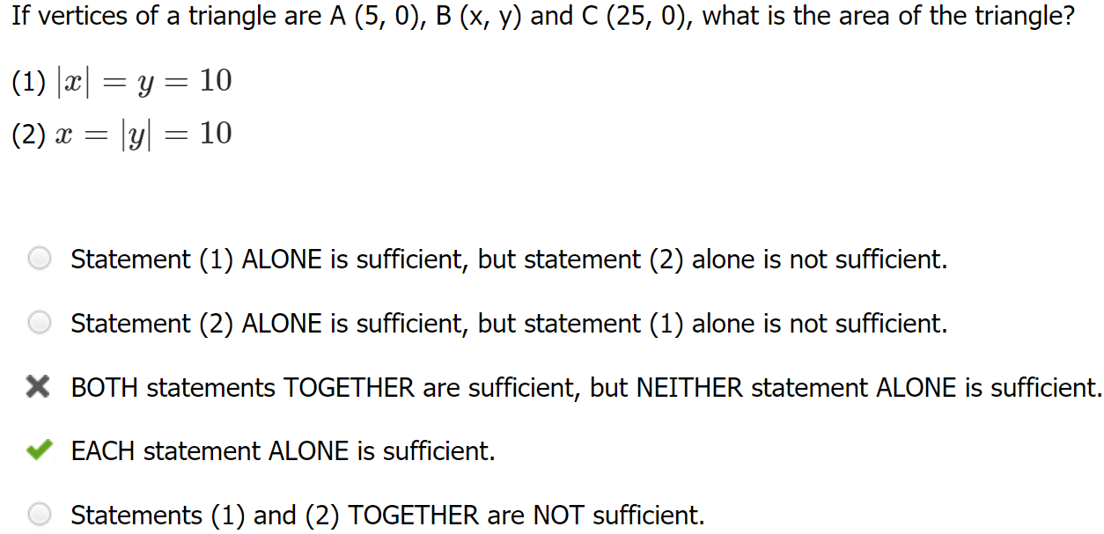
Sloppy: misread coordinate point as (0, 25). Should have seen that areas are equivalent for each
GMATClub
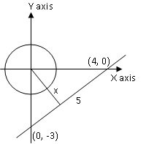
What is the least possible distance between a point on the circle x²+y²=1 and a point on the line y=(3/4)x−3 ?
A. 1.4
B. 2‾√2
C. 1.7
D. 3‾√3
E. 2.0
Tricky solution. Area of the given right triangle = (1/2)*3*4 (3 is base and 4 is altitude)= (1/2)*5*x (5 is base and x is altitude)
So x = 2.4

Arithmetic / careless errors
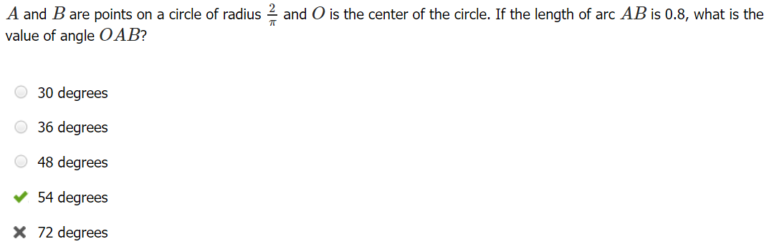
“Answer the wrong question” trap. Asks for angle OAB, not AOB
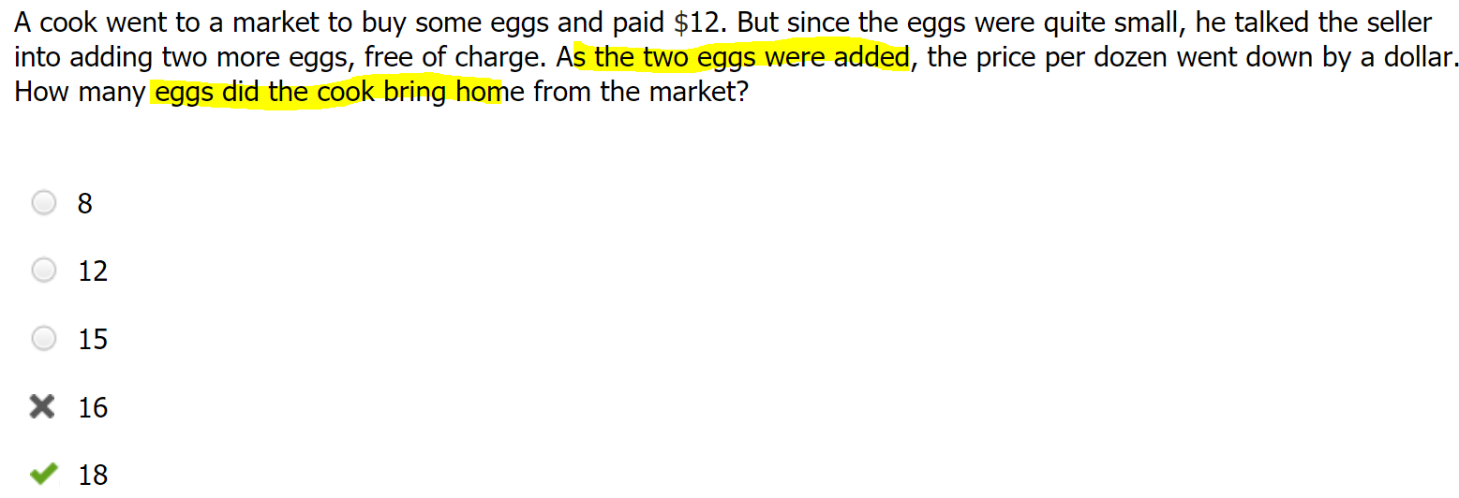
“Answer the wrong question” trap. Question asked for—AFTER two eggs
GMATClub
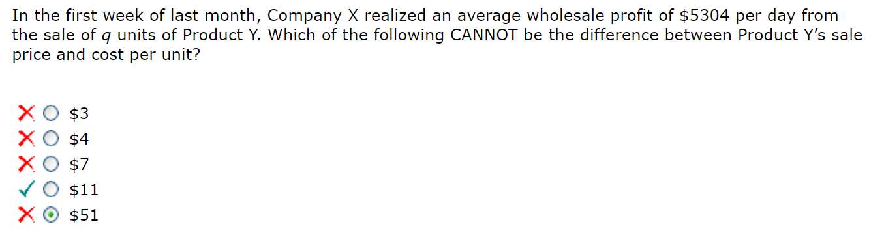
Sloppy arithmetic. Didn’t divide correctly.
GMATClub
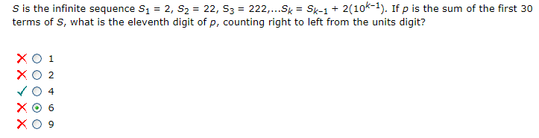
Sloppy arithmetic. Forgot that each digit adds up 1 less value of 2, and that the 11th digit carries over a 4 instead of a 6
Algebra, MCMAT

