Algebra
#219
If a two-digit positive integer has its digits reversed, the resulting integer differs from the original by 27. By how much do the two digits differ?
Answer
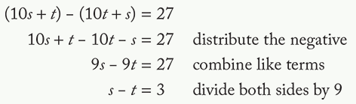

Geometry
Question
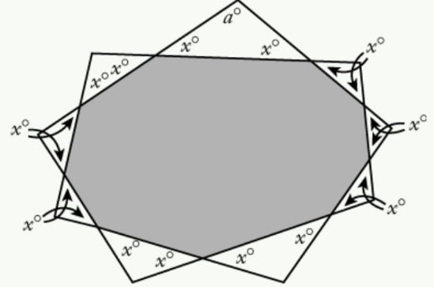
Solve for A given the 9-sided polygon:
a° = 180° – 2x°.
Each interior angle of the shaded polygon = (180 – x)°
So sum of interior angles = (9)(180 – x)°
Sum of interior angles of an n-sided polygon = (n – 2)(180°) = (7)(180°) = 1,260°.
(9)(180 – x)° = 1,260°
x = 40
a = 180 – 2x = 180 – 2(40) = 100.

Fractions, decimals, %s
#147
If there are fewer than 8 zeros between the decimal point and the first nonzero digit in the decimal expansion of (t/1000)^4, which of the following numbers could be the value of t ?
- 3
- 5
- 9
- None of the above

Answer
The decimal expansion of (1/1,000)^4 = 10−12 has 11 zeros to the right of the decimal point followed by a single digit that is 1. Therefore, in the decimal expansion of (t/1,000)^4 = t4 × 10−12, the number of zeros between the decimal point and the first nonzero digit is equal to 12 minus the number of digits in the integer t4. Since this number of zeros is fewer than 8, it follows that the number of digits in the integer t4 is greater than 4. The integer t cannot be 3, because the number of digits in 34 = 81 is not greater than 4. The integer t cannot be 5, because the number of digits in 54 = 625 is not greater than 4. The integer t cannot be 9, because the number of digits in 94 = 6,561 is not greater than 4. Therefore, none of 3, 5, or 9 could be the value of t.

Number properties
Q
If integer k is equal to the sum of all even multiples of 15 between 295 and 615, what is the greatest prime factor of k?
- 5
- 7
- 11
- 13
- 17
sum of set = (mean of set) × (# of terms in set)
300 is the 10th multiple of 30, and 600 is the 20th multiple of 30. 11 terms in the set: 20th – 10th + 1 = 10 + 1 = 11
mean of set = (first term + last term) / 2 = (300 + 600) / 2 = 450
k = sum of set = 450 × 11

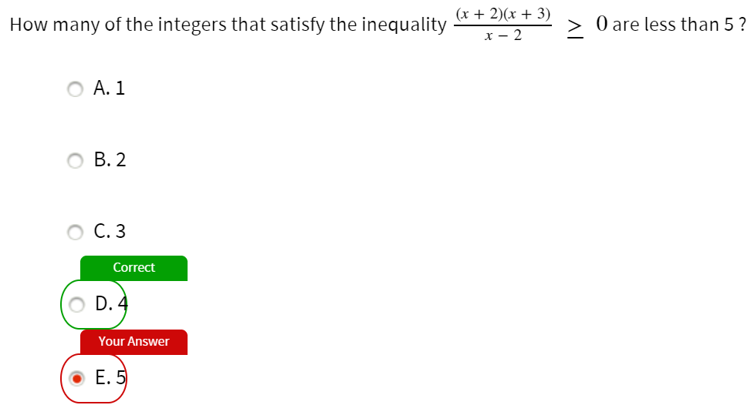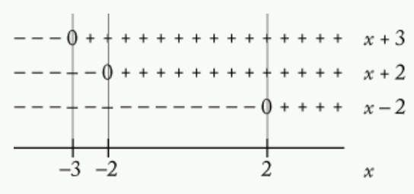
*can’t divide by 0, result is not an integer
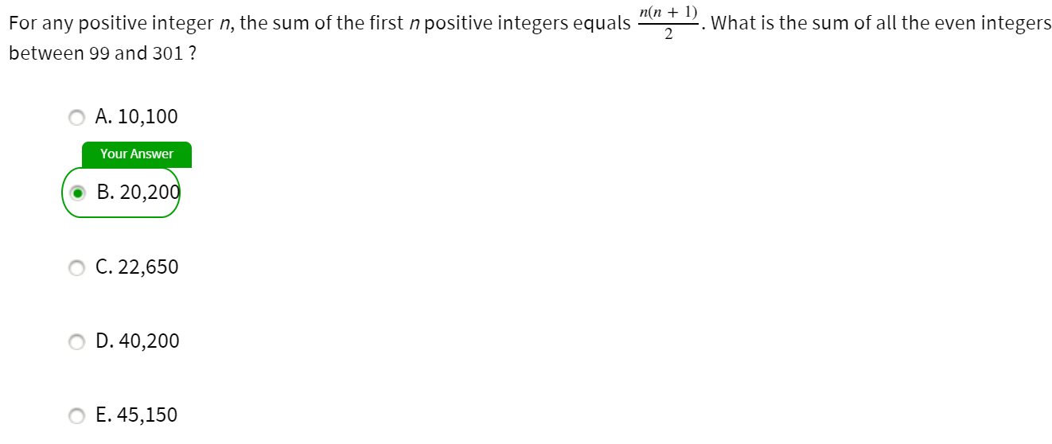
sum of even integers between 99 and 301
= sum of even integers from 100 through 300
= sum of the 50th even integer to the 150th even integer
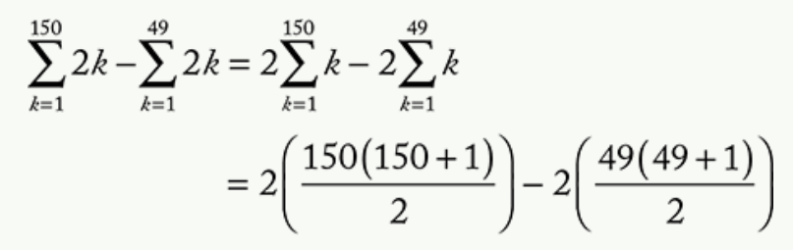

Sloppy errors: read question and diagram carefully
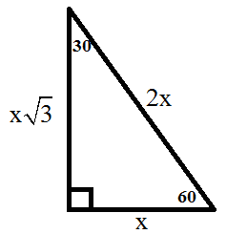
A ladder of a fire truck is elevated to an angle of 60° and extended to a length of 70 feet. If the base of the ladder is 7 feet above the ground, how many feet above the ground does the ladder reach?

Answer
7 + 35√ 3

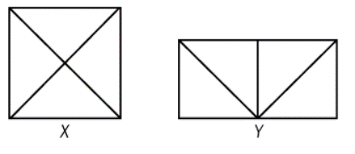
#156

Figures X and Y above show how eight identical triangular pieces of cardboard were used to form a square and a rectangle, respectively. What is the ratio of the perimeter of X to the perimeter of Y?
2√2:3


#177

In the figure shown, if the area of the shaded region is 3 times the area of the smaller circular region, then the circumference of the larger circle is how many times the circumference of the smaller circle?

2

