Algebra
Last Sunday a certain store sold copies of Newspaper A for $1.00 each and copies of Newspaper B for $1.25 each, and the store sold no other newspapers that day. If r percent of the store's revenue from newspaper sales was from Newspaper A and if p percent of the newspapers that the store sold were copies of Newspaper A, which of the following expresses r in terms of p ?
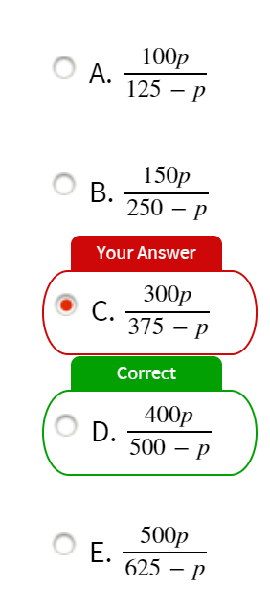
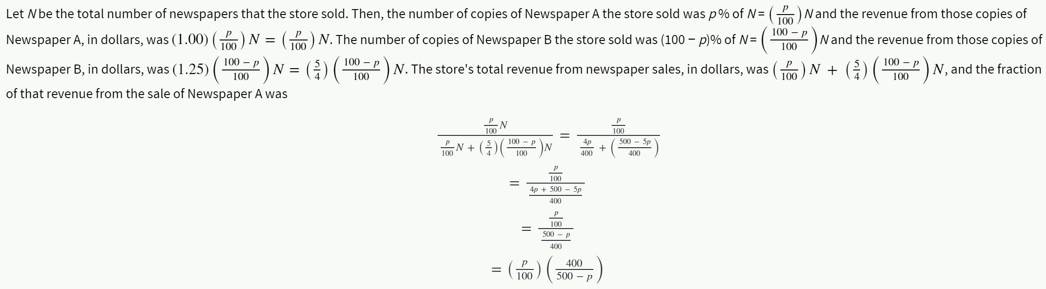
A researcher plans to identify each participant in a certain medical experiment with a code consisting of either a single letter or a pair of distinct letters written in alphabetical order. What is the least number of letters that can be used if there are 12 participants, and each participant is to receive a different code?
None of the essential aspects of the problem is affected if the letters are restricted to be the first n letters of the alphabet, for various positive integers n. With the 3 letters a, b, and c, there are 6 codes: a, b, c, ab, ac, and bc. With the 4 letters a, b, c, and d, there are 10 codes: a, b, c, d, ab, ac, ad, bc, bd, and cd. Clearly, more than 12 codes are possible with 5 or more letters, so the least number of letters that can be used is 5

Number properties
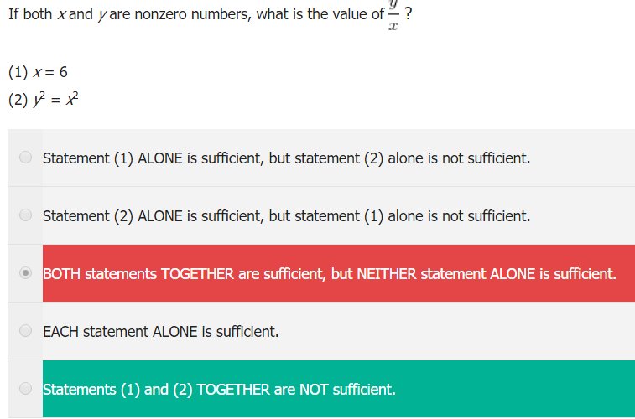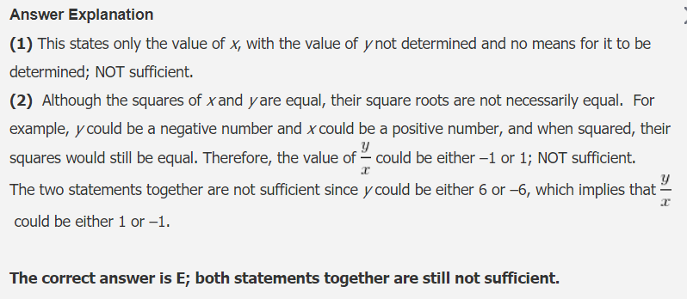
5. If a, b, and c are integers and a < b < c, are a, b, and c consecutive integers?  (1) The median of {a!, b!, c!} is an odd number.  (2) c! is a prime number  Selected: B  Answer: C | Integers can be negative also.  1) shows b is 0 or 1. Can’t be 0 bc a would be undefined. Thus b = 1, a = 0  2) shows c=2.
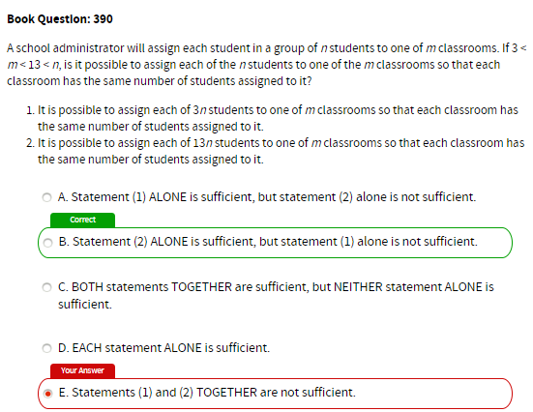 | 13 is prime so if 13n/m divisible, n/m must be divisible
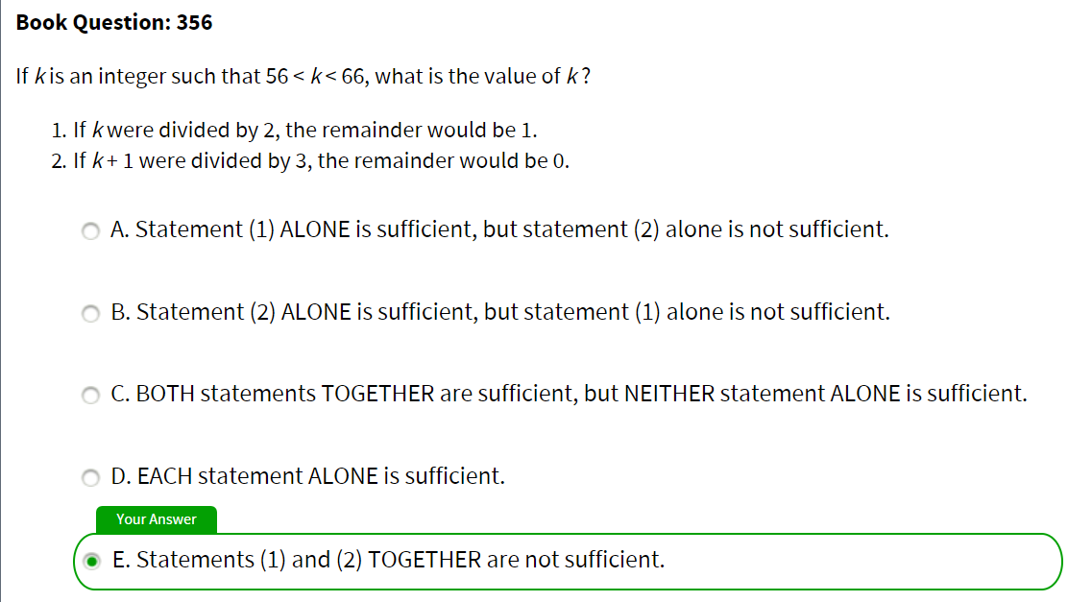

Standard deviation
1. A set of data consists of the following 5 numbers: 0,2,4,6, and 8. Which two numbers, if added to create a set of 7 numbers, will result in a new standard deviation that is close to the standard deviation for the original 5 numbers?  (A) -1 and 9  (B) 4 and 4  (C) 3 and 5  (D) 2 and 6  (E) 0 and 8 | 5. Which of the following has the same standard deviation as {s,r,t}?  I. {r-2, s-2, t-2}  II. {0, s-t, s-r}  III. {|r|, |s|, |t|}  (A) I only  (B) II only  (C) III only  (D) I and II only  (E) I and III only

Probability
3. A box contains 10 pairs of shoes (20 shoes in total). If two shoes are selected at random, what it is the probability that they are matching shoes?  A. 1/190  B. 1/20  C. 1/19  D. 1/10  E. 1/9  The probability would simply be: 1/1*1/19(as after taking one at random there are 19 shoes left and only one is the pair of the first one)=1/19  Answer: C. | 12. 4 dices are thrown at the same time. whats the probability of getting ONLY 2 dices showing the same face?  Total # of outcomes = 6^4  Favorable outcomes = 4C2=6, choosing two dice which will provide the same face, these two dice can take 6 values, other two 5 and 4. So, favorable outcomes=4C2*6*5*4.  Answer: 5/9.
4. A Coach is filling out the starting lineup for his indoor soccer team. There are 10 boys on the team, and he must assign 6 starters to the following positions: 1 goalkeeper, 2 on defence, 2 in midfield, and 1 forward. Only 2 of the boys can play goalkeeper, and they cannot play any other positions. The other boys can each play any of the other positions. How many different groupings are possible?  A. 60  B. 210  C. 2580  D. 3360  E. 151200 | 2C1 select 1 goalkeeper from 2 boys;  8C2 select 2 defence from 8 boys (as 2 boys can only play goalkeeper 10-2=8);  6C2 select 2 midfield from 6 boys (as 2 boys can only play goalkeeper and 2 we've already selected for defence 10-2-2=6);  4C1 select 1 forward from 4 boys (again as 2 boys can play only goalkeeper, 4 we've already selected for defence and midfield 10-2-4=4)  Total # of selection=2C1*8C2*6C2*4C1=3360  Answer: D.
5. In how many ways 8 different tickets can be distributed between Jane and Bill if each is to receive any even number of tickets and all 8 tickets to be distributed.  A. From 2 to 6 inclusive.  B. From 98 to 102 inclusive.  C. From 122 to 126 inclusive.  D. From 128 to 132 inclusive.  E. From 196 to 200 inclusive. | Tickets can be distributed in the following ways:  {8,0} - 8C8=1  {6,2} - 8C6*2C2=28  {4,4} - 8C4*4C4=70  {2,6} - 8C2*6C6=28  {0,8} - 8C8=1  Total # of ways=1+28+70+28+1=128  Answer: D.
8. In how many ways can 11 books on English and 9 books on French be placed in a row on a shelf so that two books on French may not be together
Imagine 11 English books in a row and empty slots like below:
*E*E*E*E*E*E*E*E*E*E*E*
Now if 9 French books would be placed in 12 empty slots, all French books will be separated by English books.
So we can "choose" 9 empty slots from 12 available for French books, which is 12C9=220.
Answer: 220.?

D-trap questions
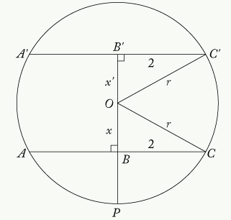
A tank is filled with gasoline to a depth of exactly 2 feet. The tank is a cylinder resting horizontally on its side, with its circular ends oriented vertically. The inside of the tank is exactly 6 feet long. What is the volume of the gasoline in the tank?
- The inside of the tank is exactly 4 feet in diameter.
- The top surface of the gasoline forms a rectangle that has an area of 24 square feet.

D. Each is sufficient
Answer
- Obvious
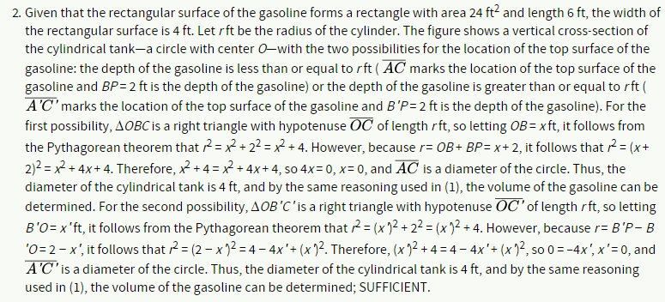

C-trap questions
#371
What is the number of cans that can be packed in a certain carton?
- The interior volume of this carton is 2,304 cubic inches.
- The exterior of each can is 6 inches high and has a diameter of 4 inches.
Answer
Need to consider DIMENSIONS as well as total area. E.g. area of glass slab vs covering question

“find the formula” errors
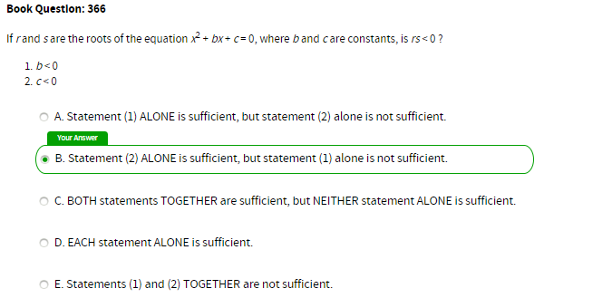
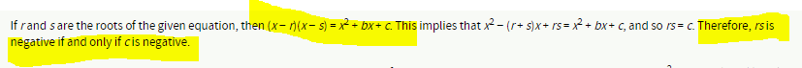
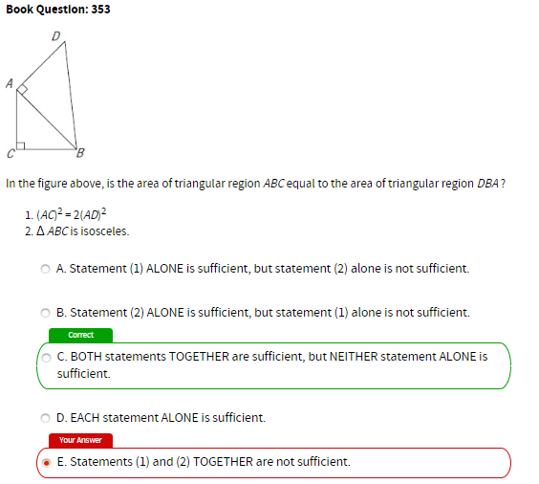
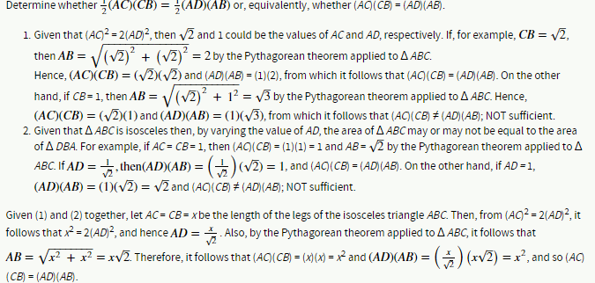

Statistics
Q
If Q is a set of consecutive integers, what is the standard deviation of Q?
(1) Set Q contains 21 terms.
(2) The median of set Q is 20.
A - 1 is sufficient, 2 is not
SD hinges on step 1: finding the difference between each term in the set and the mean of the set. ""What is the difference between each term in the set and the mean of the set?"
The difference between the mean (x) and the first term in the set (x – 10) is 10. The difference between the mean (x) and the second term in the set (x – 9) is 9. We can actually find the difference between each term in the set and the mean of the set without knowing the specific value of each term in the set!
Q
What is the median value of the set R, if for every term in the set, Rn = Rn–1 + 3?
(1) The first term of set R is 15.
(2) The mean of set R is 36.
B - Statement (2) ALONE is sufficient, but statement (1) alone is not sufficient.
(1) INSUFFICIENT: This does not give us any information about the value of the mean. The only other way to find the median of a set is to know every term of the set.
(2) SUFFICIENT: The mean must be the median of the set since this is an evenly spaced set. This statement tells us that mean is 36. Therefore, the median must be 36.
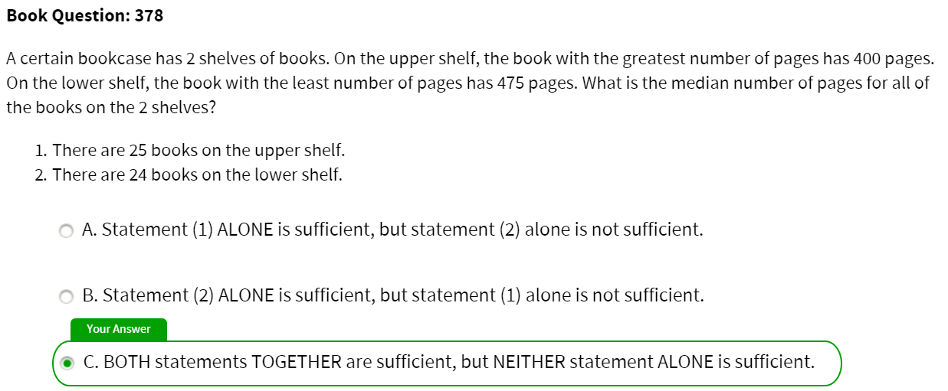

Sets
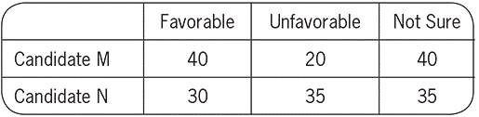
#389
The table above shows the results of a survey of 100 voters who each responded “Favorable” or “Unfavorable” or “Not Sure” when asked about their impressions of Candidate M and of Candidate N. What was the number of voters who responded “Favorable” for both candidates?
- The number of voters who did not respond “Favorable” for either candidate was 40.
- The number of voters who responded “Unfavorable” for both candidates was 10.
A. Statement (1) ALONE is sufficient, but statement (2) alone is not sufficient.
The number of voters who responded “Favorable” to at least one candidate is 40 + 30 – x = 70 – x.
1) Given that there were 40 voters who did not respond “Favorable” for either candidate and there were 100 voters surveyed, the number of voters who responded “Favorable” to at least one candidate is 100 − 40 = 60. Therefore, from the comments above, it follows that 70 − x = 60, and hence x = 10; SUFFICIENT.
2) The information given affects only the numbers of voters in the categories “Unfavorable” only. # of voters in the “Favorable” for Candidate M only, “Favorable” for Candidate N only, and “Favorable” for both candidates not affected.

Fractions, decimals. %
#354
If r and s are positive integers, can the fraction r/s be expressed as a decimal with only a finite number of nonzero digits?
1. s is a factor of 100.
2. r is a factor of 100.
A - 1 only

1. Test it out -- all fractions with factors of 100 in denominator are finite digit decimals.
2. Test--not the case for factors of 100 in numerator.

Min/max
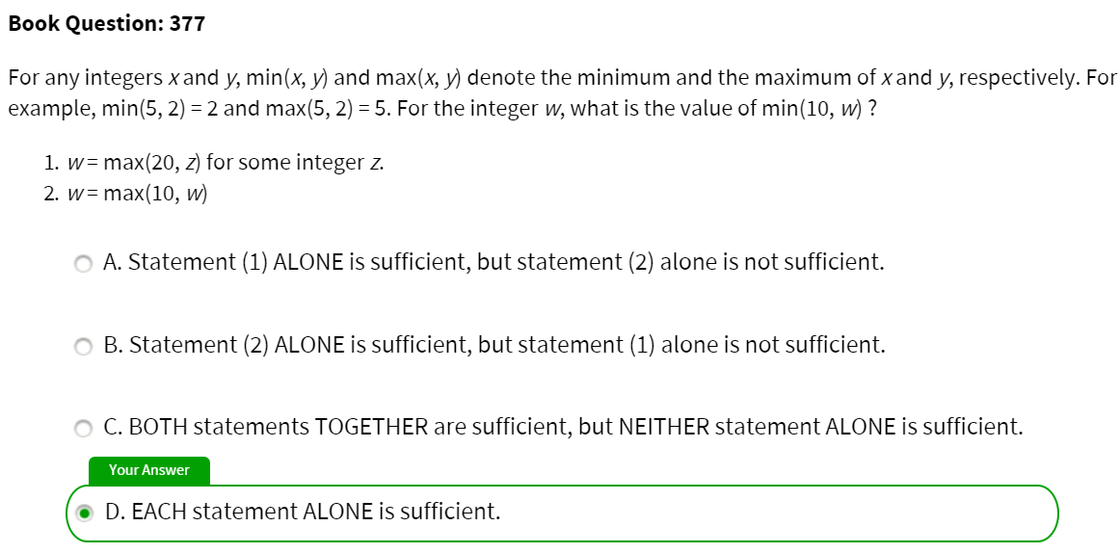

Arithmetic
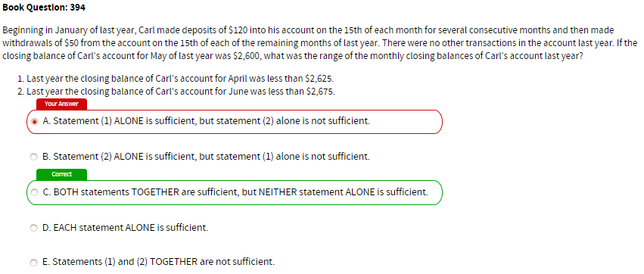
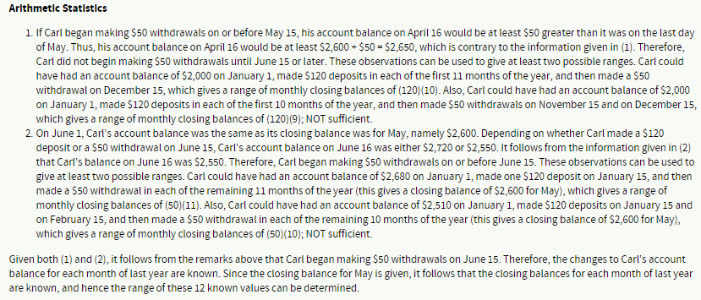
#380
In planning for a trip, Joan estimated both the distance of the trip, in miles, and her average speed, in miles per hour. She accurately divided her estimated distance by her estimated average speed to obtain an estimate for the time, in hours, that the trip would take. Was her estimate within 0.5 hour of the actual time that the trip took?
- Joan's estimate for the distance was within 5 miles of the actual distance.
- Joan's estimate for her average speed was within 10 miles per hour of her actual average speed.

Answer
Given that Joan's estimate for the distance was within 5 miles of the actual distance, it is not possible to determine whether her estimate for the time was within 0.5 hour without information about her estimated average speed.
- If estimated distance = 20 and within 5 miles of actual distance, then 15 < actual distance < 25
If estimated speed = 20 mph and within, say, 10 mph of her actual speed, 10 < actual speed < 30
- Estimated time = 20/20 = 1.0 hour. Actual time between:
15/30 = 0.5 hour (least distance over greatest speed)
25/10 = 2.5 hours (greatest distance over least speed).
Since 1.0 hour is between 0.5 hour and 2.5 hours, estimate for the time could equal the actual time, or could be as much as 2.5 − 1.0 = 1.5 hours over the actual time. NOT sufficient.

Algebra
#349
Is the positive two-digit integer N less than 40?
1. The units digit of N is 6 more than the tens digit.
2. N is 4 less than 4 times the units digit.

Answer
1. u = t + 6
N = 10t + (t + 6) = 11t + 6.
Since u is a digit, u = t + 6 ≤ 9, so t ≤ 3
N = 11t + 6 ≤ 11(3) + 6 = 39; SUFFICIENT.
2. N = 4u – 4
Since u is a digit and u ≤ 9, N = 4u − 4 ≤ 4(9) − 4 = 32; SUFFICIENT.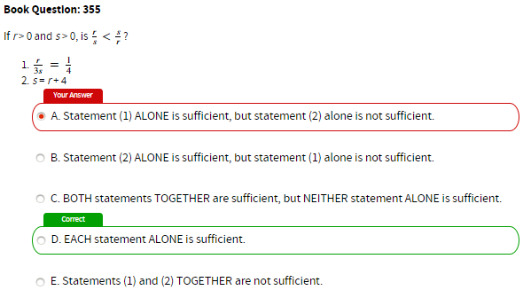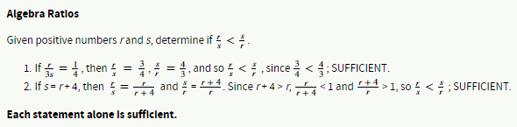
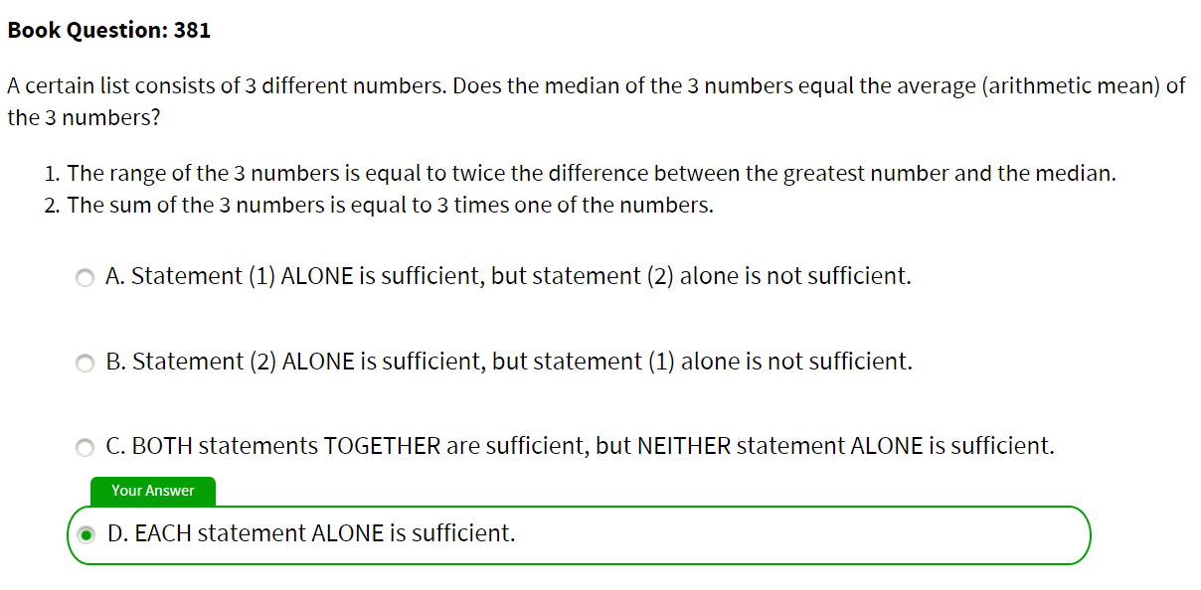

Careful what question is asking for
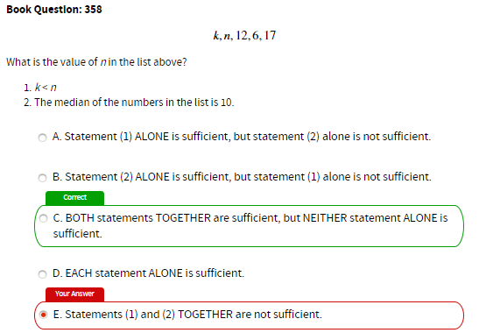
In both possible options for C, n = median = 10

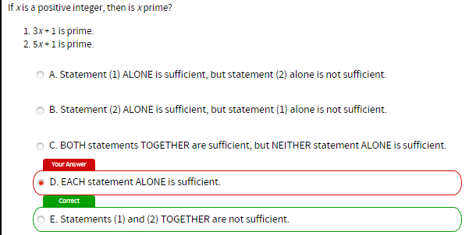

Rushing/sloppy errors

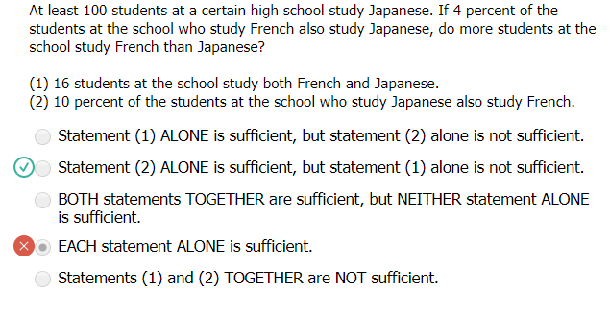 | Misread: at LEAST 100 students study Japanese

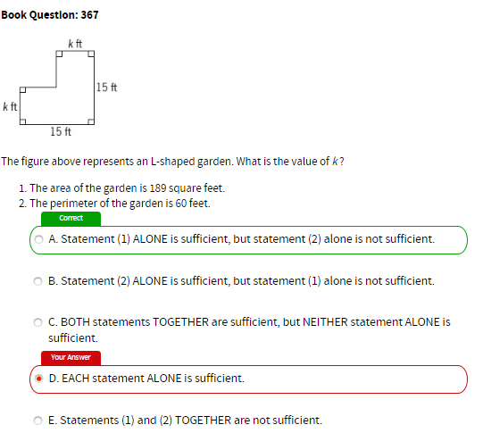
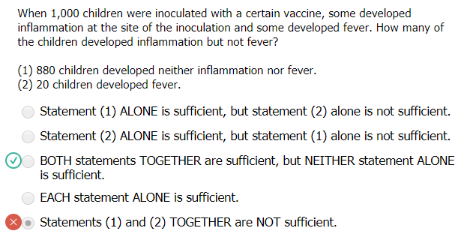 | Misread: got it right the 2nd time
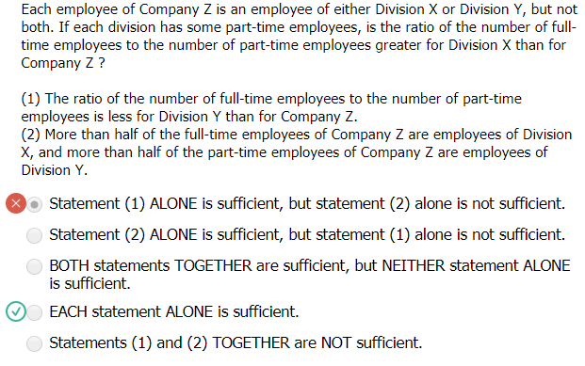 | Got it right the 2nd time.

