Errors
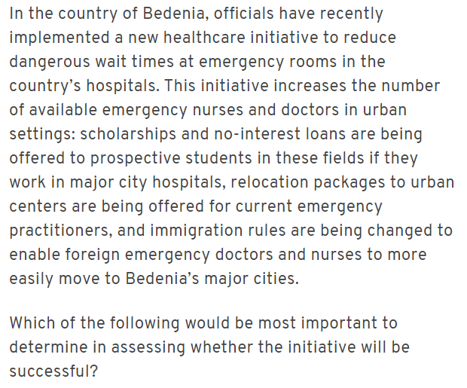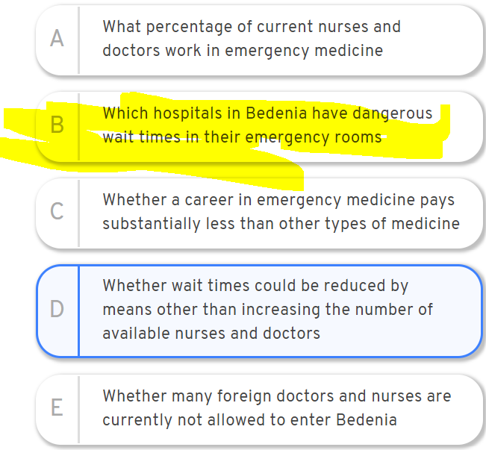
Main distinction is between COUNTRY hospital wait times and initiative’s CITY hospital methods.
D) is IRRELEVANT: question asks whether THIS initiative would work, not whether there are other options.
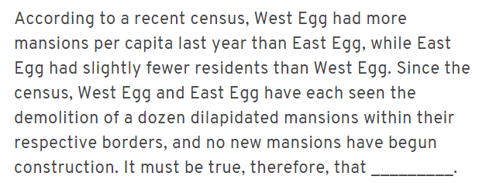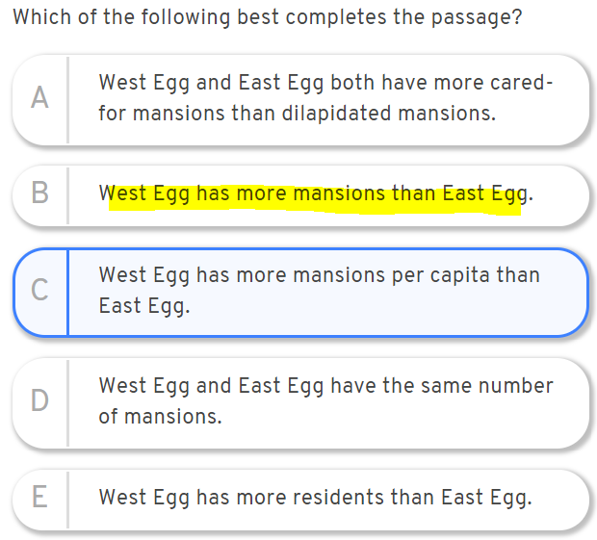
Forgot basic math principle: if West Egg has more mansions per capita and more residents, it has more mansions period. I caught that you don’t know what changes may have happened in # of people
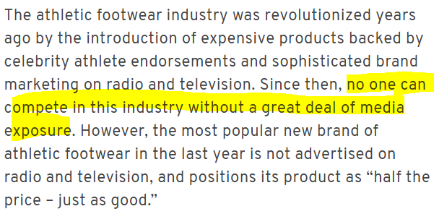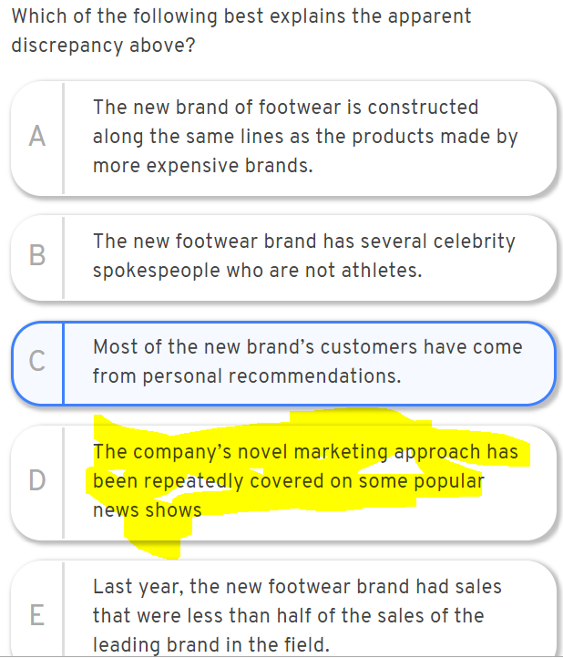
Take as GIVEN that media exposure is necessary. What logically explains the paradox?

Roland: The alarming fact is that 90 percent of the people in this country now report that they know someone who is unemployed.
Sharon: But a normal,moderate level of unemployment is 5 percent, with 1 out of 20 workers unemployed. So at any given time if a person knows approximately 50 workers,1 or more will very likely to be unemployed.
Sharon's argument relies on the assumption that [assumption]
1. normal levels of unemployment are rarely exceeded.
2. unemployment is not normally concentrated in geographically isolated segments of population.
3. the number of people who each know someone who is unemployed is always higher than 90% of the population.
4. Roland is not consciously distorting the statistics he presents
5. knowledge that a personal acquaintance is unemployed generates more fear of loosing one's job than does knowledge of unemployment statistics
B) negate this one and you get:
unemployment is normally concentrated in geographically isolated segments of the population
What is the implication of the above? If unemployment is concentrated in certain areas, how can we say that if someone who knows 50 persons will very likely know more than 1 person who is unemployed?
Let's take a simple number example. Country A has two cities: X and Y
City X: population = 100 --> 10 are unemployed
City Y: population = 100 --> 0 are unemployed
Total unemployment rate for country A: 10/200 = 5% --> as claimed by Sharon
Correct answer addresses reasoning of argument, not just conclusion
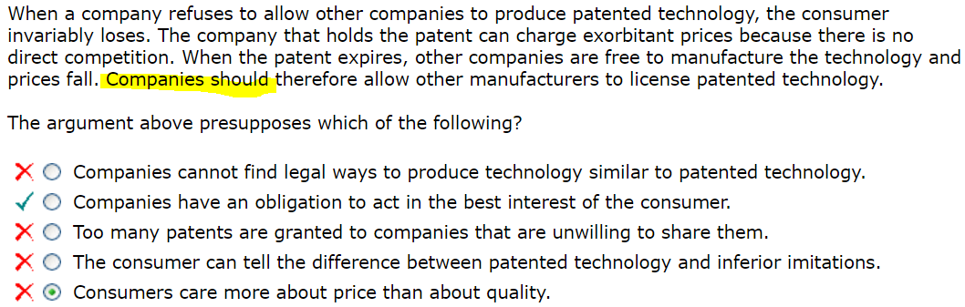
(B) CORRECT. The conclusion only makes sense if companies have an obligation to act in the best interest of the customer, as this choice states. Answer addresses the precise phrasing of the conclusion—not just what should be done but who should do it.
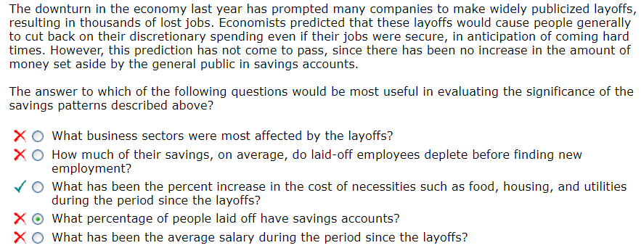
Missed precise distinction between word in answer choice and stimulus. Necessities vs. discretionary spending.
(C) CORRECT. This question asks about the prices of necessities such as food and utilities. If people have not been saving their money, perhaps they have been spending it on necessities (as opposed to spending it on discretionary items). If these items have become more expensive, then perhaps people have not been able to save money despite curtailing their discretionary spending.
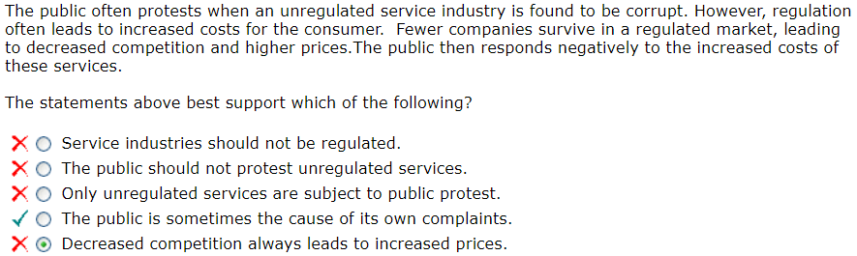
Missed the correct conclusion: actually a summary of all the premises.
(D) CORRECT. This answer summarizes what the passage describes – a cycle of public discontent. Notice that the correct “inference” or “conclusion” here isn't much more than a summary of the premises in the passage.
(E) In the passage, the author says "regulation often leads to increased costs for the consumer" due to decreased competition. Always is not the same as often. This answer choice is too extreme.
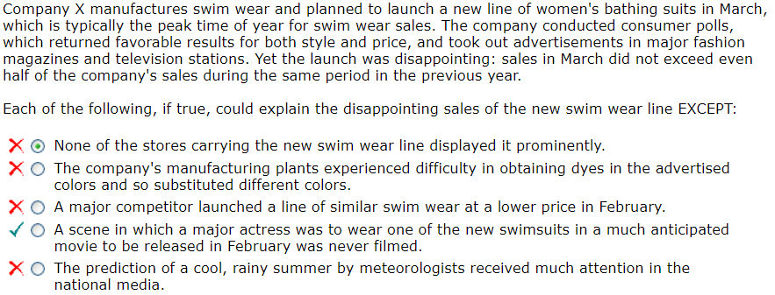
A) True. This could explain the outcome: if the swim wear was not displayed prominently, perhaps customers did not see it.
(B) True. This could explain the outcome: if the colors were not the same as the ones tested, it may be that consumers disliked the new colors they were actually offered.
(C) True. This could explain the outcome: if a competitor offered similar swim wear at a lower price, customers could have purchased the other brand instead.
(D) CORRECT. False. The poll was based upon style and price, not the idea that a major actress would wear a swimsuit in a film. The fact that the scene was not filmed is irrelevant to the argument.
(E) True. This could explain the outcome: if consumers anticipated a summer of bad weather, they may not have been as eager to buy swim wear in March.

Correct
The Dear One Baby Carrier is the safest and most comfortable baby carrier available today. The hard plastic exterior retains its shape when subjected to minor impacts, while the thick interior “comfort pad” acts as a shock absorber. The design is based on the results of the most comprehensive baby carrier study performed to date, which analyzed comfort preferences both of infants placed inside the carriers and of adults carrying the devices. As a bonus, the Dear One Baby Carrier converts easily from an at-large carrier to a car seat, reducing the risk to infants when they are being transferred from a carrier to a car seat.
Which of the following, if true, would most undermine the safety and comfort claims made about the Dear One Baby Carrier? [weaken the arg]
(A) The hard plastic exterior of the Dear One Baby Carrier does not retain its shape when dropped from an average carrying height.
(B) On average, the number of babies injured each year while riding in a car seat is greater than the number of babies injured each year while being transferred from a carrier to a car seat.
(C) According to the study on which the design of the Dear One Baby Carrier was based, the percentage of infants who prefer the comfort of a baby carrier scheduled to be released next year by a rival company is significantly higher than the percentage of infants who prefer the comfort of the Dear One Baby Carrier.
(D) Studies suggest that car seats that double as baby carriers are, on average, slightly less safe than single-function baby car seats.
(E) A rival company has successfully replicated the design of the Dear One Baby Carrier while utilizing a new type of plastic that is significantly stronger and lighter than the type used in the Dear One Baby Carrier.
Some statisticians claim that the surest way to increase the overall correctness of the total set of one’s beliefs is: never change that set, except by rejecting a belief when given adequate evidence against it. However, if this were the only rule one followed, then whenever one were presented with any kind of evidence, one would have to either reject some of one’s beliefs or else leave one’s beliefs unchanged. But then, over time, one could only have fewer and fewer beliefs. Since we need many beliefs in order to survive, the statisticians’ claim must be mistaken.
The argument is most vulnerable to criticism on the grounds that it [weaken the arg]
(A) presumes, without providing any justification, that the surest way of increasing the overall correctness of the total set of one’s beliefs must not hinder one’s ability to survive
(B) neglects the possibility that even while following the statisticians’ rule, one might also accept new beliefs when presented with some kinds of evidence
(C) overlooks the possibility that some large sets of beliefs are more correct overall than are some small sets of beliefs
(D) takes for granted that one should accept some beliefs related to survival even when given adequate evidence against them
(E) takes for granted that the beliefs we need in order to have many beliefs must all be correct beliefs
Note: B is a shell game trap/”plausible IRL” trap. A is the answer that strictly adheres to the logic of the question.
Until recently it was thought that ink used before the sixteenth century did not contain titanium. However, a new type of analysis detected titanium in the ink of the famous Bible printed by Johannes Gutenberg and in that of another fifteenth-century Bible known as B-36, though not in the ink of any of numerous other fifteenth-century books analyzed. This finding is of great significance, since it not only strongly supports the hypothesis that B-36 was printed by Gutenberg but also shows that the presence of titanium in the ink of the purportedly fifteenth century Vinland Map can no longer be regarded as a reason for doubting the map’s authenticity.
The reasoning in the passage is vulnerable to criticism on the ground that [weaken the arg]
(A) the results of the analysis are interpreted as indicating that the use of titanium as an ingredient in fifteenth-century ink both was, and was not, extremely restricted
(B) if the technology that makes it possible to detect titanium in printing ink has only recently become available, it is unlikely that printers or artists in the fifteenth century would know whether their ink contained titanium or not
(C) it is unreasonable to suppose that determination of the date and location of a document’s printing or drawing can be made solely on the basis of the presence or absence of a single element in the ink used in the document
(D) both the B-36 Bible and the Vinland Map are objects that can be appreciated on their own merits whether or not the precise date of their creation or the identity of the person who made them is known
(E) the discovery of titanium in the ink of the Vinland Map must have occurred before titanium was discovered in the ink of the Gutenberg Bible and the B-36 Bible
In an experiment, each volunteer was allowed to choose between an easy task and a hard task and was told that another volunteer would do the other task. Each volunteer could also choose to have a computer assign the two tasks randomly. Most volunteers chose the easy task for themselves and under questioning later said they had acted fairly. But when the scenario was described to another group of volunteers, almost all said choosing the easy task would be unfair. This shows that most people apply weaker moral standards to themselves than to others.
Which of the following is an assumption required by this argument? [assumption]
(A) At least some volunteers who said they had acted fairly in choosing the easy task would have said that it was unfair for someone else to do so.
(B) The most moral choice for the volunteers would have been to have the computer assign the two tasks randomly.
(C) There were at least some volunteers who were assigned to do the hard task and felt that the assignment was unfair.
(D) On average, the volunteers to whom the scenario was described were more accurate in their moral judgments than the other volunteers were.
(E) At least some volunteers given the choice between assigning the tasks themselves and having the computer assign them felt that they had made the only fair choice available to them.
Press Secretary: Our critics claim that the President’s recent highway project cancellations demonstrate a vindictive desire to punish legislative districts controlled by opposition parties. They offer as evidence the fact that 90 percent of the projects canceled were in such districts. But all of the canceled projects had been identified as wasteful in a report written by respected nonpartisan auditors. So the President’s choice was clearly motivated by sound budgetary policy, not partisan politics.
Which of the following is an assumption on which the press secretary’s argument depends? [assumption]
(A) Canceling highway projects was not the only way for the President to punish legislative districts controlled by opposition parties.
(B) The scheduled highway projects identified as wasteful in the report were not mostly projects in districts controlled by the President’s party.
(C) The number of projects canceled was a significant proportion of all the highway projects that were to be undertaken by the government in the near future.
(D) The highway projects canceled in districts controlled by the President’s party were not generally more expensive than the projects canceled in districts controlled by opposition parties.
(E) Reports by nonpartisan auditors are not generally regarded by the opposition parties as a source of objective assessments of government projects.
Research has shown that impoverished people in this country buy unhealthy snack foods on a daily basis because this kind of food is generally less expensive than more nutritious food. Therefore, improving the quality of one’s diet is a crucial step for rising out of poverty.
Which of the following choices uses reasoning that most clearly parallels the reasoning in the argument above? [method of reasoning]
A. A new study clearly demonstrates that a weed killer containing the ingredient Zorphon will make pets sick even if those pets have had minimal exposure to the weed killer. Therefore, people with pets should choose weed killers that do not contain any chemicals.
B. The size of the federal deficit has been unnecessarily increased by the unchecked expenditures of the previous administration. Therefore, any political party wishing to bring the deficit back down to manageable levels would be wise to avoid the economic policies of the previous administration.
C. It is well known that many students at state colleges take up residency in the state just to secure discounted tuition. Discounts of this sort adversely affect the financial standing of many colleges and should be reserved for students who have attended secondary school in the state.
D. Anyone looking to secure a home mortgage these days must avoid banks that advertise their low rates on the Internet, because all the banks that have recently been investigated for improper banking procedures have used the Internet to run ads that promote unrealistically low rates.
E. A recent study shows that people who drive to work do less weekend driving than car owners who take public transportation to work. To reduce the number of people who drive to work when they could be taking public transportation, buses and subways should be more readily available during the weekend.
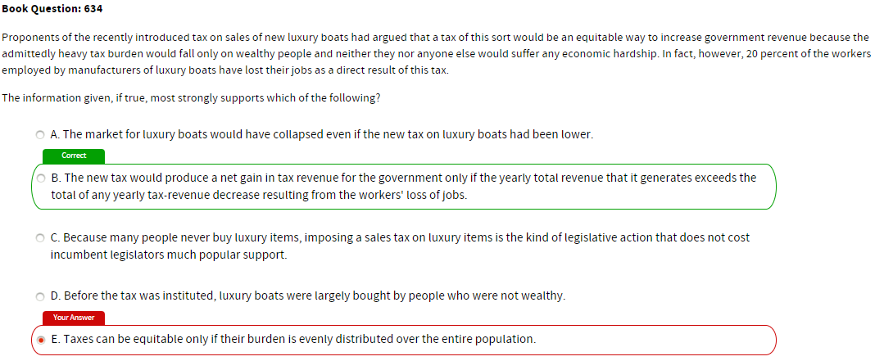
No conclusions stated—only facts/premises. The question asks what conclusions can therefore be drawn. E clearly is not a valid or relevant conclusion based on the premises given. Eliminating A, C, D, E leaves only B as a plausible conclusion that can follow from the set of facts given.
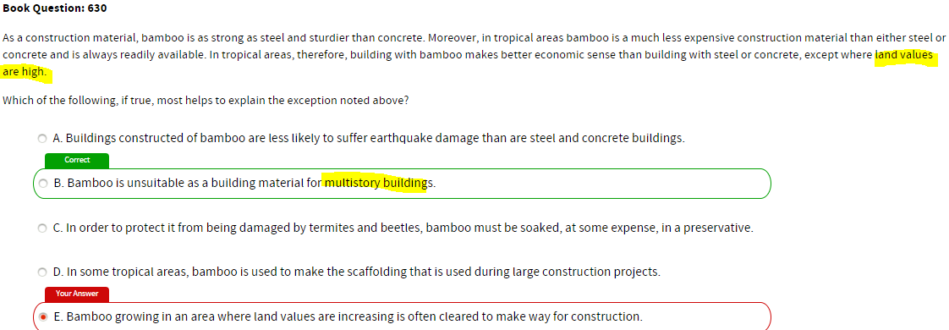
Tricky—missed the nuanced business logic that multistory buildings tend to be built on areas where land values are high.
E looked plausible—but also noticed that “clearing” is NOT the same as using. GMAT CARES ABOUT THOSE NUANCED DIFFERENCES. If the answer you pick is “just slightly off”, GO BACK AND CHECK OTHER ANSWER CHOICES. You ARE MISSING SOMETHING.
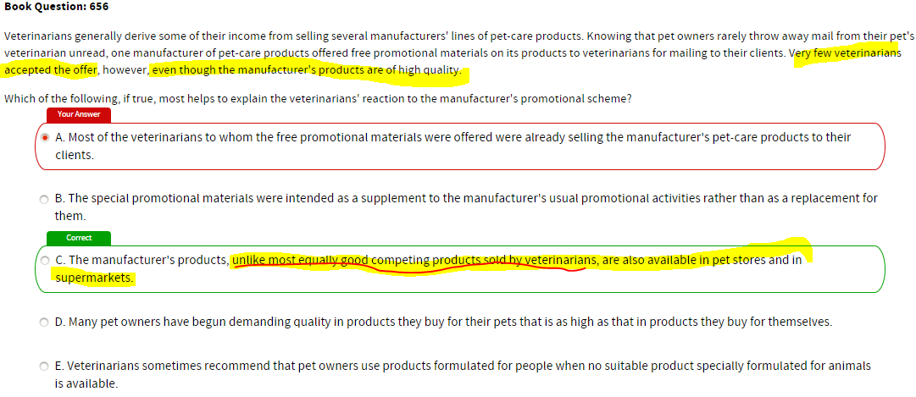
C is the only answer choice that clearly establishes distinction between the products promoted here and other products vets promote. A sounds weak, like a bad excuse. IF YOUR ANSWER CHOICE FEELS WEAK GO BACK AND CHECK OTHER ANSWER CHOICES, IT’S PROBABLY WRONG.
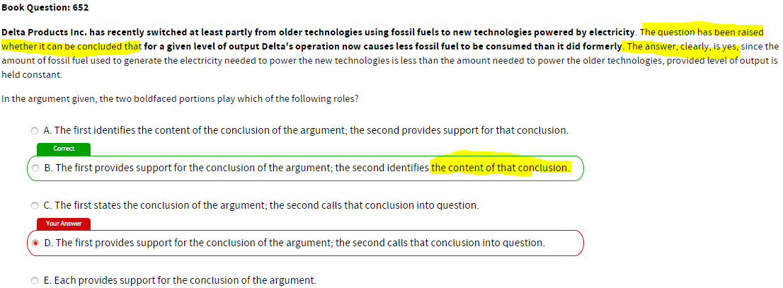
“for a given level…” isn’t the conclusion given role in the sentence which raises the question of the conclusion, it’s the literal words in the conclusion; hence it is the “content” of the conclusion. The sentence RAISES the question of whether the conclusion is accurate, but the bolded phrase itself doesn’t “call the conclusion into question”.

Took over 2:30 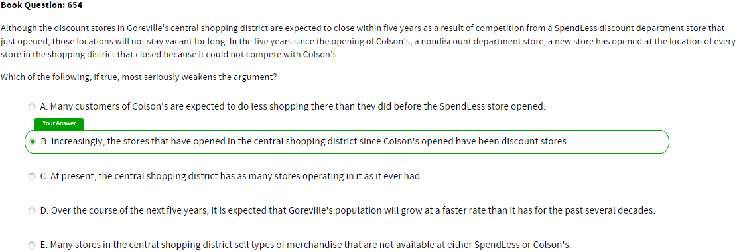
Key factor: stores opening after a nondiscount dept store have been meeting a DIFFERENT need. THAT example is DIFFERENT from this example.
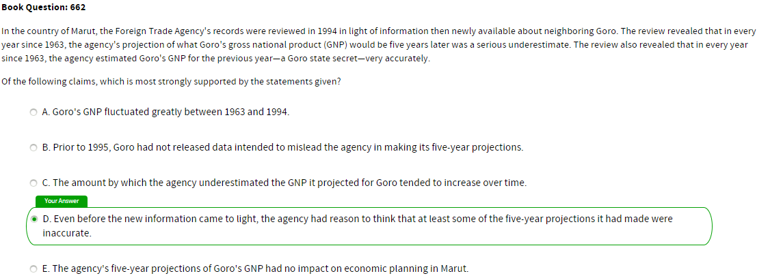
WHAT CONCLUSIONS CAN BE DRAWN FROM THE PREMISES? Last year’s estimate was generally higher than what projection was 5 years ago
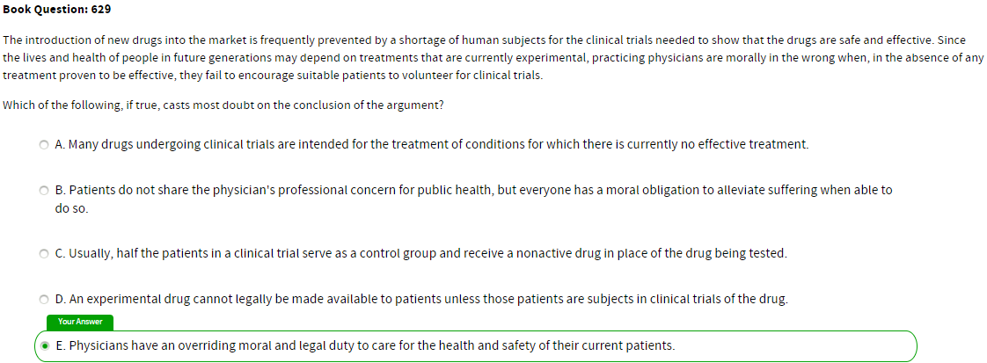
Key factor: trials are for benefit of FUTURE GENERATIONS. Trials may not be totally safe or effective for current subjects.
July 2018
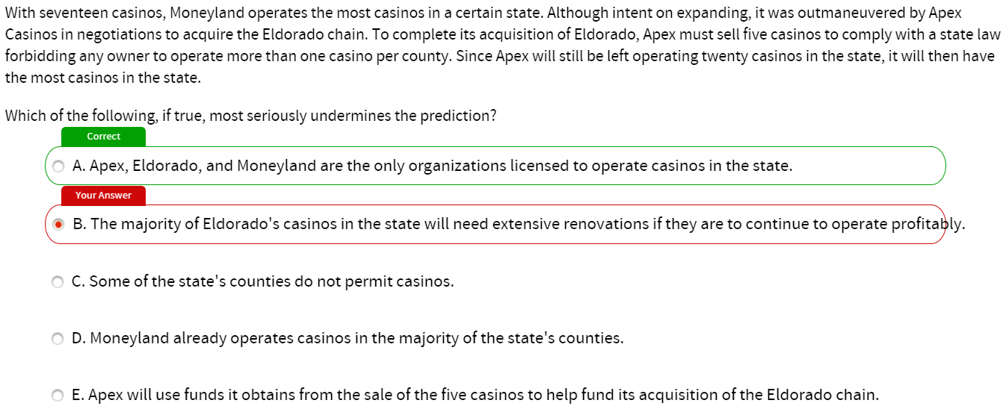
If A Moneyland is the only likely buyer for the five casinos Apex needs to sell. Moneyland is likely to acquire the five casinos during the sale and end up with twenty-two casinos—more than Apex.
***B does not undermine the prediction. This indicates you are missing something about the MEANING/IMPLICATION of the other answer choices.*** Even if the Eldorado casinos cannot operate profitably for long without extensive renovations, Apex will still have twenty casinos immediately after its transactions.

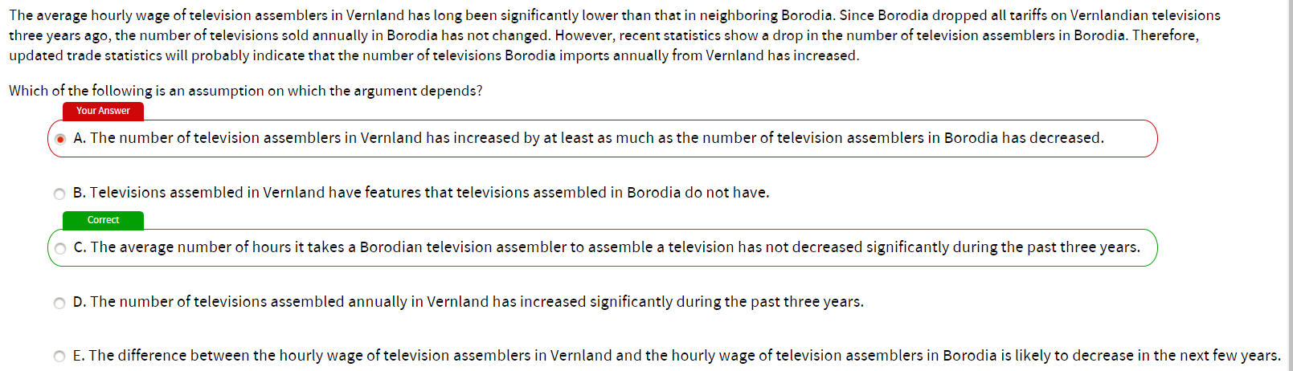
Situation Television assemblers in Vernland are paid less than those in neighboring Borodia. The number of televisions sold in Borodia has not dropped since its tariffs on Vernlandian TVs were lowered three years ago, but the number of TV assemblers in Borodia has. So, TV imports from Vernland have likely increased.
The fact that fewer individuals in Borodia are working as TV assemblers is offered as evidence that TV imports from Vernland into Borodia have likely increased Indicates the number of TVs being produced within Borodia has decreased.
But a drop in the number of TV assemblers ~ a drop in the number of TVs being assembled IF the number of TVs an average assembler puts together has increased. Thus, the argument must be assuming that the average time it takes an assembler to put together a TV has not significantly decreased.
The argument does not rely on any information about the number of television assemblers in Vernland or of TVs assembled in Vernland.

Guillemot's habitat range will not be ENLARGED but SHIFT given something not considered. Main point was the consecutive snow-free days concept, but also relevant was an earlier comment about feeding habits. If feeding habits were disrupted, would be a shift.
Also--an unusually early snow could happen in the south also. Not specific to the north.
Physically active lifestyle shown to help increase longevity. In Wistar, avg age at death is much higher than any other part of the country. Wistar is the only mountainous part of Bellaria. A mountainous terrain makes even basic activities strenuous...clearly explains the long lives.
Which most seriously weakens the argument?
a) all medical exp paid for by govt, so personal income doesn't affect quality of HC
c) many people who live in Wistar moved there in middle age or on retirement
Voters condemn politicians for being insincere, but politicians often must disguise their true feelings when they make public statements. If they expressed their honest views—about, say, their party's policies—then achieving politically necessary compromises would be much more difficult. Clearly, the very insincerity that people decry shows that our government is functioning well.
Which of the following, if true, most seriously undermines this reasoning?
A. Achieving political compromises is not all that is necessary for the proper functioning of a government.
B. Some political compromises are not in the best long-term interest of the government.
Argument doesn’t require all political compromises to help govt function well, only politically necessary ones.
A is correct bc if govts can still function poorly even if insincerity enables necessary political compromises, then politician insincerity doesn't establish govt is functioning well
Everyone who has graduated from TopNotch High School has an intelligence quotient (IQ) of over 120. Most students with an IQ of over 120 and all students with an IQ of over 150 who apply to one or more Ivy League universities are accepted by at least one of them.
The statements above, if true, best support which of the following conclusions?
- Every graduate of TopNotch High School with an IQ of 150 has been accepted by at least one Ivy-League university.
- If a person is a high-school graduate and has an IQ of less than 100, he or she could not have been a student at TopNotch High School.
- If a person has an IQ of 130 and is attending an Ivy-League university, it is possible for him or her to have graduated from TopNotch High School.
- At least one graduate from TopNotch high school who has applied to at least one Ivy-League university has been accepted to one of them.
- If a high-school graduate has an IQ of 150 and is not attending an Ivy-League university, then he or she did not apply to one of them.
Applying =/= attending, student of TopNotch HS =/= graduate. The question isn't tough. You just need to analyze the words very carefully. It doesn't have any ambiguity.
Sales at a local sandwich shop have been declining steadily since a health food restaurant opened its doors for business on the same block three months ago. The owner of the sandwich shop concludes that the best way to raise sales back to prior levels is to offer special sandwich prices that compete with the low prices at the health food restaurant.
Which of the following assumptions helps to justify the owner’s conclusion?
- Local consumers prefer the food at the sandwich shop to the food at the health food restaurant.
- Sales at the sandwich shop reached an all-time high six months ago.
- The sandwich shop’s prices are currently higher than those of a similar shop located in a neighboring town.
- The sandwich shop does not currently offer any healthful food items.
- The health food restaurant is running its special prices as a temporary promotion and will be raising its prices at the end of the year.

For-profit colleges serve far fewer students than either public or private non-profit colleges. At the same time, relative to non-profit colleges, for-profit colleges draw a disproportionate share of federal and state financial aid, such as tuition grants and guaranteed loans, for their students. It must be, then, that for-profit colleges enroll a greater proportion of financially disadvantaged students than do non-profit colleges.
In assessing the argument above, it would be most useful to compare
- the proportion of financially disadvantaged students served by public and private non-profit colleges
- the extent to which for-profit and non-profit colleges engage in fraudulent practices in helping their students obtain unneeded federal and state financial aid
- the number of students receiving federal and state financial aid at for-profit colleges and non-profit colleges
- the quality of education received by financially disadvantaged students at for-profit colleges and non-profit colleges
- the rates of default on loan repayments among graduates of for-profit and non-profit colleges

City Controller: 63% of our residents voted to approve the developer's request to build a national chain hotel on the site of the old consignment store. The hotel will increase our revenue base and, therefore, provide more money for schools and community services.
Mayor: But our recent survey showed that the most important reason people want to live here is our small-town feel resulting from the local ownership of the vast majority of businesses.
What is the best explanation for the apparent contradiction in opinions cited by the controller and the mayor?
- Most people believe having a small-town feel is more important than having quality schools.
- A locally-owned business might be able to generate as much revenue as a well-known hotel chain.
- The recent survey did not ask about preferences for a chain hotel versus a locally-owned bed and breakfast.
- An increase in the town's revenue base may not result in additional money for the schools.
- The recent survey cited by the mayor polled people who are considering moving to the town.

Scientist: Evolutionary biology has long held that the most attractive males of a species, defined as those with the highest quality physical traits that have no Darwinian survival value, will draw the most female mates. The resulting male offspring will inherit that attractiveness and themselves have more children as a result, thus ensuring widespread dissemination of the grandparents' genes. Recently, however, scientists have found that the sons of "high quality" male flycatchers failed to inherit the father's mating status. Further, the most attractive males were so busy mating that they neglected their offspring; as a result, the sons of homelier birds, who took better care of their offspring, had more success at propagating the species.
The two portions in boldface play which of the following roles in the scientist's argument?
- The first is the conclusion of a theory disputed by the scientist; the second is the scientist's new contention based upon the latest evidence.
- The first is a premise of a long-held biological theory; the second is an example of how this theory works.
- The first is an explanation of how a biological theory is thought to work; the second is an example of research results that do not support this theory.
- The first is an example of a theory that used to be prevalent; the second is the new theory that is now considered predominant by scientists.
- The first introduces a long-held theory that the scientist is going to disprove; the second is the scientist's new theory to replace the one she disproved.
First is not a conclusion but a premise—fact, observations are not conclusions. Second is also evidence/data but not a conclusion/contention.

