***MODIFIERS***
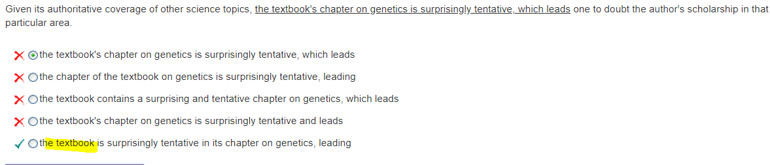
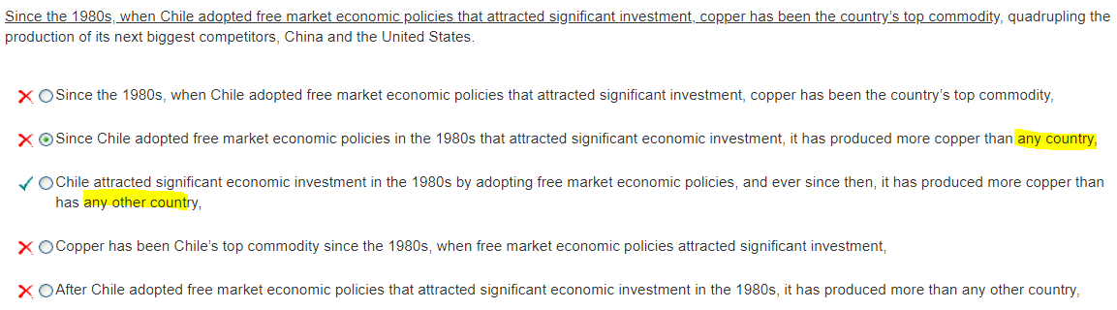
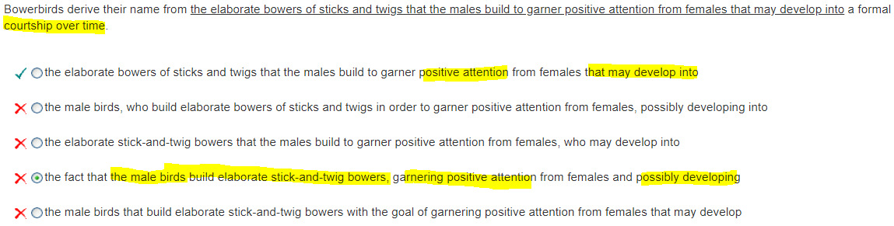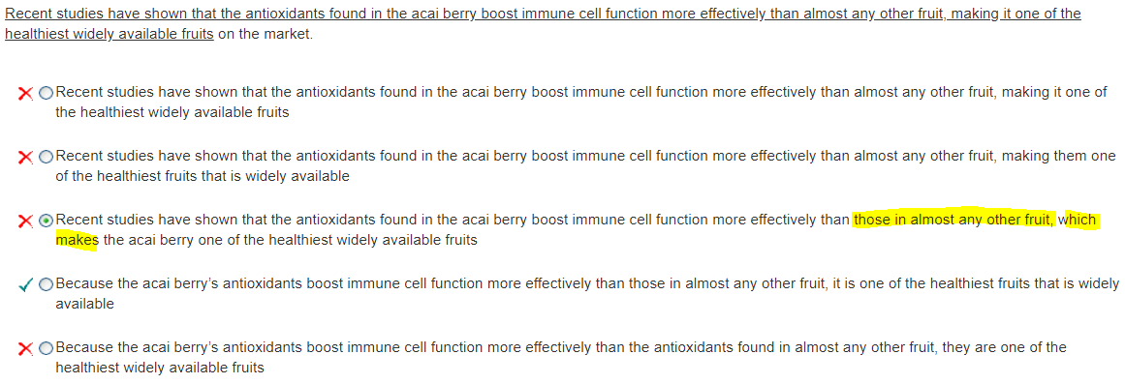
Comma-which is a noun modifier, and it must modify the preceding main noun. In this answer, the which modifier would have to refer to other fruit or those (the antioxidants in the other fruit), neither of which is the reason that the acai berry is one of the healthiest fruits.

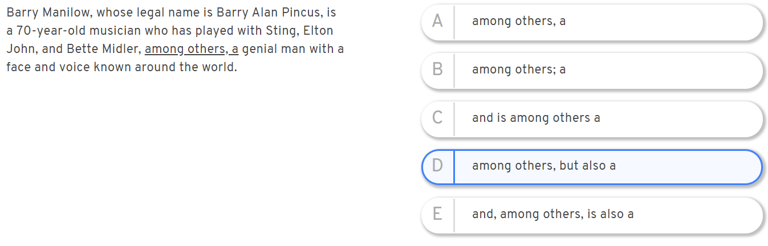
Answer: A. Appositive modifiers. E.g. “Tom fell into the Grand Canyon, an accident that changed his life.”


