Overall GMAT Exam Performance
MEAN SCORE
MEAN SCORE:
563.4
(41st percentile)
Definition

The three year mean GMAT Total score is 563.4. This score is better than 41% of GMAT Exam scores recorded in the past three years.

Note: GMAT scores are valid for five years. Even though your score won't change, your percentile ranking may change when compared with a newer pool of applicants. Shifts tend to be gradual over long periods of time.

YOUR GMAT TOTAL SCORE:

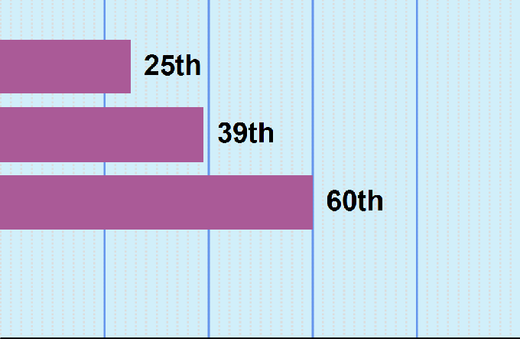
600

PERCENTILE RANKING | 0 | 20 | 40 | 60 | 80 | 100
YOUR IR SCORE:
3
YOUR VERBAL SCORE:
25
YOUR QUANTITATIVE SCORE:
47
YOUR AWA SCORE:
-
PERCENTILE RANKING | 0 | 20 | 40 | 60 | 80 | 100
PERCENTILE RANKINGS COMPARE YOUR PERFORMANCE TO 3 YEARS OF GMAT EXAMS SAMPLE SIZE: 739752
MEAN TIME
MEAN TIME FOR ALL TEST TAKERS:
1:56 minutes
Definition
For all GMAT Exam scores recorded in the past three years the mean time to complete a question in the Integrated Reasoning, Verbal, and Quantitative sections is 1:56 minutes.

TIME MANAGEMENT BY SECTION
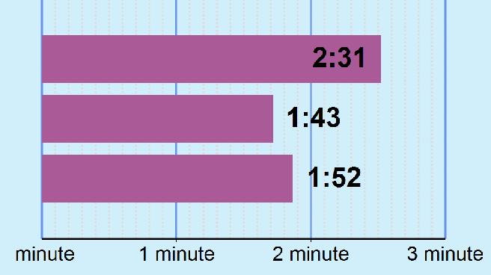
YOUR MEAN RESPONSE TIME PER QUESTION

INTEGRATED REASONING

VERBAL QUANTITATIVE

SUMMARY
- Your GMAT Total score of 600 is higher than 55% of GMAT Exam scores recorded in the past three years.
  - Your Integrated Reasoning score of 3 is higher than 21% of GMAT Exam scores recorded in the past three years.
  - Your Verbal score of 25 is higher than 39% of GMAT Exam scores recorded in the past three years.
  - Your Quantitative score of 47 is higher than 60% of GMAT Exam scores recorded in the past three years.
- Your Quantitative score of 47 and your Verbal score of 25 were used to calculate your GMAT Total score. Especially strong or weak scores on either section significantly impacts the GMAT Total score.

Integrated Reasoning Performance
MEAN SCORE
MEAN SCORE:
4.41
(35th percentile)

Definition

The three year mean GMAT Integrated Reasoning score is 4.4. This score is better than 35% of GMAT Exam scores recorded in the past three years.

Note: GMAT scores are valid for five years. Even though your score won't change, your percentile ranking may change when compared with a newer pool of applicants. Shifts tend to be gradual over long periods of time.
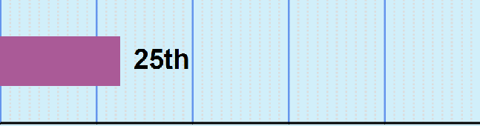
YOUR OVERALL IR SCORE:

3

PERCENTILE RANKING | 0 | 20 | 40 | 60 | 80 | 100
PERCENT OF QUESTIONS YOU ANSWERED CORRECTLY
PERCENTILE RANKING | 0 | 20 | 40 | 60 | 80 | 100
PERCENTILE RANKINGS COMPARE YOUR PERFORMANCE TO 3 YEARS OF GMAT EXAMS

TIME MANAGEMENT - INTEGRATED REASONING
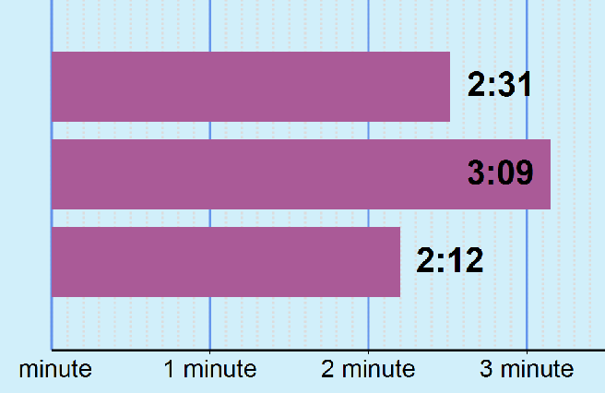
YOUR MEAN RESPONSE TIME PER QUESTION

MEAN TIME FOR ALL TEST TAKERS:
2:23 minutes
Definition
For all GMAT Exam scores recorded in the past three years the mean time to complete a question in the Integrated Reasoning section is 2:23 minutes.

OVERALL SECTION

CORRECT

INCORRECT
MEAN TIME

SUMMARY
- Your Integrated Reasoning score of 3 is higher than 21% of GMAT Exam scores recorded in the past three years. The mean score for this section is 4.41.
- Lack of familiarity with the format of the four item types may negatively impact performance in this section.
- You completed 12 of the 12 questions in the Integrated Reasoning section.

Verbal Section Performance
MEAN SCORE
MEAN SCORE:
27.08
(46th percentile)
Definition

The three year mean GMAT Verbal score is 27.1. This score is better than 46% of GMAT Exam scores recorded in the past three years.

Note: GMAT scores are valid for five years. Even though your score won't change, your percentile ranking may change when compared with a newer pool of applicants. Shifts tend to be gradual over long periods of time.
YOUR OVERALL VERBAL SCORE:
PERCENTILE RANKING 0 20 40 60 80 100

25

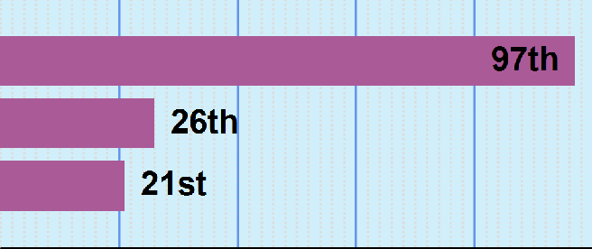
SUB-SECTION RANKINGS
CRITICAL REASONING

READING COMPREHENSION

SENTENCE CORRECTION

PERCENTILE RANKING 0 20 40 60 80 100
PERCENTILE RANKINGS COMPARE YOUR PERFORMANCE TO 3 YEARS OF GMAT EXAMS SAMPLE SIZE: 739752

SUB-SECTION TIME MANAGEMENT
MEAN TIME
MEAN TIME FOR ALL TEST TAKERS:
1:44 minutes
Definition
For all GMAT Exam scores recorded in the past three years the mean time to complete a question in the Verbal section is 1:44 minutes.
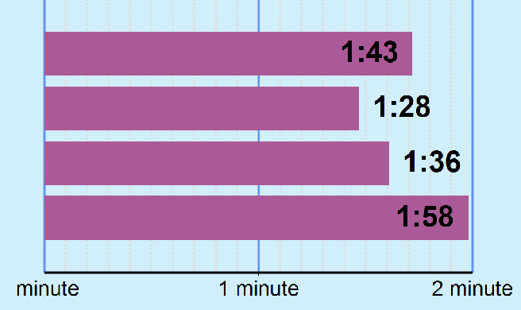
YOUR MEAN RESPONSE TIME PER QUESTION

OVERALL VERBAL CRITICAL REASONING
READING COMPREHENSION

SENTENCE CORRECTION

PERFORMANCE BY FUNDAMENTAL SKILLS

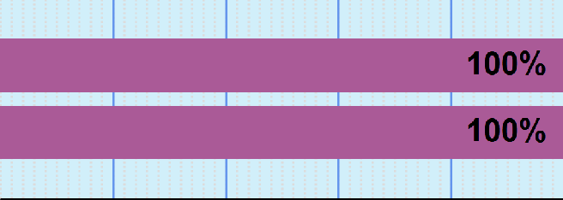
CRITICAL REASONING
This is NOT an official score report

ANALYSIS/CRITIQUE CONSTRUCTION/PLAN
PERCENTAGE CORRECT 0 20 40 60 80 100

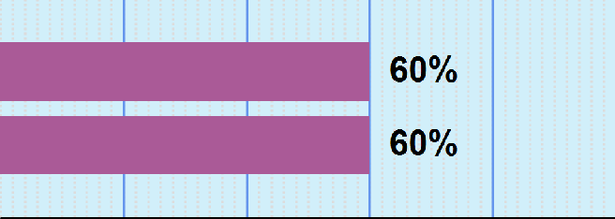
READING COMPREHENSION

IDENTIFY INFERRED IDEA IDENTIFY STATED IDEA
PERCENTAGE CORRECT 0 20 40 60 80 100

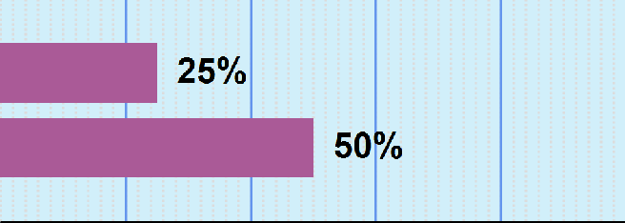
SENTENCE CORRECTION

GRAMMAR COMMUNICATION
PERCENTAGE CORRECT 0 20 40 60 80 100

This is NOT an official score report

PERCENT CORRECT

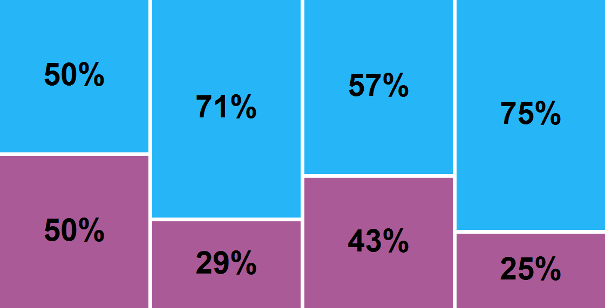
YOUR OVERALL VERBAL SCORE:
FIRST SECOND THIRD LAST

25
PERCENT OF QUESTIONS ANSWERED CORRECT/INCORRECT
- CORRECT
- INCORRECT
"Each section in this graph represents approximately one quarter of the questions in order of presentation."

AVERAGE DIFFICULTY

AVERAGE DIFFICULTY PER QUESTION
- ALL
- CORRECT
- INCORRECT
High

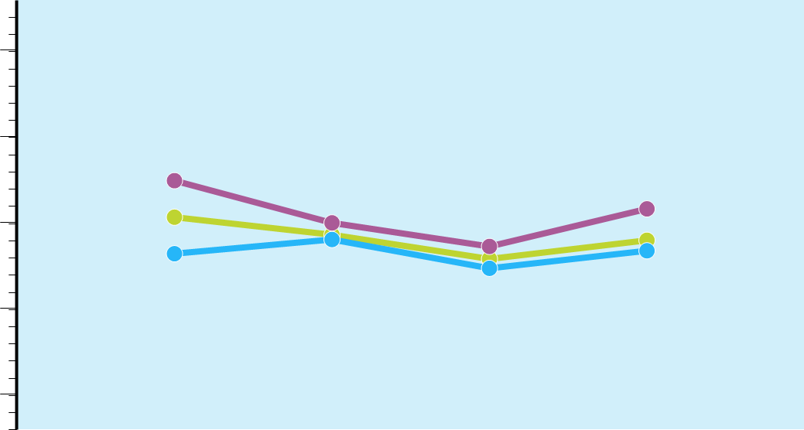Medium
FIRST
SECOND
THIRD
LAST

Low
"Each section in this graph represents approximately one quarter of the questions in order of presentation."

PERFORMANCE OVER TIME

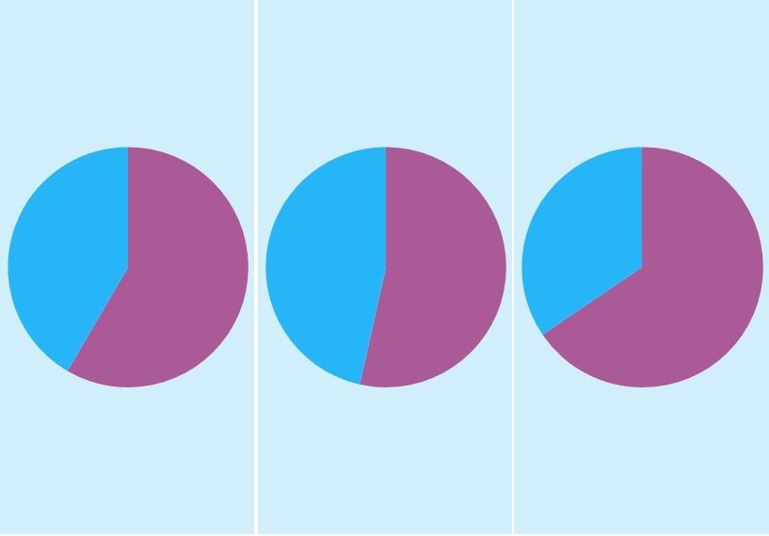AVERAGE TIME PER RESPONSE
2:04
1:51
1:13
1:42
LAST
THIRD
SECOND
FIRST

  - CORRECT
  - INCORRECT

"Each section in this graph represents approximately one quarter of the questions in order of presentation."

SUMMARY
- Your Verbal score of 25 is higher than 39% of GMAT Exam scores recorded in the past three years. The mean score for this section is 27.08.
- Your performance on Critical Reasoning questions was equivalent to a score of 51, which is better than 97% of GMAT Exam scores recorded in the past three years. The mean score for this sub-section is 27.57.
  - Your performance of 100% on Analysis/Critique questions is considered Very Strong.
  - Your performance of 100% on Construction/Plan questions is considered Very Strong.
- Your performance on Reading Comprehension questions was equivalent to a score of 20, which is better than 26% of GMAT Exam scores recorded in the past three years. The mean score for this sub-section is 27.24.
  - Your performance of 60% on Identify Inferred Idea questions is considered Average.
  - Your performance of 60% on Identify Stated Idea questions is considered Average.
- Your performance on Sentence Correction questions was equivalent to a score of 19, which is better than 21% of GMAT Exam scores recorded in the past three years. The mean score for this sub-section is 27.27.
  - Your performance of 25% on Grammar questions is considered Very Weak.
  - Your performance of 50% on Communication questions is considered Weak.
- You completed 36 questions in the Verbal section.
- You responded correctly to 50% of the first set of questions, 71% of the second set of questions, 57% of the third set of questions and 75% of the final set of questions.
- The average difficulty of questions presented to you in the first set of questions was Medium, the average for the second set of questions was Medium , the average for the third set of questions was Medium and was Medium for the final set of questions.
- The average time it took you to respond to the first set of questions presented was 2:04, the average time for the second set of questions was 1:51, the average time for the third set of questions was 1:13 and 1:42 for the final set of questions.
- Please Note: If you sat for the GMAT exam prior to April 16, 2018 this section contained 41 questions, on or after April 16, 2018 the section consists of 36 questions.

Quantitative Section Performance
YOUR OVERALL QUANTITATIVE SCORE:
MEAN SCORE
MEAN SCORE:
40.20
(38th percentile)
Definition

The three year mean GMAT Quantitative score is 40.2. This score is better than 38% of GMAT Exam scores recorded in the past three years.

Note: GMAT scores are valid for five years. Even though your score won't change, your percentile ranking may change when compared with a newer pool of applicants. Shifts tend to be gradual over long periods of time.
PERCENTILE RANKING 0 20 40 60 80 100

47

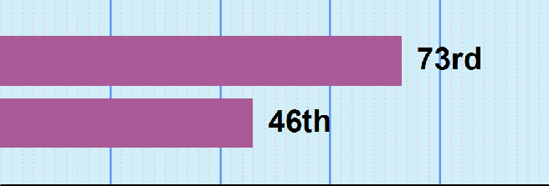
SUB-SECTION RANKINGS

PROBLEM SOLVING

DATA SUFFICIENCY

PERCENTILE RANKING | 0 | 20 | 40 | 60 | 80 | 100
ARITHMETIC

ALGEBRA/GEOMETRY
PERCENTILE RANKING | 0 | 20 | 40 | 60 | 80 | 100
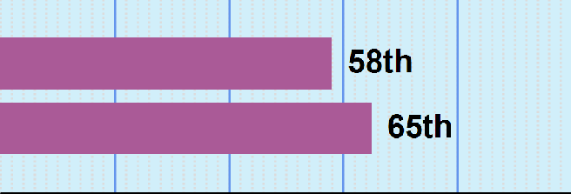
PERCENTILE RANKINGS COMPARE YOUR PERFORMANCE TO 3 YEARS OF GMAT EXAMS SAMPLE SIZE: 739752
MEAN TIME
MEAN TIME FOR ALL TEST TAKERS:
1:55 minutes
Definition
For all GMAT Exam scores recorded in the past three years the mean time to complete a question in the Quantitative sections is 1:55 minutes.

SUB-SECTION TIME MANAGEMENT
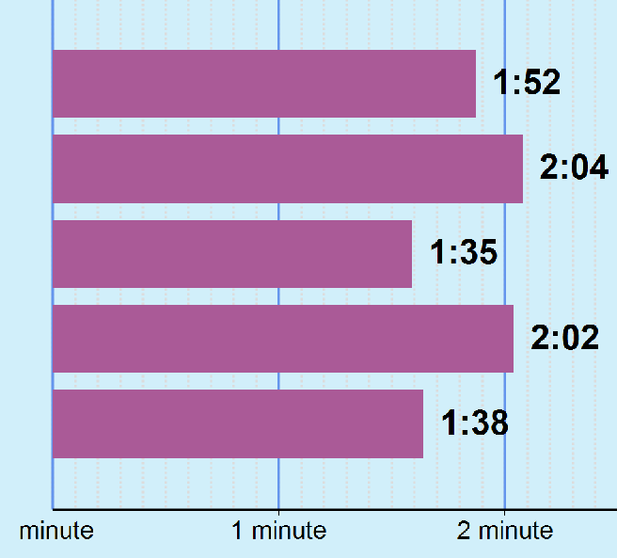
YOUR MEAN RESPONSE TIME PER QUESTION

OVERALL QUANTITATIVE

PROBLEM SOLVING

DATA SUFFICIENCY

ARITHMETIC

ALGEBRA/GEOMETRY

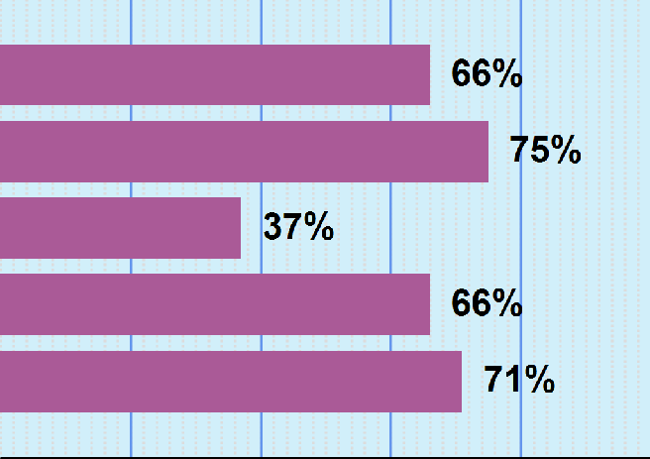
PERFORMANCE BY FUNDAMENTAL SKILLS

GEOMETRY

RATES/RATIO/PERCENT

VALUE/ORDER/FACTORS

EQUAL./INEQUAL./ALG.

COUNTING/SETS/SERIES

PERCENT CORRECT 0 20 40 60 80 100

PERCENT CORRECT

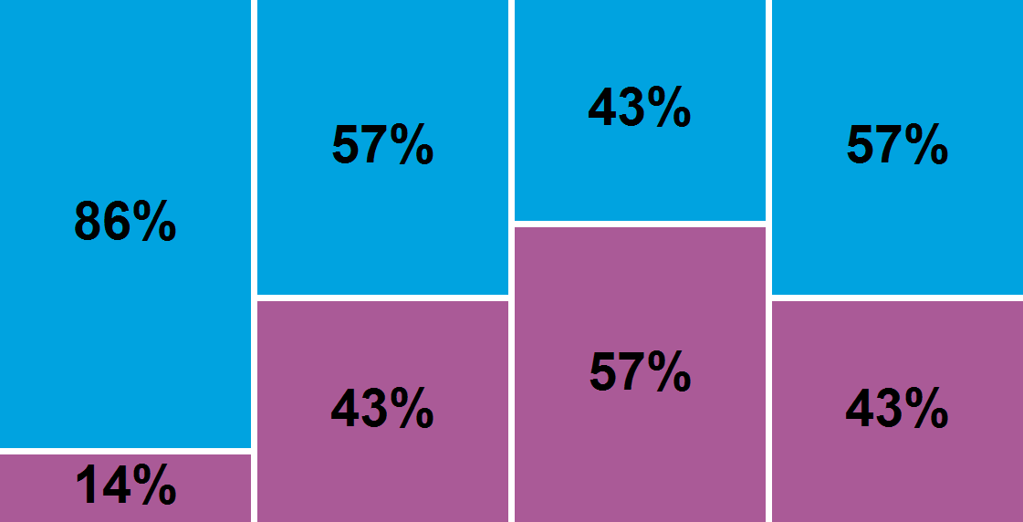
YOUR OVERALL QUANTITATIVE SCORE:
FIRST SECOND THIRD LAST

47
PERCENT OF QUESTIONS ANSWERED CORRECT/INCORRECT
- CORRECT
- INCORRECT
Each section in this graph represents approximately one quarter of the questions in order of presentation.

AVERAGE DIFFICULTY

FIRST SECOND THIRD LAST

AVERAGE DIFFICULTY PER QUESTION
- ALL
- CORRECT
- INCORRECT
High

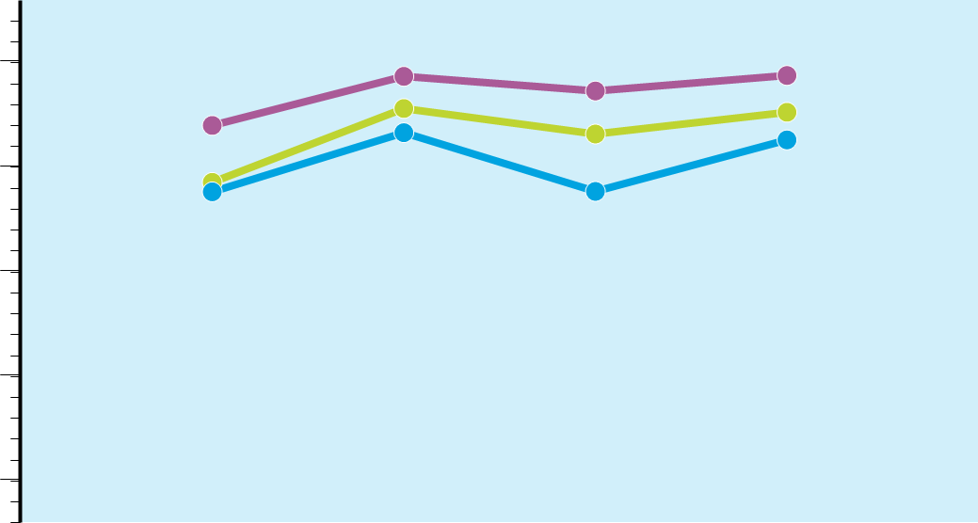
Medium

Low

Each section in this graph represents approximately one quarter of the questions in order of presentation.

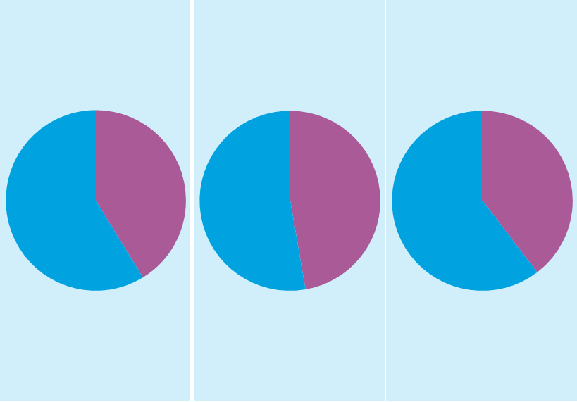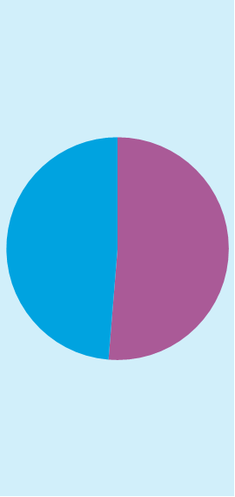 TIME MANAGEMENT
FIRST SECOND THIRD LAST
2:05
2:42
1:41
0:58
AVERAGE TIME PER RESPONSE

  - CORRECT
  - INCORRECT

Each section in this graph represents approximately one quarter of the questions in order of presentation.

SUMMARY

- Your Quantitative score of 47 is higher than 60% of GMAT Exam scores recorded in the past three years. The mean score for this section is 40.2.
- Your performance on Problem Solving questions was equivalent to a score of 49. Your score is better than 73% of all sub-section scores recorded in the past three years. The mean for all test takers is 40.2.
- Your performance on Data Sufficiency questions was equivalent to a score of 44. Your score is better than 46% of all sub-section scores recorded in the past three years. The mean for all test takers is 40.17.
- Your performance on Arithmetic questions was equivalent to a score of 47. Your score is better than 58% of all sub- section scores recorded in the past three years. The mean for all test takers is 40.33.
- Your performance on Algebra/Geometry questions was equivalent to a score of 48. Your score is better than 65% of all sub-section scores recorded in the past three years. The mean for all test takers is 40.1.
- Your performance of 66% on Geometry questions is considered Above Average.
- Your performance of 75% on Rates/Ratio/Percent questions is considered Above Average.
- Your performance of 37% on Value/Order/Factors questions is considered Weak.
- Your performance of 66% on Equal./Inequal./Alg. questions is considered Above Average.
- Your performance of 71% on Counting/Sets/Series questions is considered Above Average.
- You completed 31 questions in the Quantitative section.
- You responded correctly to 86% of the first set of questions, 57% of the second set of questions, 43% of the third set of questions and 57% of the final set of questions..
- The average difficulty of questions presented to you in the first set of questions was Medium, the average for the second set of questions was Medium High, the average for the third set of questions was Medium High and was Medium High for the final set of questions.
- The average time it took you to respond to the first set of questions presented was 2:05, the average time for the second set of questions was 2:42, the average time for the third set of questions was 1:41 and 0:58 for the final set of questions.
- Please Note: If you sat for the GMAT exam prior to April 16, 2018 this section contained 37 questions, on or after April 16, 2018 the section consists of 31 questions.

This is NOT an official score report
AWA Section Performance
This report is created before your Analytical Writing Essay is scored and will appear within 24 hours of the exam scores being made official. If the score has been cancelled for any reason, the information will not appear in the Enhanced Score Report.

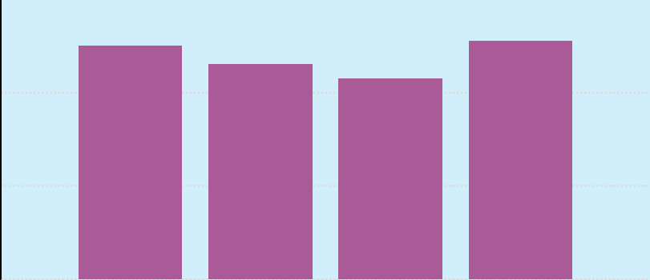
SUB-SECTION RANKINGS
MEAN SCORE
MEAN SCORE:
4.49
(17th percentile)
Definition

The three year mean GMAT Verbal score is 4.5. This score is better than 17% of GMAT Exam scores recorded in the past three years.

Note: GMAT scores are valid for five years. Even though your score won't change, your percentile ranking may change when compared with a newer pool of applicants. Shifts tend to be gradual over long periods of time.

Strong

Weak

Analyze Relevancy Organization Communication

SUMMARY
- *Please Note:
  - The AWA Sub-Section Ratings and Summary included in the GMAT Enhanced Score Report rely on computer scoring and do not reflect the human input that contributes to your official GMAT score.
- Analysis
  - You clearly identified important features of the argument and analyzed them in a generally thoughtful way.
- Relevancy
  - You effectively supported the main points of your critique.
- Organization
  - You developed and organized ideas satisfactorily, but did not always effectively transition between ideas.
- Communication
  - Your essay demonstrated strong control of language and the conventions of standard written English, but included minor flaws.

