GMAT Quant Review
Combinatorics
Combination – Problems that ask for the grouping only, and order does not matter
Example: There are ten friends, how many groups of 5 can be selected from them?
10!/5!
Permutations – Problems where order matters
Example: There are five seats at the theater. 5 friends will see the movie, and the other 5 will go to eat. How many different seating configurations are possible in the 5 theater seats?
10!/5! * 5!
Key Formulas:
- Probability = # of desired outcomes/# possible outcomes
- Probability (A and B) = Probability(A)*Probability(B)
- Probability (at least A or B) = Probability(A)+Probability(B)
- Probability (A OR B, not both) = (Probability(A)+Probability(B)) – Probability(A and B)
- Probability (A but not B) = Probability (A) – Probability (A and B)
- The number of ways to arrange n things, with no restrictions, is n!
- Circular permutations = (N-1)!
Factorials
You can use factorials when certain items can appear multiple times in a list
1 | 2 | 3 | 4
Y | Y | N | N
$\frac{N!}{\left(A!\right)\left(N-A\right)!}$ N is the number of slots available. In the denominator, list the number of times the item can appear, and also the number of times it cannot. Picture the table: ($\frac{4!}{\left(2!\right)\left(2!\right)}$ = 6 combos)
- When there are restrictions, like “Jason can’t sit next to Becky”, group them together and treat them as one, and then multiply your final answer by how every many ways that grouping can exist (JB, or BJ).
- How many ways to rearrange the letters in the word PARALLEL?
  - $\frac{8!}{\left(3!\right)\left(2!\right)\left(1!\right)\left(1!\right)\left(1!\right)}=3360$
- How many ways to rearrange the letters in the word PARALLEL if the P and R have to be together?
  - $\frac{7!}{\left(3!\right)\left(2!\right)\left(1!\right)}x 2=840$

Exponents
Tricks that can be applied only when there is a shared base
- Multiply terms: add exponents
- Divide terms: subtract exponents
- Nested exponents: multiply exponents
- The reciprocal of an exponent is 1/the exponent
  - x^2 = 1/x^2
  - To raise anything to a negative power, instead raise the reciprocal to a positive power.
- You can factor out a common term when bases with exponents are added or subtracted, the base just has to be common.
- All equations with even exponents have two solutions (+-)

General Procedure for Exponent Questions
- Check for Difference of Squares
- Find common bases by factoring
- Factor out common terms
- Make all exponents positive

Rules:

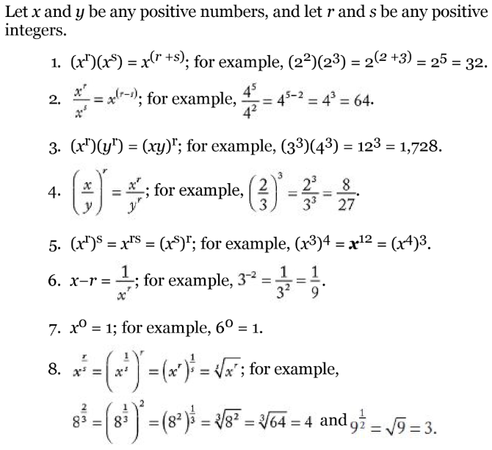

Difference of Squares (Memorize)
Difference of Squares: $x^{2}-y^{2}=(x+y)(x-y)$
Addition of Squares: ${\left(x+y\right)}^{2}=\left(x+y\right)\left(x+y\right)=x^{2}+2xy+y^{2}$
Addition of Squares: ${\left(x-y\right)}^{2}=\left(x-y\right)\left(x-y\right)=x^{2}-2xy+y^{2}$
Roots
- Roots are the opposite of exponents $x^{2}=x^{\frac{1}{2}} = \sqrt{x}$

Rate / Time Questions
R x T = D
Get everything into the R x T = D format, and in the units necessary for the answer.
Solve for the answer, don’t check the possible solutions
To convert units: multiply the number by the conversion ratio, with the units positioned to cancel (one on top, one on bottom)
Mixture Questions
Draw a table like this, and solve for the variables:
 | A | B | Mixture
Water
Salt
Total
.6x + .2y = .4(x+y)
.6x + .2(total-x) = total

Geometry
- Sum of interior angles of a polygon = (sides-2)180
- Isosceles: Two sides the same. Two angles the same.
- Right Triangles : A = Base X Height /2
- Equilateral Triangles: A = $\frac{x^{2}\sqrt{3}}{4}$
- Never use distance formula: 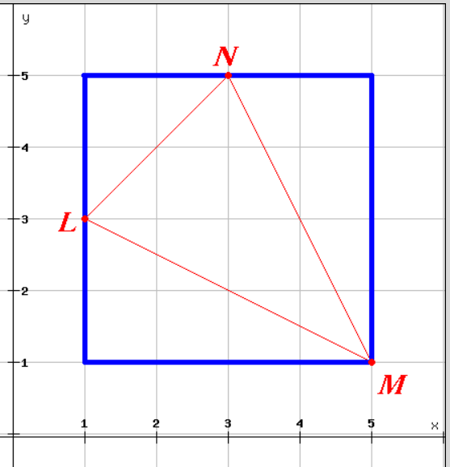

General Tips
- SIMPLIFY!!!
- Remember that the product of any number of decimals has as many decimal places as all the decimals being multiplied put together
- Venn Diagrams
  - 2 overlapping sets:
    - Total = Group1 + Group2 - Both + Neither
  - 3 Overlapping sets:
    - Total = Group1 + Group2 + Group3 - (sum of 2-group overlaps) - 2*(all three) + Neither
- 1 is not prime!
- Only positive numbers can be prime.
- Integers can be positive or negative.
- 0 is even, and an integer
- 0 is divisible by any integer, except zero
- Two lines are perpendicular if the slope of one is the negative reciprocal of the other. Y=-(1/5)x+1 is perpendicular to 5x+1
- Product of A*B = GCF * LCM
- An inscribed angle cuts off an arc that is twice its measure in degrees
- Divisibility Rules
  - 1 - All whole numbers are divisible by one
  - 2 – All even whole numbers are divisible by two
  - 3 – If the sum of all the digits is divisible by three
  - 4 – If the number made by the last two digits is divisible by 4, or if the number is divisible by 2, twice
  - 5 – If the last digit is 5 or 0
  - 6 – If the number is divisible by 3, and even
  - 7 – Take the last digit and double it, then subtract it from the number formed by the remaining digits. If that number is divisible by 7, then the whole thing is divisible by 7
  - 8 – If the number is divisible by 2, 3 times
  - 9 – If the sum of the digits is divisible by 9
  - 10 – If the number ends in 0
  - 11 – Alternately add, and subtract all the digits. If the result is divisible by 11, the whole thing is divisible by 11.


