PREREQUISITES:
- For the “timer” in the form to work, you need to have Excel 2013 or later.
- Click “Enable Content” after opening the excel.
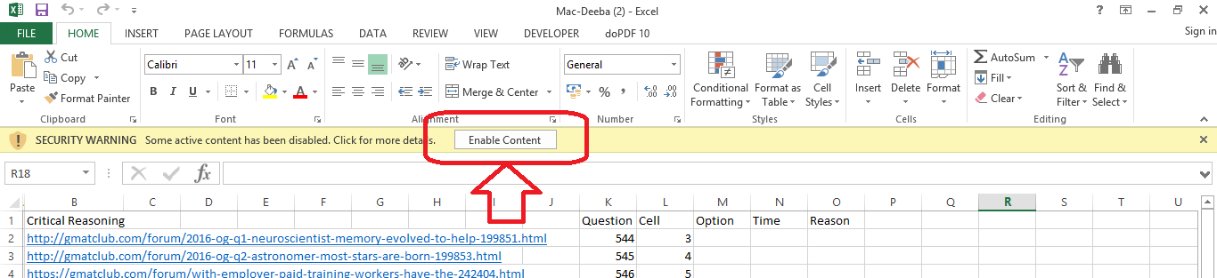
- Or follow the below steps to fix it forever
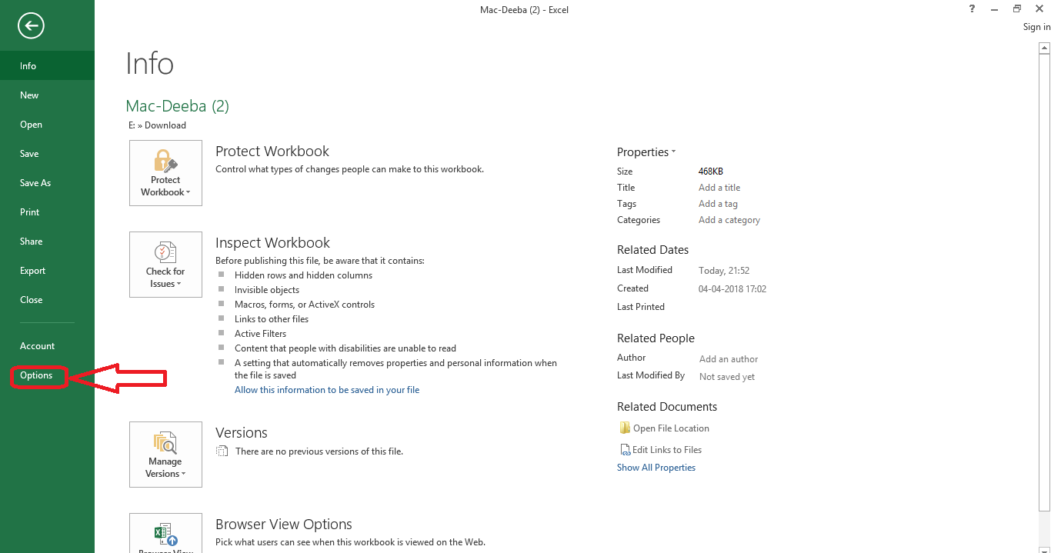
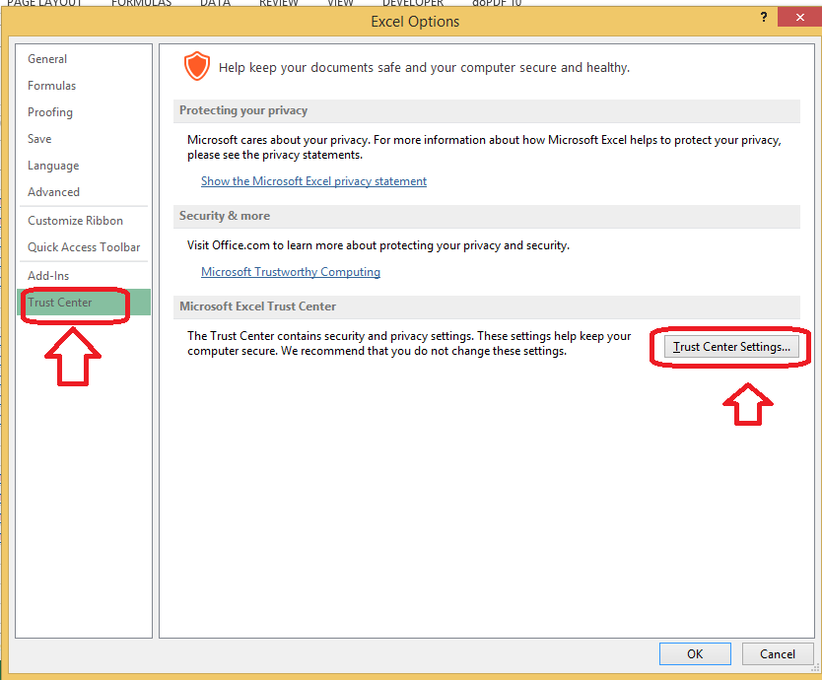
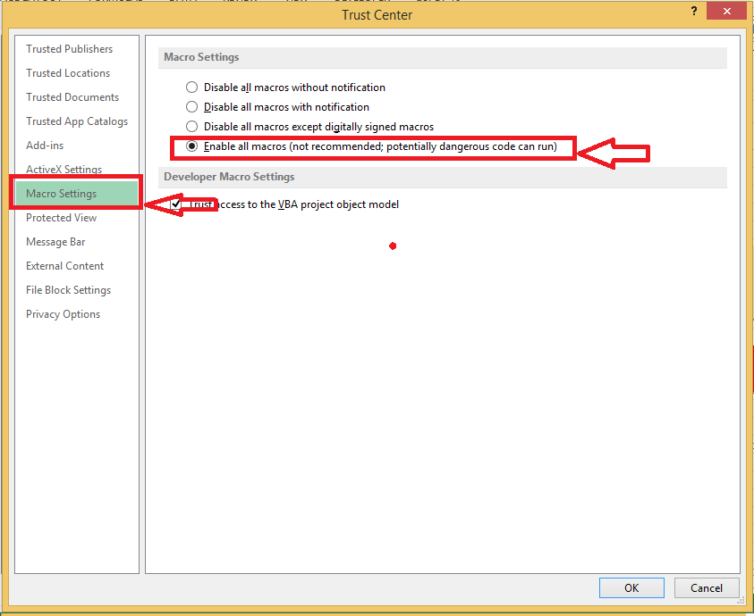
In the same window, do this as well.
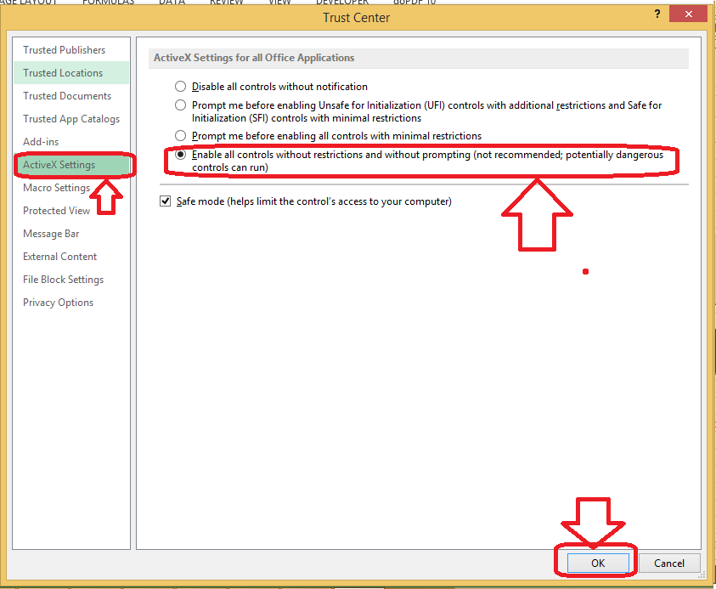

QUANT QUESTIONS:
- Go to “QuaQue” sheet in the error log
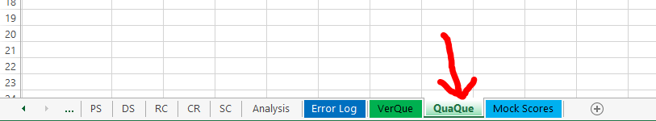
- Click on “Launch Form”
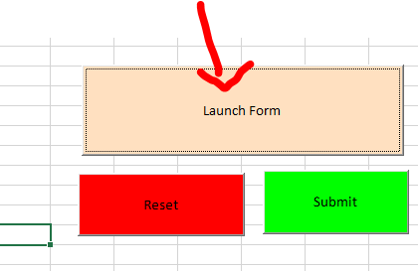
- Click “Yes” …(this will refresh the question pool available)
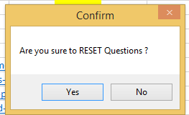
- Click “Open URL”
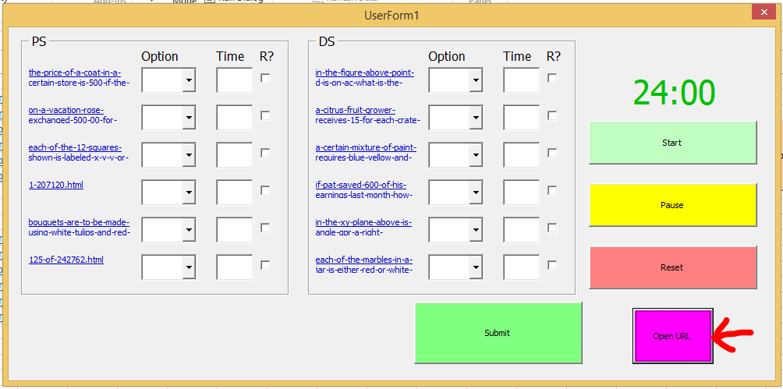
- The questions open up in gmatclub.com site
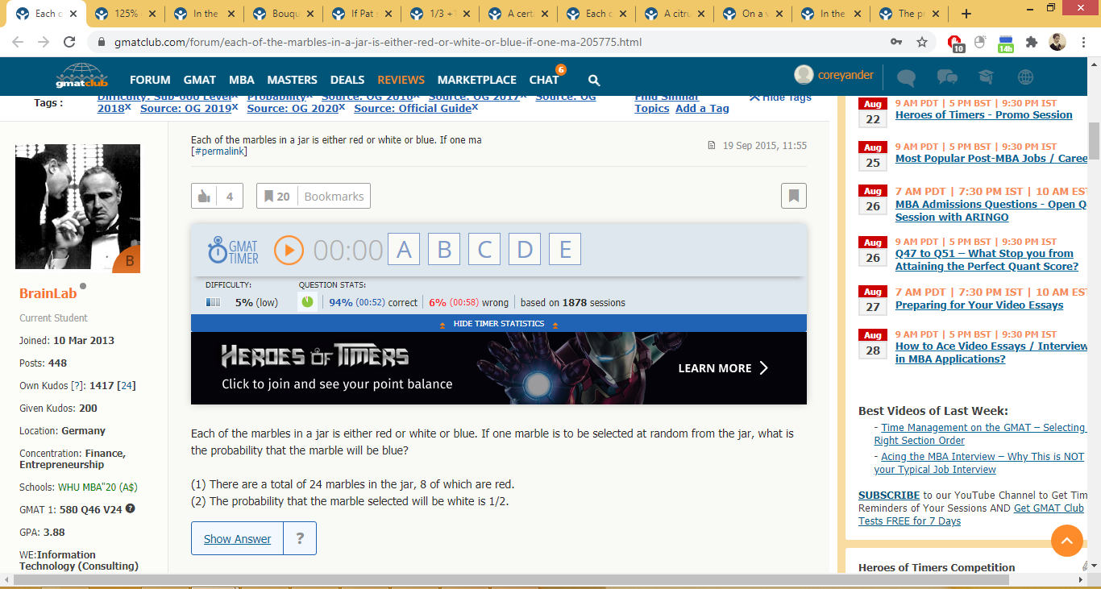
- Click “Start” in the Form to start the timer in the excel sheet
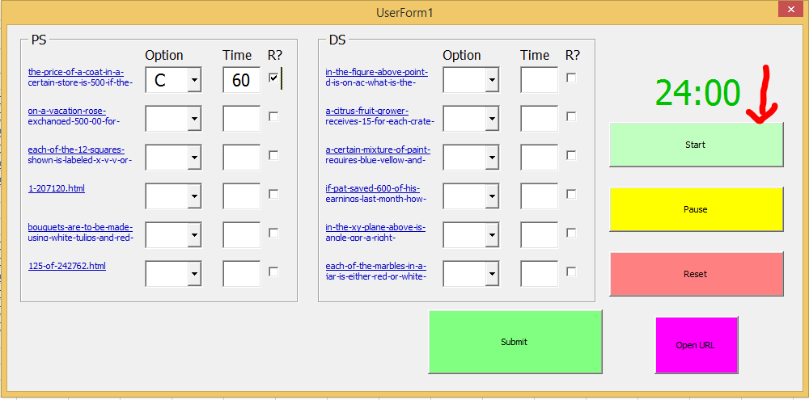
(You can pause & reset too. But the time is only for your reference. The times are not taken as input to the questions)
- Attempt the questions. Input the respective answer selected for the question in the “Form” in excel sheet.
- You can input answer for only one question too.
- Input time in SECONDS
- In case, if you want to review the question later, select the “R?” column. (R stands for Review?)
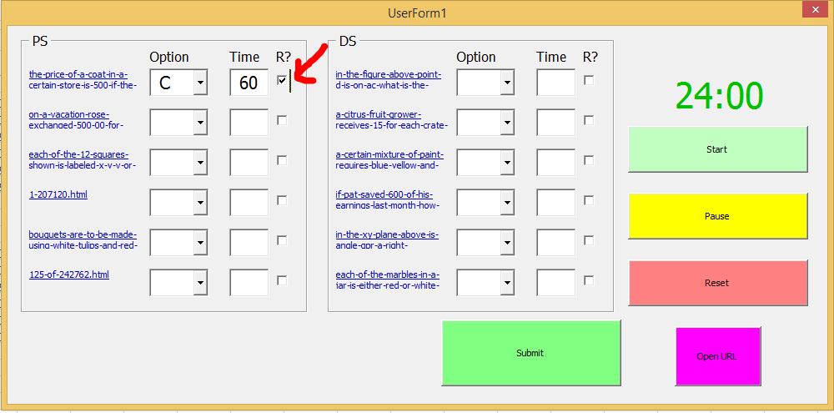
- Click “Submit”
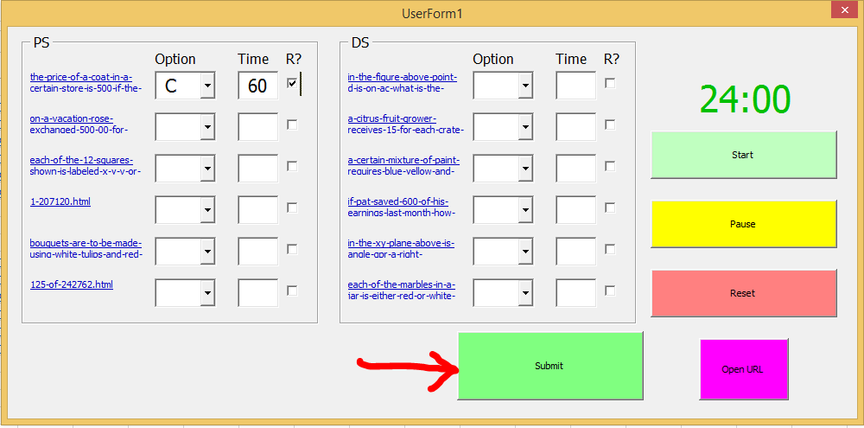
- Click “Yes”
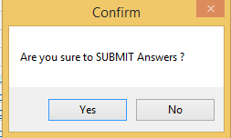
- Done! The inputs are saved in the Master Sheet “Error Log”
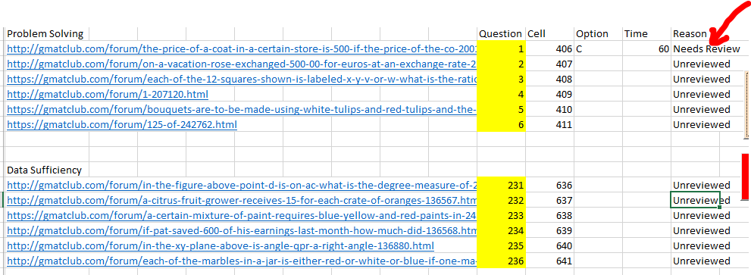
(Since we selected the “R?” box in the form for the question, the reason is filled with “Needs Review”.)
Master Sheet “Error Log”
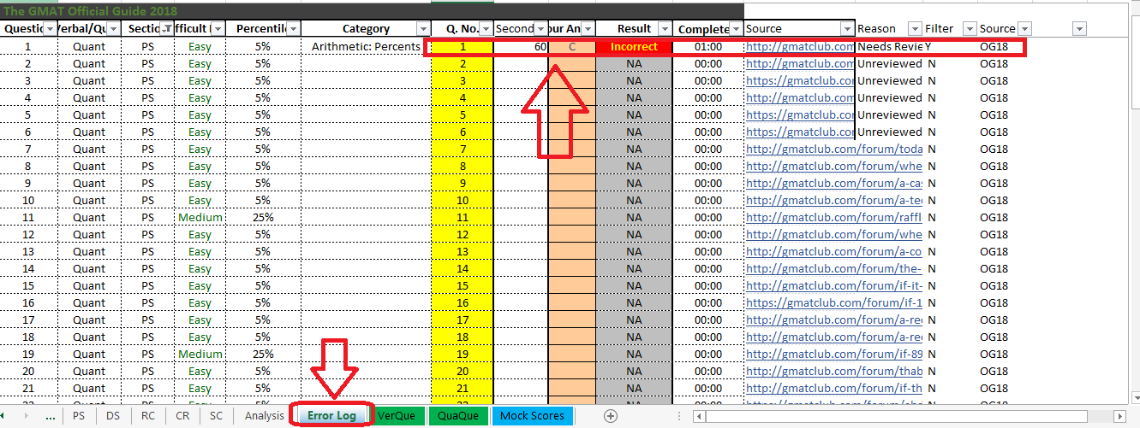
- Now, you can review the questions attempted in the “QuaQue” sheet. And, if you have any comments to give to the question, give it in the reason column.
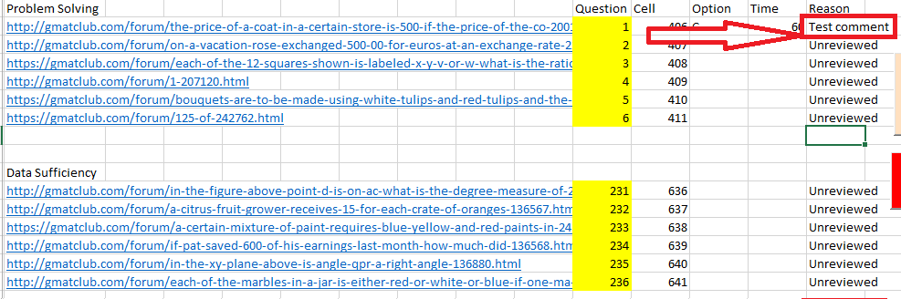
- Click on “Submit”. It gets updated on the “Error Log” sheet.
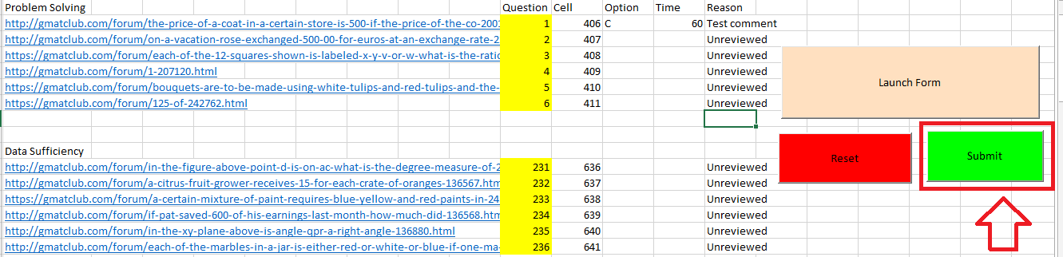
- Click “Yes”
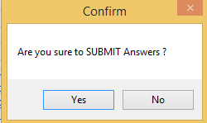

- “Error Log” Sheet
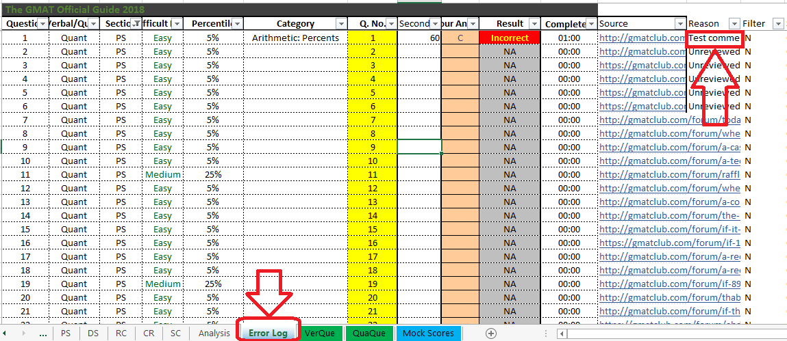
- The “Filter” option lets you filter out two types of questions for review. “Filter” set to “Y”
- The questions you got wrong…. (Need not select “R?” This is default option)
- The questions for which you selected “R?” (To know more about “R?”, see point 7)

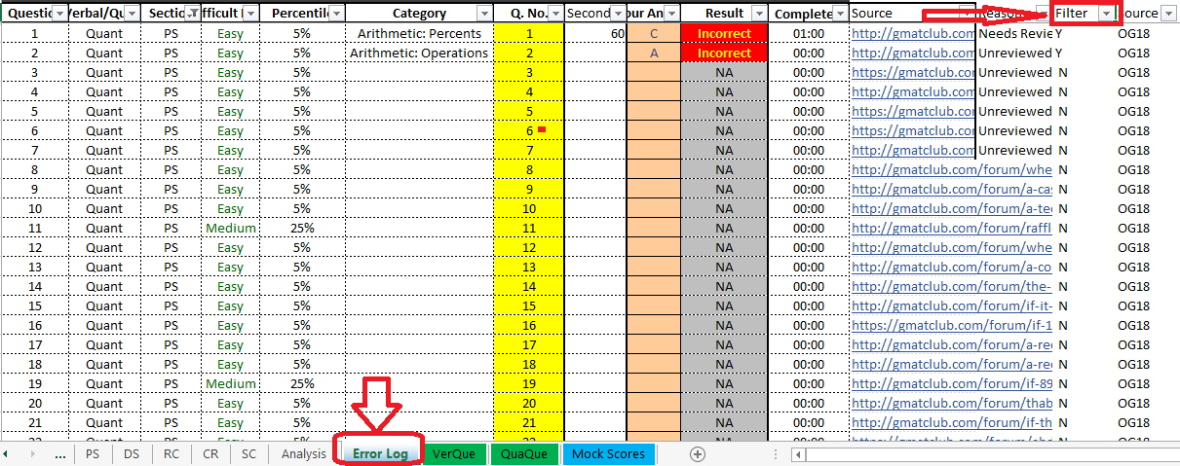
Set “Fitler” to “Y”
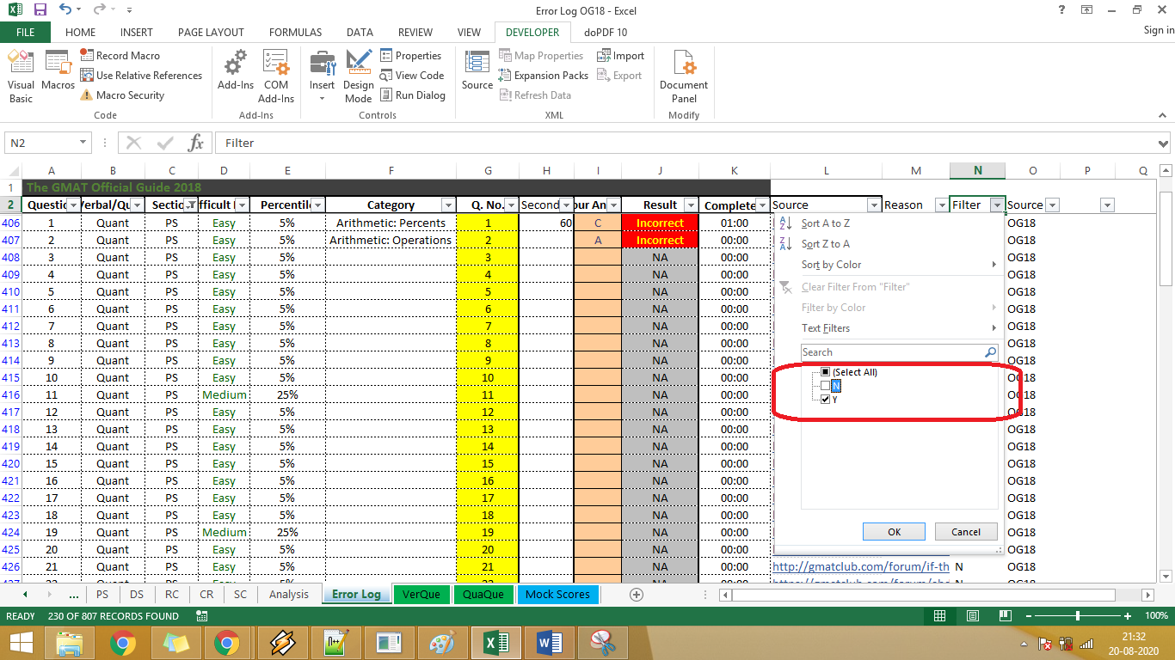
You will only get the incorrect questions and the “R?” questions
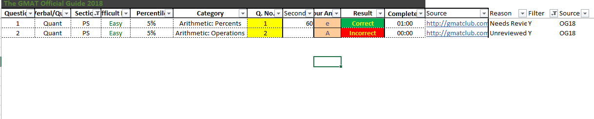
As soon as you update the “Reason“ column for these questions, the “Filter” gets set to “N”, meaning you no longer will be able to filter out.
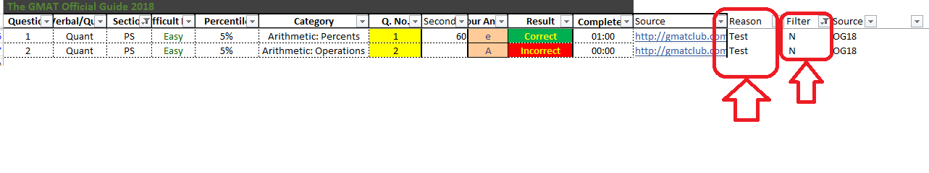
VERBAL QUESTIONS
- Go to “VerQue” sheet and follow the same


